Supplementary Material

Five doses of the mRNA vaccination potentially suppress ancestral-strain stimulated SARS-CoV2-specific cellular immunity: A cohort study from the Fukushima Vaccination Community Survey, Japan

**Yuta Tani1, Morihito Takita1,2, Masatoshi Wakui3, Hiroaki Saito2,4, Tianchen Zhao2, Chika Yamamoto2, Takeshi Kawamura5,6, Akira Sugiyama5, Aya Nakayama5, Yudai Kaneko6,7, Tetsuhiko Kodama6,** **Masaharu Tsubokura1,2,4\***

1Medical Governance Research Institute, Tokyo, Japan

2Department of Radiation Health Management, Fukushima Medical University, Fukushima, Japan

3Department of Laboratory Medicine, Keio University School of Medicine, Tokyo, Japan

4Department of Internal Medicine, Soma Central Hospital, Fukushima, Japan.

5Proteomics Laboratory, Isotope Science Center, The University of Tokyo, Tokyo, Japan.

6Laboratory for Systems Biology and Medicine, Research Center for Advanced Science and Technology, The University of Tokyo, Tokyo, Japan.

7Medical and Biological Laboratories Co., Ltd, Tokyo, Japan.

**\* Correspondence:**Masaharu Tsubokura  
[tsubo-m@fmu.ac.jp](mailto:tsubo-m@fmu.ac.jp)

# Supplementary Data Legends

Supplementary Table 1. Dates of vaccinations and blood collections

Supplementary Table 2. Logistic regression analysis at timepoint H

Supplementary Table 3. Logistic regression analysis at timepoint K using data at timepoint A as explanatory variables

Supplementary Figure 1. The dynamics of T-SPOT.COVID phytohemagglutinin (PHA) results

Supplementary Figure 2 The dynamics of humoral and cellular immunity for the three individuals who did not show reactivity

Supplementary Figure 3 The dynamics of humoral and cellular immunity for the three individuals with IgG(N) ≥ 10 AU/mL, suggesting SARS-CoV-2 infection

# Supplementary Figures and Tables

**Supplementary Table 1. Detail data on vaccinations and blood collections**

|  |  |  |  |  |  |  |  |  |  |  |  |  |  |  |  |  |  |  |
| --- | --- | --- | --- | --- | --- | --- | --- | --- | --- | --- | --- | --- | --- | --- | --- | --- | --- | --- |
| Timepoint | First dose | Second dose | Third dose | A | B | C | | D | E | Fourth dose | F | G | | H | Fifth dose | I | J | K |
| Year | 2021 | | | | | | 2022 | | | | | | 2023 | | | | | |
| The earliest date (month/day) | 5/12 | 6/2 | 1/26 | 3/28 | 4/25 | 5/23 | | 6/20 | 7/20 | 7/8 | 8/22 | 9/21 | | 11/21 | 11/28 | 12/5 | 12/19 | 2/20 |
| The latest date  (month/day) | 6/22 | 7/13 | 2/25 | 4/14 | 5/12 | 5/24 | | 6/21 | 7/21 | 8/23 | 8/23 | 9/22 | | 11/22 | 11/29 | 12/6 | 12/20 | 2/21 |
| Days between the last vaccination and blood collection | - | - | - | 61  [40–61] | 89  [68–89] | 117  [96–117] | | 145  [124–145] | 175  [154–175] | - | 28  [28–28] | 58  [56–58] | | 119  [119–119] | - | 7  [7–7] | 21  [21–21] | 84  [84–94] |

Median [interquartile] is shown for days between the last vaccination and blood collection.

**Supplemental Table 2. Results of logistic regression analysis at timepoint H**

|  |  |  |  |  |  |  |
| --- | --- | --- | --- | --- | --- | --- |
| Variables | Reactive  (n = 31) | Nonreactive and borderline (n = 17) | Univariable analysis | | Multivariable analysis | |
| OR (95% CI) | *p*-value | aOR (95 % CI) | *p*-value |
| Age | 68 [64–74] | 80 [66–83] |  |  |  |  |
| < 70 years old | 17 (54.8) | 5 (29.4) | 1 (reference) | 0.096 | 1 (reference) | 0.090 |
| ≥ 70 years old | 14 (45.2) | 12 (70.6) | 0.34 (0.097–1.21) | 0.096 | 0.32 (0.087–1.19) | 0.090 |
| Sex - Female | 9 (29.0) | 5 (29.4) | 0.98 (0.27–3.6) | 0.98 | 0.83 (0.21–3.28) | 0.79 |
| Heterologous booster at the third dose | 13 (41.9) | 1 (5.9) | 11.6 (1.36–98.5) | 0.025 | - | - |
| Drinking habits | 13 (41.9) | 1 (5.9) | 11.6 (1.36—98.5) | 0.025 | - | - |
| Smoking | 5 (16.1) | 0 (0.0) | - | - | - | - |
| Comorbidities |  |  |  |  |  |  |
| Hypertension | 30 (96.8) | 15 (88.2) | 4.0 (0.34–47.7) | 0.27 | - | - |
| Diabetes mellitus | 15 (48.4) | 8 (47.1) | 1.06 (0.32–3.45) | 0.93 | 0.85 (0.24–3.00) | 0.81 |
| Dyslipidemia | 6 (16.1) | 1 (5.9) | 3.08 (0.33–28.8) | 0.32 | - | - |

Median [interquartile] or number (percentage) are shown for continuous or categorical variables. 95% CI, 95% confidence interval; aOR, adjusted odds ratio; OR, odds ratio.

**Supplemental Table 3. Logistic regression analysis at timepoint K using data at timepoint A as explanatory variables**

|  |  |  |  |  |  |  |
| --- | --- | --- | --- | --- | --- | --- |
| Variables | Reactive  (n = 11) | Nonreactive and Borderline (n = 14) | Univariable analysis | | Multivariable analysis | |
| OR (95% CI) | *p*-value | aOR (95% CI) | *p*-value |
| Age | 66 [61–70] | 79.5 [68–84] | 0.92 (0.84–1.00) | 0.048 | 0.86(0.73–1.00) | 0.051 |
| CoV(A) reactive | 11 (100) | 8 (57.1) | - | - | - | - |
| IgG(S) (1000AU/mL) | 5.67 [2.95–6.48] | 2.67 [0.91–4.96] | 1.42 (0.97–2.08) | 0.071 | 1.23(0.67–2.28) | 0.50 |
| N(Ab) (100AU/mL) | 8.85 [8.54–8.91] | 8.69 [7.12–8.89] | 3.25 (0.45–23.6) | 0.24 | 2.46(0.42–14.4) | 0.32 |
| Positive control | 323 [182–389] | 368 [245–524] | 1.00 (0.99–1.00) | 0.11 | 0.99(0.98–1.00) | 0.056 |

Median [interquartile] or number (percentage) are shown for continuous or categorical variables. 95% CI, 95 % confidence interval; aOR, adjusted odds ratio; OR, odds ratio. The positive control referred to the PHA-stimulated wells of T-SPOT.COVID assay.

**Supplementary Figure 1. The dynamics of T-spot COVID phytohemagglutinin results**

(A) The dynamics of T-SPOT.COVID phytohemagglutinin (PHA) results. We divided the cohort into two groups: the reactive group (n = 11) and the nonreactive and borderline group (n = 14), and (B) illustrated the dynamics of the T-SPOT.COVID PHA results.

**Supplementary Figure 2. The dynamics of humoral and cellular immunity for the three individuals who did not show reactivity**

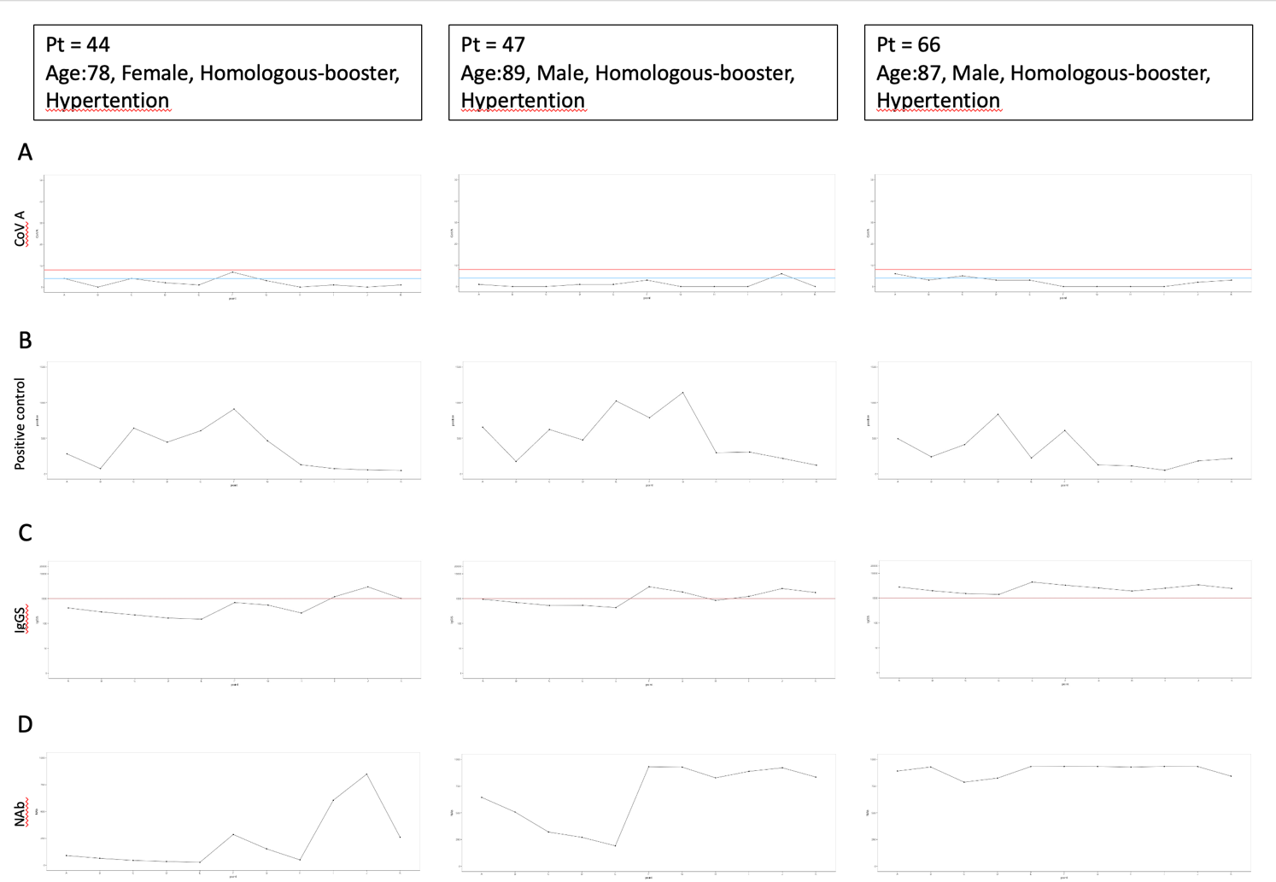

(**A**) The dynamics of T-SPOT.COVID COV(A) results, (**B**) T-SPOT.COVID phytohemagglutinin (PHA) results, (**C**) IgG(S) levels, and (**D**) NAb titers. In (**A**), spots ≥50 are scored as 50. Spots ≤4, 5–7, and ≥8 were considered nonreactive, borderline, and reactive, respectively.

**Supplementary Figure 3. The dynamics of humoral and cellular immunity for the three individuals with IgG(N) ≥ 10 AU/mL suggest SARS-CoV-2 infection**

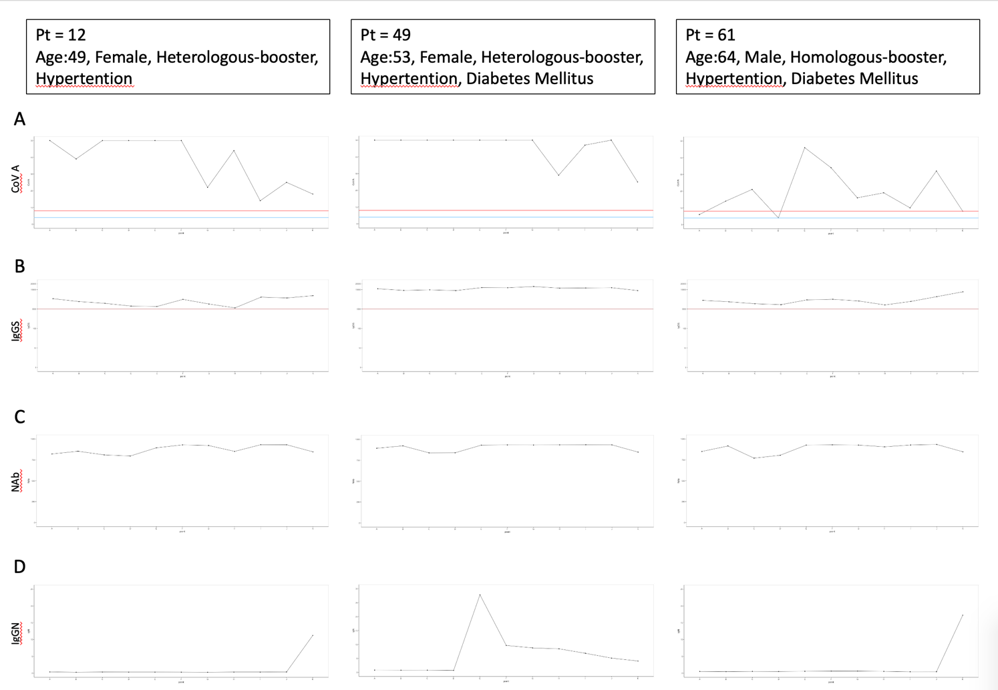

(**A**) The dynamics of T-SPOT.COVID COV(A) results, (**B**) IgG(S) levels, (**C**) NAb titers, and (**D**) IgG against the nucleocapsid protein (IgG(N)) levels. In (**A**), spots ≥50 are scored as 50. Spots ≤4, 5–7, and ≥8 were considered nonreactive, borderline, and reactive, respectively.