**SUPPLEMENTARY TABLE AND FIGURE LEGENDS**

**Supplementary Table 1. Real-time primer sequences used.**

**Supplementary Table 2. List of primary antibodies used.**

**Supplementary Figure 1. Cellular localisation of mammalian sirtuins.** Two mammalian sirtuins (SIRT1 and SIRT6) are localised to the nucleus. Only SIRT2 has been reported in the cytoplasm. SIRT3-5 represent mitochondrial sirtuins. SIRT7 is found in the nucleolus. Abbreviations: GDH (Glutamate Dehydrogenase); CS2 (Citrate Synthase isoenzyme-2).

**Supplementary Figure 2. Anatomical changes in sirtuin mRNA expression in the ageing rat brain using RT-PCR. (A) SIRT1 (B) SIRT2 (C) SIRT3 (D) SIRT4 (E) SIRT5 (F) SIRT6 (G) SIRT7.** Graphs are mean ± S.E.M. brains obtained from eight rats for each age group. Significance *p<0.01 compared to 3 month old rats.

**Supplementary Figure 3. Altered expression level in the ageing rat brain.** Western blotting for SIRT1 in **(A)** frontal lobe, **(B)** temporal lobe, **(C)** occipital lobe, and **(D)** hippocampus in the brain with ageing using anti-SIRT1 antibody. The blots shown are representative data from an experiment repeated eight times. Western blot intensities were integrated using densitometry and the resulting graphs are mean ± S.E.M. of data from eight rats for each age group. Significance *p<0.01 was established by comparison with 3 month old rats.

**Supplementary Figure 4. Changes in SIRT2 protein expression in the ageing rat brain.** Western blotting for SIRT2 in **(A)** frontal lobe, **(B)** temporal lobe, **(C)** occipital lobe, and **(D)** hippocampus in the brain with ageing using anti-SIRT2 antibody. The blots shown are representative data from an experiment repeated eight times. Graphs are mean ± S.E brains from brains of eight rats for each age group. Each bar of the quantification graph represents the corresponding band for each age group. Significance *p<0.01 was established by comparison with 3 month old rats.

**Supplementary Figure 5. SIRT3 protein expression in the ageing rat brain.** Western blotting for SIRT3 in **(A)** frontal lobe, **(B)** temporal lobe, **(C)** occipital lobe, and **(D)** hippocampus in the brain with ageing using anti-SIRT3 antibody. The blots shown are representative tracings of an experiment done eight times. Graphs are mean ± S.E brains from brains from eight different rats for each age group. Each bar of the quantification graph represents the corresponding band for each age group. Significance *p<0.01 compared to 3 month old rats.

**Supplementary Figure 6. SIRT4 protein expression in the ageing rat brain.** Western blotting for SIRT3 in **(A)** frontal lobe, **(B)** temporal lobe, **(C)** occipital lobe, and **(D)** hippocampus in the brain with ageing using anti-SIRT4 antibody. The blots shown are representative tracings of an experiment done eight times. Graphs are mean ± S.E brains from brains from eight different rats for each age group. Each bar of the quantification graph represents the corresponding band for each age group. Significance *p<0.01 compared to 3 month old rats. **(E)** Fatty acid oxidation in aged rat brain tissue. Significance *p<0.01 compared to 3 month old rats.

**Supplementary Figure 7. SIRT5 protein expression in the ageing rat brain.** Western blotting for SIRT3 in **(A)** frontal lobe, **(B)** temporal lobe, **(C)** occipital lobe, and **(D)** hippocampus in the brain with ageing using anti-SIRT5 antibody. The blots shown are representative tracings of an experiment done eight times. Graphs are mean ± S.E brains from brains from eight different rats for each age group. Each bar of the quantification graph represents the corresponding band for each age group. Significance *p<0.01 compared to 3 month old rats.

**Supplementary Figure 8. SIRT6 protein expression in the ageing rat brain.** Western blotting for SIRT6 in **(A)** frontal lobe, **(B)** temporal lobe, **(C)** occipital lobe, and **(D)** hippocampus in the brain with ageing using anti-SIRT6 antibody. The blots shown are representative tracings of an experiment done eight times. Graphs are mean ± S.E brains from brains from eight different rats for each age group. Each bar of the quantification graph represents the corresponding band for each age group. Significance *p<0.01 compared to 3 month old rats.

**Supplementary Figure 9. SIRT7 protein expression in the ageing rat brain.** Western blotting for SIRT6 in **(A)** frontal lobe, **(B)** temporal lobe, **(C)** occipital lobe, and **(D)** hippocampus in the brain with ageing using anti-SIRT7 antibody. The blots shown are representative tracings of an experiment done eight times. Graphs are mean ± S.E brains from brains from eight different rats for each age group. Each bar of the quantification graph represents the corresponding band for each age group. Significance *p<0.01 compared to 3 month old rats.

**Supplementary Figure 10. Anatomical changes in sirtuin expression in the ageing rat brain.** SIRT1 mRNA and protein expression is increased in the frontal, temporal, occipital lobes and hippocampus with age. SIRT2 mRNA and protein levels increase only in the occipital lobe. The mRNA and protein expression of mitochondrial sirtuins declines significantly in the hippocampus and frontal lobe, while SIRT6 mRNA and protein levels decline significantly with age in the frontal, temporal, occipital lobes and hippocampus. SIRT7 mRNA and protein expression increase only in the frontal lobe with ageing.

**Supplementary Table 1.**

|  |  |  |
| --- | --- | --- |
| Primer name | Oligo name | Sequence (5’→3’) |
| SIRT1-Forw | NM_012238-Forw | CAC-CAG-AAA-GAA-CTT-CAC-CAC-CAG |
| SIRT1-Rev | NM_012238-Rev | ACC-ATC-AAG-CCG-CCT-ACT-AAT-CTG |
| SIRT2-Forw | AJ505014-Forw | AGG-GAC-AAG-GAG-CAG-GGT-TC |
| SIRT2-Rev | AJ505014-Rev | GAA-GAG-AGA-CAG-CGG-CAG-GAC |
| SIRT3-Forw | NM_12239-Forw | GAG-GTT-CTT-GCT-GCA-TGT-GGT-TG |
| SIRT3-Rev | NM_12239-Rev | AGT-TTC-CCG-CTG-CAC-AAG-GTC |
| SIRT4-Forw | NM_012240-Forw | TTG-TGC-CAG-CAA-GTC-CTC-CTC |
| SIRT4-Rev | NM_012240-Rev | GTC-TCT-TGG-AAA-GGG-TGA-TGA-AGC |
| SIRT5-Forw | NM_12241-Forw | TCC-AGC-GTC-CAC-ACG-AAA-CC |
| SIRT5-Rev | NM_12241-Rev | AAC-ACC-AGC-TCC-TGA-GAT-GAT-GAC |
| SIRT6-Forw | NM_016539-Forw | GCT-GGA-GCC-CAA-GGA-GGA-ATC |
| SIRT6-Rev | NM_016539-Forw | AGT-AAC-AAA-GTG-AGA-CCA-CGA-GAG |
| SIRT7-Forw | NM_016538-Forw | GAG-CCA-ACC-CTC-ACC-CAC-ATG |
| SIRT7-Rev | NM_016538-Rev | ACG-CAG-GAG-GTA-CAG-ACT-TCA-ATG |
| GAPDH-Forw | NM_017008-Forw | TGG-AGT-CTA-CTG-GCG-TCT-T |
| GAPDH –Rev | NM_017008-Rev | TGT-CAT-ATT-TCT-CGT-GGT-TCA |

**Supplementary Table 2.**

|  |  |  |  |  |
| --- | --- | --- | --- | --- |
| Antibody | Type | Antigen | Dilution | Source |
| SIRT1 | Polyclonal | Anti-SIRT1 | 1:1000 | Abcam |
| SIRT2 | Polyclonal | Anti-SIRT2 | 1:1000 | Abcam |
| SIRT3 | Polyclonal | Anti-SIRT3 | 1:1000 | Abcam |
| SIRT4 | Polyclonal | Anti-SIRT4 | 1:1000 | Abcam |
| SIRT5 | Polyclonal | Anti-SIRT5 | 1:1000 | Abcam |
| SIRT6 | Polyclonal | Anti-SIRT6 | 1:1000 | Abcam |
| SIRT7 | Polyclonal | Anti-SIRT7 | 1:1000 | Abcam |
| Acetyl K386 | Polyclonal | Acetylated p53 at Lysine 386 | 1:1000 | Abcam |
| p53 Oncogene | Monoclonal | Total p53 Oncogene | 1:1000 | Millipore |
| FOXO3 | Polyclonal | Anti-FOXO3a | 1:1000 | Millipore |
| MnSOD | Monoclonal | Anti-MNSOD | 1:1000 | Millipore |
| CPS1 | Monoclonal | Anti-CPS1 | 1:1000 | Abcam |
| Histone H3 | Polyclonal | Anti-Histone H3 | 1:1000 | Abcam |
| Polymerase I | Monoclonal | Anti-Polymerase I | 1:1200 | Sigma-Aldrich |
| MTC02 | Monoclonal | Anti-Mitochondria | 1:1000 | Abcam |

**Supplementary Figure 1.**

**Supplementary Figure 2.**

A.

*

*

*

*

*

*

*

*

B.

*

*

C.

*

*

*

*

D.

*

*

*

*

E.

*

*

*

*

F.

*

*

*

*

*

*

*

*

G.

*

*

**Supplementary Figure 3.**

A.

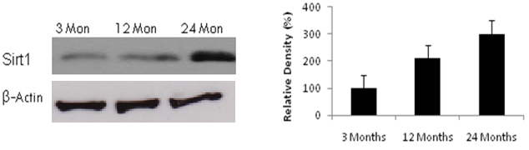

*

B.

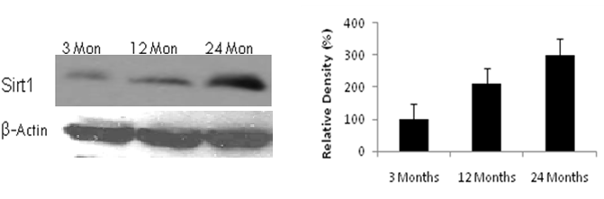

*

*

C.

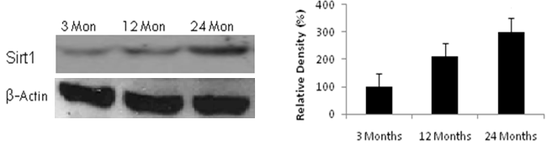

*

*

D.

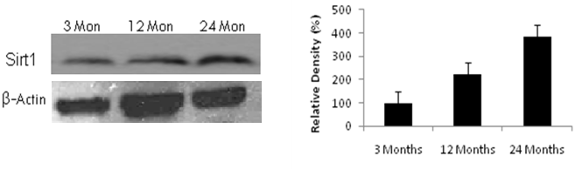

*

*

**Supplementary Figure 4.**

**A.**

**B.**

**C.**

*

*

**D.**

**Supplementary Figure 5**

**A.**

*

*

**B.**

**C.**

**D.**

*

*

**Supplementary Figure 6**

**A**

*

*

**B.**

**C.**

**D.**

*

**Supplementary Figure 7**

**A.**

*

*

**B**

**C.**

**D.**

*

*

**Supplementary Figure 8**

**A.**

*

*

**B.**

*

*

**C.**

*

*

**D.**

*

*

**Supplementary Figure 9**

**A.**

*

*

**B.**

**C.**

**D.**

**Supplementary Figure 10**

