**Recent Genome resequencing paraded COBL gene family roles in abiotic stress and wood formation in Poplar.**

**Supplementary Figure 1.** Chromosomal and gene locations of the identified PtrCOBL genes.

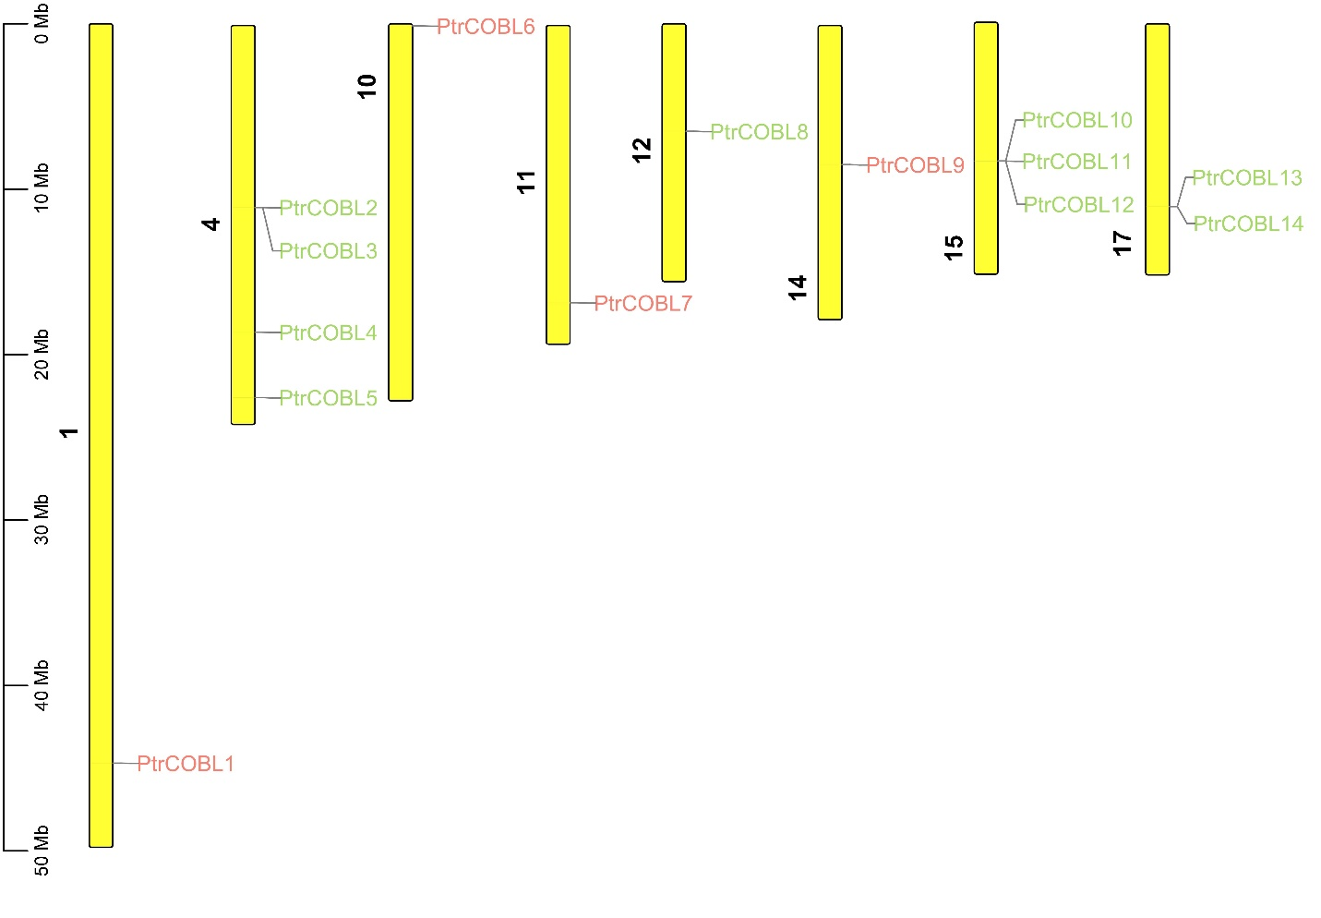

**Supplementary Figure 2.** Global Ptr-miRNA identification and localizations targeting PtrCOBL genes.

