Supplementary Information
The supplementary information below includes a table on the statistical details of stroke versus contralateral mirrored (CM) electrodes’ NREM oscillations comparisons (Supp. Table 1), and stroke versus contralateral non-mirrored (CNM) electrodes’ NREM oscillations comparisons (Supp. Table 2); and a table on one-way ANOVA results for just stroke electrodes comparison in 3 medication-based groupings (Supp. Table 3). Supplementary figure (Supp. Fig. 1) shows the topographical density plots for different NREM oscillations with each panel with specific colormap scale for easier visualization of trends. Supplementary figure (Supp. Fig. 2) is included at the end that compares the NREM oscillations’ densities for different patient groups on stroke verses contralateral non-mirror (CNM) electrodes.

NREM oscillation density | Fixed-effects coefficients (95% CIs) |  |  |  | Random effects covariance parameters (95% CIs) |  |  |  |  |  | Model
 | Intercept |  | Electrode |  | Intercept | Electrode | Medication group | Intercept$-$  Electrode | Intercept$-$  Medication group | Electrode$-$  Medication group
 | tStat₄₂ | p value | tStat₄₂ | p value | std | std | std | corr. | corr. | corr. | Cohen’s d | R²
Spindle | 6.9079 | 1.9688  x10^{–8} | 0.85155 | 0.39929 | 1.7457 | 1.45640 | 0.54078 | –0.95336 | –0.61764 | 0.82622 | 0.5651 | 0.2719
SO | 7.2316 | 6.7928 x10^{–9} | 3.0559 | 0.00389 | 0.6636 | 0.50056 | 0.46378 | –1 | –1 | 1 | 0.5346 | 0.2582
Delta (δ) | 5.4601 | 2.3645 x10^{–6} | 3.6979 | 0.00063 | 5.0144 | 2.90430 | 2.559 | –1 | –1 | 1 | 0.7788 | 0.3629
Nested SO-Spindle | 7.1156 | 9.939  x10^{–9} | 0.82454 | 0.41429 | 0.1458 | 0.18701 | 0.14452 | –0.99279 | –0.2272 | 0.34227 | 0.6823 | 0.3229
Nested δ-Spindle | 5.6176 | 1.4069  x10^{–6} | 0.56857 | 0.57268 | 1.0624 | 0.98551 | 0.43146 | –0.9972 | –0.56061 | 0.621 | 0.9031 | 0.4115

Supplementary Table 1. Linear mixed effect model results for stroke vs contralateral mirrored (CM) electrode analysis. tStat_{df}: t-statistic and df: degree of freedom; std: standard deviation; corr.: correlation; R²: coefficient of determination.

NREM oscillation density | Fixed-effects coefficients (95% CIs) |  |  |  | Random effects covariance parameters (95% CIs) |  |  |  |  |  | Model
 | Intercept |  | Electrode |  | Intercept | Electrode | Medication group | Intercept$-$  Electrode | Intercept$-$  Medication group | Electrode$-$  Medication group
 | tStat₃₈ | p value | tStat₃₈ | p value | std | std | std | corr. | corr. | corr. | Cohen’s d | R²
Spindle | 6.3677 | 1.7844  x10^{–7} | 1.9379 | 0.060086 | 3.1972 | 2.6202 | 1.4867 | -0.96893 | -0.91878 | 0.98787 | 0.5043 | 0.2445
SO | 5.5363 | 2.4625 x10^{–6} | 3.5961 | 0.00091675 | 1.3433 | 0.99767 | 0.85578 | –1 | –1 | NaN | 0.5522 | 0.2662
Delta (δ) | 4.9445 | 1.579  x10^{–5} | 3.9165 | 0.00036151 | 6.905 | 4.4912 | 4.0991 | –1 | –1 | 1 | 0.6900 | 0.3261
Nested SO-Spindle | 6.1161 | 3.9458  x10^{–7} | 1.8632 | 0.070179 | 0.42091 | 0.41908 | 0.23671 | -0.99061 | -0.95263 | 0.98526 | 0.6246 | 0.2981
Nested δ-Spindle | 6.1211 | 3.8835  x10^{–7} | 1.8995 | 0.065103 | 1.8198 | 1.6238 | 0.93552 | -0.99626 | -0.95183 | 0.97478 | 0.6374 | 0.3036

Supplementary Table 2. Linear mixed effect model results for stroke vs contralateral non-mirrored (CNM) electrode analysis. tStat_{df}: t-statistic and df: degree of freedom; std: standard deviation; corr.: correlation; R²: coefficient of determination.

NREM oscillation density | Group |  |  | Error |  |  | F | p
 | SS | df | MS | SS | df | MS
Spindle | 44.844 | 2 | 22.4218 | 137.218 | 19 | 7.22 | 3.1 | 0.0681
SO | 7.8303 | 2 | 3.91514 | 82.5297 | 19 | 4.34367 | 0.9 | 0.4227
Delta (δ) | 106.01 | 2 | 53.0062 | 1041.95 | 19 | 54.8394 | 0.97 | 0.3983
Nested SO-Spindle | 0.53641 | 2 | 0.26821 | 4.3391 | 19 | 0.23153 | 1.16 | 0.3352
Nested δ-Spindle | 5.7491 | 2 | 2.87454 | 37.112 | 19 | 1.95326 | 1.47 | 0.2546

Supplementary Table 3. One-way ANOVA results for stroke electrode analysis. SS: sum of squares; df: degree of freedom; MS: mean square; F: F-statistic (ratio of two MS); p: significance values.

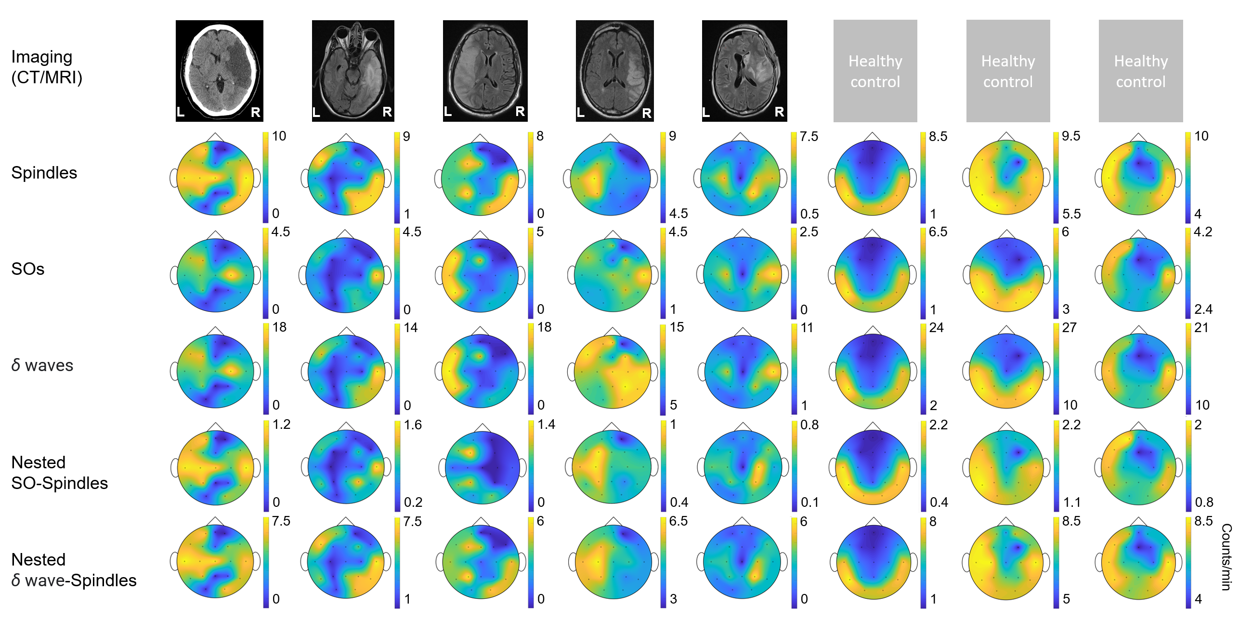
Supplementary Figure 1. Imaging data and topographical density plots for different NREM oscillations. Top to bottom: Imaging data: CT (computed tomography) image for patient P1, T2 sequences of MRI (magnetic resonance imaging) images for patients P2 to P5; no imaging data available for healthy subjects (P6 to P8). Radiologic imaging has been flipped horizontally to align with topographic density maps, i.e., image left, and right are ipsilateral to patient left and right. Left and right are marked in imaging figures (P1-P5) and apply to density topographical maps below them; Topographical maps for detected spindle density (count/min) during NREM sleep for all subjects; Topographical maps for detected SO density (count/min) during NREM sleep for all subjects; Topographical maps for detected δ waves’ density (count/min) during NREM sleep for all subjects; Topographical maps for detected nested SO-spindle density (count/min) during NREM sleep for all subjects; Topographical maps for detected δ wave-nested-spindle density (count/min) during NREM sleep for all subjects. Colormap scale shown at right individually for each topographical plot.
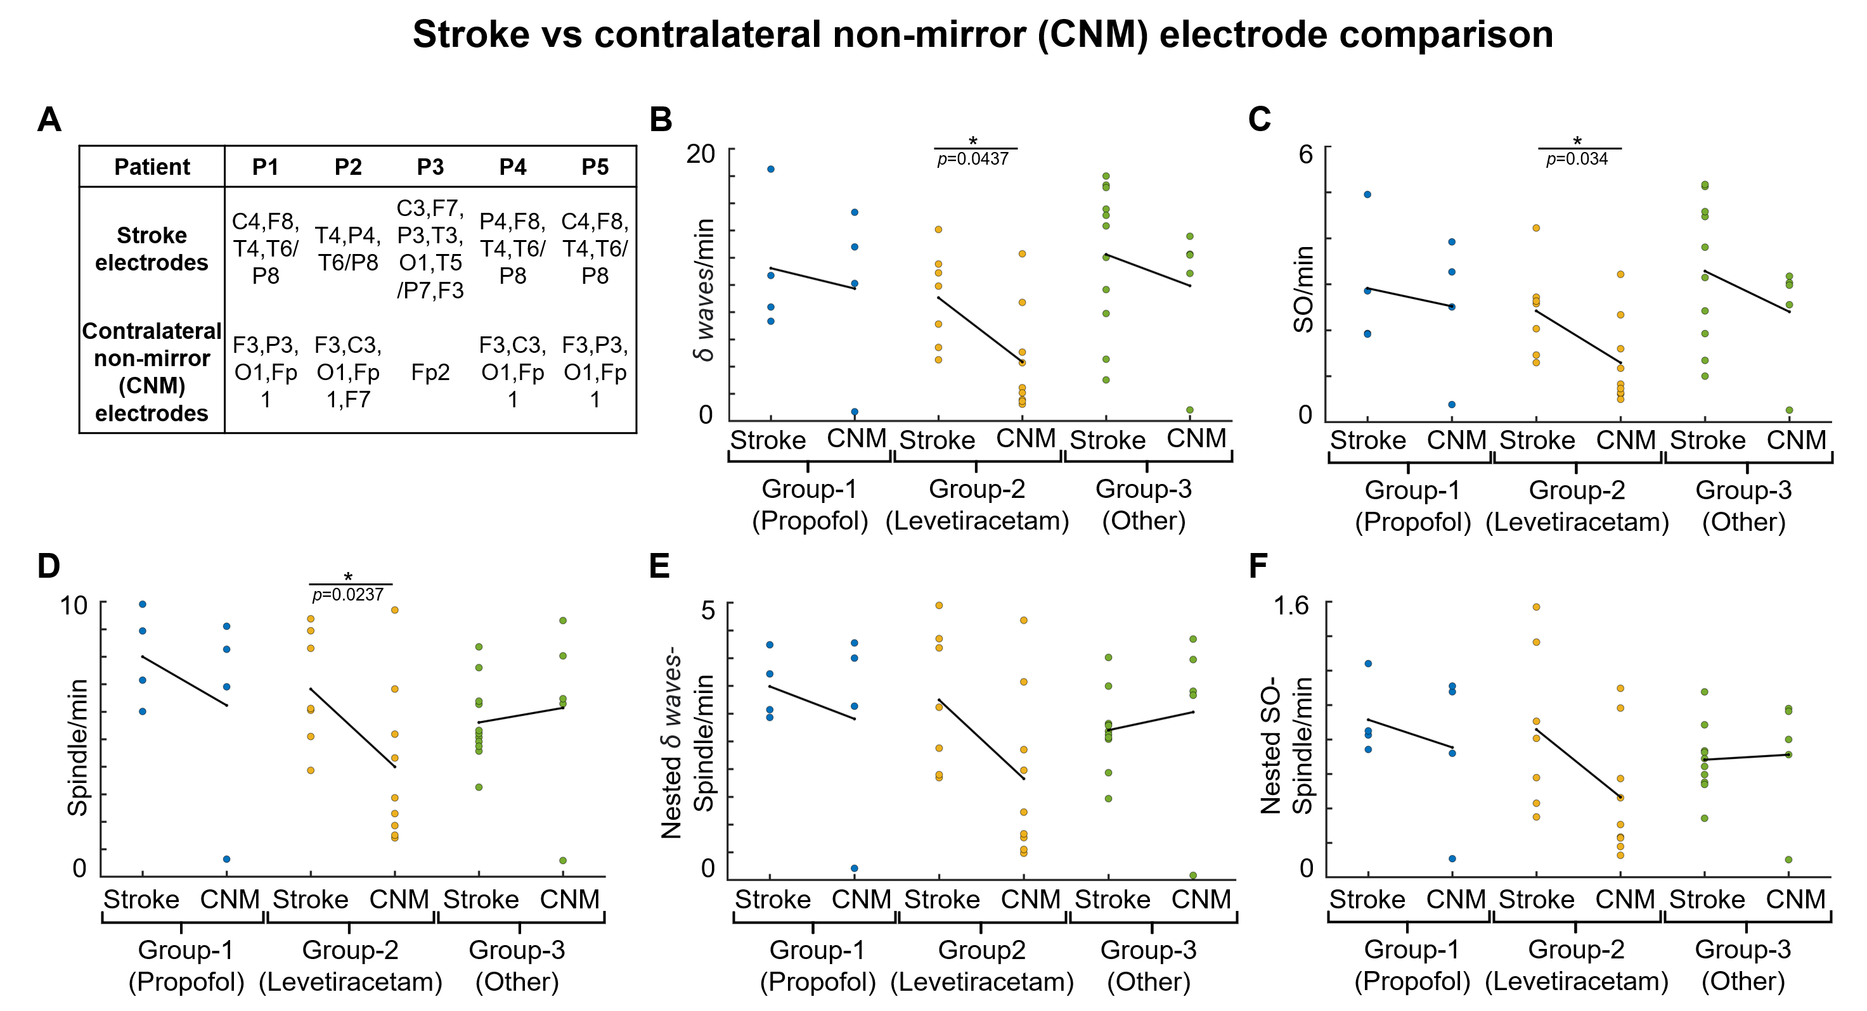
Supplementary Figure 2. NREM oscillations’ densities for different patient groups on stroke verses contralateral non-mirror (CNM) electrodes. A, Table showing selected stroke and contralateral non-mirror electrodes (CNM) for all patients. B, Comparison of δ wave density (count/min) on stroke versus CNM electrodes for patients on different medications. Black line shows the mean values within the group. Dots represent the NREM oscillations’ density for single electrode. C, Same as B for SO density. D, Same as B for spindle density. E, Same as B for nested δ wave-nested spindle density. F, Same as B for SO-nested spindle density. *: statistically significant p values for two-tailed t-test.

