Supplementary Material
Mental Health Symptoms in German Elite Athletes: A Network Analysis
Sheila Geiger^{1,2*}, Lisa Maria Jahre^{1,2}, Julia Aufderlandwehr¹, Julia Barbara Krakowczyk^{1,2}, Anna Julia Esser^{1,2}, Thomas Muehlbauer³, Eva-Maria Skoda^{1,2}, Martin Teufel^{1,2}, Alexander Baeuerle^{1,2}
* Correspondence: Sheila Geiger: sheila.geiger@uni-due.de

Supplementary Figures and Tables

Supplementary Figures

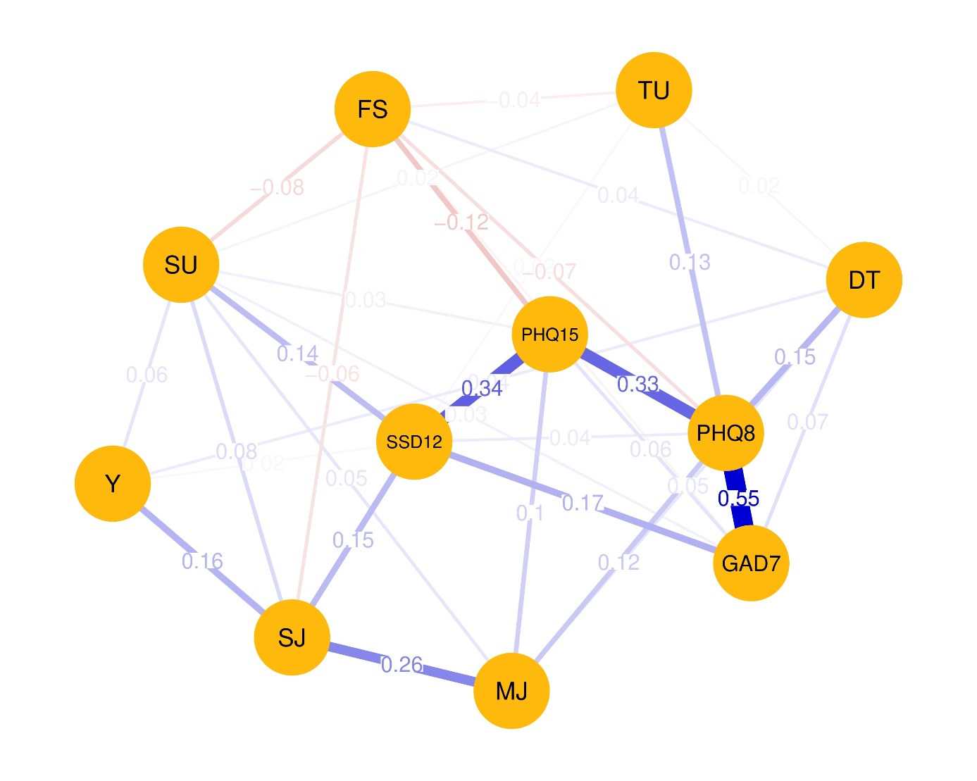

Supplementary Figure 1. Visualized Partial Correlation Network. The abbreviations within the network display the nodes. The thickness of the edges represents the edge connections between those nodes are referred to as edges. The thickness of the edges represents the edge weight, which is an indication of the strength of the edge. The thicker the edge, the higher the edge weight. Blue edges represent positive associations, whereas red edges represent negative associations. The meanings of the variables’ abbreviations can be seen on the right side of the network display. FS: financial situation, TU: training units per week, SU: substance use, Y: years in elite sports, DT: distress, PHQ8: Depressive symptoms, GAD7: Generalized Anxiety symptoms, SSD12: Somatic Symptom Disorder symptoms, PHQ15: Somatic Symptom Disorder symptoms, MJ: mild to moderate injuries, SJ: severe injuries to operation necessary.
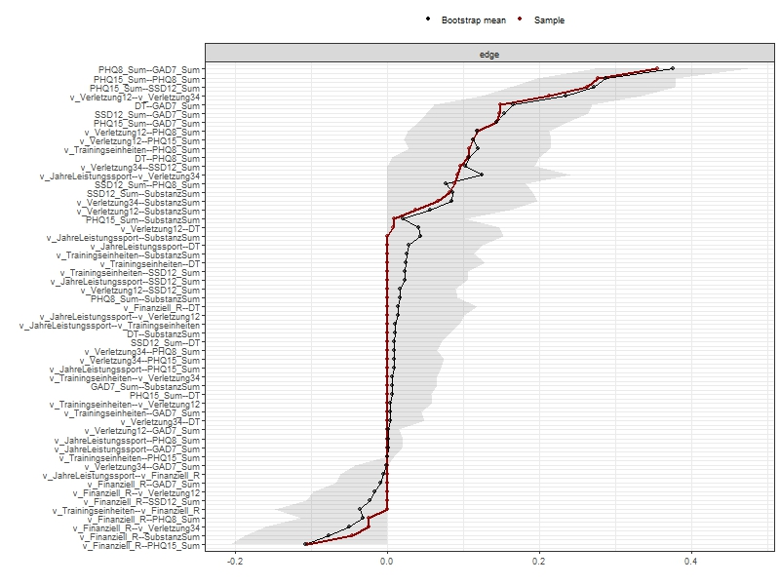
Supplementary Figure 2. Bootstrapped edge-weights for the network are displayed as black line. Point estimates of the edge weights are visualized by the red line. 95% confidence intervals are represented in grey.

Supplementary Tables
Supplementary Table 1. Regression models of PHQ-8
Predictor
Predictor | β | B | T | R² | Δ R² | P value
Sociodemographic predictors |  |  |  | .287 | .222
Sex | .183 | 1.736 | 3.197 |  |  | .002
Age | -.133 | -.098 | -1.679 |  |  | .094
Earn a living | .079 | .929 | 1.353 |  |  | .177
Financial situation | -.232 | -.516 | -3.961 |  |  | <.001
Professional activity(ies)  besides sports | -.036 | -.395 | -.634 |  |  | .527
Family status
Single | -.173 | -1.716 | -.891 |  |  | .374
Married | -.113 | -1.978 | -.815 |  |  | .416
Partnership | .189 | -2.088 | -1.034 |  |  | .302
Living situation
Alone | -.120 | -1.301 | -1.064 |  |  | .288
With partner | -.139 | -1.691 | -1.243 |  |  | .215
With partner and child(ren) | -.049 | -1.101 | -.511 |  |  | .610
With parents | -.175 | -1.816 | -1.526 |  |  | .128
Flat sharing | .009 | .102 | .084 |  |  | .933
Sports related variables
Years in elite sport | .077 | .068 | 1.145 |  |  | .253
Number of training units  per week | .235 | .256 | 3.646 |  |  | <.001
Duration of training units | .000 | -2.324 | -.003 |  |  | .988
Types of sports
Ball sports | .220 | 2.174 | 1.781 |  |  | .076
Combat sports | .096 | 1.746 | 1.178 |  |  | .240
Strength sports | .157 | 3.210 | 1.997 |  |  | .047
Track and field | .139 | 2.156 | 1.559 |  |  | .120
Equestrian sports | -.121 | -2.320 | -1.495 |  |  | .136
Gymnastics | -.013 | -.301 | -.177 |  |  | .859
Water sports | .009 | .093 | .073 |  |  | .942
Note. N = 275. β: standardized coefficient beta; B: unstandardized coefficient beta; R²: determination coefficient; Δ R²: Changes in R²; PHQ-8: Depressive symptoms.

Supplementary Table 2. Regression models of GAD-7
Predictor
Predictor | β | B | T | R² | Δ R² | P value
Sociodemographic predictors |  |  |  | .246 | .176
Sex | .242 | 1.895 | 4.116 |  |  | .892
Age | .011 | -.007 | .136 |  |  | <.001
Earn a living | .063 | .610 | 1.049 |  |  | .295
Financial situation | -.243 | -.232 | -4.043 |  |  | <.001
Professional activity(ies)  besides sports | -.042 | -.036 | -.722 |  |  | .471
Family status
Single | .012 | .097 | .059 |  |  | .953
Married | -.129 | -1.848 | -.898 |  |  | .370
Partnership | -.067 | -.607 | -.354 |  |  | .723
Living situation
Alone | -.274 | -2.445 | -2.360 |  |  | .019
With partner | -.220 | -2.211 | -1.918 |  |  | .056
With partner and child(ren) | -.059 | -1.096 | -.601 |  |  | .548
With parents | -.290 | -2.484 | -2.463 |  |  | .014
Flat sharing | -.118 | -1.108 | -1.079 |  |  | .282
Sports related variables
Years in elite sport | .056 | .077 | .817 |  |  | .415
Number of training units  per week | .096 | .235 | 1.441 |  |  | .151
Duration of training units | -.009 | .000 | -.154 |  |  | .878
Type of sports
Ball sports | .304 | 2.477 | 2.394 |  |  | .017
Combat sports | .075 | 1.135 | .904 |  |  | .367
Strength sports | .229 | 3.842 | 2.820 |  |  | .005
Track and field | .208 | 2.660 | 2.269 |  |  | .024
Equestrian sports | -.021 | -.337 | -.256 |  |  | .798
Gymnastics | .037 | .727 | -.506 |  |  | .613
Water sports | .112 | .941 | .876 |  |  | .382
Note. N = 275. β: standardized coefficient beta; B: unstandardized coefficient beta; R²: determination coefficient; Δ R²: Changes in R²; GAD-7: Generalized Anxiety Disorder symptoms.

Supplementary Table 3. Regression models of Distress
Predictor
Predictor | β | B | T | R² | Δ R² | P value
Sociodemographic predictors |  |  |  | .088 | .004
Sex | -.074 | -.032 | -1.145 |  |  | .253
Age | -.044 | -.001 | -.496 |  |  | .620
Earn a living | .015 | -.008 | -.227 |  |  | .821
Financial situation | -.056 | -.006 | -.839 |  |  | .402
Professional activity(ies)  besides sports | -.068 | -.034 | -1.056 |  |  | .292
Family status
Single | -.156 | .071 | -.710 |  |  | .478
Married | .028 | .022 | .176 |  |  | .860
Partnership | -.156 | -.079 | -.754 |  |  | .452
Living situation
Alone | .086 | .043 | -671 |  |  | .503
With partner | .000 | 3.432 | .000 |  |  | 1.000
With partner and child(ren) | -.005 | -.005 | -.049 |  |  | .961
With parents | -.060 | .029 | .467 |  |  | .641
Flat sharing | .007 | .004 | .057 |  |  | .955
Sports related variables
Years in elite sport | .081 | .003 | 1.068 |  |  | .286
Number of training units  per week | .107 | .005 | 1.465 |  |  | .144
Duration of training units | -.045 | .000 | -.683 |  |  | .496
Type of sports
Ball sports | .203 | .092 | 1.450 |  |  | .148
Combat sports | .170 | .142 | 1.851 |  |  | .065
Strength sports | .086 | .080 | .960 |  |  | .338
Track and field | .075 | .054 | .748 |  |  | .455
Equestrian sports | .138 | .121 | 1.508 |  |  | .133
Gymnastics | -.023 | -.025 | -.285 |  |  | .776
Water sports | .185 | .086 | 1.311 |  |  | .191
Note. N = 275. β: standardized coefficient beta; B: unstandardized coefficient beta; R²: determination coefficient; Δ R²: Changes in R².

Supplementary Table 4. Regression models of PHQ-15
Predictor
Predictor | β | B | T | R² | Δ R² | P value
Sociodemographic predictors |  |  |  | .296 | .231
Sex | .248 | 2.167 | 4.352 |  |  | <.001
Age | -.083 | -.057 | -1.616 |  |  | .290
Earn a living | -.013 | -.145 | -.231 |  |  | .817
Financial situation | -.293 | -.601 | -5.035 |  |  | <.001
Professional activity(ies)  besides sports | -.072 | -.727 | -1.272 |  |  | .205
Family status
Single | -.162 | -1.477 | -.836 |  |  | .404
Married | -.072 | -1.151 | -.517 |  |  | .605
Partnership | -.143 | -1.450 | -.783 |  |  | .434
Living situation
Alone | -.065 | -.649 | -.579 |  |  | .563
With partner | -.156 | -1.754 | -1.406 |  |  | .161
With partner and child(ren) | -.051 | -1.076 | -.545 |  |  | .586
With parents | -.223 | -2.134 | -1.957 |  |  | .052
Flat sharing | .014 | .146 | .131 |  |  | .896
Sports related variables
Years in elite sport | .059 | .048 | .885 |  |  | .377
Number of training units  per week | .160 | .160 | 2.492 |  |  | .013
Duration of training units | .004 | .000 | .062 |  |  | .950
Type of sports
Ball sports | .197 | 1.795 | 1.605 |  |  | .110
Combat sports | .156 | 2.619 | 1.928 |  |  | .055
Strength sports | .122 | 2.292 | 1.555 |  |  | .121
Track and field | .143 | 2.048 | 1.615 |  |  | .108
Equestrian sports | -.097 | -1.721 | -1.210 |  |  | .228
Gymnastics | .108 | 2.344 | 1.507 |  |  | .133
Water sports | -.014 | -.130 | -.112 |  |  | .911
Note. N = 275. β: standardized coefficient beta; B: unstandardized coefficient beta; R²: determination coefficient; Δ R²: Changes in R²; PHQ-15: Somatic Symptom Disorder symptoms.

Supplementary Table 5. Regression models of SSD-12
Predictor
Predictor | β | B | T | R² | Δ R² | P value
Sociodemographic predictors |  |  |  | .191 | .117
Sex | .147 | 2.366 | 2.413 |  |  | .017
Age | -.049 | -.061 | -.581 |  |  | .562
Earn a living | .043 | -.145 | .688 |  |  | .492
Financial situation | -.213 | -.601 | -3.418 |  |  | <.001
Professional activity(ies)  besides sports | -.031 | -.727 | -.503 |  |  | .615
Family status
Single | -.182 | -3.047 | -.876 |  |  | .382
Married | -.130 | -3.843 | -.878 |  |  | .381
Partnership | -.267 | -4.977 | -1.365 |  |  | .174
Living situation
Alone | -.068 | -1.248 | -.566 |  |  | .572
With partner | -.121 | -2.507 | -1.021 |  |  | .308
With partner and child(ren) | -.099 | -3.789 | -.975 |  |  | .330
With parents | -.208 | -3.672 | -1.709 |  |  | .089
Flat sharing | -.103 | -1.990 | -.909 |  |  | .364
Sports related variables
Years in elite sport | .130 | .048 | 1.826 |  |  | .069
Number of training units  per week | .142 | .160 | 2.060 |  |  | .040
Duration of training units | .020 | .000 | .323 |  |  | .747
Type of sports
Ball sports | .148 | 2.473 | 1.122 |  |  | .263
Combat sports | -.014 | -.439 | -.164 |  |  | .870
Strength sports | .052 | 1.787 | .616 |  |  | .538
Track and field | .094 | 2.483 | .994 |  |  | .321
Equestrian sports | -.124 | -4.042 | -1.443 |  |  | .150
Gymnastics | .106 | 4.229 | 1.380 |  |  | .169
Water sports | -.013 | -.227 | -.099 |  |  | .921
Note. N = 275. β: standardized coefficient beta; B: unstandardized coefficient beta; R²: determination coefficient; Δ R²: Changes in R²; SSD12: Somatic Symptom Disorder symptoms.

Supplementary Confirmatory Factor Analyses
To confirm the factorial structure of the PHQ-8 in this sample of elite athletes, we performed a CFA to test the single-factor structure of the PHQ-8. The χ2-test was significant, (χ2[20] = 123.23, p < .001). The approximate fit indices used to assess model fit (RMSEA = .137, SRMR = .070, CFI = .852, TLI = .793) did not meet recommended criteria (Hu & Bentler, 1999). The single-factor structure of the PHQ-8 cannot be assumed based on the study sample. Reliability analyses revealed ω = 0.87.
CFA was used to test the single-factor structure of the PHQ-15. The χ2-test was significant, (χ2[90] = 332.47, p < .001). The approximate fit indices used to assess model fit (RMSEA = .098, SRMR = .089, CFI = .483, TLI = .397) did not meet recommended values (Hu & Bentler, 1999). The single-factor structure of the PHQ-15 cannot be assumed based on the study sample. Reliability analyses revealed ω = 0.69.
CFA was used to test the three-factorial structure of the SSD-12. The χ2-test was significant, (χ2[51] = 186.92, p < .001). The approximate fit indices used to assess model fit (RMSEA = .137, SRMR = .056, CFI = .886, TLI = .853) met recommended values (Hu & Bentler, 1999). The three-factorial structure of the SSD-12 can be assumed based on the study sample. ω was .59 for the cognitive scale, 0.87 for the affective scale and 0.83 for the behavioural scale. Overall ω was = 0.83.
CFA was used to test the single-factor structure of the GAD-7. The χ2-test was significant, (χ2[14] = 63.26, p < .001). The approximate fit indices used to assess model fit (RMSEA = .113, SRMR = .523, CFI = .930, TLI = .894) did not meet recommended values (Hu & Bentler, 1999). The single-factor structure of the GAD-7 cannot be assumed based on the study sample. Reliability analyses revealed ω = 0.88. .
CFAs could not confirm the factor structure for all instruments. However, the items of the questionnaires PHQ-15, PHQ-8 and GAD-7 were not determined in a factor-analytically guided approach but were based on the official diagnostic criteria of the assessed psychopathology.
Supplementary Table 6. Confirmatory Factor Analyses
Questionnaire | Model | Chi²(df) | p | CFI | TLI | RMSEA | SRMR
PHQ-8 | 1 | 123.23 (20) | < .001 | 0.852 | 0.793 | 0.137 | 0.070
PHQ-15 | 1 | 332.47 (90) | < .001 | 0.483 | 0.397 | 0.099 | 0.089
SSD-12 | 3 | 186.92 (51) | < .001 | 0.886 | 0.852 | 0.098 | 0.056
GAD-7 | 1 | 63.26 (14) | < .001 | 0.930 | 0.894 | 0.113 | 0.523
Chi²: Chi²-coefficient; df: degrees of freedom; CFI: comparative fit index; TLI: Tucker Lewis index; RMSEA: root mean square error of approximation; SRMR: standardized root mean square residual; PHQ-8: Depressive symptoms, GAD-7: Generalized Anxiety Disorder symptoms, SSD-12: Somatic Symptom Disorder symptoms, PHQ-15: Somatic Symptom Disorder symptoms.

