Supplementary Material

Temporal variations of the two oxygen depleted zones in the Bohai Sea

**Hanzheng Wang, Haiyan Zhang*, Hao Wei, Han Zuo**

**\* Correspondence:** Haiyan Zhang: haiyan_zhang@tju.edu.cn

# Supplementary Figures and Tables

## Supplementary Figures

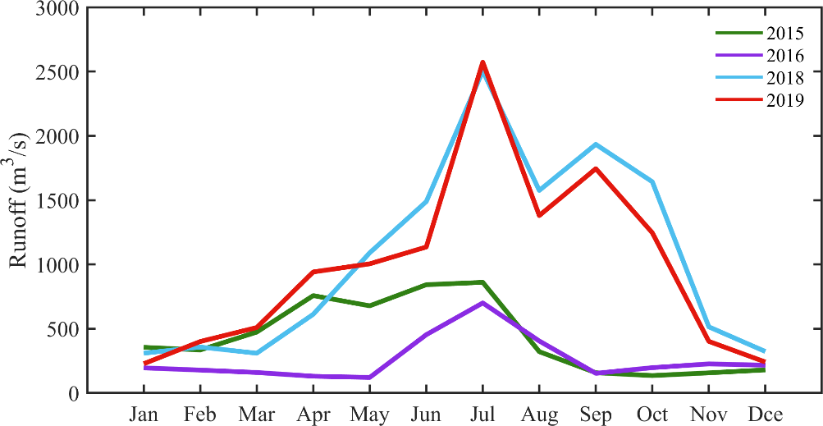

**Supplementary Figure 1.** Runoff(m3/s) of the Yellow River in 2015, 2016, 2018, and 2019.

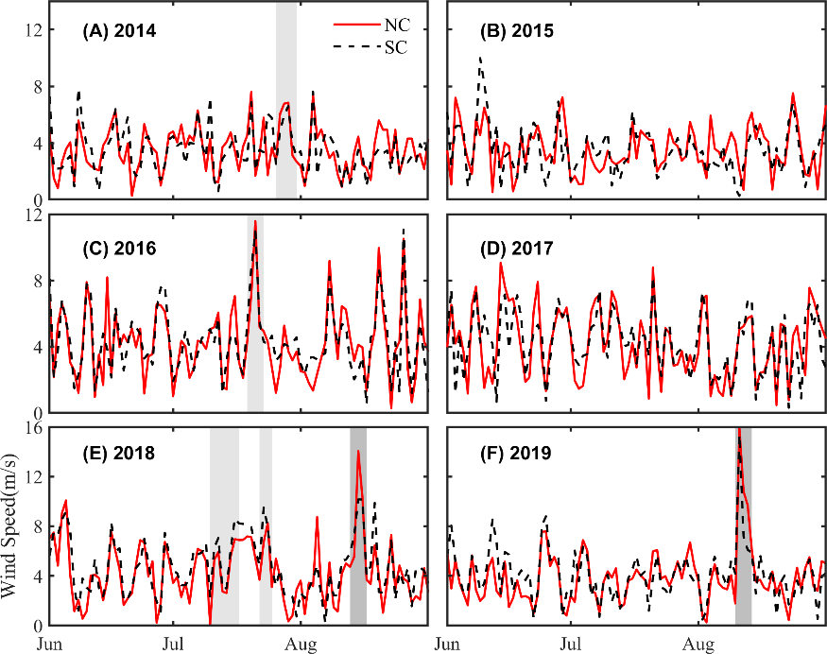

**Supplementary Figure 2.** Time series of wind speed(m/s) from June to August in the NC and SC from 2014 to 2019. Light gray shadows represent the strong wing events in A, C, and E. Dark gray shadows represent typhoons in E and F.

## Supplementary Tables

**Supplementary Table 1.** Averaged depth(m) of the upper and lower boundaries, and thickness(m) of the stratification from June to August in the NC and SC from 2014 to 2019.

|  |  |  |  |  |  |  |
| --- | --- | --- | --- | --- | --- | --- |
| **Year** | **Depth of the upper boundary** | | **Depth of the lower boundary** | | **Thickness** | |
| **NC** | **SC** | **NC** | **SC** | **NC** | **SC** |
| **2014** | 6.30±0.70 | 6.37±1.10 | 8.14±0.94 | 8.86±1.16 | 1.84 | 2.49 |
| **2015** | 7.10±0.68 | 6.26±1.25 | 9.44±0.99 | 8.78±1.17 | 2.35 | 2.51 |
| **2016** | 7.13±1.64 | 4.67±1.87 | 9.29±2.09 | 6.39±2.17 | 2.16 | 1.71 |
| **2017** | 7.31±1.37 | 4.52±1.51 | 9.80±1.43 | 6.53±1.52 | 2.49 | 2.00 |
| **2018** | 7.54±1.68 | 6.71±1.45 | 10.83±2.02 | 10.11±1.48 | 3.29 | 3.40 |
| **2019** | 6.85±1.59 | 4.12±1.92 | 9.05±2.14 | 6.40±2.15 | 2.20 | 2.29 |
| **Mean** | 7.04 | 5.44 | 9.43 | 7.84 | 2.39 | 2.40 |

**Supplementary Table 2.** Maximum depth (m), the gradient of topography, and the averaged PEA (J/m3) from June to August in the NC and SC from 2014 to 2019.

|  |  |  |  |  |  |  |
| --- | --- | --- | --- | --- | --- | --- |
| **Year** | **PEA** | | **Max depth** | | **Gradient** | |
| **NC** | **SC** | **NC** | **SC** | **NC** | **SC** |
| **2014** | -32.08±10.66 | -34.99±11.11 | 26.84 | 25.97 | 0.73±0.22 | 0.35±0.20 |
| **2015** | -42.06±8.74 | -42.39±11.92 | 26.55 | 26.22 | 0.52±0.23 | 0.19±0.19 |
| **2016** | -35.92±13.16 | -24.45±10.03 | 28.26 | 25.61 | 0.54±0.28 | 0.26±0.17 |
| **2017** | -35.35±7.97 | -24.33±6.86 | 28.68 | 25.51 | 0.51±0.28 | 0.22±0.12 |
| **2018** | -40.73±13.22 | -39.26±10.92 | 27.39 | 25.55 | 0.46±0.27 | 0.20±0.18 |
| **2019** | -33.90±13.05 | -27.27±12.10 | 27.60 | 26.09 | 0.44±0.26 | 0.14±0.09 |
| **Mean** | -36.67 | -32.12 | 27.56 | 25.82 | 0.53 | 0.23 |