Supplementary Material
SARS-CoV-2 pre-exposure prophylaxis with tixagevimab/cilgavimab (AZD7442) provides protection in Inborn Errors of Immunity with Antibody Defects: a real-world experience.
Federica Pulvirenti, MD, PhD, Giulia Garzi, MD, Eleonora Sculco, MD, Maddalena Sciannamea, MD, Cinzia Milito, MD, PhD, Anna Napoli, MD, Lilia Cinti, BD, Piergiorgio Roberto, BD, Alessandra Punziano, MD, Maria Carrabba, MD, PhD, Eva Piano Mortari, Rita Carsetti, Guido Antonelli, MD, PhD, Isabella Quinti, MD, PhD*.
Correspondence: Isabella Quinti, Department of Molecular Medicine, Viale Regina Elena 291, 00161, Rome, Italy. Telephone number: +300649972007. Email address: isabella.quinti@uniroma1.it.

Supplementary Tables
Supplementary Table 1. Characteristics of patients recently infected by SARS-CoV-2 within three months before the enrollment.

 | Recently infected  n= 35 | p value¹ | p value²
Age (years), median (IQR) | 54 (41-66) | 0.498 | 0.865
Gender (female), n (%) | 21 (61.8) | 0.199 | 0.397
IgA (mg/dL), median (IQR) | 11 (2-59) | 0.106 | 0.005
Residual IgG (mg/dL), median (IQR) | 621 (605-670) | 0.503 | 0.801
IEI Diagnosis
CVID, n (%) | 22 (62.9) | 0.065 | 0.082
XLA, n (%) | 2 (5.7) | 0.801 | 0.590
Good syndrome, n (%) | 1 (2.9) | 0.860 | 0.966
UAD, n (%) | 9 (25.7) | 0.003 | 0.072
Others n (%) | 1 (2.9) | 0.353 | 0.966
Lymphocytes count, median (IQR) | 1620 (1160-2040) | 0.908 | 0.171
CD3+CD4+ (cell/mm3), median (IQR) | 472 (402-784) | 0.799 | 0.366
CD19+ (cell/mm3), median (IQR) | 83.9 (8.2-250.6) | 0.641 | 0.381
MBC (CD19+CD27, cell/mm3), median (IQR) | 21.2 (2.4-39.9) | 0.774 | 0.952
Complicated phenotype, n (%) | 10 (30) | 0.078 | 0.016
COPD, n (%) | 23 (46.7) | <0.0001 | 0.068
SARS-COV-2 vaccine doses >=3, n (%) | 35 (100) | 0.018 | 0.068
Abbreviation: IEI inborn errors of immunity, CVID common variable immunodeficiency, XLA X linked agammaglobulinemia, UAD undefined antibody deficiency, COPD Chronic Pulmonary Disease, COVID-19 coronavirus disease 2019, IQR interquartile range, MBC memory B cells, SARS-CoV-2 severe acute respiratory syndrome coronavirus 2.
¹comparison with No-AZD7442 group; ²comparison with AZD7442 group.
Supplementary Table 2. Univariate analysis of patient’s characteristics associated with SARS-CoV-2 infection.
 | Not infected  n= 156 | SARS-Cov-2 infection  n=59 | p value
Age (years), median (IQR) | 49 (36-59) | 54 (45-64) | 0.047
Gender (female), n (%) | 69 (44.2) | 32 (54.2) | 0.439
Serum IgA (mg/dL), median (IQR) | 2 (1-22) | 5 (2-13) | 0.439
Lymphocytes count, median (IQR) | 1445 (1130-2020) | 1460 (930-1890) | 0.146
CD3+CD4+ (cell/mm3), median (IQR) | 516 (400-728) | 578 (395-859) | 0.797
CD19+ (cell/mm3), median (IQR) | 52.5 (21.9-161.1) | 57.6 (11-134.5) | 0.635
CD19+ CD27+ (% of CD19+), median (IQR) | 22.2 (5.9-45) | 22.6 (8-41) | 0.468
Complicated phenotype, n (%) | 59 (47.2) | 23 (47.9) | 0.804
COPD, n (%) | 52 (33.6) | 24 (41.7) | 0.322
Prior episode of COVID-19, n (%) | 56 (36.1) | 3 (5.1) | <0.0001
Vaccinated (>=3 doses), n (%) | 134 (86.3) | 52 (88.1) | 0.668
Last vaccine dose within 6 months | 79 (50.7) | 25 (43.2) | 0.279

Abbreviation: IEI inborn errors of immunity, CVID common variable immunodeficiency, XLA X linked agammaglobulinemia, UAD undefined antibody deficiency, COPD Chronic Pulmonary Disease, COVID-19 coronavirus disease 2019, IQR interquartile range, SARS-CoV-2 severe acute respiratory syndrome coronavirus 2.
Supplementary Table 3. Univariate analysis of patient’s characteristics associated with symptomatic SARS-CoV-2 infection.

 | Symptomatic infections  n=42 | Asymptomatic infections  n=10 | p value
Age (years), median (IQR) | 52 (43-58) | 50 (25-55) | 0.179
Gender (female), n (%) | 21 (50) | 3 (30) | 0.254
Serum IgA (mg/dL), median (IQR) | 3 (2-20) | 12 (2-43) | 0.520
Lymphocytes count, median (IQR) | 1745 (1280-2280) | 1070 (990-1380) | 0.034
Complicated phenotype, n (%) | 19 (45.2) | 2 (20) | 0.144
COPD, n (%) | 10 (23.8) | 4 (40) | 0.299
Prior episode of COVID-19, n (%) | 14 (33.3) | 2 (20) | 0.412
Vaccinated (>=3 doses), n (%) | 34 (80.1) | 8 (80) | 0.945
Last vaccine dose within 6 months | 26 (61.9) | 5 (50) | 0.490

Abbreviation: COPD Chronic Pulmonary Disease, COVID-19 coronavirus disease 2019, IQR interquartile range, SARS-CoV-2 severe acute respiratory syndrome coronavirus 2.

Supplementary Figure 1. Gating strategy. (A) FACS plots depict the gating strategy for the identification of total (CD19+CD24+CD27+), IgM+ and IgM- MBCs, in a representative HCW. Low (S+) and high (S++) affinity spike-specific MBCs are shown. (B) IgM+, IgM- and RBD+ MBCs among S+ and S++. IgM expression on receptor binding domain (RBD+) MBCs is shown.
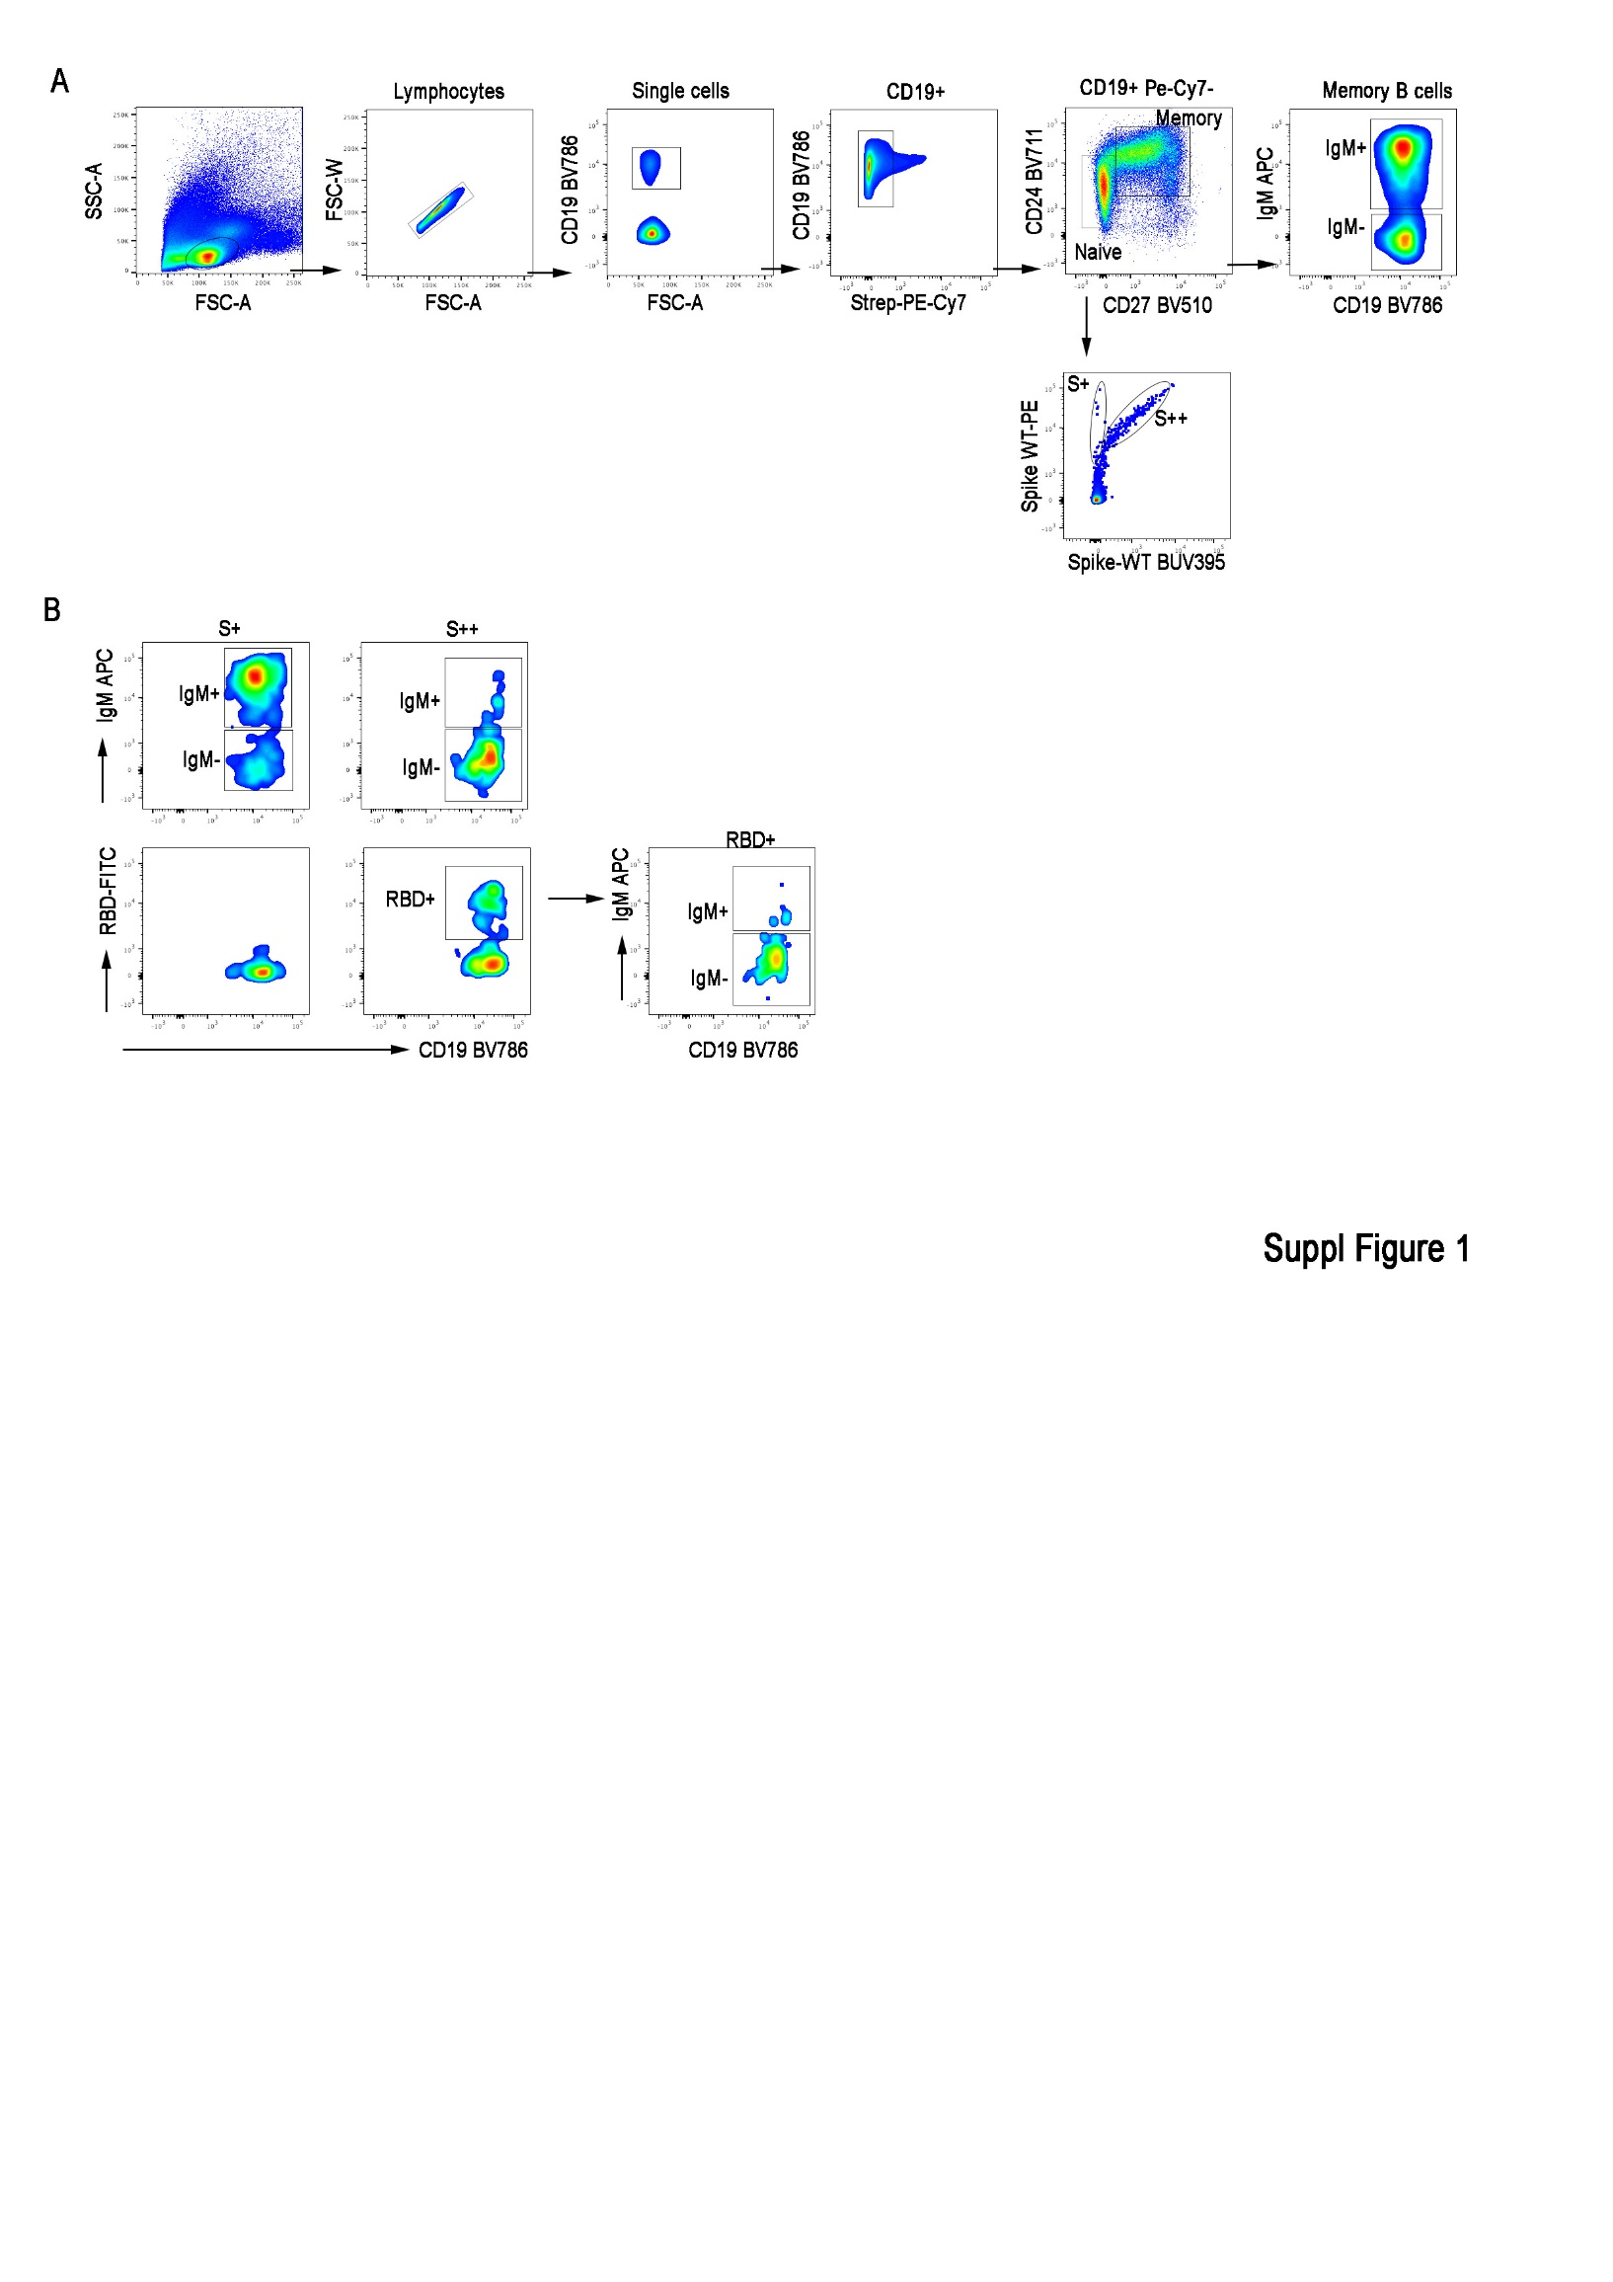

Supplementary Figure 2. Patients infected by SARS-CoV-2 in the AZD7442 group (red line) and in the no-AZD7442 (blue line) stratified for the entry condition of being COVID-19 naive. The difference between the two groups is expressed as Log-rank (the last significant comparison was reported). Red dots and blue squares represent participants infected in the AZD7442 and in the no-AZD744 group, respectively.
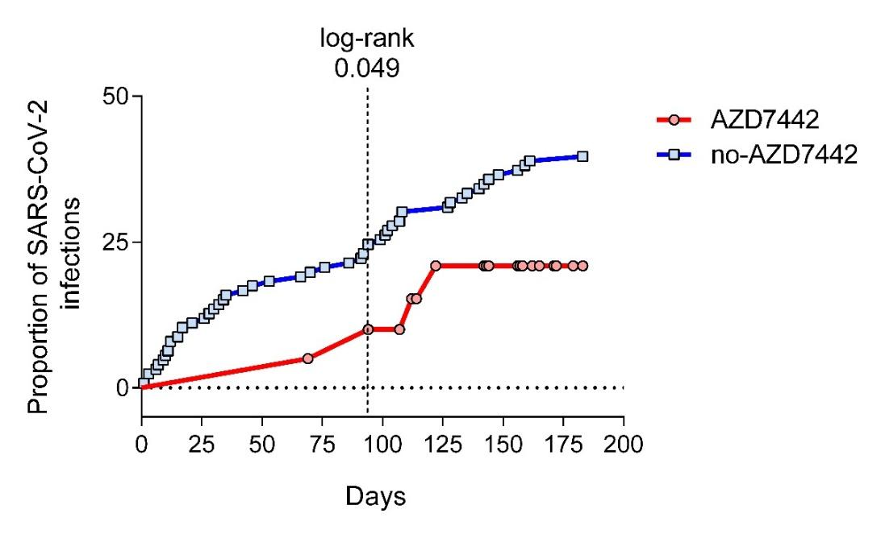
Supplementary Figure 3. The proportion of MBC (CD19+CD27+) recorded in patients infected or not by SARS-CoV-2 in the AZD7442 (red histograms) and in the no-AZD7442 group (blue histograms). Histograms indicated median. Non-parametric Mann–Whitney t-test was used to evaluate statistical significance. Two-tailed P value significances are shown as *p< 0.05. Abbreviations: MBC memory B cells, COVID-19 coronavirus 19 disease.

