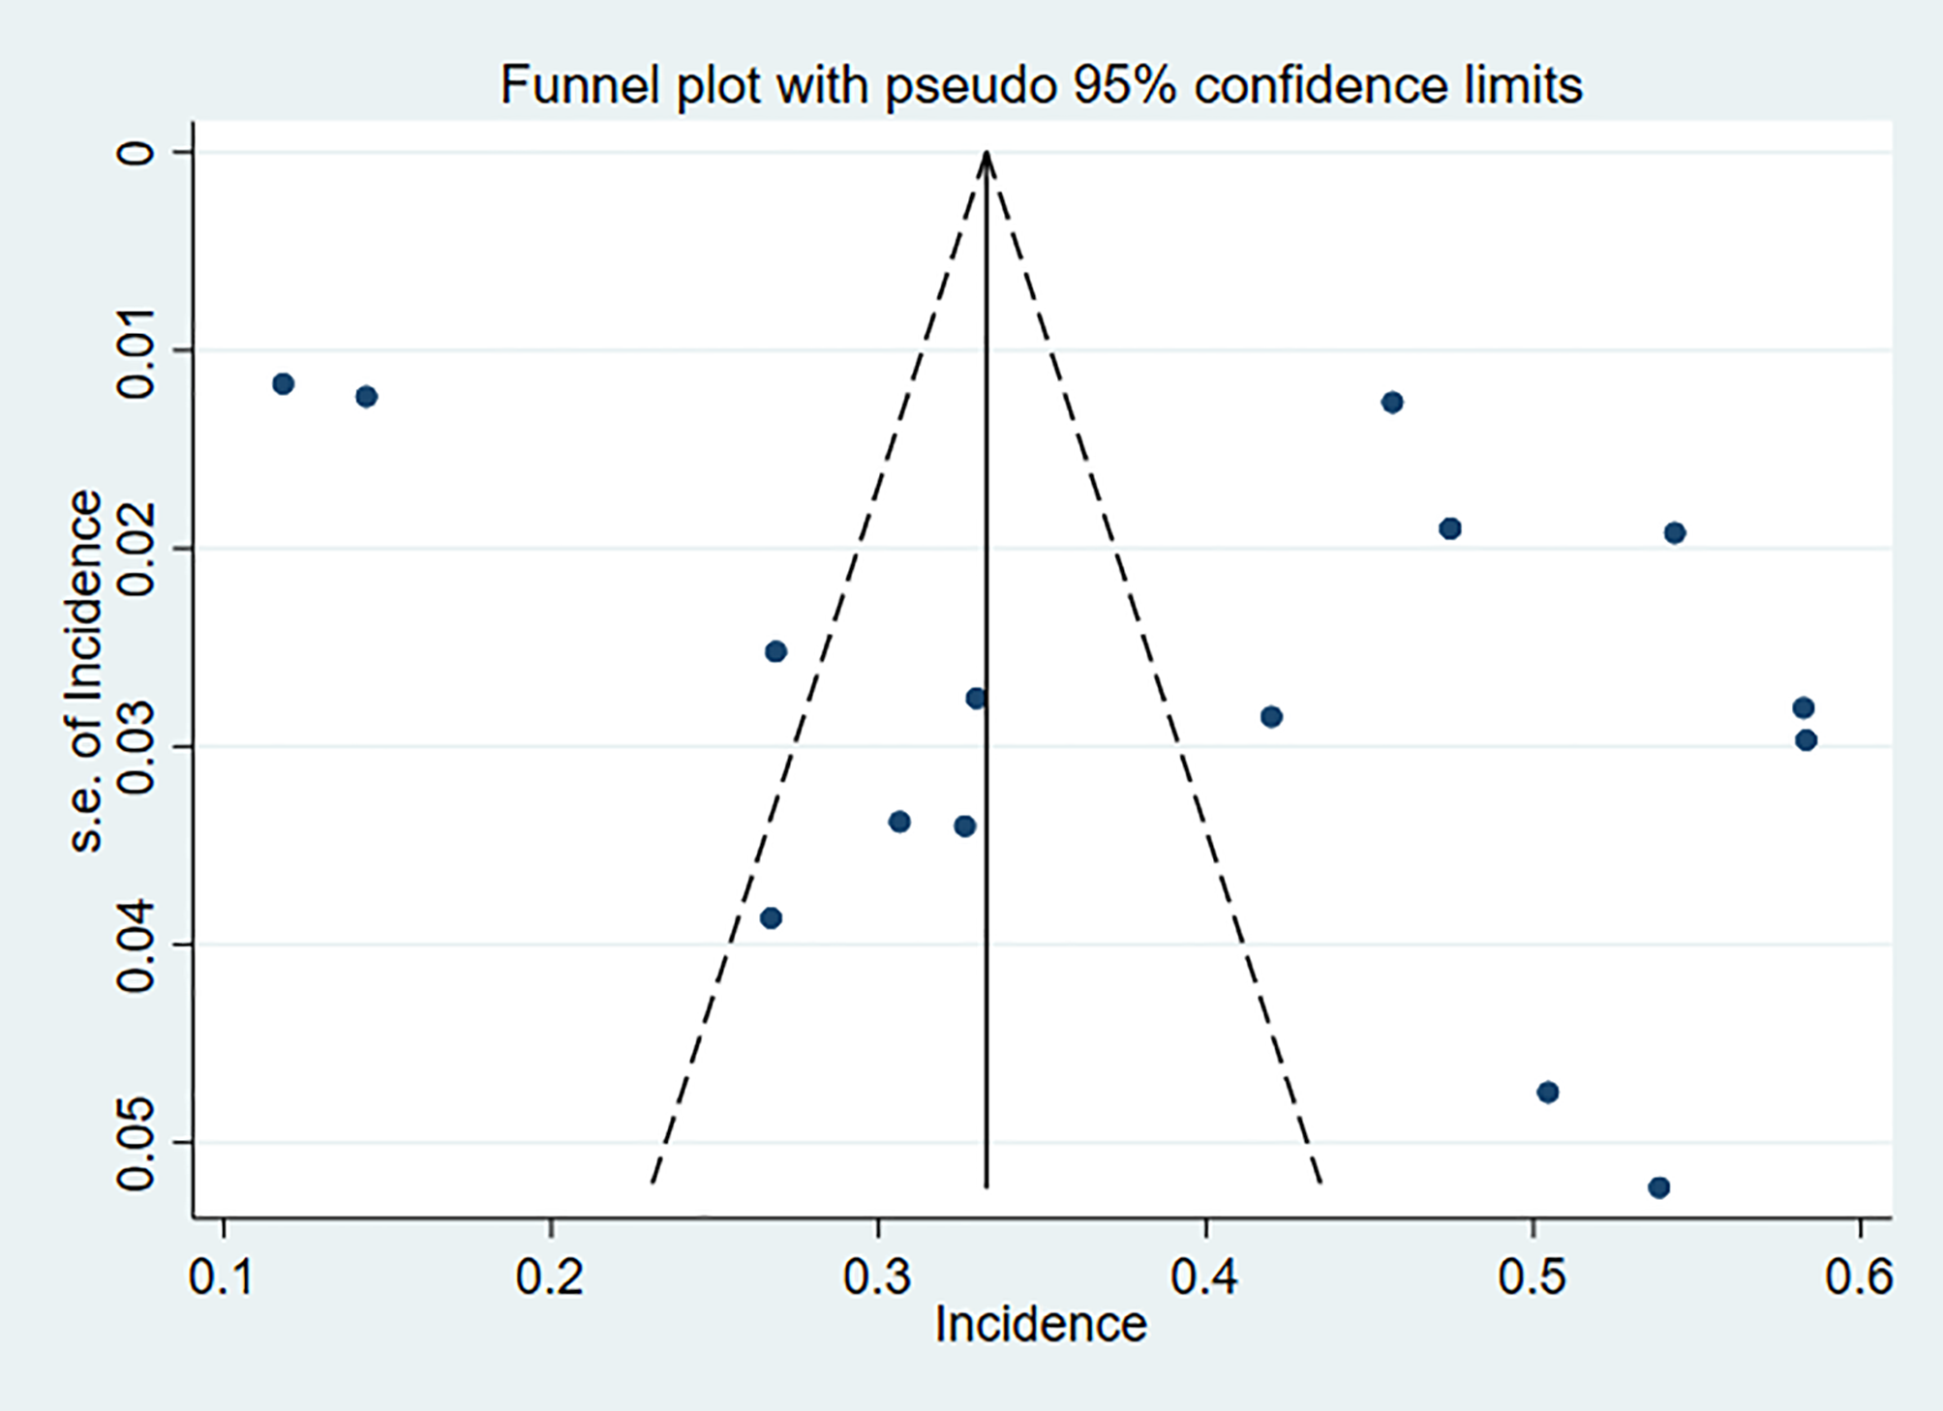

**Figure S1:** Funnel plot with pseudo 95% confidence limits

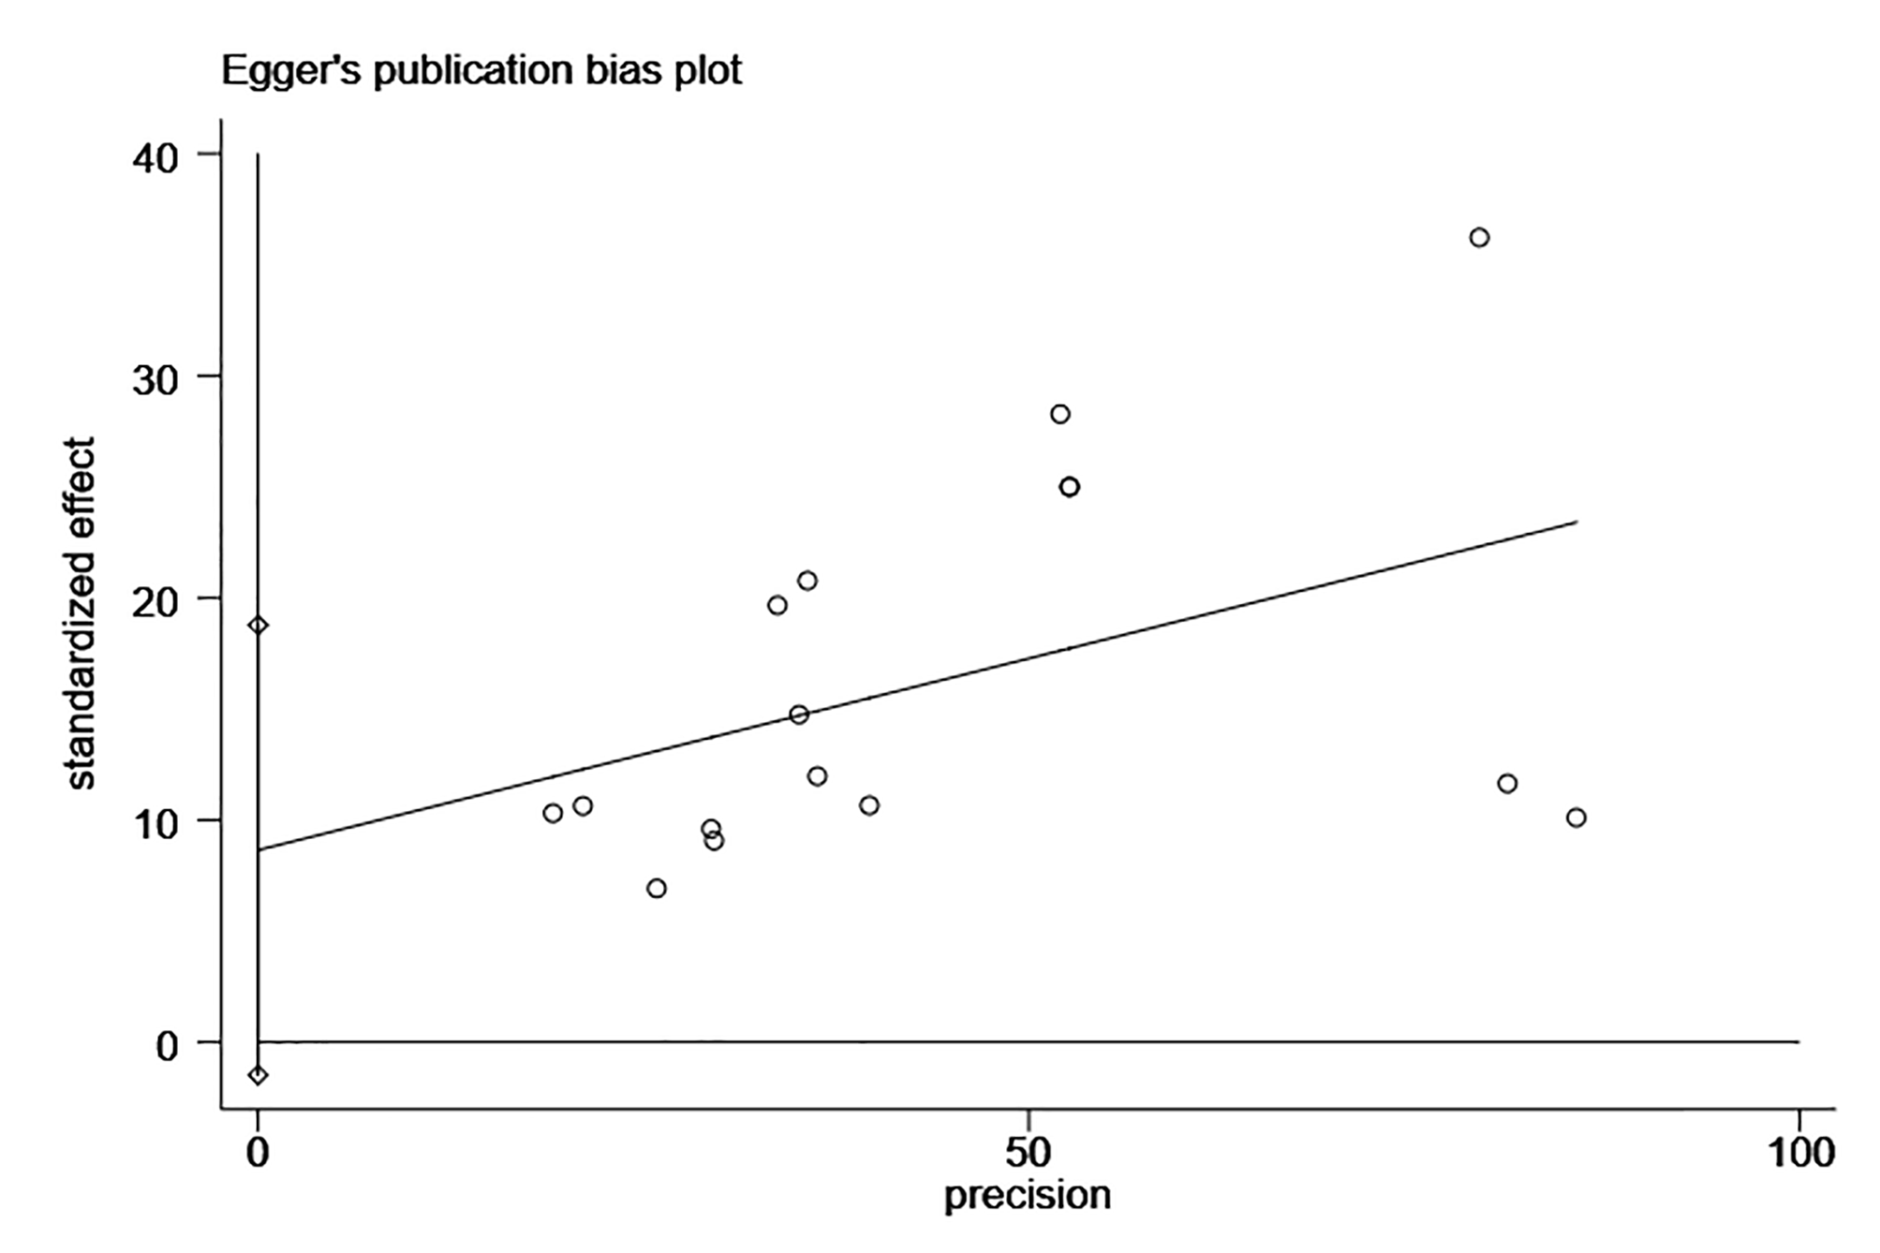

**Figure S2:** Egger’s publication bias plot

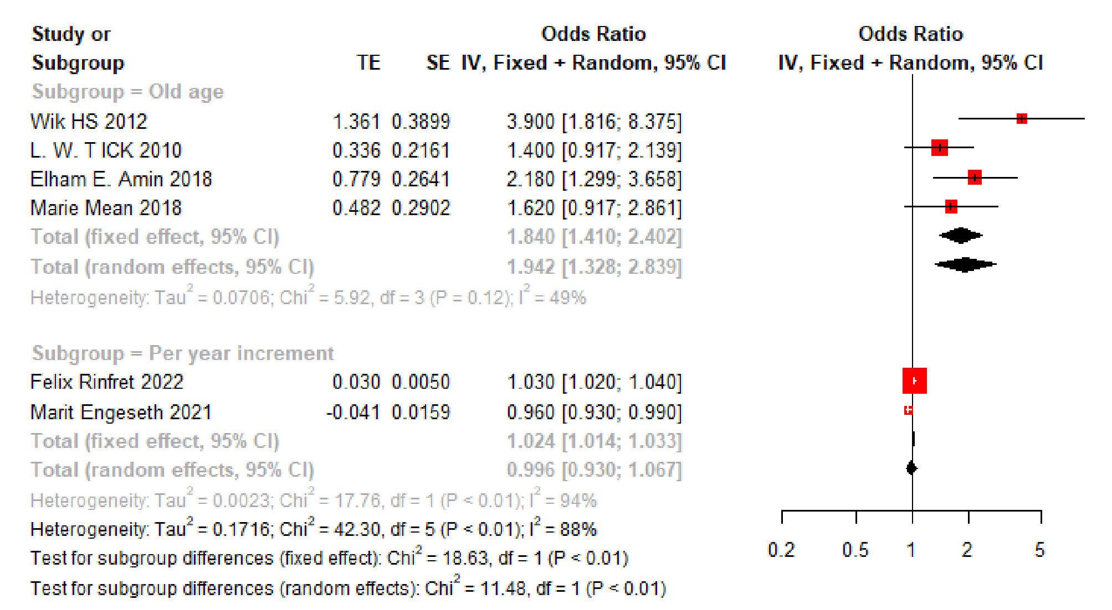

**Figure S3:** Forest plots of age

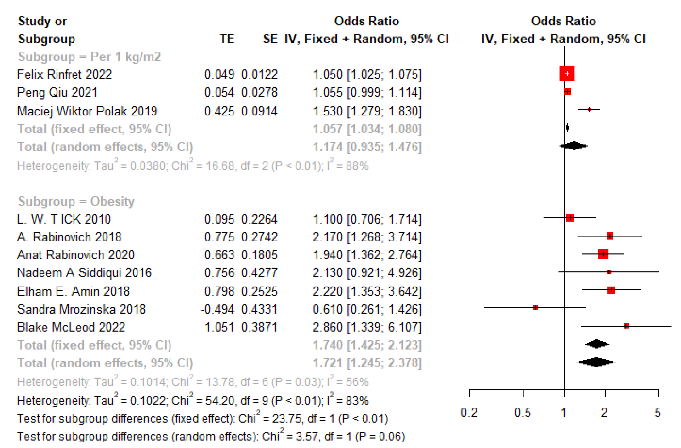

**Figure S4:** Forest plots of BMI

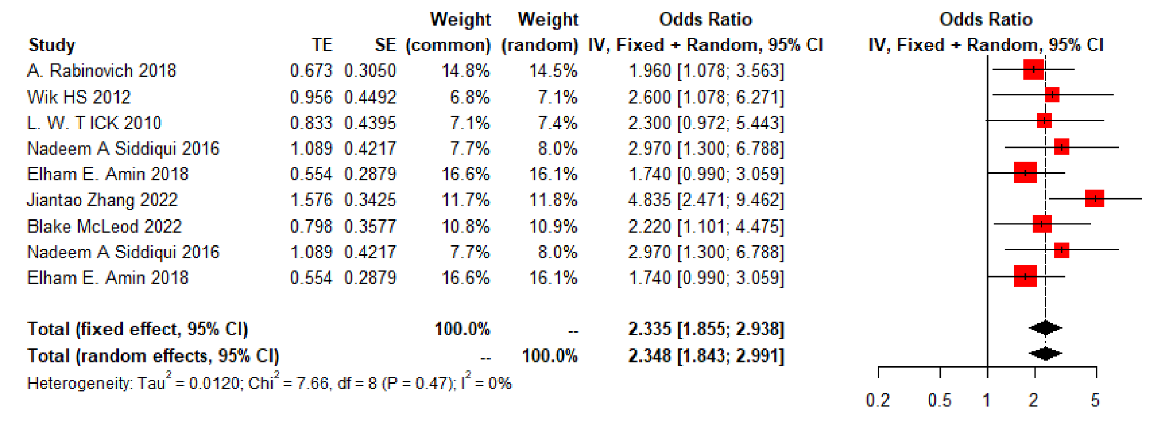

**Figure S5:** Forest plots of DVT localization

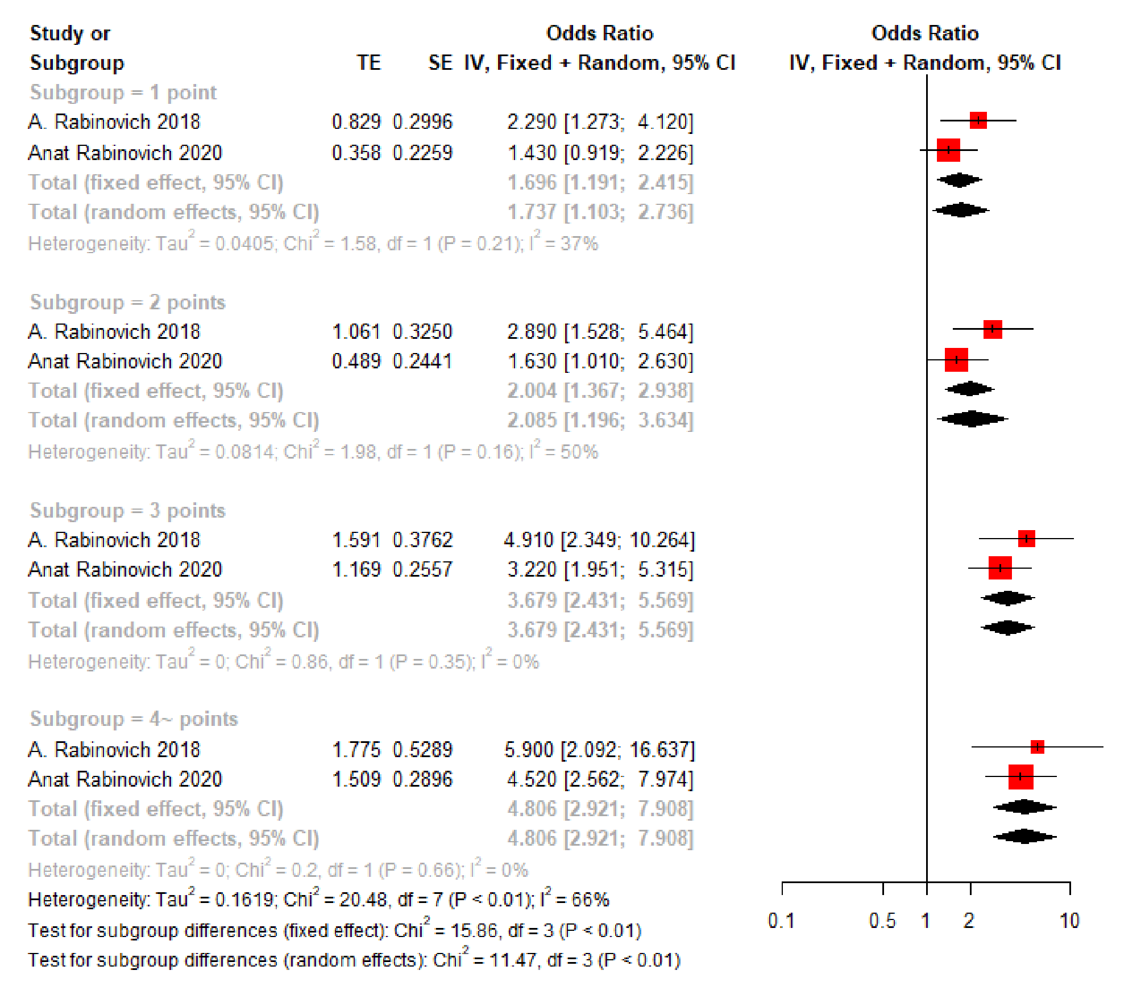

**Figure S6:** Forest plots of SOX-PTS Score

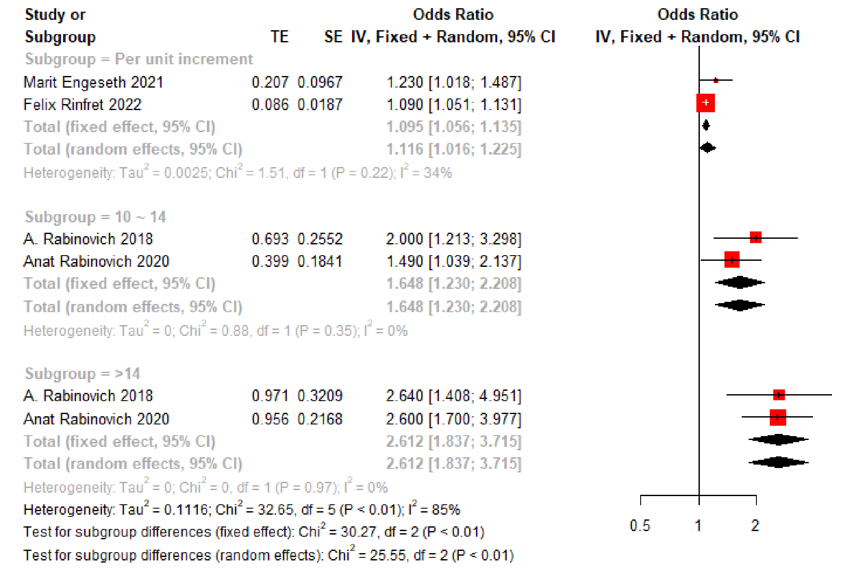

**Figure S7:** Forest plots of Villalta score category

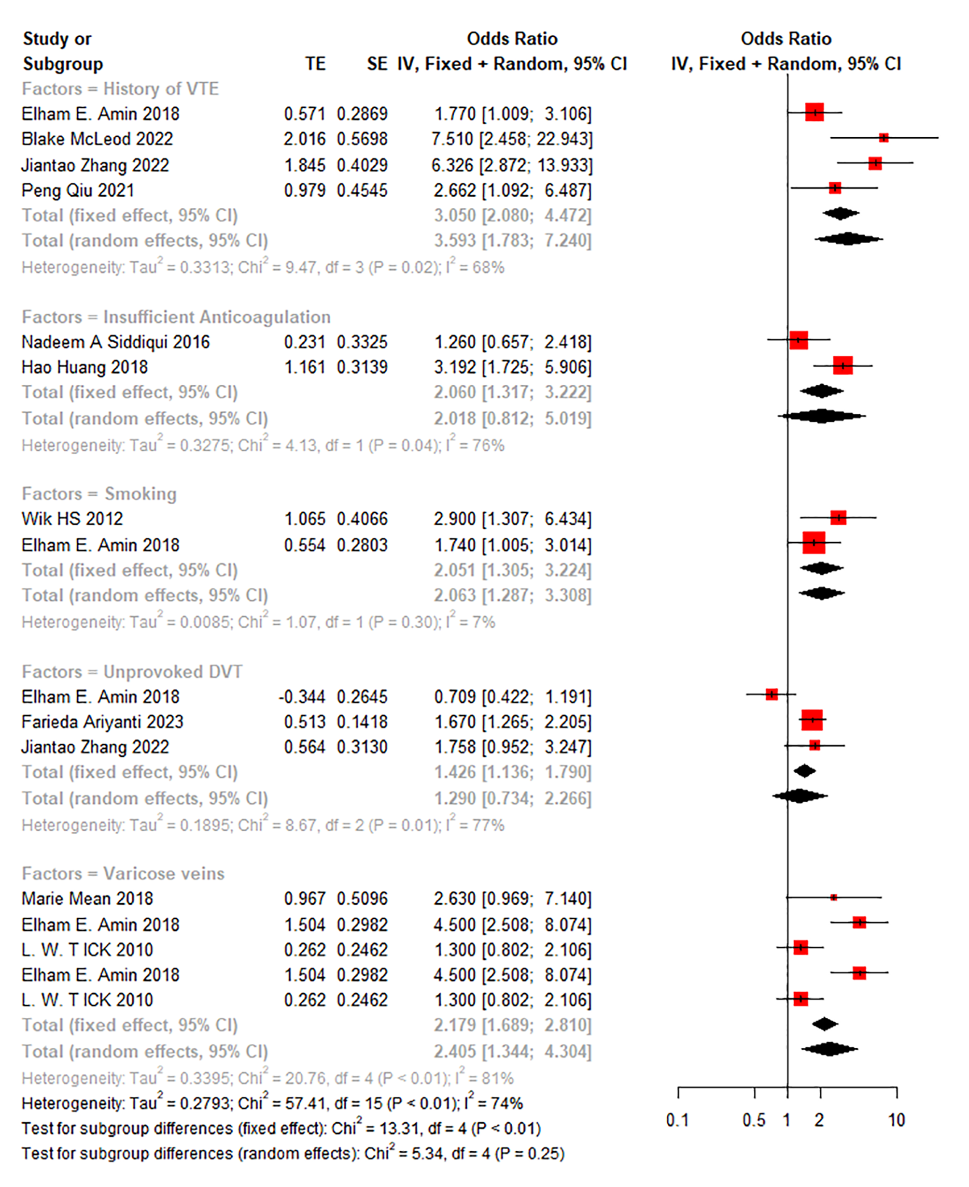

**Figure S8:** Forest plots of other main predictors