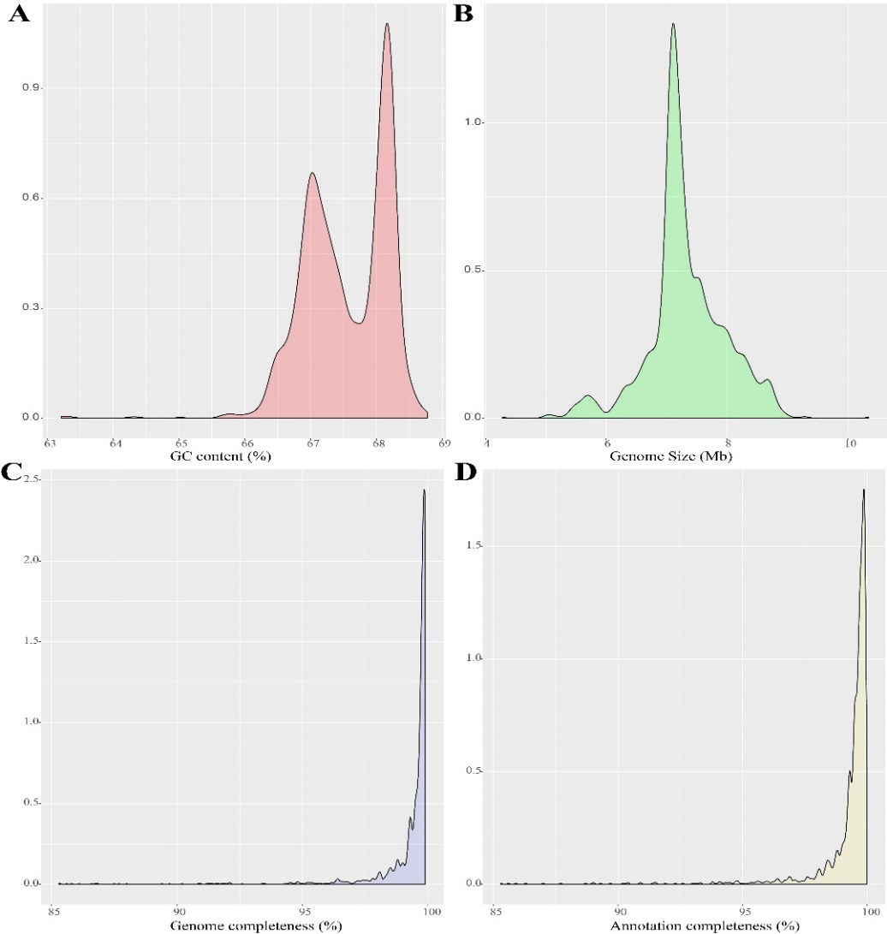
Figure S1 Genomic features Burkholderia. A) GC content nuclear density map; B) genome size nuclear density map; C) BUSCO assessed genome integrity nuclear density map; D) BUSCO assessed proteomic integrity nuclear density map.

Table 1. The strain used in the experiment. The number of original genomes not downloaded in parentheses, outside the brackets is the number of genes remaining after BUSCO assessment. * indicates that the strain belongs to Bcc.
Species | Total number of strains | type strains | Total number of plasmids
B. pseudomallei | 739（741） | B. pseudomallei Mahidol-1106a | 10
B. cenocepacia* | 258（262） | B. cenocepacia MSMB384WGS | 16
B. ubonensis* | 294 | B. ubonensis ATCC 31433 | 6
B. cepacia* | 97 | B. cepacia BC16 | 30
B. multivorans* | 88（90） | B. multivorans FDAARGOS_246 | 8
B. mallei | 64 | B. mallei Turkey2 | 10
B. stagnalis* | 64 | B. stagnalis MSMB735WGS | 0
B. vietnamiensis* | 43 | B. vietnamiensis FL-2-3-10-S3-D0 | 11
B. thailandensis | 42 | B. thailandensis 2002721643 | 4
B. territorii* | 34 | B. territorii RF8-non-BP5 | 0
B. gladioli | 19 | B. gladioli BBB-01 | 30
B. diffusa* | 12 | B. diffusa LMG 29043 | 0
B. contaminans* | 10 | B. contaminans CH-1 | 1
B. ambifaria* | 9 | B. ambifaria FDAARGOS_1027 | 10
B. pseudomultivorans* | 9 | B. pseudomultivorans BCC1191 | 2
B. anthina* | 8 | B. anthina LMG 20980 | 0
B. glumae | 8（9） | B. glumae 257sh-1 | 15
B. pyrrocinia* | 5 | B. pyrrocinia DSM 10685 | 2
B. lata* | 4 | B. lata FDAARGOS_899 | 0
B. humptydooensis | 3 | B. humptydooensis FDAARGOS_899 | 0
B. seminalis* | 3 | B. seminalis FL-5-4-10-S1-D7 | 0
B. stabilis* | 3 | B. stabilis E | 2
B. dolosa* | 3 | B. dolosa AU0158 | 0
B. latens* | 2 | B. latens BCC1625 | 2
B. metallica* | 2 | B. metallica FL-6-5-30-S1-D7 | 0
B. plantarii | 2 | B. plantarii ATCC 43733 | 2
B. singularis | 2 | B. singularis TSV85 | 0
B. catarinensis* | 1 | B. catarinensis 89 | 0
B. dabaoshanensis | 1 | B. dabaoshanensis GIMN1.004 | 0
B. paludis* | 1 | B. paludis LMG 30113 | 0
B. puraquae* | 1 | B. puraquae LMG 29660 | 1
B. novacaledonica | 1 | B. novacaledonica LMG 28615 | 0
Burkholderia sp. | 0 |  | 77

Table S2 General features of bacterial genomes used in pan-genome analysis
Species | Strain | GenBank no. | Level | Size(Mb) | GC(%) | No. of genes | No. of protein
B. pseudomallei | BPC006 | GCA_000294635.1 | Complete | 7.16 | 68.22 | 7373 | 6885
B. pseudomallei | Bp1651 | GCA_001318245.1 | Complete | 7.26 | 68.10 | 7499 | 6817
B. pseudomallei | VB976100 | GCA_001885195.1 | Complete | 7.28 | 68.02 | 7507 | 6865
B. cenocepacia | DDS 22E-1 | GCA_000755725.1 | Complete | 8.05 | 66.97 | 7347 | 7030
B. cenocepacia | VC7722 | GCA_001992875.1 | Contig | 8.15 | 66.90 | 7926 | 7352
B. ubonensis | A21 | GCA_001957105.1 | Scaffold | 7.01 | 67.30 | 6390 | 6064
B. ubonensis | MSMB22 | GCA_000959245.1 | Complete | 7.19 | 67.31 | 6473 | 6127
B. ubonensis | MSMB1754 | GCA_001527465.1 | Contig | 7.60 | 67.30 | 6912 | 6573
B. cepacia | ATCC_25416 | GCA_001411495.1 | Complete | 8.61 | 66.60 | 8014 | 7614
B. cepacia | INT3-BP132 | GCA_001525965.1 | Contig | 8.74 | 66.50 | 8141 | 7690
B. cepacia | JBK9 | GCA_000701165.2 | Complete | 8.48 | 66.81 | 7822 | 7476
B. multivorans | ATCC 17616 | GCA_000018505.1 | Complete | 7.01 | 66.69 | 6739 | 6397
B. multivorans | ATCC BAA-247 | GCA_000959525.1 | Complete | 6.32 | 67.20 | 6016 | 5787
B. mallei | ATCC 10399 | GCA_000152305.1 | Scaffold | 5.93 | 68.40 | 6240 | 5783
B. mallei | NCTC 10229 | GCA_000015605.1 | Complete | 5.74 | 68.48 | 6004 | 5602
B. stagnalis | MSMB1967 | GCA_001527725.1 | Contig | 7.69 | 67.60 | 7004 | 6642
B. stagnalis | MSMB757WGS | GCA_001534205.1 | Contig | 7.51 | 67.70 | 6852 | 6503
B. vietnamiensis | FL-7-3-30-S2-D0 | GCA_001524225.1 | Contig | 6.53 | 67.30 | 5910 | 5641
B. vietnamiensis | HI3392 | GCA_001529645.1 | Contig | 7.62 | 66.40 | 7174 | 6781
B. thailandensis | E264_ATCC_700388 | GCF_000152285.1 | Complete | 6.35 | 67.63 | 5990 | 5374
B. thailandensis | FDAARGOS_426 | GCA_002386205.1 | Complete | 6.73 | 67.47 | 6423 | 5808
B. territorii | A63 | GCA_002151255.1 | Scaffold | 8.87 | 66.40 | 8468 | 8047
B. territorii | MSMB1838 | GCA_001526425.1 | Contig | 6.82 | 66.80 | 6205 | 5928
B. gladioli | ATCC_10248 | GCA_000959725.1 | Complete | 8.90 | 67.62 | 7729 | 7386
B. gladioli | FDAARGOS_389 | GCA_002393425.1 | Complete | 8.29 | 67.97 | 7271 | 6978
B. diffusa | RF8-non_BP2 | GCA_001522375.1 | Contig | 5.84 | 66.70 | 5410 | 5173
B. diffusa | RF2-non-BP9 | GCA_001718315.1 | Complete | 6.86 | 66.46 | 6346 | 6059
B. contaminans | 170816 | GCA_002924455.1 | Complete | 8.63 | 66.46 | 8127 | 7632
B. contaminans | LTEB | GCA_001865715.1 | Contig | 8.00 | 66.50 | 7394 | 7075
B. ambifaria | RZ2MS16 | GCA_001443045.1 | Scaffold | 8.10 | 65.70 | 7551 | 7000
B. ambifaria | MC40-6 | GCA_000019925.1 | Complete | 7.64 | 66.38 | 6739 | 6575
B. pseudomultivorans | MSMB368WGS | GCA_001532035.1 | Contig | 7.74 | 66.90 | 7162 | 6793
B. pseudomultivorans | SUB-INT24-BP10 | GCA_001525825.1 | Contig | 7.91 | 67.40 | 7244 | 6939
B. anthina | MSMB1496 | GCA_001527785.1 | Contig | 7.51 | 67.00 | 6974 | 6595
B. anthina | AZ-4-2-30-S1-D7 | GCA_001523905.1 | Contig | 7.20 | 67.20 | 6703 | 6325
B. glumae | PG1 | GCA_000835205.1 | Complete | 7.90 | 68.78 | 6718 | 6402
B. glumae | BGR1 | GCA_000022645.2 | Complete | 7.28 | 67.93 | 6485 | 6151
B. pyrrocinia | CH-67 | GCA_000297475.1 | Contig | 8.05 | 67.40 | 7476 | 6945
B. pyrrocinia | DSM_10685 | GCA_001028665.1 | Complete | 7.96 | 66.47 | 7298 | 6929
B. lata | lata_383 | GCA_000012945.1 | Complete | 8.68 | 66.26 | 7991 | 7678
B. lata | lata_LK13 | GCA_001038835.1 | Contig | 8.67 | 66.50 | 8015 | 7599
B. humptydooensis | MSMB121 | GCA_002888035.1 | Contig | 6.65 | 67.50 | 6479 | 5732
B. humptydooensis | MSMB122 | GCA_001462435.1 | Complete | 6.79 | 67.47 | 6471 | 5891
B. seminalis | FL-5-4-10-S1-D7 | GCA_001718535.1 | Complete | 7.65 | 67.27 | 7091 | 6765
B. seminalis | TC3.4.2R3 | GCA_001742345.1 | Contig | 7.67 | 67.20 | 7164 | 6799
B. stabilis | ATCC_BAA-67 | GCA_001742165.1 | Complete | 8.53 | 66.41 | 7946 | 7510
B. stabilis | FERMP-21014 | GCA_002356275.1 | Complete | 7.72 | 66.69 | 7109 | 6770
B. dolosa | AU0158 | GCA_000152585.1 | Scaffold | 6.42 | 66.10 | 5058 | 4822
B. dolosa | PC543 | GCA_000497165.1 | Complete | 6.30 | 67.05 | 5817 | 5448
B. latens | AU17928 | GCA_001718795.1 | Complete | 6.61 | 66.39 | 6145 | 5820
B. latens | RF32-BP12 | GCA_001525985.1 | Contig | 6.50 | 66.50 | 5972 | 5689
B. metallica | A53 | GCA_003034145.1 | Scaffold | 8.23 | 66.60 | 7848 | 7188
B. metallica | FL-6-5-30-S1-D7 | GCA_001718555.1 | Complete | 7.42 | 67.12 | 6827 | 6491
B. plantarii | ATCC_43733 | GCA_001411805.1 | Complete | 8.08 | 68.58 | 6879 | 6575
B. plantarii | ZJ171 | GCA_001755835.1 | Scaffold | 8.02 | 68.50 | 6920 | 6495
B. singularis | LMG_28154 | GCA_900176645.1 | Contig | 5.54 | 64.30 | 4972 | 4653
B. singularis | TSV85 | GCA_001523725.1 | Contig | 5.56 | 64.30 | 4909 | 4632
B. catarinensis | - | GCA_001883705.1 | Contig | 8.14 | 66.50 | 7709 | 6128
B. dabaoshanensis | - | GCA_002879885.1 | Contig | 7.09 | 63.30 | 6514 | 6329
B. paludis | - | GCA_000732615.1 | Contig | 8.63 | 67.10 | 7098 | 6963
B. puraquae |  | GCA_002099195.1 | Contig | 8.10 | 66.60 | 7574 | 7182
B. novacaledonica | - | GCA_900258035.1 | Contig | 6.78 | 63.30 | 6240 | 6179

Table S3 Average nucleotide identity of bacterial genomes used in pan-genome analysis.
Species | Strain | GenBank no. | Level | Size(Mb) | GC(%) | No. of genes | No. of protein
B. pseudomallei
B. cenocepacia | AU0756 | GCF_002981045.1 | Contig | 7.26 | 67.00 | 6853 | 6509
B. cenocepacia | DDS 22E-1 | GCF_000755725.1 | Complete | 8.05 | 66.97 | 7347 | 7030
B. cenocepacia | VC7722 | GCF_001992875.1 | Contig | 8.15 | 66.9 | 7926 | 7352
B. ubonensis
B. cepacia | ATCC_25416 | GCA_001411495.1 | Complete | 8.61 | 66.60 | 8014 | 7614
B. cepacia | INT3-BP132 | GCA_001525965.1 | Contig | 8.74 | 66.50 | 8141 | 7690
B. cepacia | JBK9 | GCA_000701165.2 | Complete | 8.48 | 66.81 | 7822 | 7476
B. multivorans | ATCC 17616 | GCA_000018505.1 | Complete | 7.01 | 66.69 | 6739 | 6397
B. multivorans | ATCC BAA-247 | GCA_000959525.1 | Complete | 6.32 | 67.20 | 6016 | 5787
B. mallei | ATCC 10399 | GCA_000152305.1 | Scaffold | 5.93 | 68.40 | 6240 | 5783
B. mallei | NCTC 10229 | GCA_000015605.1 | Complete | 5.74 | 68.48 | 6004 | 5602
B. stagnalis | MSMB1967 | GCA_001527725.1 | Contig | 7.69 | 67.60 | 7004 | 6642
B. stagnalis | MSMB757WGS | GCA_001534205.1 | Contig | 7.51 | 67.70 | 6852 | 6503
B. vietnamiensis | FL-7-3-30-S2-D0 | GCA_001524225.1 | Contig | 6.53 | 67.30 | 5910 | 5641
B. vietnamiensis | HI3392 | GCA_001529645.1 | Contig | 7.62 | 66.40 | 7174 | 6781
B. thailandensis | E264_ATCC_700388 | GCF_000152285.1 | Complete | 6.35 | 67.63 | 5990 | 5374
B. thailandensis | FDAARGOS_426 | GCA_002386205.1 | Complete | 6.73 | 67.47 | 6423 | 5808
B. territorii | A63 | GCA_002151255.1 | Scaffold | 8.87 | 66.40 | 8468 | 8047
B. territorii | MSMB1838 | GCA_001526425.1 | Contig | 6.82 | 66.80 | 6205 | 5928
B. gladioli | ATCC_10248 | GCA_000959725.1 | Complete | 8.90 | 67.62 | 7729 | 7386
B. gladioli | FDAARGOS_389 | GCA_002393425.1 | Complete | 8.29 | 67.97 | 7271 | 6978
B. diffusa | RF8-non_BP2 | GCA_001522375.1 | Contig | 5.84 | 66.70 | 5410 | 5173
B. diffusa | RF2-non-BP9 | GCA_001718315.1 | Complete | 6.86 | 66.46 | 6346 | 6059
B. contaminans | 170816 | GCA_002924455.1 | Complete | 8.63 | 66.46 | 8127 | 7632
B. contaminans | LTEB | GCA_001865715.1 | Contig | 8.00 | 66.50 | 7394 | 7075
B. ambifaria | RZ2MS16 | GCA_001443045.1 | Scaffold | 8.10 | 65.70 | 7551 | 7000
B. ambifaria | MC40-6 | GCA_000019925.1 | Complete | 7.64 | 66.38 | 6739 | 6575
B. pseudomultivorans | MSMB368WGS | GCA_001532035.1 | Contig | 7.74 | 66.90 | 7162 | 6793
B. pseudomultivorans | SUB-INT24-BP10 | GCA_001525825.1 | Contig | 7.91 | 67.40 | 7244 | 6939
B. anthina | MSMB1496 | GCA_001527785.1 | Contig | 7.51 | 67.00 | 6974 | 6595
B. anthina | AZ-4-2-30-S1-D7 | GCA_001523905.1 | Contig | 7.20 | 67.20 | 6703 | 6325
B. glumae | PG1 | GCA_000835205.1 | Complete | 7.90 | 68.78 | 6718 | 6402
B. glumae | BGR1 | GCA_000022645.2 | Complete | 7.28 | 67.93 | 6485 | 6151
B. pyrrocinia | CH-67 | GCA_000297475.1 | Contig | 8.05 | 67.40 | 7476 | 6945
B. pyrrocinia | DSM_10685 | GCA_001028665.1 | Complete | 7.96 | 66.47 | 7298 | 6929
B. lata | lata_383 | GCA_000012945.1 | Complete | 8.68 | 66.26 | 7991 | 7678
B. lata | lata_LK13 | GCA_001038835.1 | Contig | 8.67 | 66.50 | 8015 | 7599
B. humptydooensis | MSMB121 | GCA_002888035.1 | Contig | 6.65 | 67.50 | 6479 | 5732
B. humptydooensis | MSMB122 | GCA_001462435.1 | Complete | 6.79 | 67.47 | 6471 | 5891
B. seminalis | FL-5-4-10-S1-D7 | GCA_001718535.1 | Complete | 7.65 | 67.27 | 7091 | 6765
B. seminalis | TC3.4.2R3 | GCA_001742345.1 | Contig | 7.67 | 67.20 | 7164 | 6799
B. stabilis | ATCC_BAA-67 | GCA_001742165.1 | Complete | 8.53 | 66.41 | 7946 | 7510
B. stabilis | FERMP-21014 | GCA_002356275.1 | Complete | 7.72 | 66.69 | 7109 | 6770
B. dolosa | AU0158 | GCA_000152585.1 | Scaffold | 6.42 | 66.10 | 5058 | 4822
B. dolosa | PC543 | GCA_000497165.1 | Complete | 6.30 | 67.05 | 5817 | 5448
B. latens | AU17928 | GCA_001718795.1 | Complete | 6.61 | 66.39 | 6145 | 5820
B. latens | RF32-BP12 | GCA_001525985.1 | Contig | 6.50 | 66.50 | 5972 | 5689
B. metallica | A53 | GCA_003034145.1 | Scaffold | 8.23 | 66.6 | 7848 | 7188
B. metallica | FL-6-5-30-S1-D7 | GCA_001718555.1 | Complete | 7.42 | 67.12 | 6827 | 6491
B. plantarii | ATCC_43733 | GCA_001411805.1 | Complete | 8.08 | 68.58 | 6879 | 6575
B. plantarii | ZJ171 | GCA_001755835.1 | Scaffold | 8.02 | 68.50 | 6920 | 6495
B. singularis | LMG_28154 | GCA_900176645.1 | Contig | 5.54 | 64.3 | 4972 | 4653
B. singularis | TSV85 | GCA_001523725.1 | Contig | 5.56 | 64.3 | 4909 | 4632
B. catarinensis | - | GCA_001883705.1 | Contig | 8.14 | 66.5 | 7709 | 6128
B. dabaoshanensis | - | GCF_002879885.1 | Contig | 70.9 | 63.3 | 6514 | 6329
B. paludis | - | GCF_000732615.1 | Contig | 8.63 | 67.1 | 7098 | 6963
B. puraquae |  | GCF_002099195.1 | Contig | 8.10 | 66.6 | 7574 | 7182
B. novacaledonica | - | GCA_900258035.1 | Contig | 6.78 | 63.3 | 6240 | 6179

Table S4 Distribution of mercury resistance genes in the genus of Burkholderia. The value in parentheses is the number of genomes in which the resistance gene is present and the total number of genomes used for analysis.
Hg resistance gene | Species
merA | B. cenocepacia(120/258); B. cepacian(2/97); B. contaminans(5/10)  B. gladioli (3/19); B. glumae(5/8); B. multivorans(11/88)  B. plantarii(1/2); B. pseudomallei(630/739); B. thailandensis(4/442)  B. vietnamiensis(6/43)
merB | B. cenocepacia(77/258); B. contaminans(5/10); B. gladioli(1/19)  B. multivorans(5/88); B. vietnamiensis(2/43)
merC | B. cenocepacia(17/258); B. contaminans(2/10); B. gladioli(1/19)  B. glumae(4/19); B. multivorans(1/88); B. thailandensis(4/442)  B. vietnamiensis(2/43)
merD | B. cenocepacia(40/258); B. contaminans(1/10); B. gladioli(4/19)  B. multivorans(2/88); B. vietnamiensis(2/43)
merF | B. gladioli(2/19); B. multivorans(1/88)
merP | B. cenocepacia(116/258); B. cepacian(2/97); B. contaminans(5/10)  B. gladioli(4/19); B. humptydooensis(3/3); B. multivorans(11/88)  B. thailandensis(39/442); B. ubonensis(1/294); B. vietnamiensis(4/43)
merT | B. cenocepacia(119/258); B. cepacian(2/97); B. contaminans(5/10)  B. gladioli(3/19); B. multivorans(11/88); B. thailandensis(4/442)  B. ubonensis(1/294); B. vietnamiensis(4/43)

Table S5 Distribution of arsenic resistance genes in the genus of Burkholderia. The value in parentheses is the number of genomes in which the resistance gene is present and the total number of genomes used for analysis.
As resistance gene | Species
arsA | B. cenocepacia(6/258); B. cepacian(1/97); B. contaminans(2/10)  B. gladioli (1/19); B. glumae(7/8); B. ubonensis(1/294)  B. vietnamiensis(440/43)
arsB | B. ambifaria(9/9); B. anthina(8/8); B. cenocepacia(248/258)  B. cepacian(96/97); B. contaminans(10/10); B. diffusa(11/12)  B. dolosa(3/3); B. gladioli(19/19); B. glumae(2/8); B. humptydooensis(3/3)  B. lata(4/4); B. latens(2/2); B. mallei(45/64); B. metallica(1/2)  B. multivorans(88/88); B. plantarii(2/2); B. pseudomallei(728/739)  B. pseudomultivorans(9/9); B. puraquae(1/1); B. pyrrocinia(5/5)  B. seminalis(3/3); B. stabilis(3/3); B. stagnalis(64/64)  B. territorii(33/34); B. thailandensis(42/42); B. ubonensis(294/294)  B. vietnamiensis(43/43)
arsC | B. ambifaria(9/9); B. anthina(8/8); B. cenocepacia(258/258)  B. cepacian(97/97); B. contaminans(10/10); B. diffusa(12/12)  B. dolosa(3/3); B. gladioli(19/19); B. glumae(8/8); B. humptydooensis(3/3)  B. lata(4/4); B. latens(2/2); B. mallei(63/64); B. metallica(2/2)  B. multivorans(88/88); B. novacaledonica(1/1); B. paludis(1/1)  B. plantarii(2/2);B. pseudomallei(739/739); B. pseudomultivorans(9/9)  B. puraquae(1/1); B. pyrrocinia(5/5);B. seminalis(3/3); B. singularis(2/2); B. stabilis(3/3); B. stagnalis(64/64);B. territorii(34/34)  B. thailandensis(42/42); B. ubonensis(294/294);B. vietnamiensis(43/43)
arsD | B. cenocepacia(6/258); B. cepacian(1/97); B. contaminans(2/10);  B. multivorans(7/88); B. vietnamiensis(14/43)
arsH | B. ambifaria(9/9); B. anthina(8/8); B. cenocepacia(248/258)  B. cepacian(92/97); B. contaminans(10/10); B. diffusa(11/12)  B. gladioli(19/19); B. glumae(2/8); B. lata(4/4); B. latens(2/2)  B. metallica(1/2); B. multivorans(26/88);B. paludis(1/1)  B. plantarii(2/2);B. pseudomallei(8/739);B. pseudomultivorans(9/9)  B. puraquae(1/1); B. pyrrocinia(5/5); B. seminalis(3/3); B. stabilis(3/3)  B. stagnalis(64/64); B. territorii(34/34); B. ubonensis(40/294)  B. vietnamiensis(19/43)
arsR | B. ambifaria(9/9); B. anthina(8/8); B. cenocepacia(258/258)  B. cepacian(96/97); B. contaminans(10/10); B. diffusa(12/12)  B. dolosa(3/3); B. gladioli(9/19); B. glumae(7/8); B. humptydooensis(3/3)  B. lata(4/4); B. latens(2/2); B. mallei(64/64); B. metallica(2/2)  B. multivorans(88/88); B. paludis(1/1); B. pseudomallei(735/739)  B. pseudomultivorans(9/9); B. puraquae(1/1); B. pyrrocinia(5/5)  B. seminalis(3/3); B. stagnalis(64/64); B. territorii(34/34)  B. thailandensis(42/42); B. ubonensis(88/294); B. vietnamiensis(43/43)
aioA/aoxB | B. cenocepacia(6/258); B. cepacian(6/97); B. multivorans(7/88)  B. pseudomallei(7/739); B. ubonensis(30/294); B. vietnamiensis(12/43)
aioB/aoxA | B. cenocepacia(6/258); B. cepacian(3/97); B. multivorans(8/88)  B. pseudomallei(7/739); B. ubonensis(30/294); B. vietnamiensis(12/43)

Table S6 Distribution of Cadmium, zinc, cobalt, copper resistance genes in the genus of Burkholderia. The value in parentheses is the number of genomes in which the resistance gene is present and the total number of genomes used for analysis.
Cd, Zn, Co, and Cu resistance gene | Species
czc/cusABC | B. ambifaria(9/9); B. anthina(8/8); B. cenocepacia(258/258)  B. cepacian(97/97); B. contaminans(10/10); B. diffusa(12/12)  B. dolosa(3/3); B. gladioli(19/19); B. glumae(8/8); B. humptydooensis(3/3)  B. lata(4/4); B. latens(2/2); B. mallei(64/64); B. metallica(2/2)  B. multivorans(88/88); B. plantarii(1/2); B. paludis(2/2)  B. pseudomallei(739/739); B. pseudomultivorans(9/9); B. puraquae(1/1)  B. pyrrocinia(5/5); B. seminalis(3/3); B. stabilis(2/3); B. stabilis(3/3)  B. stagnalis(64/64); B. territorii(33/34); B. thailandensis(42/42)  B. ubonensis(294/294); B. vietnamiensis(43/43)
czcD | B. contaminans(1/10); B. seminalis(1/3); B. stabilis(1/3); B. metallica(1/2)
cop | B. ambifaria(9/9); B. anthina(8/8); B. cenocepacia(258/258);  B. cepacian(97/97); B. contaminans(10/10); B. diffusa(12/12); B. dolosa(3/3)  B. gladioli(19/19); B. glumae(8/8); B. humptydooensis(3/3); B. lata(4/4)  B. latens(2/2); B. mallei(64/64); B. metallica(2/2); B. multivorans(88/88)  B. plantarii(1/2); B. paludis(2/2); B. pseudomallei(739/739)  B. pseudomultivorans(9/9); B. puraquae(1/1); B. pyrrocinia(5/5)  B. seminalis(3/3); B. stabilis(2/3); B. stabilis(3/3); B. stagnalis(64/64)  B. territorii(33/34); B. thailandensis(42/42); B. ubonensis(294/294)  B. vietnamiensis(43/43)
Table S7. Distribution of Tn7-like components within the genus. * indicates that the strain belongs to Bcc.
Species | Tn7-like element | Tn7 like is related to heavy metal resistance
B. pseudomallei | YES | -
B. cenocepacia* | YES | YES
B. ubonensis* | YES | -
B. cepacia* | YES | -
B. multivorans* | YES | YES
B. mallei | NO | -
B. stagnalis* | YES | -
B. vietnamiensis* | YES | -
B. thailandensis | YES | -
B. territorii* | YES | -
B. gladioli | YES | -
B. diffusa* | YES | -
B. contaminans* | YES | YES
B. ambifaria* | NO | -
B. pseudomultivorans* | NO | -
B. anthina* | YES | -
B. glumae | YES | -
B. pyrrocinia* | NO | -
B. lata* | YES | -
B. humptydooensis | NO | -
B. seminalis* | YES | -
B. stabilis* | NO | -
B. dolosa* | NO | -
B. latens* | NO | -
B. metallica* | NO | -
B. plantarii | NO | -
B. singularis | NO | -
B. catarinensis* | NO | -
B. dabaoshanensis | YES | -
B. paludis* | NO | -
B. puraquae* | NO | -

Table S8. The location of genomic island BGImetal in the genome. * indicates that BGImetal is incomplete and exists on multiple contigs.
Species | BGImetal（chromosme/contig; start-end）
B. contaminans 293K04B | NQOD01000075.1; 20730-54371
B. contaminans LMG 23361 | MCAU02000003.1; 612785-649152
B. contaminans 170816* | PQVP01000004.1; PQVP01000005.1
B. contaminans AU20979* | PVGK01000099.1; PVGK01000069.1
B. multivorans AU15954 | PVFW01000019.1; 3961- 47200
B. multivorans AU26250 | PVGY01000031.1; 2435- 45674
B. multivorans DDS 15A-1 | CP008728.1; 574969-618208
B. multivorans MSMB1272WGS | LPEO01000047.1; 24509- 67748
B. multivorans DSOPR54* | NGKK01000224.1; NGKK01000047.1
B. multivorans DSOPR57* | NGKL01000053.1; NGKL01000062.1
B. multivorans AU22892* | PVGO01000033.1; PVGO01000005.1
B. cenocepacia PT15 | NZ_AXZX01000464.1; 20603- 54244
B. cenocepacia S2AES | NZ_AXZY01000021.1; 11315- 44956
B. cenocepacia VC10178 | NZ_MUQU01000095.1; 23162- 56803
B. cenocepacia VC10287 | NZ_MURH01000048.1; 29763- 63404
B. cenocepacia VC10878 | NZ_MURI01000024.1; 76857- 110498
B. cenocepacia VC11482 | NZ_MUSL01000012.1; 8220- 41864
B. cenocepacia VC11575 | NZ_MURJ01000014.1; 214318- 247959
B. cenocepacia VC13300 | NZ_MUQV01000198.1; 58933- 92574
B. cenocepacia VC13395 | NZ_MUSN01000088.1; 20254- 53896
B. cenocepacia VC13450 | NZ_MURL01000197.1; 29823- 63464
B. cenocepacia VC14165 | NZ_MUSO01000109.1; 20553- 54195
B. cenocepacia VC14507 | NZ_MUQW01000039.1; 116897- 150538
B. cenocepacia VC14543 | NZ_MURN01000158.1; 126810- 160451
B. cenocepacia VC14636 | NZ_MUSP01000098.1; 8202- 41844
B. cenocepacia VC15221 | NZ_MUSR01000175.1; 13267- 46909
B. cenocepacia VC15235 | NZ_MURO01000051.1; 29727- 63368
B. cenocepacia VC3868 | NZ_MURA01000153.1; 70571- 104212
B. cenocepacia VC3929 | NZ_MUQL01000031.1; 116839- 150480
B. cenocepacia VC4480 | NZ_MURB01000220.1; 56091- 89732
B. cenocepacia VC4558 | NZ_MUJO01000009.1; 1451252- 1484893
B. cenocepacia VC5300 | NZ_MURC01000058.1; 154489- 188130
B. cenocepacia VC5731 | NZ_MUQN01000004.1; 110428- 144069
B. cenocepacia VC5732 | NZ_MUQM01000160.1; 116739- 150380
B. cenocepacia VC6903 | NZ_MUQP01000108.1; 116777- 150418
B. cenocepacia VC6904 | NZ_MUQO01000169.1; 23273- 56914
B. cenocepacia VC6916 | NZ_MUSE01000114.1; 20333- 53977
B. cenocepacia VC6917 | NZ_MUSF01000049.1; 8189- 41832
B. cenocepacia VC7378 | NZ_MUSG01000009.1; 20553- 54196
B. cenocepacia VC7603 | NZ_MUQQ01000029.1; 116815- 150456
B. cenocepacia VC7604 | NZ_MUJP01000005.1; 1447227-1480868
B. cenocepacia VC7884 | NZ_MUSI01000099.1; 13381- 47028
B. cenocepacia VC8057 | NZ_MUQR01000181.1; 23190- 56831
B. cenocepacia VC8556 | NZ_MUQS01000052.1; 116609- 150250
B. cenocepacia VC8946 | NZ_MURE01000079.1; 69664- 103305
B. cenocepacia VC8947 | NZ_MURF01000120.1; 73175- 106816
B. cenocepacia VC9612 | NZ_MUQT01000045.1; 21309- 54950
B. cenocepacia VC9670 | NZ_MURG01000002.1; 29828- 63469
B. cenocepacia VC9970 | NZ_MUSK01000104.1; 13302- 46947
B. cenocepacia VC7379 | NZ_MUSH01000129.1; 20430- 54073
B. cenocepacia VC10394* | NZ_MUTE01000093.1; NZ_MUTE01000024.1
B. cenocepacia VC11261* | NZ_MUTF01000081.1; NZ_MUTF01000001.1
B. cenocepacia VC11903* | NZ_MUTG01000051.1; NZ_MUTG01000078.1
B. cenocepacia VC12229* | NZ_MUSM01000016.1; NZ_MUSM01000148.1; NZ_MUSM01000040.1
B. cenocepacia VC13112* | NZ_MUTH01000042.1; NZ_MUTH01000020.1
B. cenocepacia VC14637* | NZ_MUSQ01000043.1; NZ_MUSQ01000194.1
B. cenocepacia VC14761* | NZ_MUTI01000070.1; NZ_MUTI01000001.1
B. cenocepacia VC14762* | NZ_MUTJ01000015.1; NZ_MUTJ01000057.1
B. cenocepacia VC15305* | NZ_MUTK01000019.1; NZ_MUTK01000083.1
B. cenocepacia VC7292* | NZ_MUTB01000015.1; NZ_MUTB01000038.1
B. cenocepacia VC7530* | NZ_MUTC01000138.1; NZ_MUTC01000134.1
B. cenocepacia VC8945* | NZ_MURD01000024.1; NZ_MURD01000028.1
B. cenocepacia VC9855* | NZ_MUTD01000036.1; NZ_MUTD01000021.1
B. cenocepacia 79 BCEN* | NZ_JUSV01002379.1; NZ_JUSV01002454.1
B. cenocepacia BC-19* | NZ_JYMX01000131.1; NZ_JYMX01000077.1; NZ_JYMX01000040.1
B. cenocepacia BC-21* | NZ_JYMY01000097.1; NZ_JYMY01000023.1; NZ_JYMY01000040.1
B. cenocepacia BC-40* | NZ_JYMZ01000125.1; NZ_JYMZ01000126.1; NZ_JYMZ01000001.1
B. cenocepacia BC-41* | NZ_JYNA01000095.1; NZ_JYNA01000074.1; NZ_JYNA01000011.1
B. cenocepacia VC12599* | NZ_MURK01000044.1; NZ_MURK01000086.1
B. cenocepacia VC14013* | NZ_MURM01000147.1; NZ_MURM01000157.1
B. cenocepacia VC14748* | NZ_MUQX01000143.1; NZ_MUQX01000034.1
B. cenocepacia VC14815* | NZ_MUQY01000002.1; NZ_MUQY01000205.1
B. cenocepacia VC15049* | NZ_MUQZ01000003.1; NZ_MUQZ01000042.1
B. cenocepacia VC15566* | NZ_MURP01000084.1; NZ_MURP01000091.1
B. cenocepacia VC8222* | NZ_MUSJ01000053.1; NZ_MUSJ01000009.1; NZ_MUSJ01000073.1

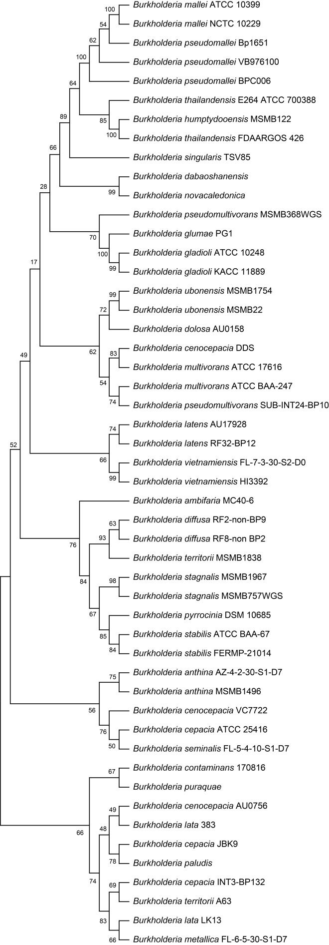
Figure S2. The 16s rDNA phylogenetic tree of 60 Burkholderia genomes.

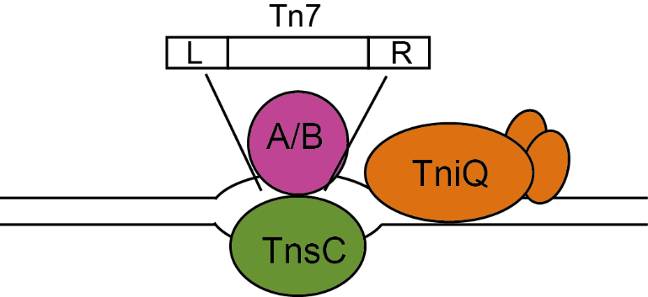
Figure S3 Model of Tn7 transposition. Targeting a specific binding site (attTn7) of TniQ leads to asymmetric aberration of DNA, thereby recruiting TnsC to bind to the target site. TnsA/TnsB transposase complexes with the target protein to activate transcription and translocate Tn7 into the genome.

