**Supplementary Material**

**Supplementary Table S1** Incidence density of hyperuricemia in participants ≥18 years in Beijing Physical Examination Center

**Supplementary Table S2** Prevalence of hyperuricemia in participants ≥18 years in Beijing Physical Examination Center

**Supplementary Table S3** Parameters of the PLSPM in the population grouped by follow-up time

**Supplementary Fig. S1** Flow chart of the study

**Supplementary Fig. S2** Association between SU concentrations at follow-up and baseline metabolism-related risk factors when using the cut-offs founded in the URRAH project (>5.1 mg/dL for females and >5.6 mg/dL for males) to define hyperuricemia (n=33,130)

**Supplementary Fig. S3** The sex-specific relationships between SU concentrations at-follow and baseline FBG concentrations

**Supplementary Fig. S4** The sex-specific relationships between SU concentrations at-follow and baseline age

**Supplementary Table S1** Incidence density of hyperuricemia in participants ≥18 years in Beijing Physical Examination Center

|  |  |  |  |
| --- | --- | --- | --- |
| Variable | Number of new cases of hyperuricemia | Person time (person-years) | Incidence density (1/1000 person-years) |
| Men | 4,259 | 37,086 | 115 |
| Women | 1,560 | 37,288 | 42 |
| Total | 5,819 | 74,374 | 78 |

**Supplementary Table S2** Prevalence of hyperuricemia in participants ≥18 years in Beijing Physical Examination Center

|  |  |  |  |
| --- | --- | --- | --- |
| Year | Number of cases of hyperuricemia | Number of the total population | Prevalence (%) |
| 2014 | 10,983 | 71,964 | 15 |
| 2015 | 12,260 | 70,983 | 17 |
| 2016 | 12,659 | 66,221 | 19 |

**Supplementary Table S3** Parameters of the PLSPM in the population grouped by follow-up time

|  |  |  |  |  |  |
| --- | --- | --- | --- | --- | --- |
| Subgroup | Latent variable | Path coefficients | Observed variable | Loading | R2 |
| 1 | SU | - | SU | 1.000* | 0.656 |
| Age | -0.011 | Age | 1.000* |
| Sex | 0.106* | Sex | 1.000* |
| FBG | -0.003 | FBG | 1.000* |
| Baseline SU | 0.673* | Baseline SU | 1.000* |
| Obesity | 0.071* | BMI | 0.894* |
|  |  | WC | 0.999* |
| Lipid metabolism | 0.048* | TG | 0.924* |
|  |  | TC | 0.660* |
|  |  | HDL-C | -0.323* |
|  |  | LDL-C | 0.442* |
| Blood pressure | 0.015* | SBP | 0.985* |
|  |  | DBP | 0.913* |
| 2 | SU | - | SU | 1.000* | 0.619 |
| Age | -0.005 | Age | 1.000* |
| Sex | 0.111* | Sex | 1.000* |
| FBG | -0.006 | FBG | 1.000* |
| Baseline SU | 0.677* | Baseline SU | 1.000* |
| Obesity | 0.047* | BMI | 0.829* |
|  |  | WC | 0.999* |
| Lipid metabolism | 0.040* | TG | 0.929* |
|  |  | TC | 0.619* |
|  |  | HDL-C | -0.323* |
|  |  | LDL-C | 0.421* |
| Blood pressure | -0.004 | SBP | 0.986* |
|  |  | DBP | 0.901* |
| 3 | SU | - | SU | 1.000* | 0.628 |
| Age | -0.021* | Age | 1.000* |
| Sex | 0.106* | Sex | 1.000* |
| FBG | -0.024* | FBG | 1.000* |
| Baseline SU | 0.694* | Baseline SU | 1.000* |
| Obesity | 0.031* | BMI | 0.886* |
|  |  | WC | 0.999* |
| Lipid metabolism | 0.032* | TG | 0.939* |
|  |  | TC | 0.609* |
|  |  | HDL-C | -0.352* |
|  |  | LDL-C | 0.397* |
| Blood pressure | 0.011 | SBP | 0.984* |
|  |  | DBP | 0.917* |

SU: serum urate; TG: total triglycerides; HDL-C: high-density lipoprotein cholesterol; TC: total cholesterol; LDL-C: low-density lipoprotein cholesterol; FBG: fasting blood glucose; BMI: body mass index; WC: waist circumference; SBP: systolic blood pressure; DBP: diastolic blood pressure.

Subgroup 1 (number=12470): the participants with follow-up time ≤1 year; Subgroup 2 (number =24907): the participants with follow-up time >1 year and ≤2 years; Subgroup 3 (number =11602): the participants with follow-up time >2 years and ≤3 years

\**p* <0.05

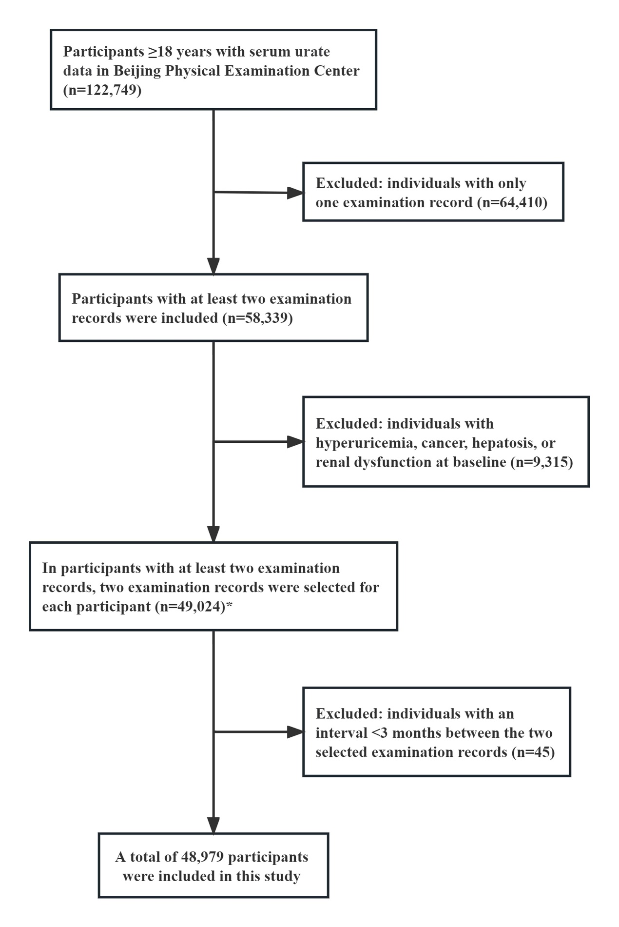

**Supplementary Fig. S1** Flow chart of the study

**\***The selection criteria for two examination records for each participant are as follows: 1. Participants with only two examination records have both records included. 2. For participants with more than two examination records: a) If hyperuricemia is absent in all examination records, then the first and last examination records are chosen. b) If hyperuricemia is diagnosed in any of the follow-up examination records, then the first examination record and the earliest one with hyperuricemia diagnosis are selected.

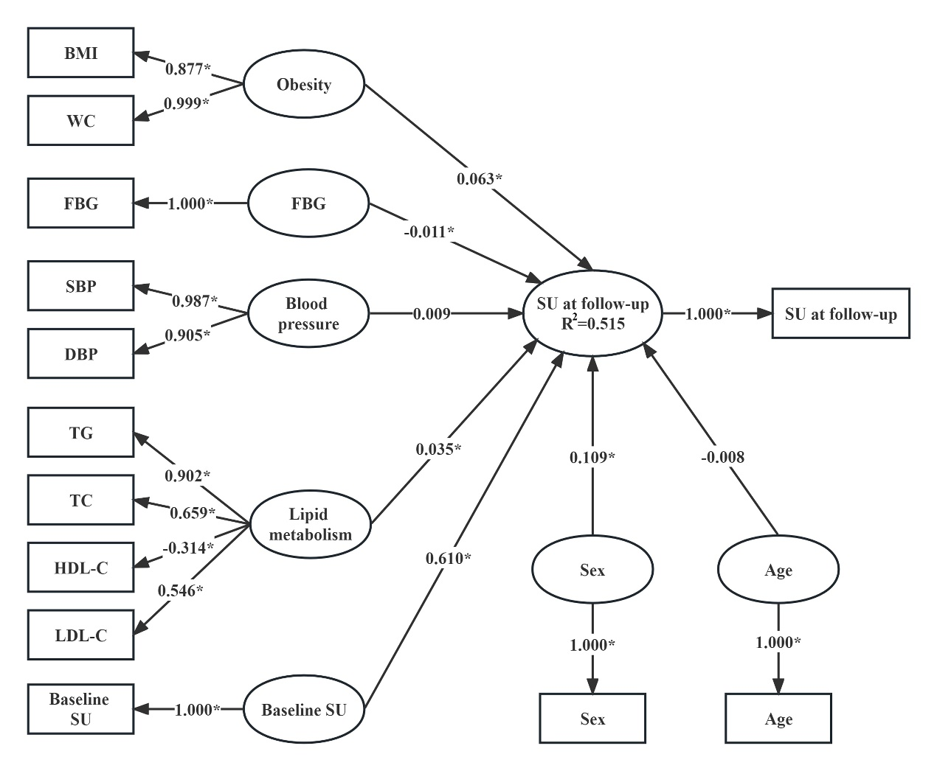

**Supplementary Fig. S2** Association between SU concentrations at follow-up and baseline metabolism-related risk factors when using the cut-offs founded in the URRAH project (>5.1 mg/dL for females and >5.6 mg/dL for males) to define hyperuricemia (n=33,130)**†**

**†**Variables in the rectangle are observed variables, those in the ellipse are latent variables. Apart from SU at Follow-up, which was measured at follow-up, the other observed variables were measured at baseline. The coefficients between the latent variable “SU at follow-up” and other latent variables are the path coefficients (*β* coefficients) and they represent the direction and strength of the relations between the latent response variable “SU at follow-up” and other latent predictors. The coefficients between the latent variables and the observed variables are the loadings (*λ* coefficients) and they represent in what direction and to what extent the observed variables reflect the latent variables. The R2 is the determination coefficient of the model where the latent "SU at follow-up" is the response variable and other latent variables are predictors, and it indicates the amount of variance in the latent response variable explained by its independent latent predictors.

\**p* <0.05

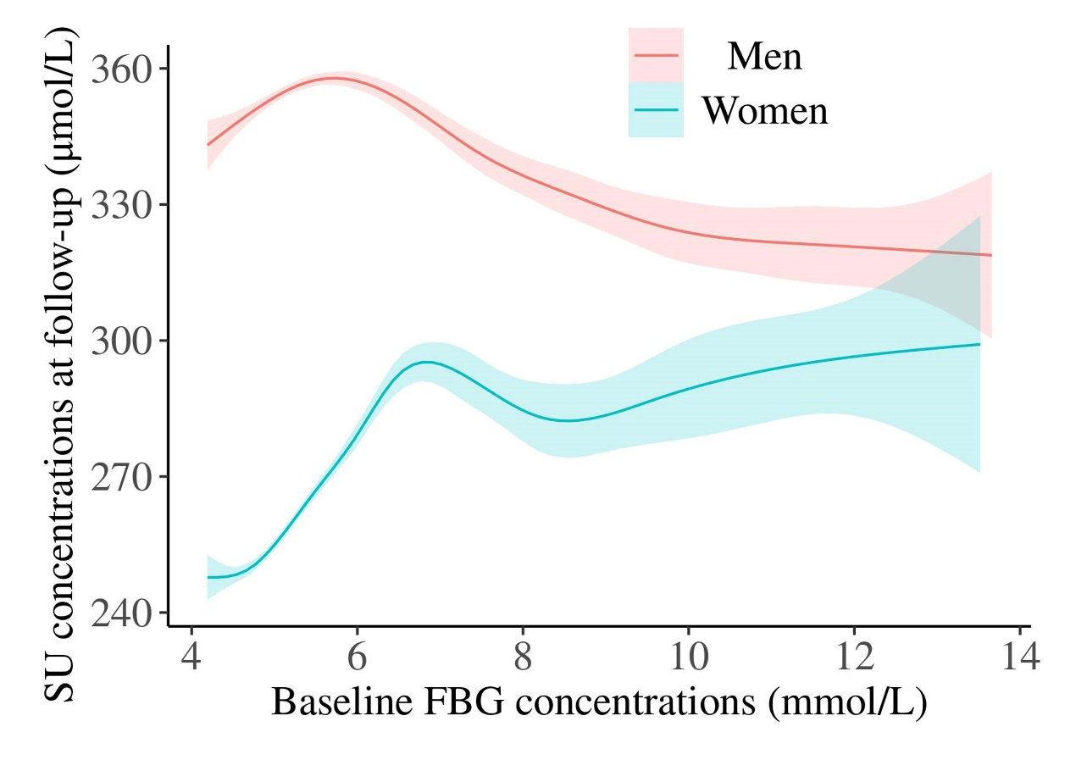

**Supplementary Fig. S3** The sex-specific relationships between SU concentrations at-follow and baseline FBG concentrations. The solid lines represent the point estimates and the shaded areas indicate 95% confidence intervals.

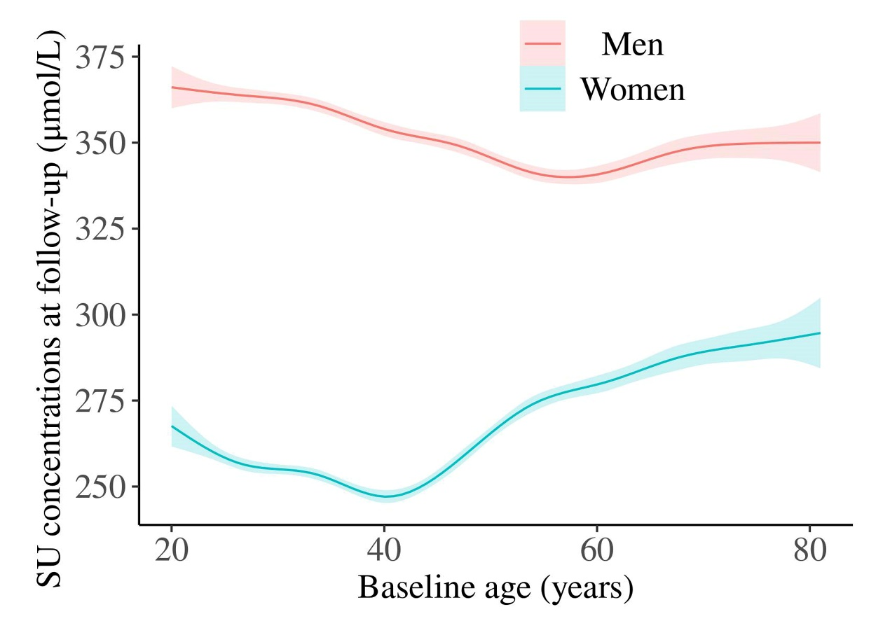

**Supplementary Fig. S4** The sex-specific relationships between SU concentrations at-follow and baseline age. The solid lines represent the point estimates and the shaded areas indicate 95% confidence intervals.