Supplementary Material

Rats did not show preference for exploring the necessary cue for solving a later problem: Absence of prospective information-seeking?

Sumie Iwasaki*, Tohru Taniuchi

**\* Correspondence:** Sumie Iwasaki: siwasaki623@staff.kanazawa-u.ac.jp

# Supplementary Figures

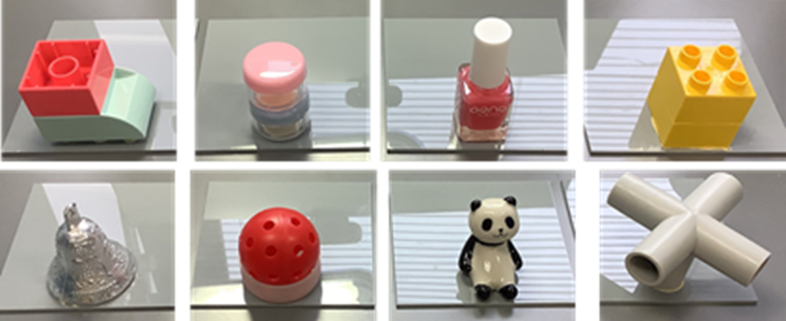

**Supplementary Figure 1.** Objects used as cues for locating food rewards.



**Supplementary Figure 2.** The difference in duration of time spent in the two areas in Experiment 2 (a), where cue objects were present in both areas for the information-seeking phase, and in Experiment 3 (b), where a cue object was present in the memory area only.