Supplementary Material
Widespread dominance of methane ebullition over diffusion in freshwater aquaculture ponds
Renske J.E. Vroom*, Sarian Kosten, Rafael M. Almeida, Raquel Mendonça, Ive S. Muzitano, Icaro Barbosa, Jonas Nasário, Ernandes S. Oliveira Junior, Alexander S. Flecker, Nathan Barros
* Correspondence: Corresponding Author: renske.vroom@ru.nl

Supplementary Figures and Tables
For more information on Supplementary Material and for details on the different file types accepted, please see here.

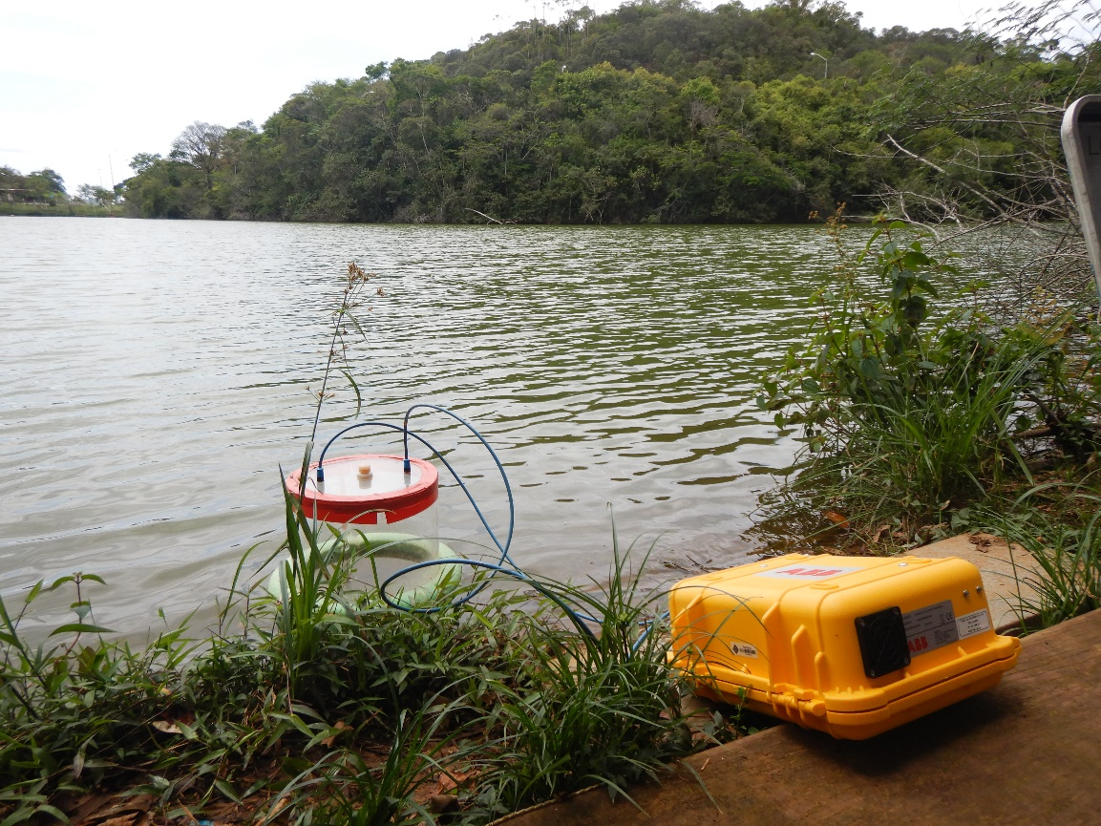
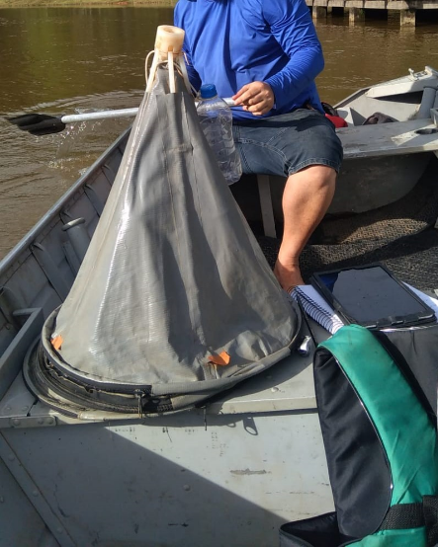
Supplementary Figures

Supplementary Figure 1. CH₄ measurement equipment. Left: floating chamber connected with gastight tubing to a portable greenhouse gas analyzer (yellow box). Right: ebullition trap with a plastic bottle attached for buoyancy. The bottom is open, and glass bottle could be screwed on the white top after submersion to collect the bubbles.

Supplementary Tables
Table S1. Characteristics of fishponds assessed in this study.
Pond nr | Type | Species | Goal | Area (m²) | Depth (m) | Miscellaneous
1 | Excavated earthen | Tilapia, armored catfish | Breeding, research | 511.27 | 0.4
2 | Excavated earthen | Tilapia | Breeding, research | 744.74 | 0.2
3 | Excavated earthen | Grass carp, Tilapia, Astyanax | Breeding, research | 623.99 | 0.7
4 | Excavated earthen | Tilapia | Breeding, research | 357.53 | 0.5
5 | Excavated earthen | Tilapia | Breeding, research | 554.12 | 0.7
6 | Excavated earthen | Tilapia, Astyanax | Breeding, research | 600.85 | 0.4
7 | Excavated earthen | No fish | Breeding, research | 376.35 | 0.6
8 | Excavated earthen | Grass carp | Breeding, research | 621.12 | 0.2
9 | Excavated earthen | Tilapia | Breeding, research | 555.95 | 0.5
10 | Excavated earthen | Tilapia | Breeding, research | 580.98 | 0.4
11 | Excavated earthen | Tilapia | Breeding, research | 521.18 | 0.4
12 | Excavated earthen | Tilapia | Commercial | 459.62 | 0.5
13 | Excavated earthen | Tilapia | Commercial | 460.65 | 0.6
14 | Excavated earthen | Tilapia | Commercial | 331.55 | 0.4
15 | Excavated earthen | Tilapia | Commercial | 349.97 | 0.55
16 | Excavated earthen | Tilapia | Commercial | 699.6 | 0.5
17 | Excavated earthen | Tilapia | Commercial | 477.5 | 0.7
18 | Excavated earthen | Tilapia | Commercial | 320.8 | 0.55
19 | Natural | Tilapia | Commercial | 4470.56 | 0.55
20 | Natural | Tilapia | Commercial | 2658.22 | 0.6
21 | Natural | Tilapia, Astyanax, Pearl cichlid, Hoplias | Commercial | 984.59 | 0.6 | Tilapia in mesh cages, rest of fish wild in pond
22 | Excavated earthen | Tilapia | Commercial | 466.65 | 0.8
23 | Excavated earthen | Tilapia | Recreation | 650.92 | 1.4
24 | Excavated earthen | Tilapia, Pacu, tambaqui |  | 1354.13 | 0.6
25 | Excavated earthen | Tilapia, Hoplias, Pacu, Leporinus macrocephalus, Oscar | Recreation | 1911.5 | 0.4
26 | Excavated earthen | Tilapia, Pacu, Spotted sorubim | Commercial | 2009.6 | 0.5
28 | Excavated earthen | Tilapia | Sustenance, recreation | 258.79 | 0.4
29 | Excavated earthen | Tilapia | Sustenance | 111.39 | 0.4
30 | Excavated earthen | Tilapia | Commercial, sustenance | 460.05 | 0.6
31 | Excavated earthen | Unknown |  | 224.88 | 0.4
32 | Excavated earthen | Unknown |  | 2775.54 | 0.25
33 | Natural | Tilapia, Wild species |  | 6378.49 | 1 | Tilapia in mesh cages, rest of fish wild in pond
34 | Excavated earthen | Unknown |  | 4214.75 | 0.5
35 | Excavated earthen | Tilapia, Hoplias, Pearl cichlid, Astyanax |  | 82.79 | 0.25
36 | Excavated earthen | Tilapia, Hoplias, Pearl cichlid, Astyanax |  | 68.79 | 0.25
37 | Excavated earthen | Tilapia, Hoplias, Pearl cichlid, Astyanax |  | 107.74 | 0.2
38 | Excavated earthen | Tilapia, Hoplias, Pearl cichlid, Astyanax |  | 80.02 | 0.5
39 | Excavated earthen | Tilapia, Hoplias, Pearl cichlid, Astyanax |  | 310.64 | 0.2
40 | Excavated earthen | Tilapia, Hoplias, Pearl cichlid, Astyanax |  | 1807.9 | 0.45
41 | Excavated concrete | Tilapia, Dourado, Loricariidae, Astyanax | Commercial | 369.01 | 0.15 | Pond was drained during ebullition measurements
42 | Natural | Unknown |  | 1587.94 | 0.5
43 | Excavated earthen | Unknown |  | 268.71 | 0.2
44 | Excavated earthen | Tilapia, Hoplias, Loricariidae, Pearl cichlid | Sustenance | 332.57 | 0.5
45 | Excavated earthen | Unknown | Breeding, research | 1142.2 | 1
46 | Excavated earthen | Tilapia | Breeding, research | 1024.47 | 0.6
47 | Excavated earthen | Tilapia | Breeding, research | 1041.25 | 0.35
48 | Excavated earthen | Unknown mix | Breeding, research | 1068.84 | 0.6
49 | Excavated earthen | Unknown | Breeding, research | 95.43 | 0.7
50 | Excavated earthen | Unknown | Breeding, research | 94.09 | 0.5
51 | Excavated earthen | Unknown | Breeding, research | 848.95 | 0.2
52 | Excavated earthen | Unknown | Breeding, research | 1034.94 | 0.2

