**Supplementary materials**

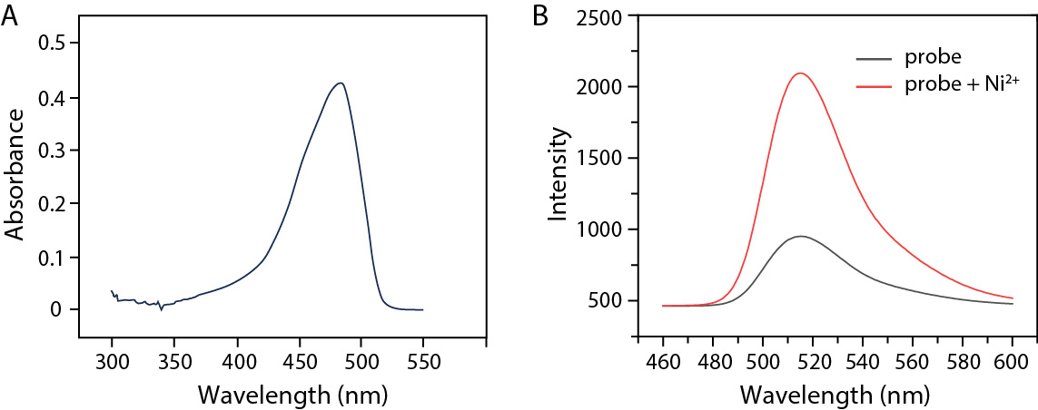

**Figure S1 Excitation and emission spectra of the probe**

A) The excitation spectra of the probe SSC-Ni (5 μM). The scanning range of the spectrum was 300-550 nm. B) The change of fluorescence intensity before and after adding 5 μM nickel ions in the test system, the probe and nickel ion were incubated at 25 ℃ for 12 h. λex = 450 nm, the emission range was 460-600 nm, slit widths: Wex = 4 nm, Wem = 4 nm.