Supplementary Material

Electronic supplementary material, linked to
The great tit abdominal stripe contains a sexually dichromatic colour patch hidden from the human eye

Authors: Miklós Laczi, Gábor Herczeg, Gyula Szabó, Helga Gyarmathy, Fanni Sarkadi, János Török, Gergely Hegyi

Supplementary Methods
Data collection and spectral measurements
In the territory establishment and pairing period (19th Jan-17th March), birds were captured using mist nets at a bird feeder baited with sunflower seed. During the later nestling feeding period (14th May-10th June), birds were captured in their artificial nest-boxes when their nestlings were 8-10 days old. Sex was determined according to Demongin (2016).
During reflectance sampling, we excluded ambient light from the sensor that was oriented perpendicular to the plumage surface. Each plumage part was spectrally sampled two times consecutively by removing and repositioning the sensor between the measurements. The detector (USB2000 spectrometer) we used here measures all components of reflectance (i.e. the mix of diffuse and specular reflectance). We used OOIBase32 software (Ocean Optics Europe). To get better signal-to-noise ratio, the ‘Boxcar’ function was set to 10, and there were 10 sequential scans (with 15 msec integration time of each scan) within a measurement, which were automatically averaged before saving the spectral recording. From the spectral curves (figure S1) we calculated only brightness (average intensity between 320-700 nm, R₃₂₀₋₇₀₀) and UV chroma (R₃₂₀₋₄₀₀ / R₃₂₀₋₇₀₀) as these black reflectance curves do not contain peaks or plateaus, hence these are the two main axes that represent the individual variation of the curves (see also in Hegyi et al. 2008). We estimated repeatability of spectral measurements using the ‘rptR v0.9.22’ package (Stoffel et al. 2017) in R 4.2.1 (R Development Core Team, 2016). For the pooled data set, Lessells–Boag’s repeatability estimates and CIs for brightness: 0.80 (0.76, 0.83); UVC: 0.87 (0.85, 0.89).

Settings of the visual models
We used the following settings for ‘vismodel’ in pavo2 package: ‘blue tit’ as visual system; all photoreceptors used to calculate achromatic stimulation; ‘D65’ as irradiance; ‘blue tit’ as ocular transmission spectrum; ‘Qi’ as quantal catch metric; ‘ideal’ as background spectrum; von Kries transformation allowed.
In ‘coldist’, we used the following settings for calculating chromatic contrast: ‘neural’ as noise calculation; ‘Qi’ as quantal catch metric; ‘1, 1.92, 2.68, 2.70’ as blue tit photoreceptor densities (Hart et al. 2000); ‘0.15, 0.15, 0.17, 0.20’ as Weber fractions from a recent blue tit study (Silvasti et al. 2021) for the two short, the medium and the long wavelength channels, respectively; and ‘0.1’ as Weber fraction for calculating achromatic contrast. Importantly, if parameters of the visual system and the changing light environments are not known exactly (like in our case), employing visual models to evaluate JNDs might lead to misleading results. Hence, to minimize this possibility, it has been suggested to use a conservative approach with regards to Weber fractions, namely to apply higher values instead of the commonly used 0.05 and 0.02 (Silvasti et al. 2021).

Supplementary Results
Results of within-individual across-season analyses of the great tit black stripe colouration.
We also conducted the across-seasons analyses with repeated measures from the few individuals that were captured in both seasons. The patterns were nearly exactly the same as those reported in the above section, the only difference being that some of the weakest significant interactions and main effects became marginally non-significant.
In more detail, for brightness, the three-way interaction between sex, season and patch was not significant (table S3). The interaction of season and patch was significant in males (F_{2,66}=5.88, P<0.01) and had less strong effect in females (F_{2,45}=2.80, P=0.07). Subsequently we ran separate tests of the same interaction for pairs of patches. In males, the season x patch interaction was significant for breast-throat (F_{1,44}=8.73, P<0.01) and breast-belly (F_{1,44}=5.17, P=0.03), but not for throat-belly comparison (F₁₄₄=0.87, P=0.36). Hence, independently of season, throat was darker than belly (main effect F_{1,45}=5.50, P=0.02). The breast had higher brightness than the other two areas, and the difference was weakened in spring (winter, breast-throat: F_{1,11}=46.72, P<0.001; breast-belly: F_{1,22}=23.28, P<0.001; spring, breast-throat: F_{1,22}=6.60, P=0.02; breast-belly: F_{1,22}=3.18, P=0.088). In females, the season x patch interaction was marginally significant for throat-belly comparison (F_{1,27}=4.01, P=0.055). The throat was darker in winter (main effect F_{1,9}= 7.57, P=0.02), but the difference disappeared in spring (main effect F_{1,9}= 1.96, P=0.20). The breast was darker than the throat (main effect: F_{1,28}=6.28, P=0.02) and belly (main effect: F_{1,28}= 8.85, P<0.01), with no seasonal change in these differences (interaction breast-throat: F_{1,27}= 2.45, P=0.13; breast-belly: F_{1,27}= 0.87, P=0.36).
For UV chroma, the sex x season x patch was not significant, and the only significant two-way interaction was between sex and patch (table S3), with a seasonal decline across sexes and patches (main effect of season in Table 1). The effect of patch was significant in both sexes (males: F_{2,57}=19.85, P<0.001; females: F_{2,47}=6.68, P<0.01). In males, breast UV chroma significantly differed from throat (F_{1,35}=35.42, P<0.001) and belly (F_{1,34}=19.41, P<0.001), and the difference was weaker between throat and belly (F_{1,35}=2.86, P=0.099). In females, the throat UV chroma was lower than in the other two areas (throat-breast: F_{1,29}=8.60, P<0.01; throat-belly: F_{1,28}=10.62, P<0.01), and there was no difference between the breast and the belly (F_{1,28}=0.00, P=0.99).

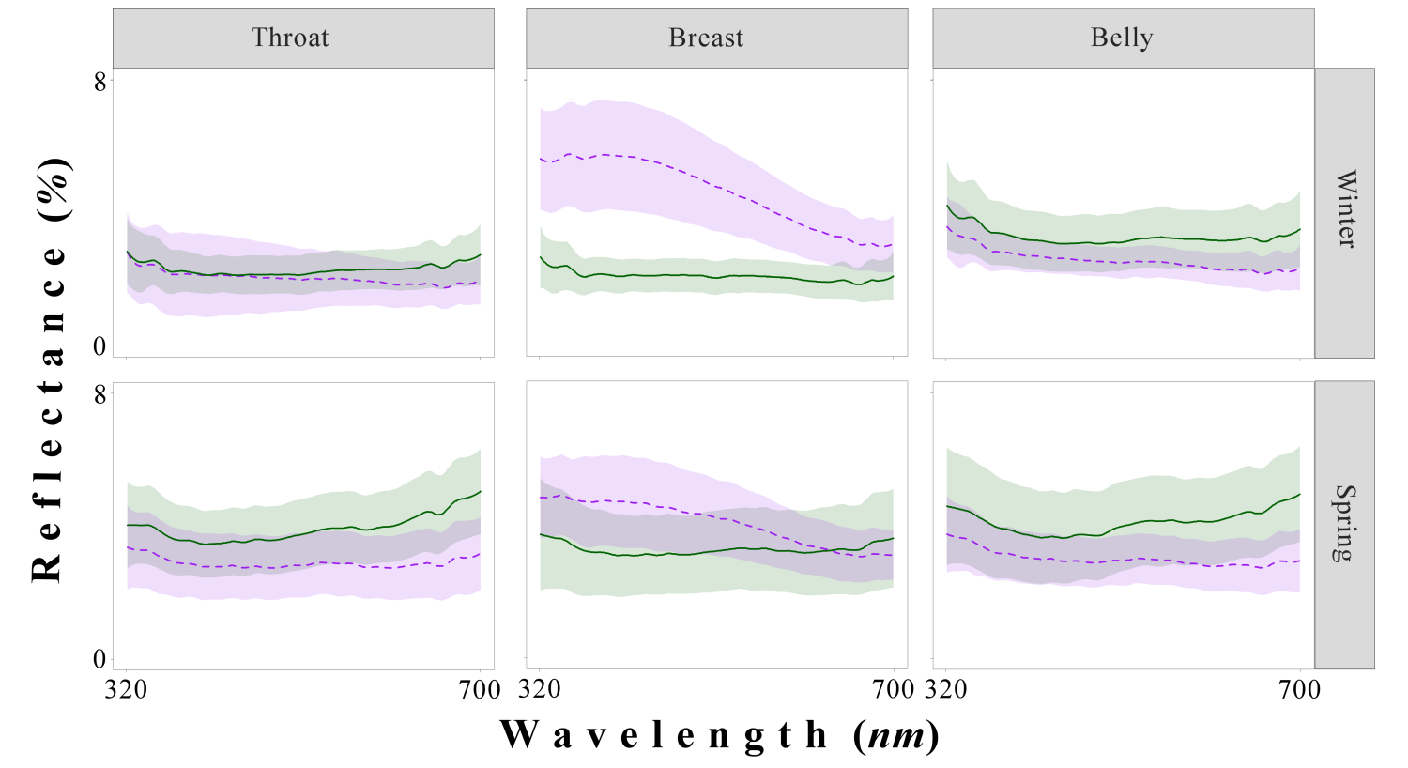
Figure S1. Averaged (±SD) reflectance curves of three segments of the abdominal black stripe of great tit females (solid green line) and males (dashed purple line) in the pairing period (winter) and the nestling feeding period (spring)

Table S1. Interactions between seasons, sexes and patch regions in great tits’ black stripe colouration. Individual identity (random factor) was included in all models (results not shown here).
Predictor | Brightness |  | UVC
 | F(df) |  | F(df)
Season | 65.44(1,365.86) | *** | 74.52(1,421.28) | ***
Sex | 0.00(1,252.01) |  | 213.98(1,319.72) | ***
Patch | 27.44(2,323.26) | *** | 88.02(2,309.74) | ***
Season x sex | 25.73(1,202.40) | *** | 0.02(1,251.51)
Season x patch | 10.80(2,323.26) | *** | 2.05(2,307.79)
Sex x patch | 96.46(2,323.26) | *** | 9.48(2,309.74) | ***
Season x sex x patch | 7.05(2,323.26) | ** | 1.68(5,342.61)
*P<0.05, **P<0.01, ***P<0.001

Table S2. Chromatic (colour) differences, based on visual model, between throat, breast, and belly in the abdominal black stripe of great tit females and males sampled in winter and spring, using a different parameterization in the ‘vismodel’, namely setting the Weber fraction of cones to 0.05. Values are presented in ‘just noticeable difference’ units, and value larger than 1 (in bold) suggest differences that possibly detectable by the birds’ visual system.

Focus | Patch1 | Patch2 | Chromatic
Patch | W♀1 | W♀2 | 2.12
Patch | W♀1 | W♀3 | 1.14
Patch | W♀2 | W♀3 | 1.29
Patch | W♂1 | W♂2 | 4.63
Patch | W♂1 | W♂3 | 0.63
Patch | W♂2 | W♂3 | 4.18
Patch | S♀1 | S♀2 | 1.72
Patch | S♀1 | S♀3 | 0.65
Patch | S♀2 | S♀3 | 1.29
Patch | S♂1 | S♂2 | 4.18
Patch | S♂1 | S♂3 | 0.88
Patch | S♂2 | S♂3 | 3.38
Sex | W♂1 | W♀1 | 2.61
Sex | W♂2 | W♀2 | 5.20
Sex | W♂3 | W♀3 | 2.03
Sex | S♂1 | S♀1 | 2.16
Sex | S♂2 | S♀2 | 4.61
Sex | S♂3 | S♀3 | 2.53
Season | W♀1 | S♀1 | 1.11
Season | W♀2 | S♀2 | 1.35
Season | W♀3 | S♀3 | 1.68
Season | W♂1 | S♂1 | 1.49
Season | W♂2 | S♂2 | 1.94
Season | W♂3 | S♂3 | 1.16
Notes. W=winter, S=spring; 1=throat, 2=breast, 3=belly.

Table S3. Interactions between seasons, sexes and patch areas in the colouration of the great tit black stripe at within-individual level.
Predictor | Brightness |  | UV chroma
 | F(df) |  | F(df)
Season | 18.65(1,102) | *** | 10.20(1,105) | **
Sex | 0.05(1,2) |  | 18.34(1,2) | ***
Patch | 3.14(2,102) | * | 21.42(2,105) | ***
Season x sex | 8.53(1,102) | ** | 0.00(1,104)
Season x patch | 5.46(2,2) | ** | 0.84(2,103)
Sex x patch | 22.50(1,102) | *** | 4.34(2,105) | *
Season x sex x patch | 2.49(2,2) |  | 0.56(5,100)
*P<0.05, **P<0.01, ***P<0.001

References
Demongin L. 2016 Identification guide to birds in the hand. Ain: Beauregard-Vendon
Hart NS, Partridge JC, Cuthill IC, Bennett ATD. 2000 Visual pigments, oil droplets, ocular media and cone photoreceptor distribution in two species of passerine bird: the blue tit (Parus caeruleus L.) and the blackbird (Turdus merula L.). J. Comp. Physiol. A 186, 375-387.
Hegyi G, Szigeti B, Laczi M, Eens M, Török J. 2008 Correlated variation of colour between melanin and carotenoid pigmented plumage areas in great tits. Evol. Ecol. Res. 10, 559-574.
R Core Team. 2022 R: A language and environment for statistical computing. R Foundation for Statistical Computing, Vienna, Austria. URL: https://www.R-project.org/.
Silvasti SA, Valkonen JK, Nokelainen O. 2021 Behavioural thresholds of blue tit colour vision and the effect of background chromatic complexity. Vis. Res. 182, 46-57.
Stoffel MA, Nakagawa S, Schielzeth H. 2017 rptR: repeatability estimation and variance decomposition by generalized linear mixed-effects models. Methods Ecol. Evol. 8, 1639-1644.

