Online repository. Figure E1
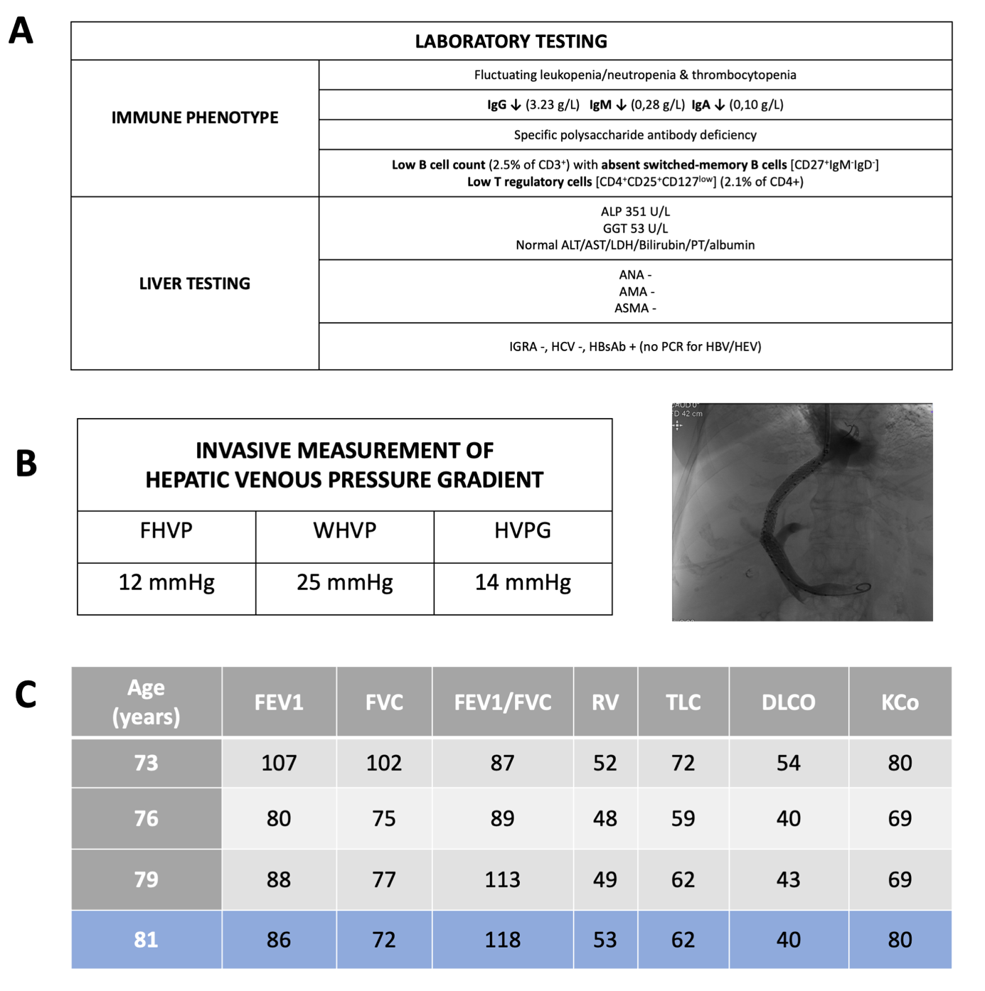
A) Main immunological and hepatic laboratory findings at diagnosis (positive anti-HBs antibodies possibly secondary to passive transfer with IVIG therapy); B) results of invasive hepatic venous pressure gradient measurement (pre-TIPS) and periprocedural fluoroscopic image of transjugular intrahepatic portosystemic shunt (TIPS); C) Sequential lung function testing (shown as percentage of predicted value), post-treatment testing is marked in blue.
Abbrevations: ALP = alkaline phosphatase, GGT = gamma-glutamyltransferase, ALT = alanine transaminase, AST = aspartate transaminase, LDH = lactate dehydrogenase, PT= prothrombin time, ANA = antinuclear antibody, AMA = antimitochondrial antibody, ASMA = anti-smooth muscle antibody, IGRA= interferon gamma release assay, HbsAb = hepatitis B surface antibody, FHVP = free hepatic venous pressure, WHVP = wedged hepatic venous pressure, HVPG = hepatic venous-portal gradient, FEV1 = forced expiratory volume during the first second, FVC = forced vital capacity, RV = residual volume, TLC = total lung capacity, DLCO = diffusing capacity for carbon monoxide, KCo = carbon monoxide transfer coefficient.

Online repository, Table E1: Overview of articles reporting on the use of rituximab for the treatment of CVID-related inflammatory complications (in chronological order)
 | Type of publication | Year | Total no. of patients | No. of patients treated with RTX | Indication for RTX | RTX regimen | Concomittant immune suppressants | RTX-related complications | Effect on comorbidities | Reported liver involvement | Reported effect on liver disease | Reference (PMID)
1 | Case Report | 2005 | 1 | 1 | ITP | 375 mg/m² IV weekly × 5 | dexamethasone 40mg 4d | / | + (ITP) | NRH with severe portal hypertension | NA | 16127007
2 | Case Report | 2006 | 1 | 1 | Autoimmune cytopenia | 375 mg/m² IV weekly × 4 | Corticosteroids | / | + (autoimmune cytopenia) | NA | NA | 16823831
3 | Case Report | 2007 | 1 | 1 | Autoimmune cytopenia | 375 mg/m² IV weekly, 1x | / | / | + (only ITP) | NA | NA | 17483248
4 | Case report | 2010 | 1 | 1 | ITP | 375 mg/m² IV weekly × 4 | / | NA | + (ITP) | NA | NA | 20635793
5 | Retrospective multicentre study | 2011 | 33 | 33 | Autoimmune cytopenia | Several regimens | NA | Severe infections (n = 8) of whom 4 were not on IVIG/SCIG | + (autoimmune cytopenia) | Cholestatic hepatitis (n = 1) | NA | 21981575
6 | Retrospective cohort | 2013 | 59 | 3 | GLILD | NA | Corticosteroids (n =1) | / | + (GLILD, lymphadenopathies) | Granulomatous liver disease (n = 3/59) | Partial remission (n =1) and complete remission (n = 1 of liver granulomatous disease | 22986767
7 | Retrospective multicentre study | 2013 | 45 | 5 | Autoimmune cytopenia | NA | corticosteroids, high-dose IVIG, splenectomy | NA | + (autoimmune cytopenia) | Undefined liver disease (n = 3/45*) | NA | 23480186
8 | Case Report | 2013 | 1 | 1 | ITP | 375 mg/m² IV weekly × 4 | no | Unmasking hypogammaglobulinemia with infections | + (ITP) | hepatosplenomegaly and hyperplasia on spleen biopsy | NA | 25213054
9 | Retrospective monocentre study | 2013 | 7 | 7 | GLILD | 375 mg/m² IV weekly × 4 | AZA, 6-MP, or MMF | / | + (GLILD, reduction in spleen size) | NA | NA | 22930256
10 | Orginal article | 2014 | 6 | 1 | GLILD | 375 mg/m² IV weekly | NA | / | + (GLILD) | NA | NA | 24131823
11 | Case Report | 2015 | 1 | 1 | GLILD, neuropthalmic sarcoidosis | 375 mg/m² IV weekly × 4, 6-monthly | AZA, prednisone | / | + (GLILD, intracranial lesion) | NA | NA | 25609323
12 | Case Report | 2016 | 1 | 1 | GLILD | 375 mg/m² IV weekly × 4, 4 to 6-monthly | IVIG, AZA | / | + (GLILD, ITP) | Ascites (SAAG > 1.1) | Reduction of ascites | 27335365
13 | Case Report | 2016 | 1 | 1 | ITP | NA | / | Severe bacterial infections (no IVIG/SCIG) | + (ITP) | NA | NA | 27276370
14 | Case Report | 2016 | 1 | 1 | Lymphoproliferative disease | 375 mg/m² IV weekly × 4 | NA | NA | + (Lympho-proliferative disease) | NA | NA | 27614471
15 | Case Report | 2017 | 1 | 1 | GLILD | 1g IV , 2x | MMF | / | + (GLILD, lymphadenopathy) | NA | NA | 27896807
16 | Abstract | 2018 | 1 | 1 | GLILD | 375 mg/m² IV weekly × 4, 6-monthly | NA | / | + (GLILD, ITP, splenic granulomas) | NA | Reduction in ALP | 30602282
17 | Case Report | 2019 | 2 | 2 | GLILD | Different regimens | NA | / | + (GLILD, lymphadenopathies) | NA | NA | 31060706
18 | Case Report | 2019 | 1 | 1 | GLILD | 375 mg/m² IV weekly × 4 | / | / | + (GLILD) | NA | NA | 31825316
19 | Original article | 2019 | 11 | 11 | GLILD | 375 mg/m² IV weekly × 4 | NA | / | + (GLILD) | NA | NA | 30843876
20 | Case Report | 2019 | 1 | 1 | GLILD | 375 mg/m² IV weekly, 6-monthly | AZA | / | + (GLILD) | NA | NA | 30984724
21 | Case Report | 2019 | 1 | 1 | GLILD | 375 mg/m² IV weekly, 3-weekly | / | Infections (pneumococcal, herpes zoster reactivation) | + (GLILD, decrease in spleen size) | NA | NA | 30713498
22 | Case series | 2019 | 3 | 3 | GLILD | 375 mg/m² IV weekly × 4, 6-monthly | / | / | + (GLILD) | 1 patient with 'NASH' | NA | 30408616
23 | Retrospective - Monocentre study | 2021 | 39 | 39 | GLILD | 375 mg/m² IV weekly × 4, 6-monthly | AZA or MMF | Fatal septicemia (n = 1) | + (GLILD) | NRH (n = 7/39) | NA | 32745555
24 | Case Report | 2022 | 1 | 1 | GLILD | 375 mg/m² IV weekly × 4, 3-monthly | / | / | + (GLILD) | NA | NA | 34718215
For data collection, we performed a comprehensive literature search in the electronic database MEDLINE with the following search terms: “common variable immunodeficiency”, “CVID” and “rituximab”. Relevant references within the retrieved articles were evaluated and included if relevant. Red = articles reporting on liver involvement, Bold = articles reporting on the effect of rituximab on liver involvement
NA = not applicable or not reported
* unknown whether patients with reported liver disease were treated with rituximab

