**Appendix C - posters**

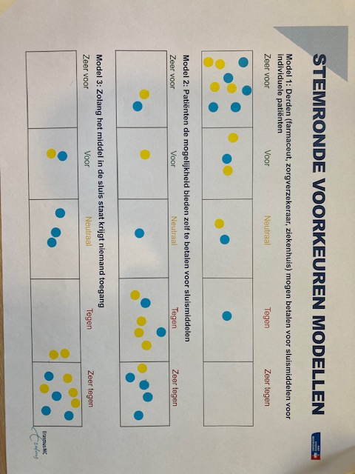

First round: blue, second round: yellow

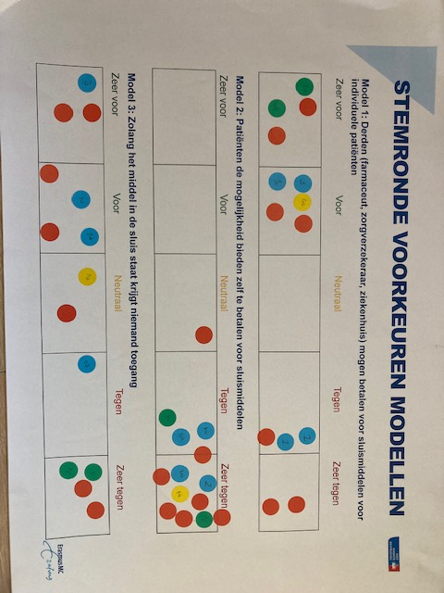

First round: green, blue and yellow, second round: red

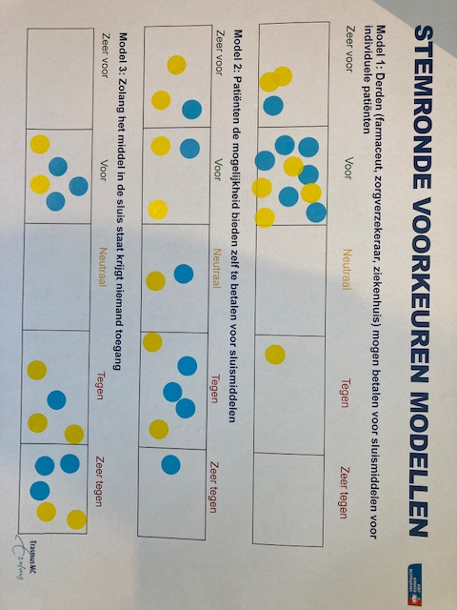

First round: blue, second round: yellow