Supplementary Material
- Introduction
The most commonly reported RSNs in the literature are shown with the brain regions involved and behavioural interpretations of the different RSNs shown in Table s1
RSN | Regions | Function
Lateral visual | Middle temporal visual association area at the temporal-occipital junction | Most important in complex (emotional) stimuli (e.g. viewing faces/films)
Medial visual |  | Simple visual stimuli (e.g. flickering checkerboard)
Occipital visual |  | High order visual stimuli (orthography)(1)
Sensorimotor network | Involves SMA/MCC, bilateral primary motor cortex, and bilateral middle frontal gyri | The sensorimotor network resembles the activations seen in motor and sensory tasks(2)
Dorsal attention network (DAN) | Involves the intraparietal sulcus, the junction of the precentral and superior frontal sulcus (frontal eyelids) | Orienting focus to a particular task(3), also involved in cognitive top-down processing, which involves factors such as knowledge, expectation and current goals(3)
Salience network | Involves fronto-insular and ACC with connections to the subcortical and limbic region | Implicated in orientation toward salient emotional stimuli, conflict monitoring, response choice, information integration, pain-related processes during acute stimulus-induced pain(4)
Temporal RSN | Involves inferior frontal gyrus, medial temporal gyrus, superior temporal gyrus | Involved in reading and language processing (5)
DMN | Involves precuneus, PCC, mesiofrontal/ACC and temporoparietal junction regions | Less active during task performance, compared with resting state, linked to self-related and internal process such as thoughts independent of any stimulus(6)
FPN | Involves frontal and parietal lobules and cingulate gyrus | FPN has been associated with different functions, i.e., executive function working memory, language, attention and visual processes(5).
Cerebellar network | Cerebellum | Associated with action and somesthesis (sense of touch, pressure, temperature, etc.)(1)
Executive control network (ECN) | Involves the medial frontal gyrus, superior frontal gyrus, and ACC | Involved in tasks relying on executive functions, such as control processes and working memory. (7).
Table s1. Different RSNs and their behavioural interpretation

- Results

ID | Disease phase | Sex | Age (years) | BMI (kg/m²) | Montreal | Smoking | Medication | MRE | Colonoscopy | disease duration | CRP | FCP | HBI | EIM
1 | A | M | 30 | 28 | A1L1B3 | Never | TH | Evidence of inflammatory disease |  | 15 | 5 | 30 | 8
2 | A | M | 20 | 19 | A2L1B1 | Never | AZA, |  |  | 3 | 5 | 1027 | 4
3 | A | M | 22 | 24 | A2L1B1 | Never | AZA, | Evidence of inflammatory disease |  | 5 |  |  | 3
4 | A | M | 30 | 29 | A1L1B3 | Never | TH ,INF, |  | Evidence of inflammatory disease | 17 |  |  | 5 | aphthous ulcers
5 | A | M | 44 | 33 | A2L1B2 | Unknown | INF, aminosalicylates | Evidence of inflammatory disease |  | 9 |  |  | 2 | Arthralgia
6 | A | M | 32 | 30 | A2L1PB2 | Unknown | TH, AD | Evidence of inflammatory disease |  | 14 |  | 574 | 8 | Arthralgia, erythema nodosum
7 | A | M | 63 | 27 | A2L3B1 | Ex-smoker |  |  | Evidence of inflammatory disease | 20 | 5 | 167 | 3
8 | A | F | 20 | 16 | A2L3B2 | Unknown | NIL |  | Evidence of inflammatory disease | 1 |  |  | 5 | Arthralgia, aphthous ulcers
9 | A | M | 28 | 19 | A2L1B1 | Unknown | Tacrolimus, |  | Evidence of inflammatory disease | 1 | 5 | 174 | 3
10 | A | M | 38 | 31 | A2L1B1 | Ex-smoker | AD, TH |  |  | 7 | 6 | 785 | 8 | uveitis
11 | A | F | 67 | 22 | A3L3B1 | Ex-smoker | MTX, | Evidence of inflammatory disease |  | 1 | 224 | 1800 | 8 | aphthous ulcers, abscess
12 | A | F | 38 | 27 | A2L3PB2 | Never | TH | Evidence of inflammatory disease | Evidence of inflammatory disease | 18 | 10 |  | 2 | Abscess
13 | A | M | 68 | 19 | A3L3B1 | Ex-smoker |  |  | Evidence of inflammatory disease. | 1 | 5 | 458 | 9
14 | A | M | 25 | 22 | A1L3B1 | Never | AD | Evidence of inflammatory disease | Evidence of inflammatory disease | 9 | 5 | 607 | 1
15 | A | F | 20 | 20 | A1L3PB1 | Never | INF |  |  | 8 | 25 |  | 0
16 | A | M | 18 | 22 | A1L2B1 | Unknown | TH |  |  | 6 | 5 | 1266 | 8
17 | A | M | 41 | 22 | A2L1B1 | Current | MTX, |  |  | 2 | 5 | 414 | 5
18 | A | F | 19 | 22 | A2L3B3P | Never | NIL |  | Evidence of inflammatory disease | 1 | 11 | 1800 | 1
19 | A | M | 25 | 30 | A2L3B3P | Never | TH | Evidence of inflammatory disease |  | 8 | 25 | 1800 | 2
20 | A | F | 24 | 22 | A1L2B1 | Never | AD |  | Evidence of inflammatory disease | 11 |  |  | 1
21 | A | F | 62 | 20 | A3L3B1 | Ex-smoker | AD, TH, | Evidence of inflammatory disease |  | 2 | 5 | 404 | 1
22 | A | F | 32 | 29 | A2L3B1 | Never | TH | Evidence of inflammatory disease | Evidence of inflammatory disease | 10 |  |  | 6 | Arthralgia
23 | A | F | 31 | 21 | A2L3PB1 | Unknown | Nil | Evidence of inflammatory disease |  | 10 | 5 | 194 | 6
24 | A | M | 41 | 19 | A2L2B2 | Never | AD, TH |  | Evidence of inflammatory disease | 7 | 5 | 434 | 1
25 | A | M | 18 | 23 |  |  | TH, Inf | Evidence of inflammatory disease |  | 1 | 27 | 18 | 0
Table s2 : Patient characteristics
A= ACTIVE DISEASE, M = MALE , F= FEMALE, EIM = EXTRAINTESTINAL MANIFESTATIONS, AD=ADALIMUMAB, AZA= AZATHIOPRINE INF=INFLIXIMAB, , MTX=METHOTREXATE, TH = THIOPURINE Montreal classification Age (A); A2=17-40 years, A3= over 40 years. Disease location (L); L1 terminal ileum, L2= colon, L3= ileocolon, L4= upper gastrointestinal tract (a perianal disease modifier may be added in the presence of perianal fistulas). Disease behavior (B); B1= non-stricturing non-penetration, B2= structuring, B3 penetrating

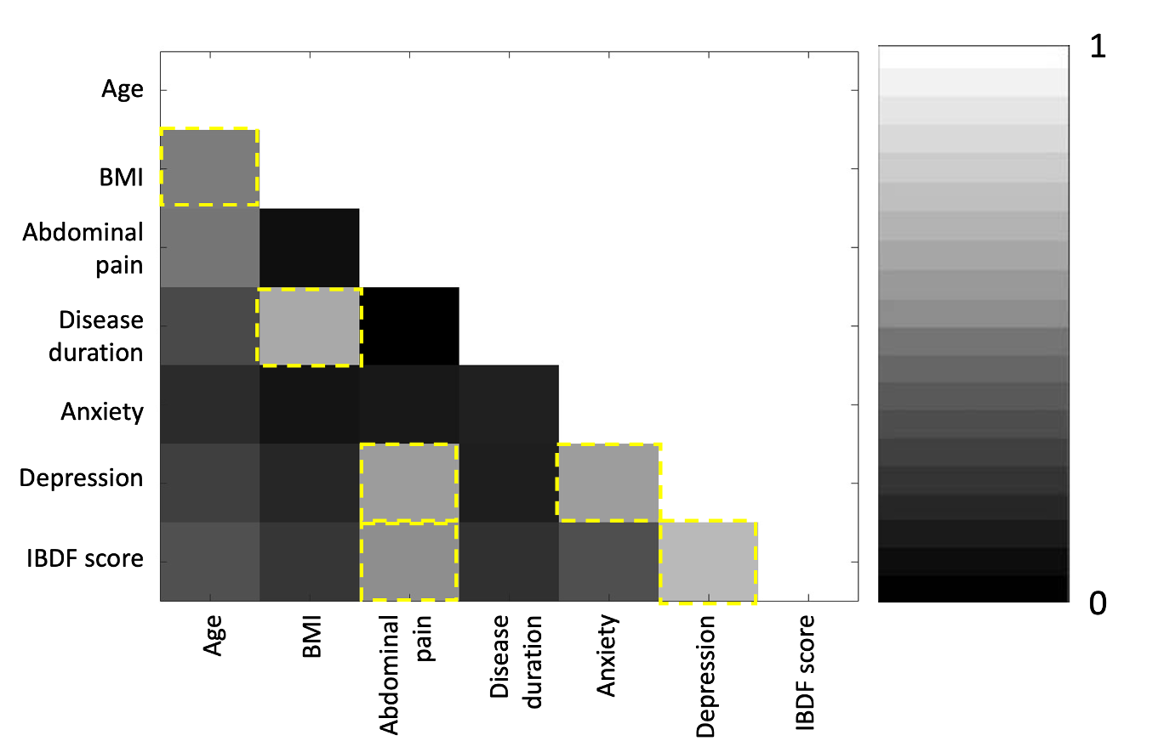
Figure s1. A heat map of the correlation between each of the clinical and behavioural variables. Yellow squares indicate a significant correlation.

