Supplementary Material

Protection against insect predation during fruit development: the role of fleshy fruit wings of three species of Zygophyllum in the cold desert of Central Asia
Kaiqing Xie^{1,2}, Juan Qiu², Jannathan Mamut^{1,2}, Yuting Li² and Dunyan Tan^{2*}
* Correspondence: Dunyan Tan: tandunyan@163.com

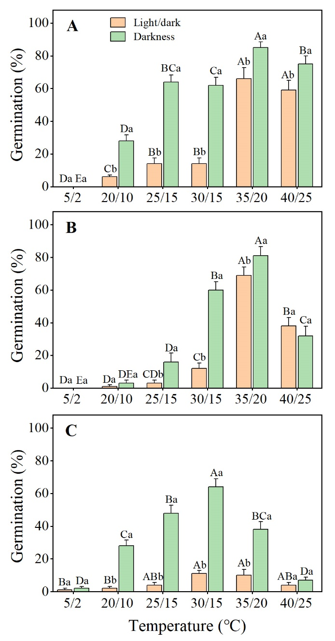
Supplementary Figure

Supplementary Figure 1. Germination percentages of fresh matured seeds in light and in darkness at six temperature regimes of the three Zygophyllum species (mean ± SE). (A) Z. potaninii, (B) Z. lehmannianum, (C) Z. macropterum. Bars with different uppercase letters indicate significant differences among different temperature regimes in light or in darkness and different lowercase letters indicate significant differences between in light and in darkness at the same temperature (P < 0.05).

