Supplementary Material

**Figure 1.** Schematic representation of the process of dendritic cell vaccinations (DCVs). DCVs have certain antigens that induce immune responses against cancer, including glioblastomas. Certain agents can improve the efficiency of the vaccines against glioblastoma. This image was created using BioRender.com. IL-2 = Interleukin 2, GM-CSF = Granulocyte-Macrophage Colony-Stimulating Factor,  IL-12 = Interleukin 12, TLR3 = Toll-Like Receptor 3, TLR7 = Toll-Like Receptor 7, TLR7/8 agonist = Toll-Like Receptor 7/8, EGFRvIII = Epidermal Growth Factor Receptor variant III, IL-13Ra2 = Interleukin-13 Receptor Alpha 2, HER2 = Human Epidermal Growth Factor Receptor 2, SOX2 = Sex-Determining Region Y-Box 2, MAGE-A1 = Melanoma Antigen Gene A-1, AIM2 = Absent in Melanoma 2, TRP-2 = Tyrosinase-Related Protein 2.

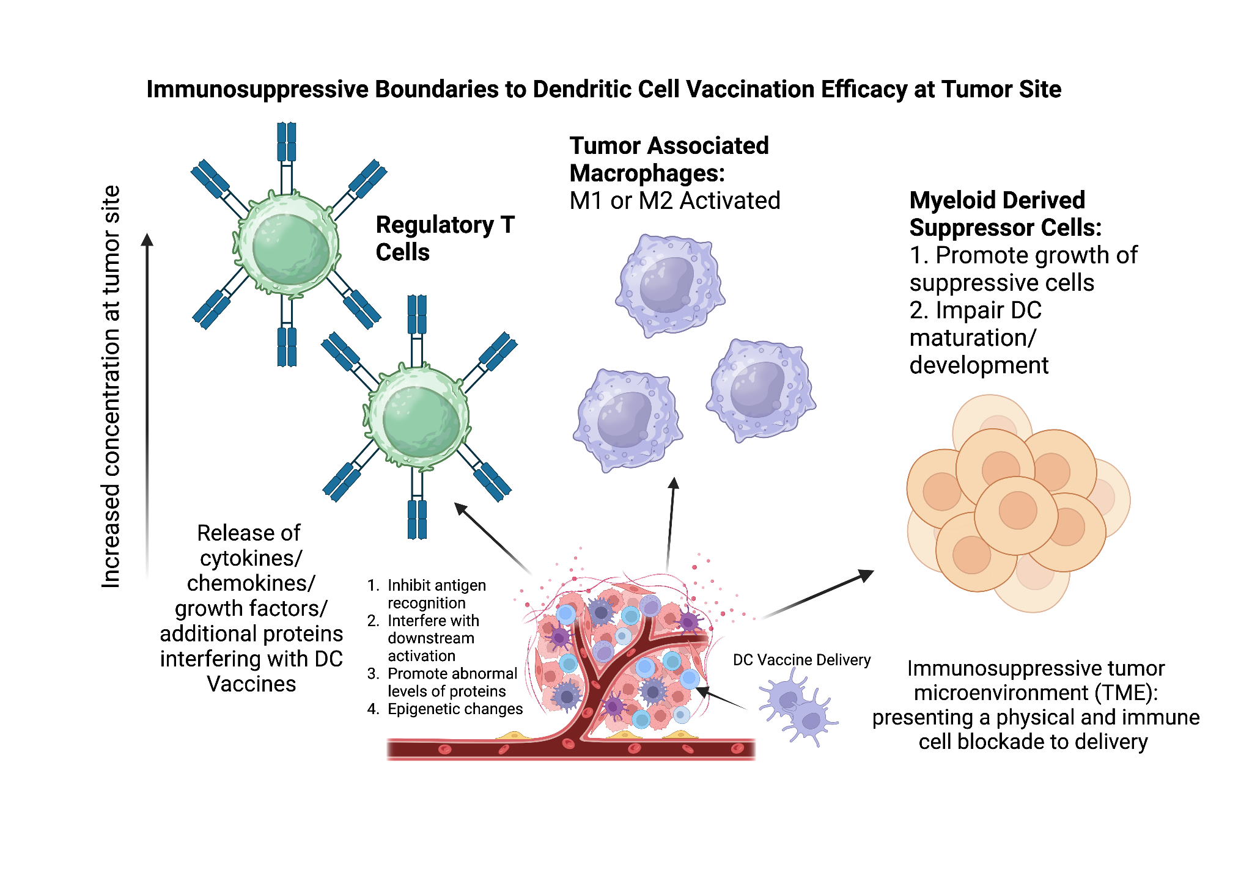

**Figure 2.** Immunosuppressive tumor microenvironment (TME) inhibits effectiveness of dendritic cell vaccination. TME growth results in abnormal concentrations of immunosuppressive cells including regulatory T cells, tumor associated macrophages, and myeloid derived suppressor cells. Created with Biorender.com.

**Table 1:** Randomized Controlled Trials of DCV Therapy for GBM

|  |  |  |  |  |  |  |  |  |  |
| --- | --- | --- | --- | --- | --- | --- | --- | --- | --- |
| **Trial** | **Phase** | **GBM** | **Control** | **TAA** | **Maturation** | **Site** | **Schedule | Dosing** | **mOS (m)†** | **PFS (m)†** |
| Cho et al. 2012 | II | 18  (18 nd) | 16 | Tumor lysate |  | SC | 4x weekly + 2x biweekly + 4x monthly | 20-50 x 106 cells | **31.9** | **8.5** |
| Jie et al. 2012 | II | 13  (13 nd) | 12 | Tumor lysate | TNFα, IL-1β, PGE2 | SC | 2x weekly + 2x biweekly | 6 x 10^6 cells | **17** |  |
| Yao et al. 2018 NCT01567202 | II | 22  (13 nd) | 21 | Glioma stem cell lysate |  | ID | 3x weekly | 2-3 x 106 cells | **13.7**1 | **7.7**1 |
| Buchroithner et al. 2018 (Audencel) NCT01213407 | II | 34  (34 nd) | 42 | Tumor lysate | IFNγ, LPS | IN | 4x weekly + 5x monthly + every 3 months up to 15 doses total | 1-5 x 106 cells | 18.8 |  |
| Wen et al. 2018 (ICT-107) NCT01280552 | II | 81  (81 nd) | 43 | MAGE-1, AIM-2, HER-2, TRP-2, gp100 and IL-13Ra2 | IFNγ, LPS | ID | 4 weekly + 4 monthly + every 6 months until tumor progression | 11 x 106 cells | 17 | **11.2** |
| Batich et al. 2020 NCT00639639NCT02366728 | II | 23  (23 nd) | 6 | CMVpp65 mRNA | TNFα, IL-1β, PGE2 | ID | 3x biweekly then monthly until tumor progression | 20 x 106 cells | **41.1 (GM-CSF), 41.4 (Td)** |  |
| Liau et al. 2023 NCT00045968 | III | 232 (232 nd) | 992 | Glioma stem cell lysate |  | ID | 3x every 10 days, 3x monthly, then evey 6 months | 2.6 x 106 cells | **19.3 (nd), 13.2 (r)** |  |

nd – newly diagnosed; r – recurrent; TAA – tumor-associated antigen; SC – subcutaneous; ID – intradermal; IN – intranodal; mOS – median overall survival; PFS – progression free survival; m – months;

† - **Bold** indicates statistically significant increase.

1Significant only after stratification for IDH1 and TERT promoter mutation status. Additionally, the study does not discriminate between newly diagnosed and recurrent GBM patients when reported survival results.

264 controls crossed over to receive vaccine after tumor recurrence and were analyzed as recurrent GBM patients. External controls were used for statistical analysis.

**Table 2:** Strategies for Optimization of Dendritic Cell Vaccination for Malignant Gliomas