**Supplement for**

Stability of potassium-promoted hydrotalcites for CO2 capture over numerous repetitive adsorption and desorption cycles

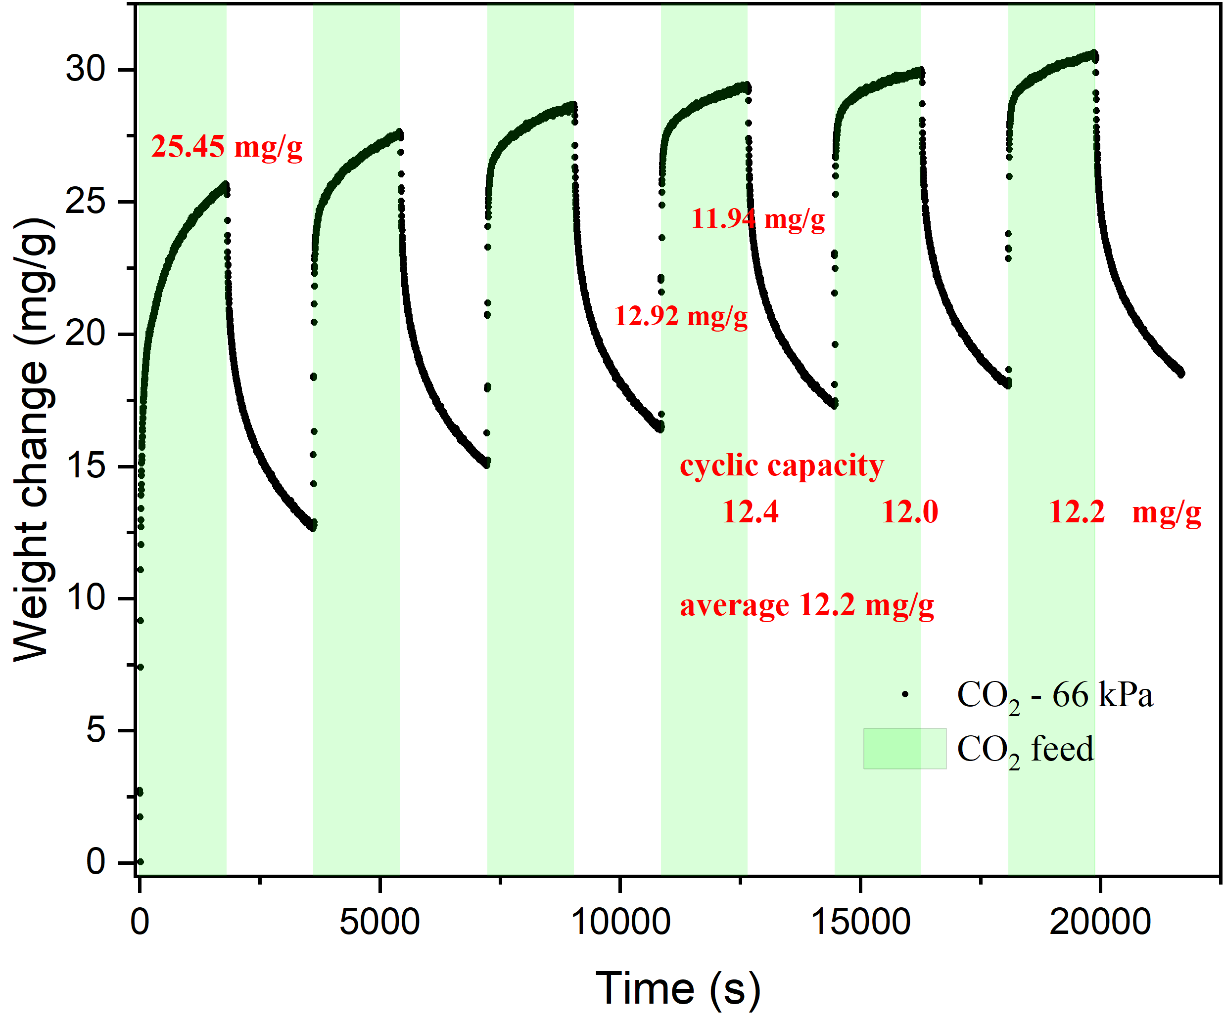

Fig. S1. Adsorption of CO2 at 400 °C and with dry (N2) regeneration.

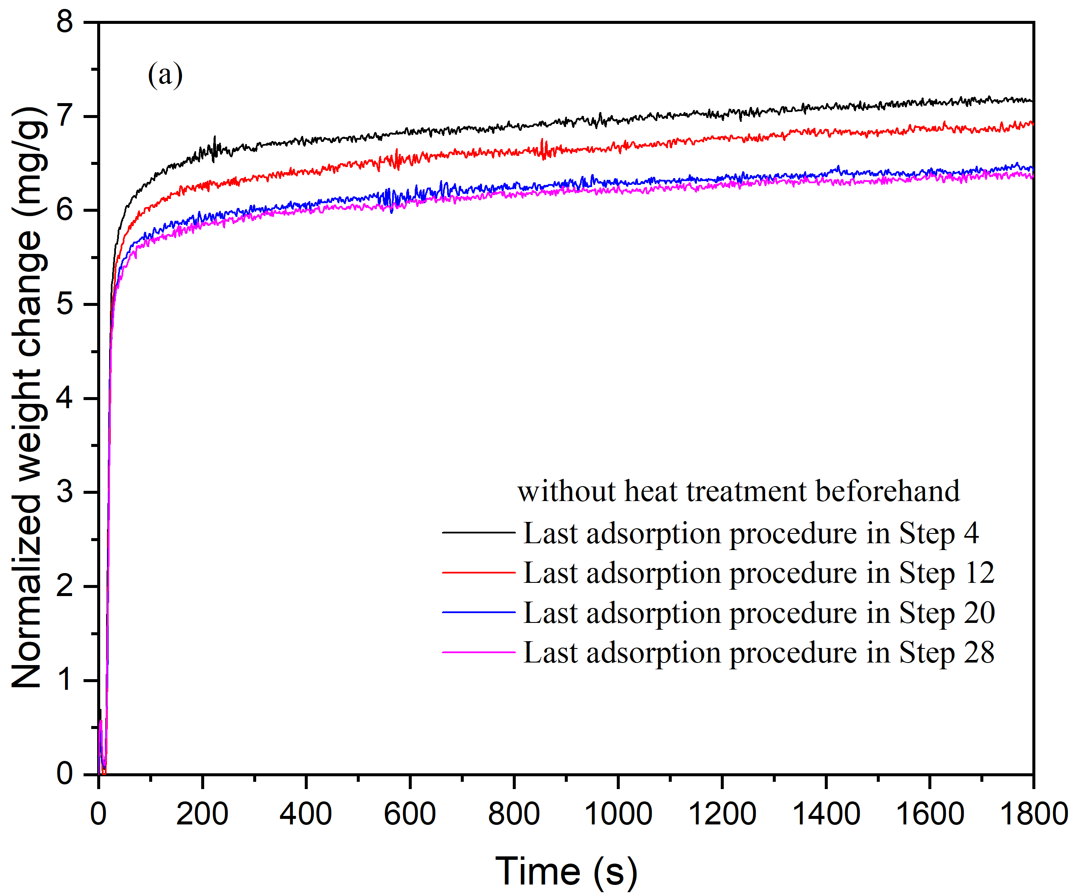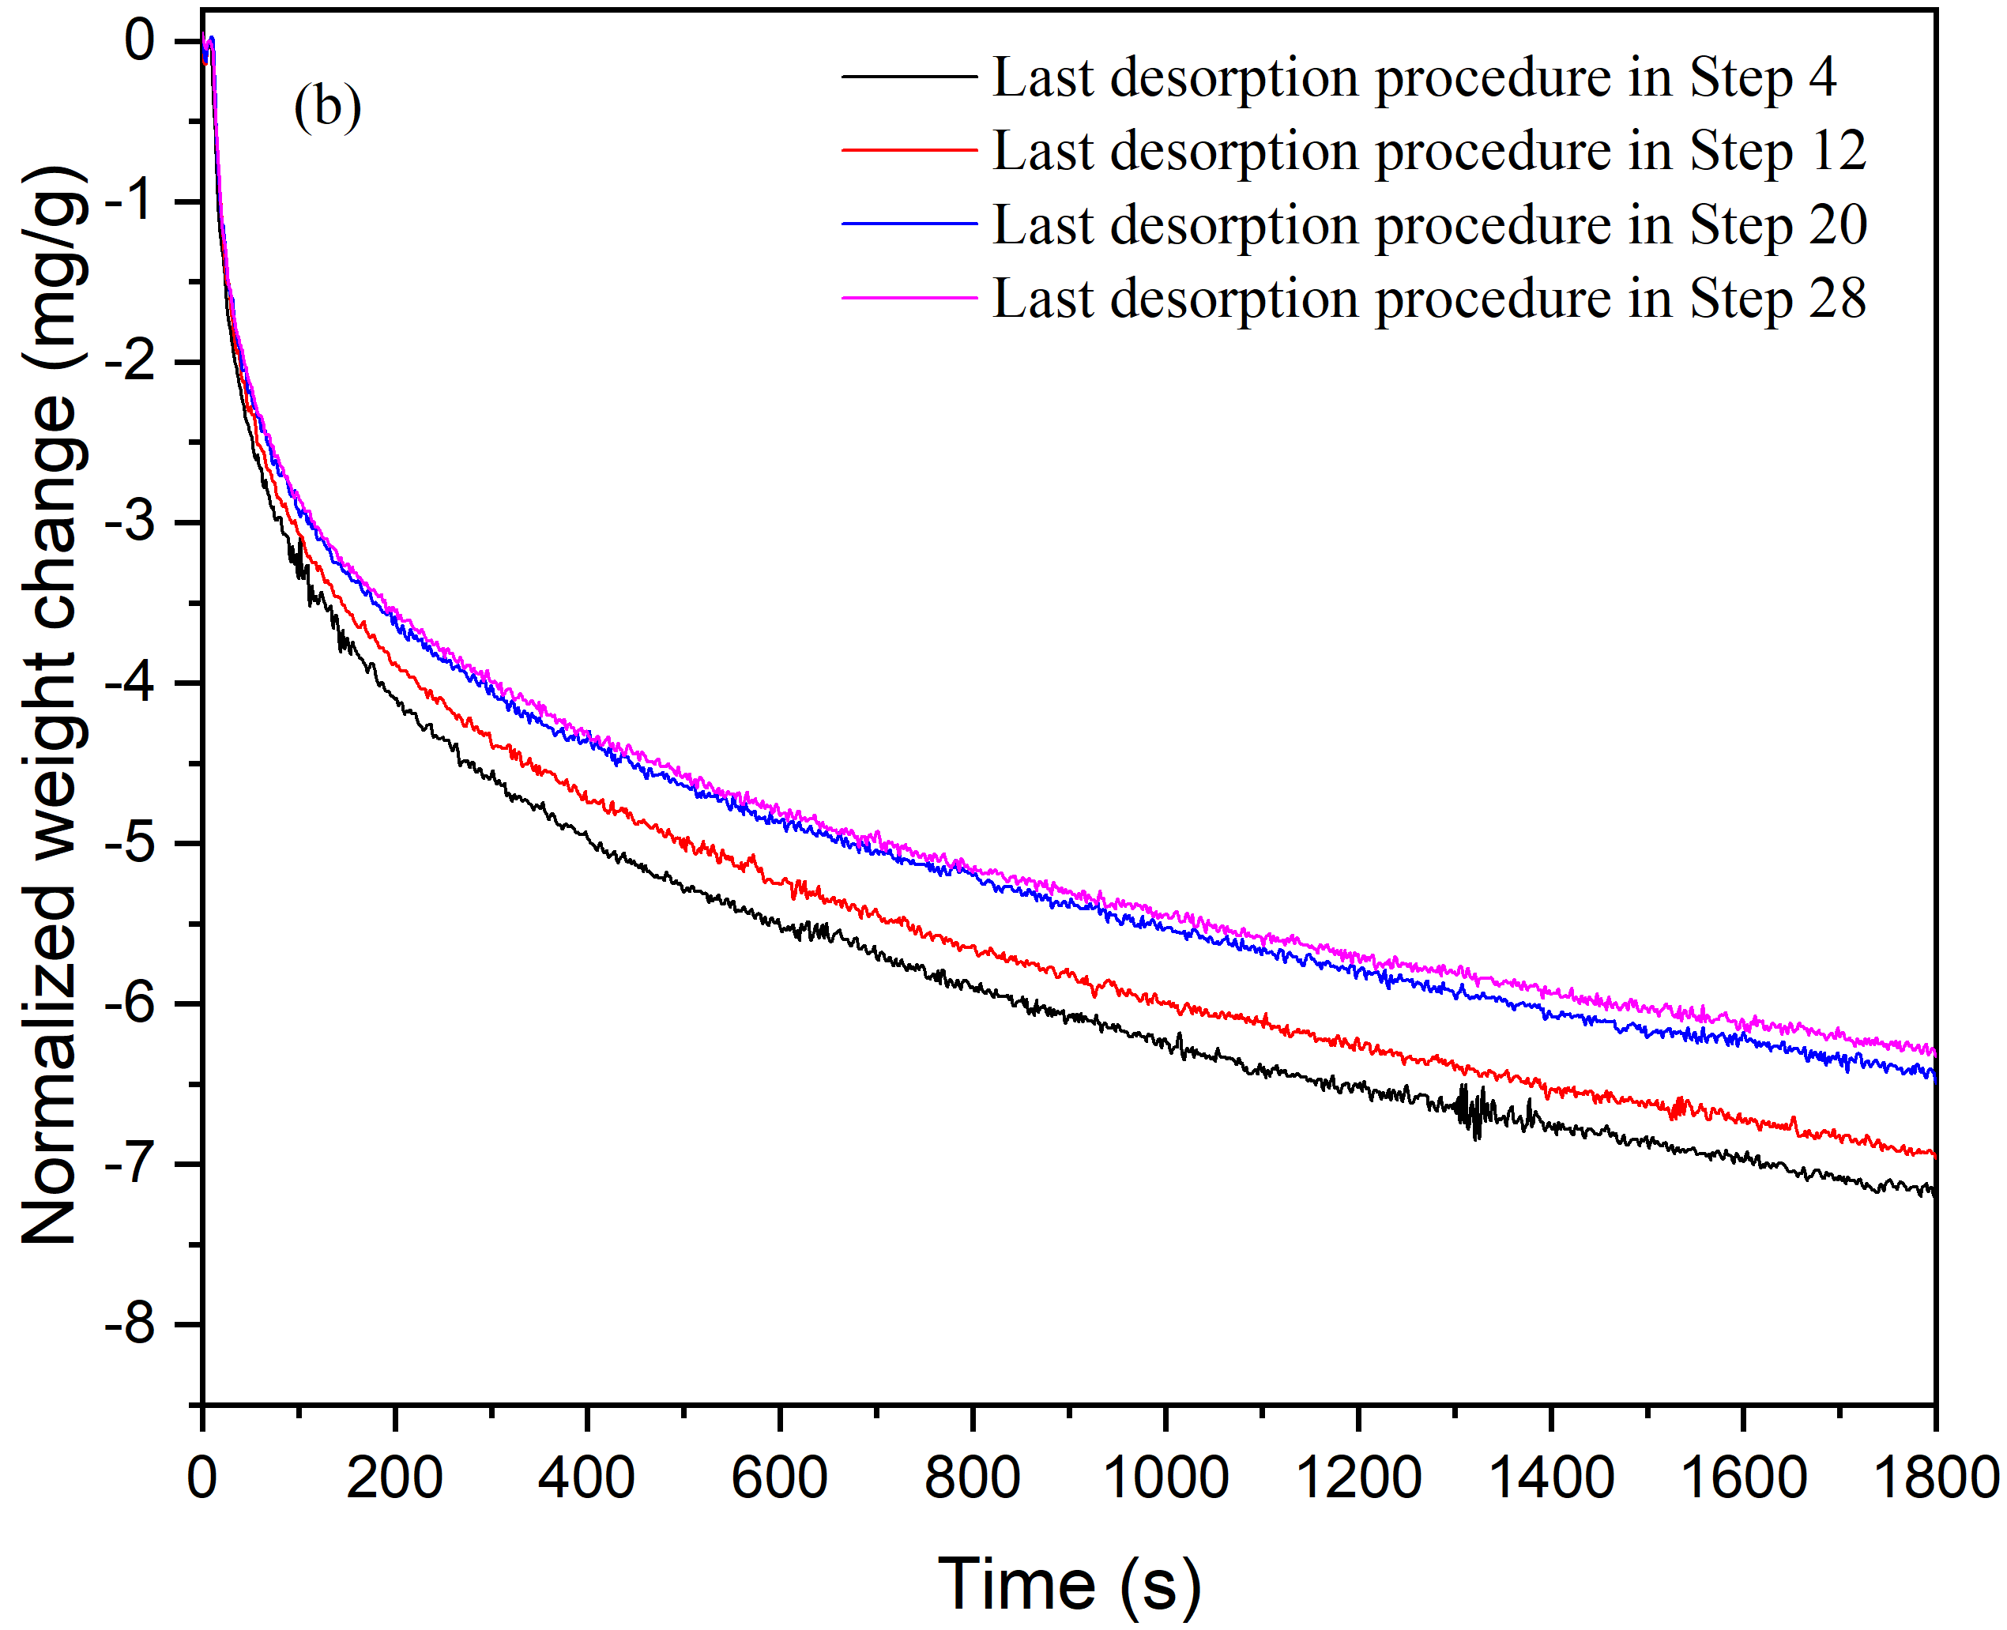

Fig. S2. (a) Adsorption kinetics of the last procedures at 400 °C in Steps 4, 12, 20 and 28 (Exp. 1 without heat treatment before the step starts). (b) Desorption kinetics of the last procedures at 400 °C in Steps 4, 12, 20 and 28 in Exp. 1.

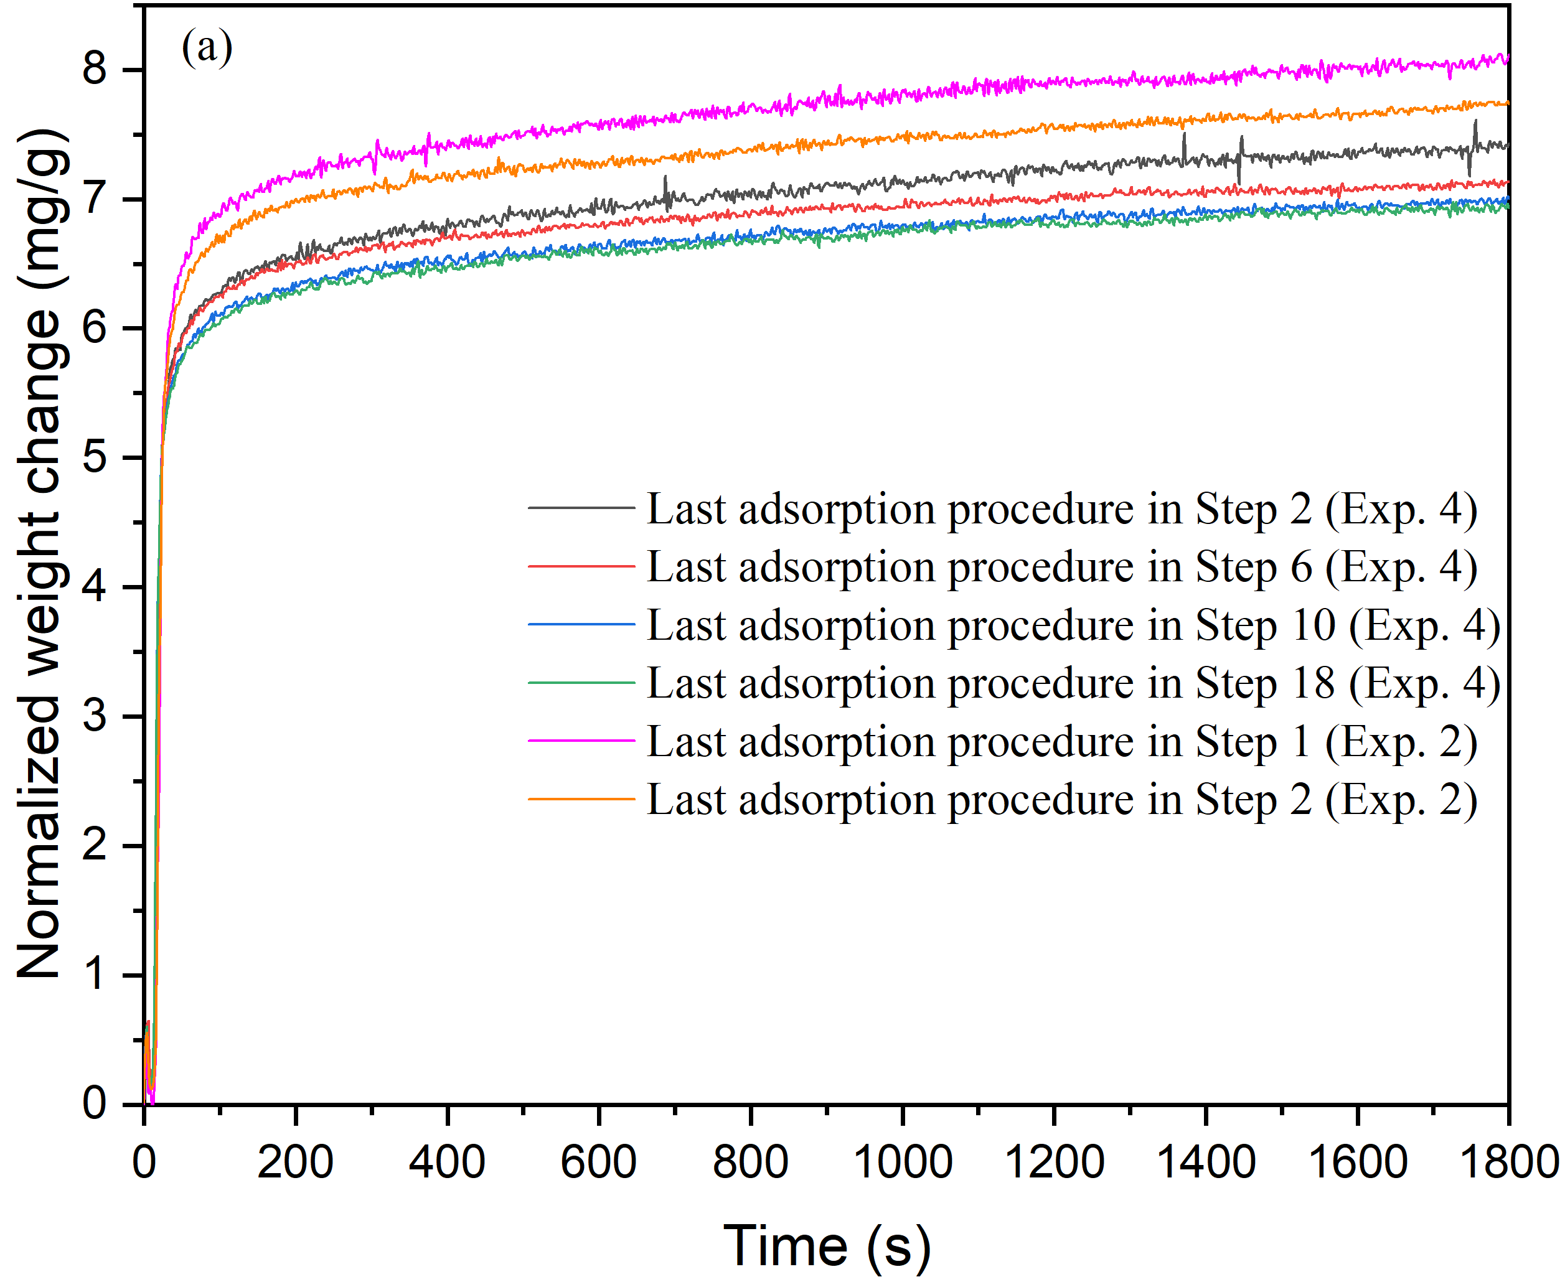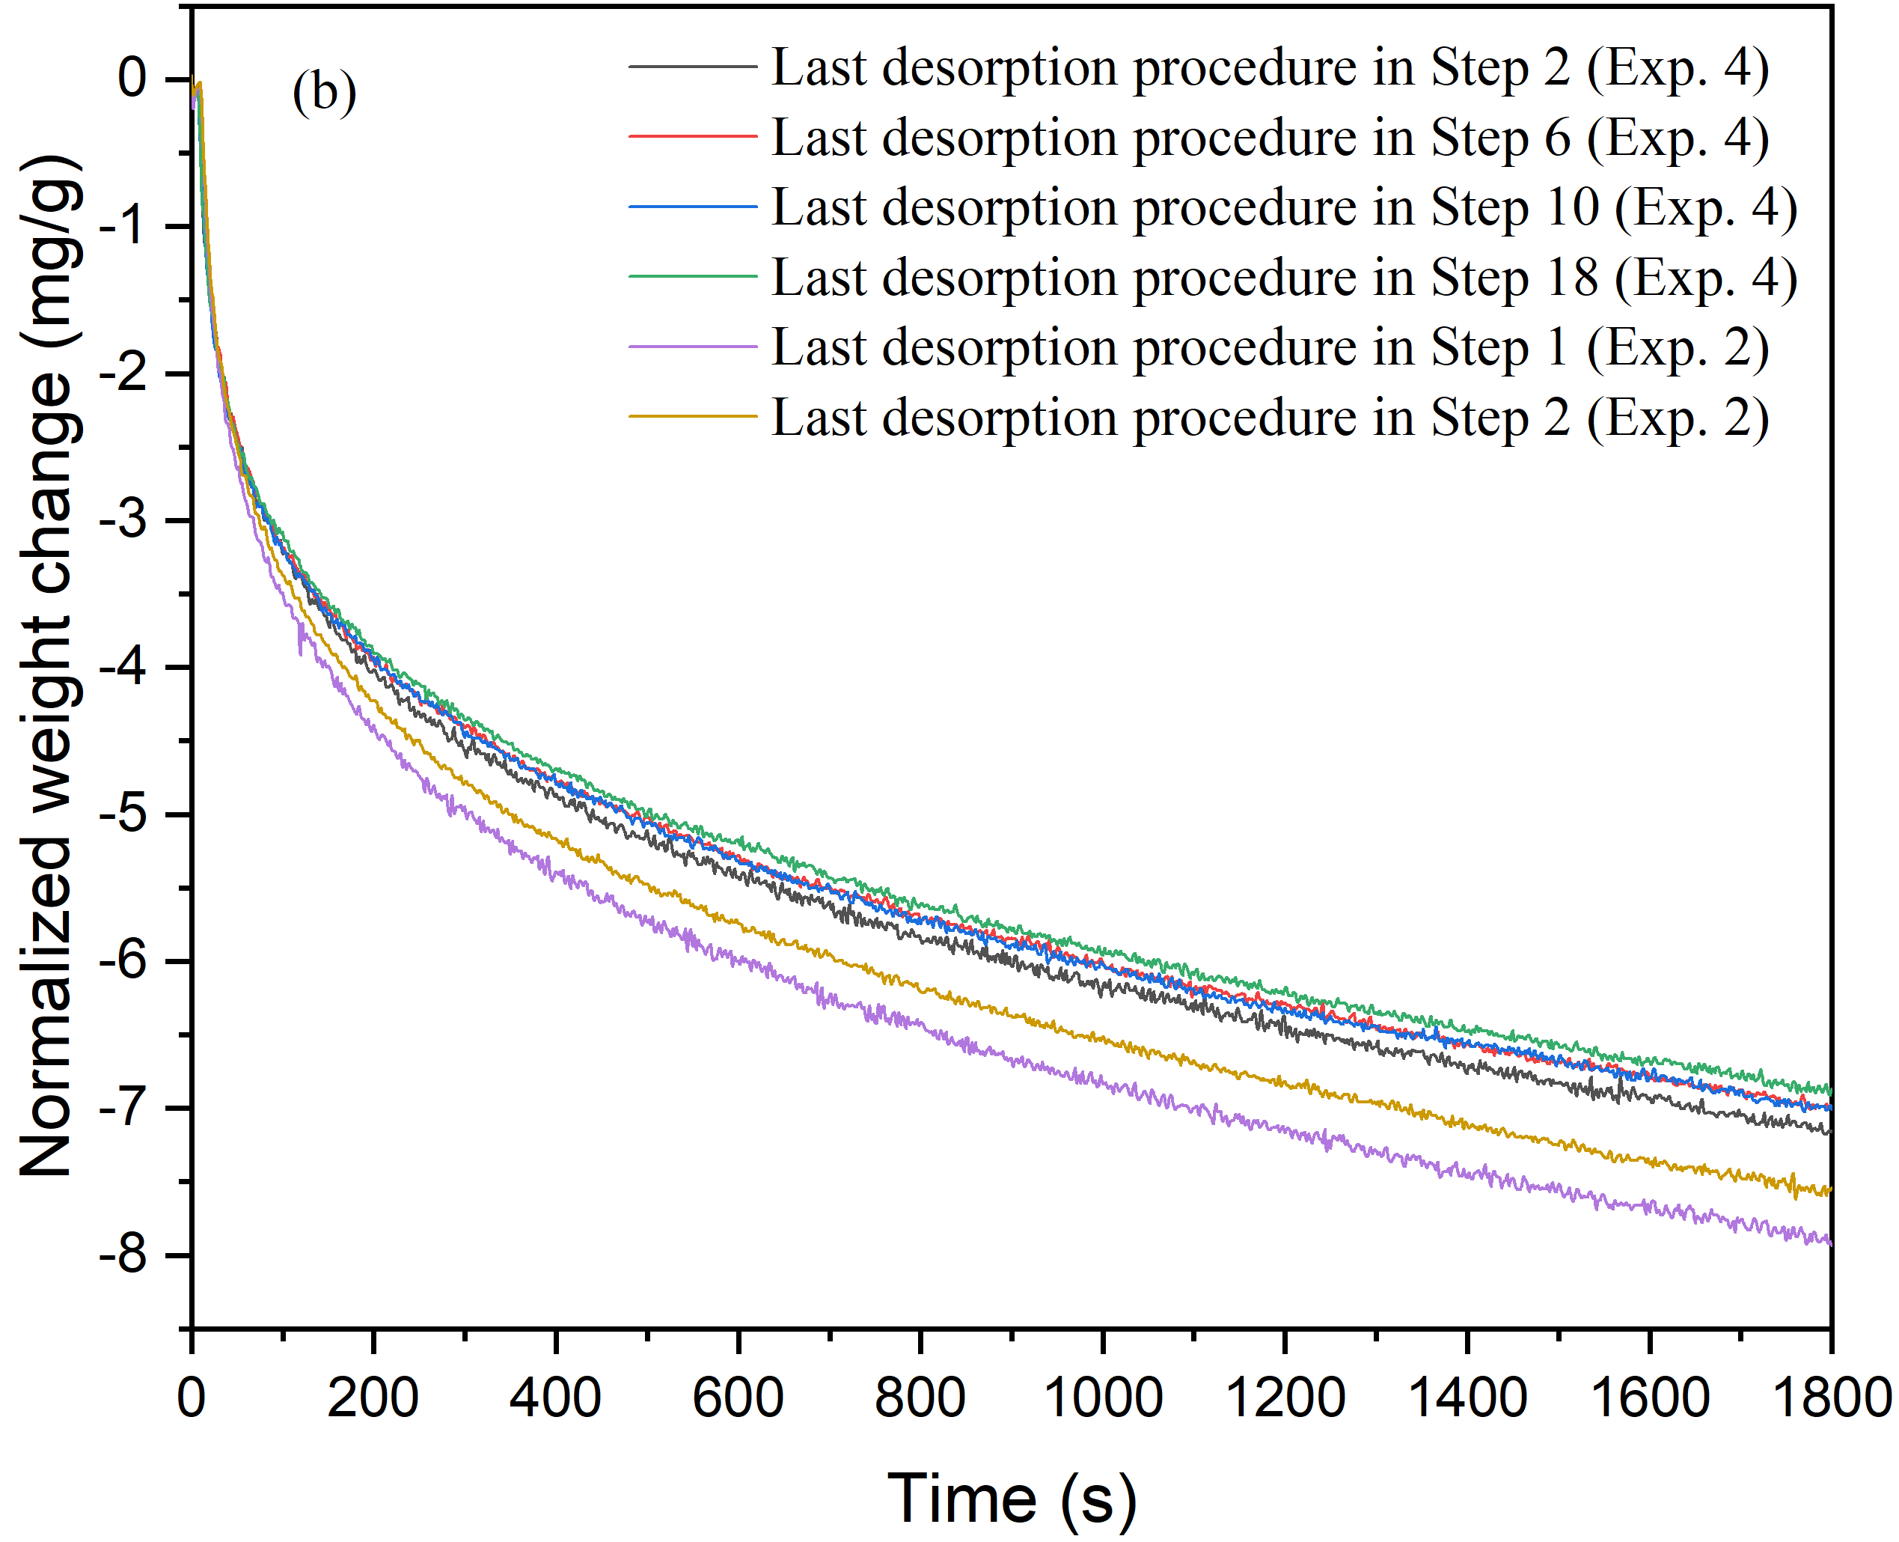

Fig. S3. Adsorption (subfigure (a)) and desorption (subfigure (b)) kinetics of the last procedures at 400 °C in Steps 2, 6, 10 and 18 from Exp.4 and in Steps 1 and 2 from Exp. 2.

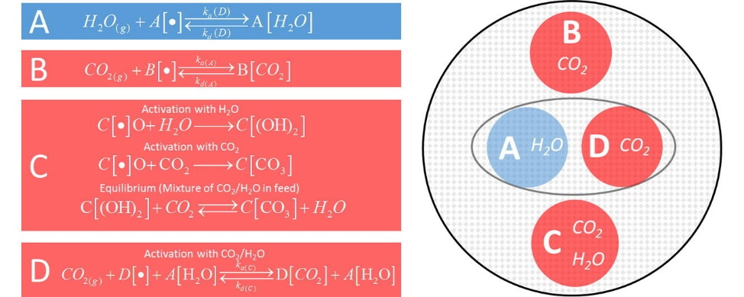

Fig. S4. Proposed model by Coenen et al.1 for CO2 and H2O adsorption on KGM30 at 400 °C.

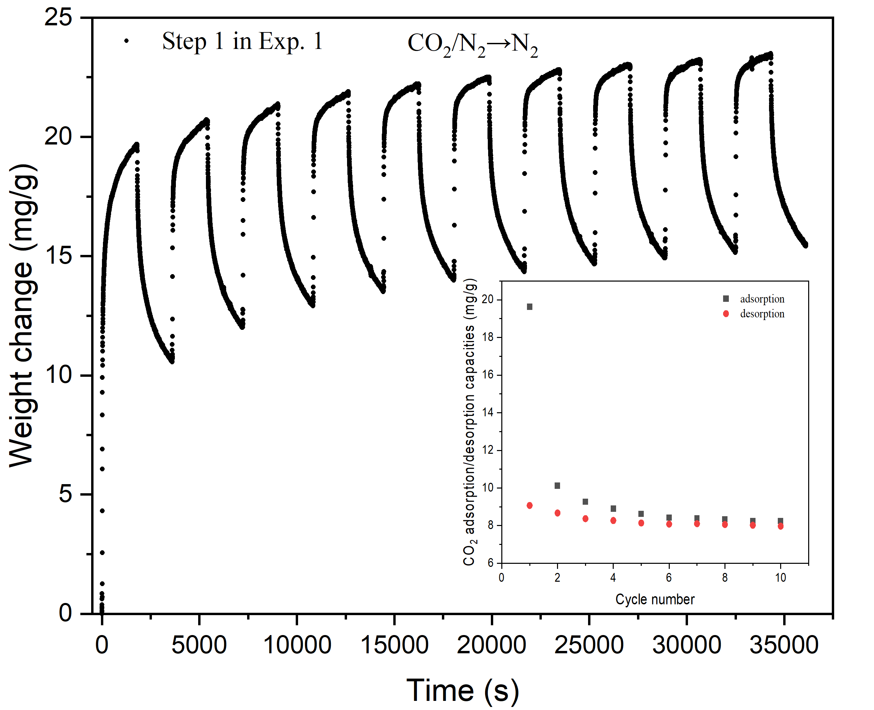

Fig. S5. Experimental results for the Step 1 in Exp. 1.

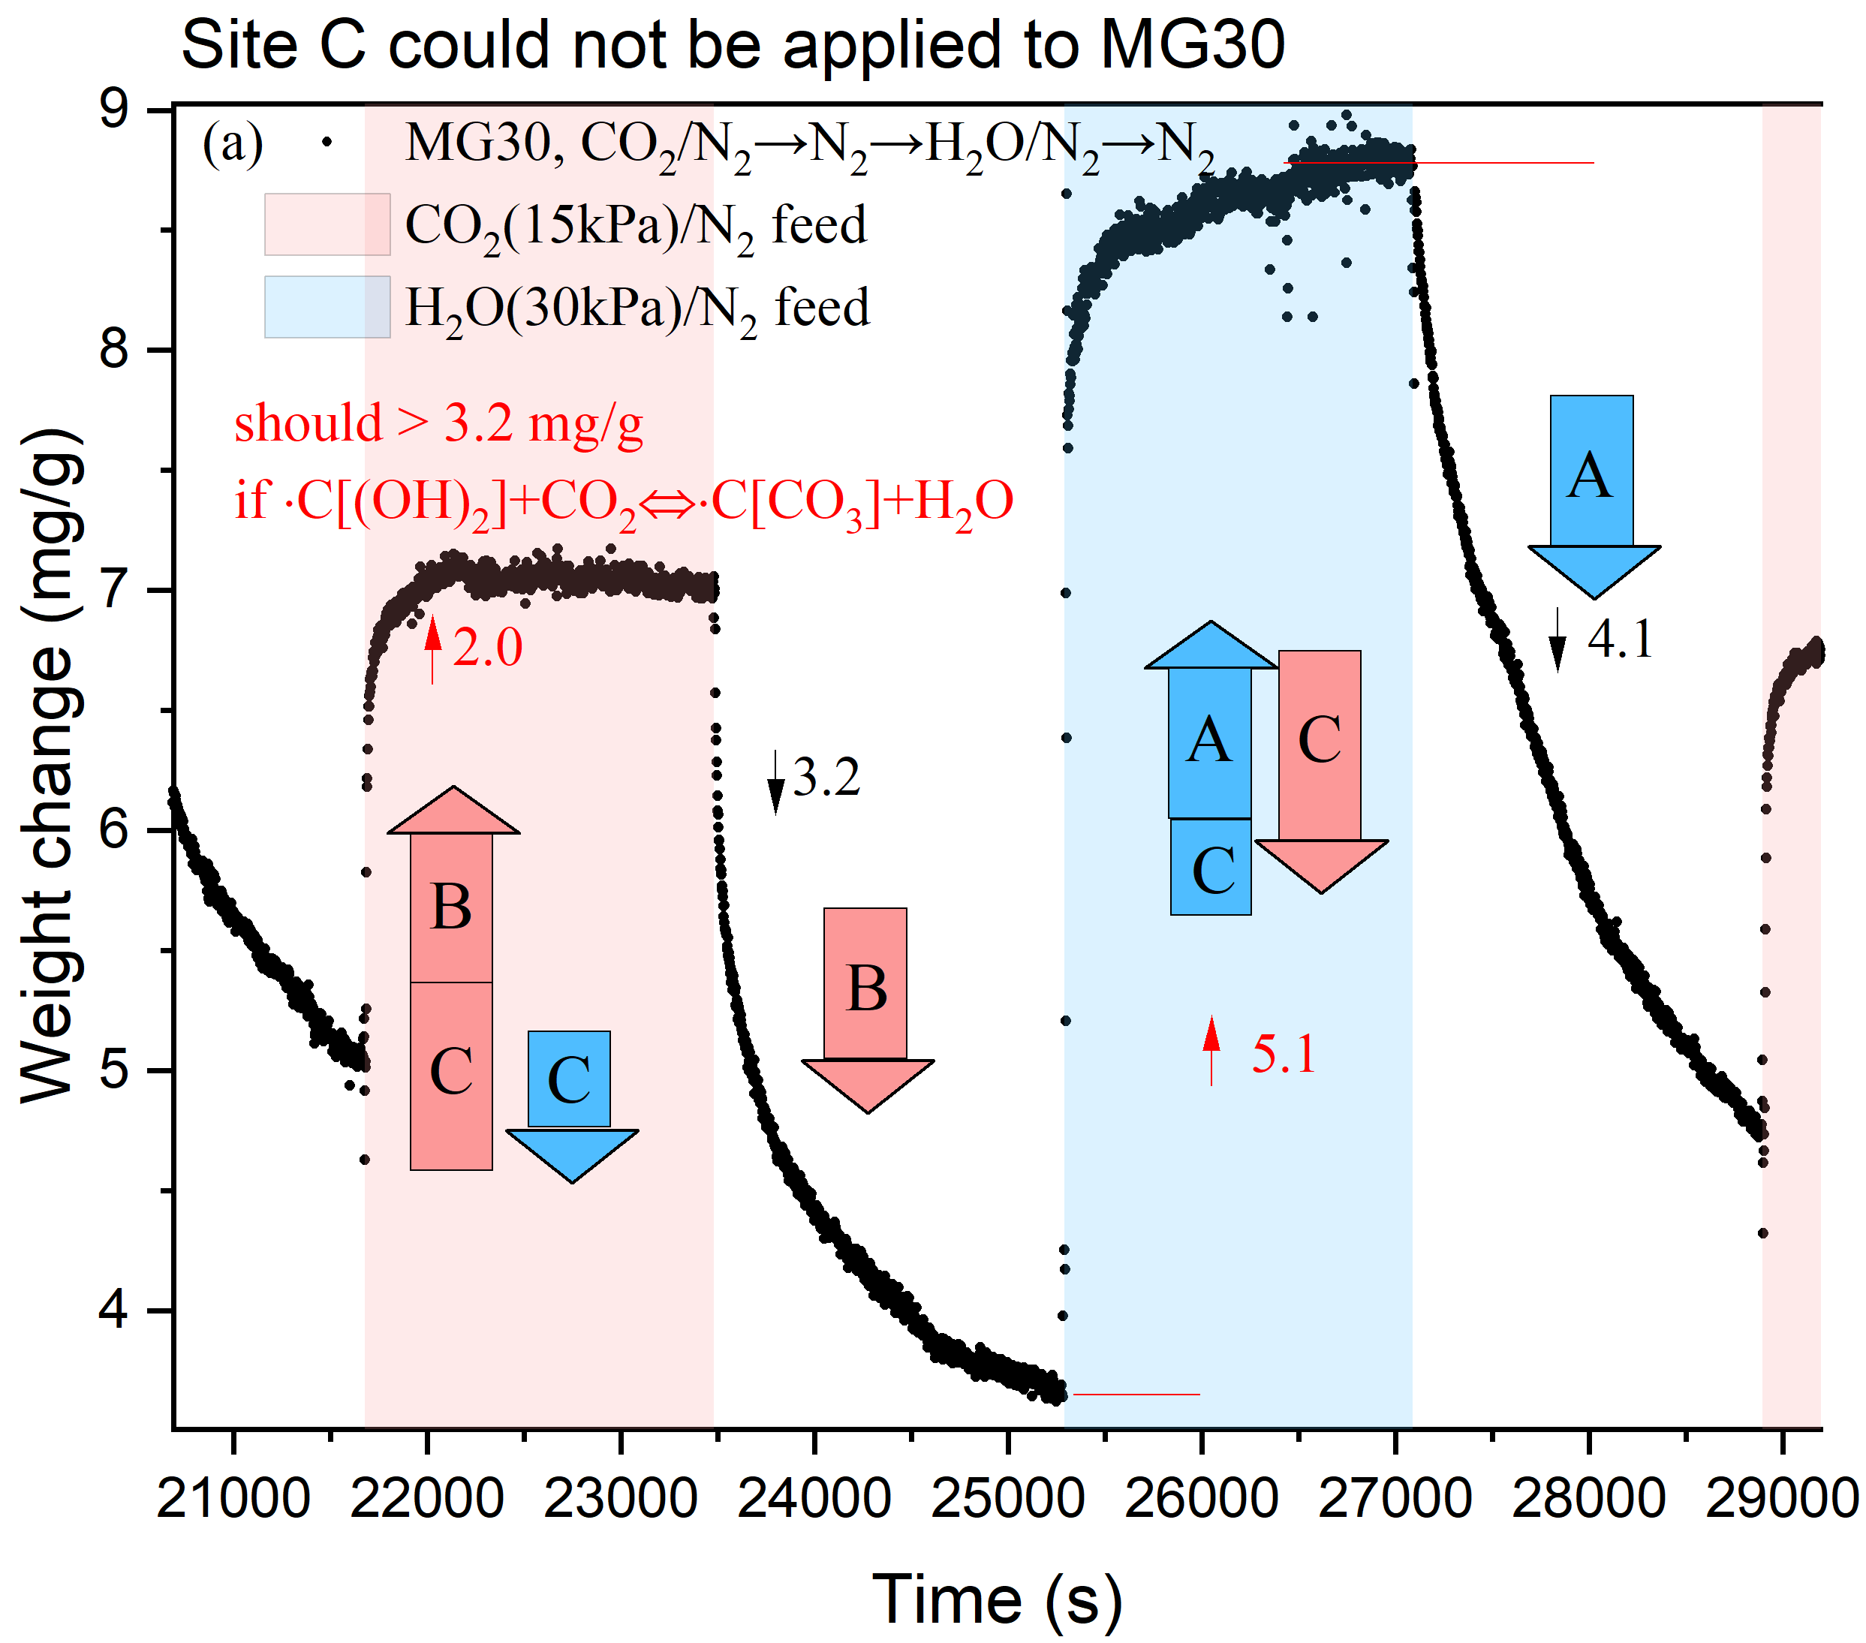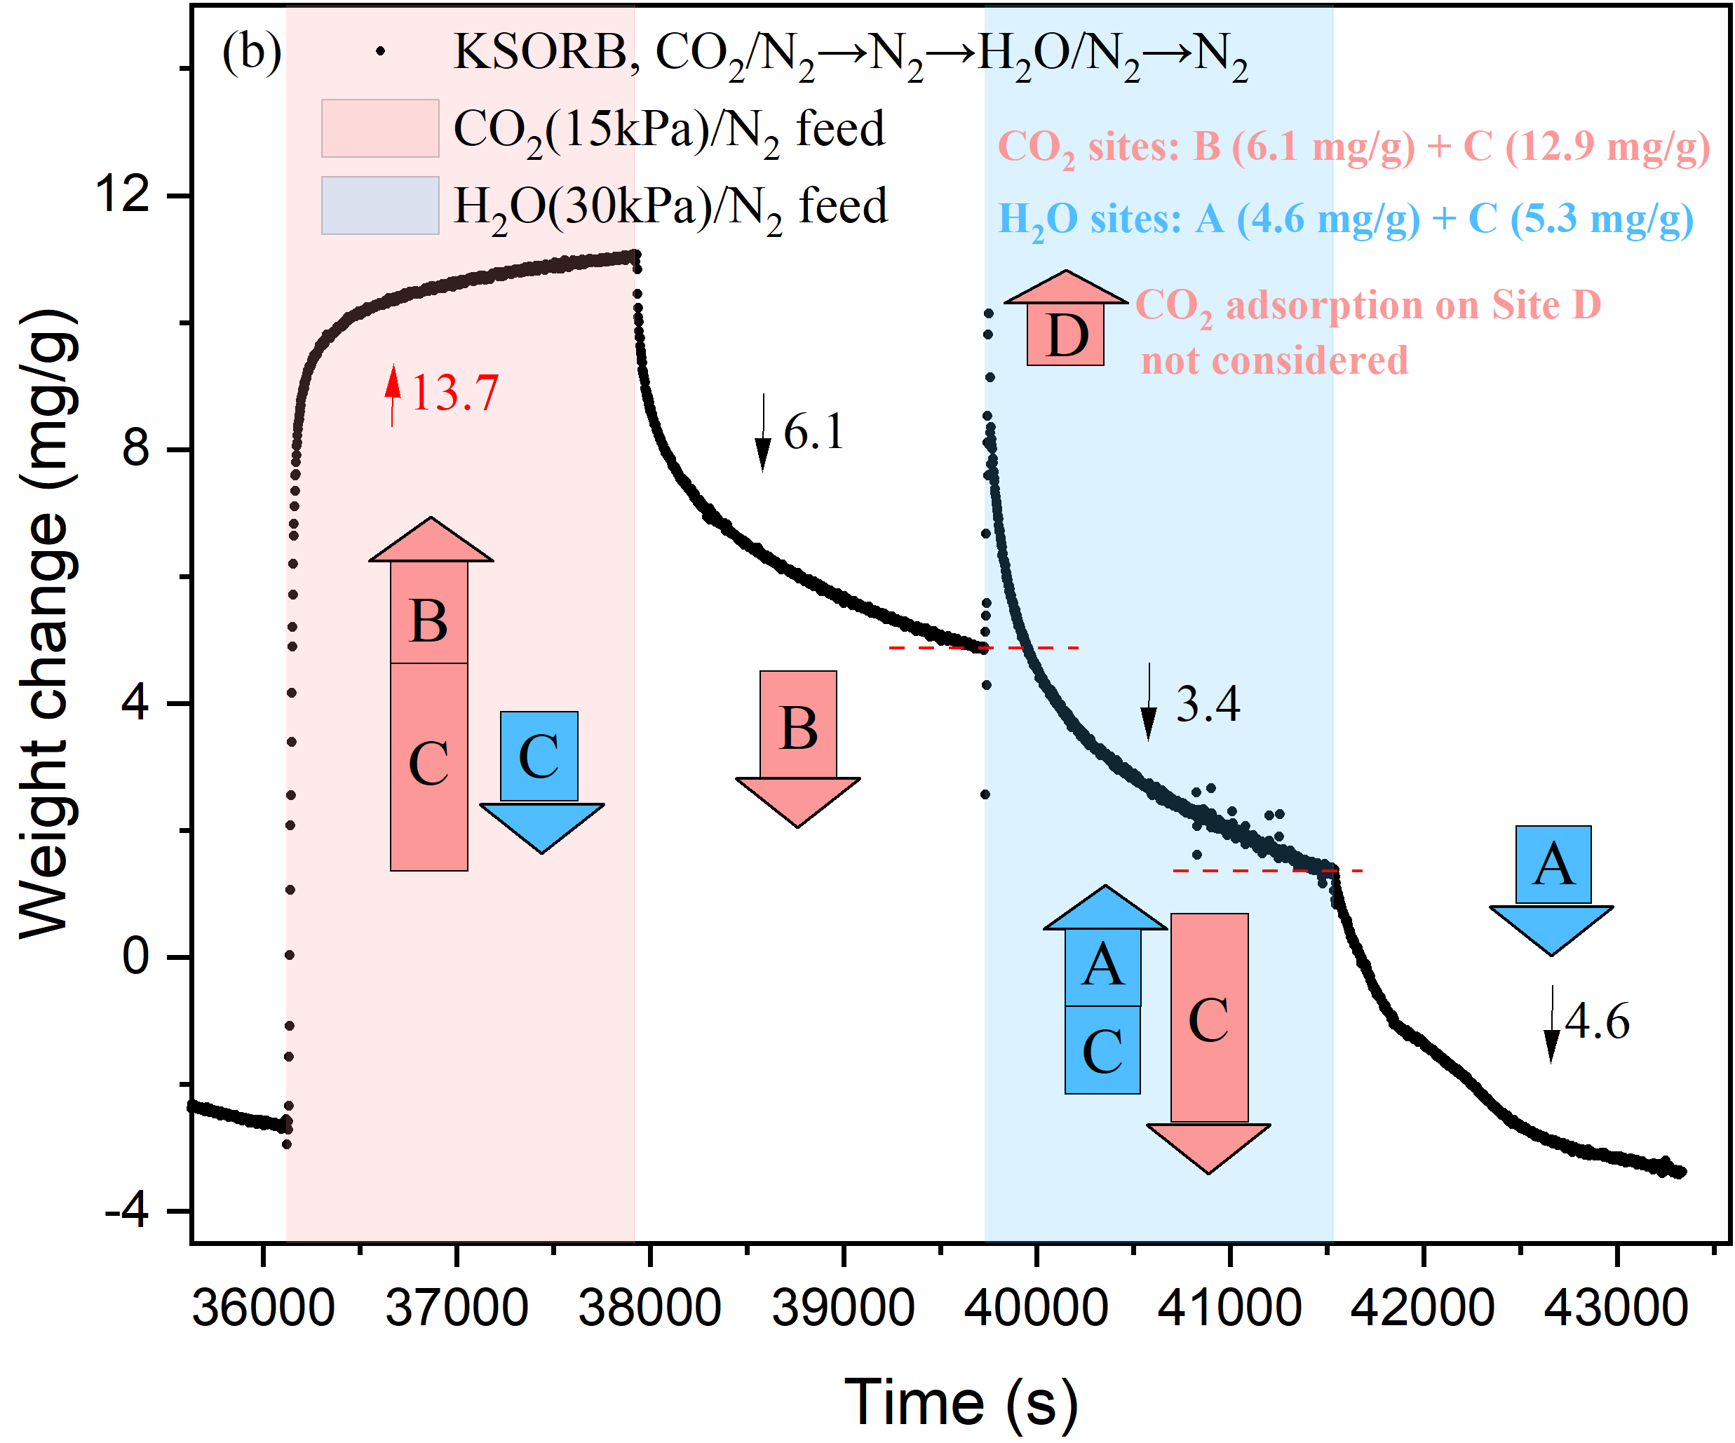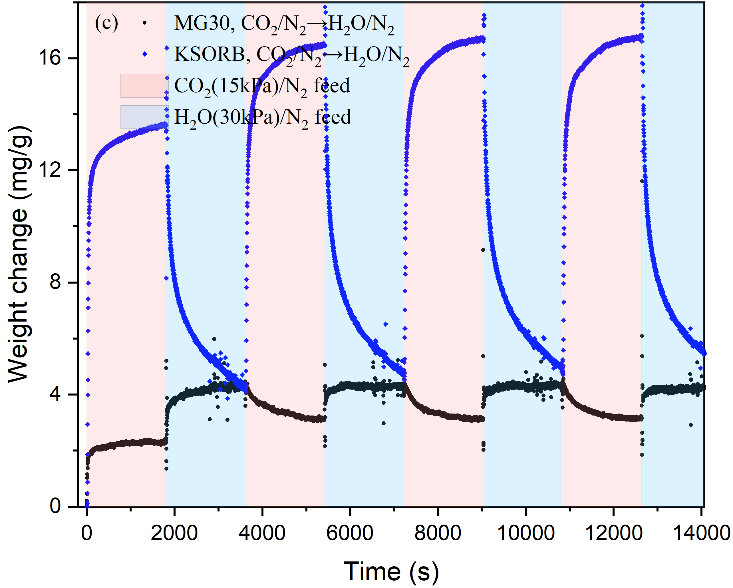

Fig. S6. (a) Weight change of MG30 during a cycle of [CO2→N2→H2O→N2]. (b) Weight change of KSORB during a cycle of [CO2→N2→H2O→N2]. (c) Weight change of MG30 and KSORB during cycles of [CO2→H2O].

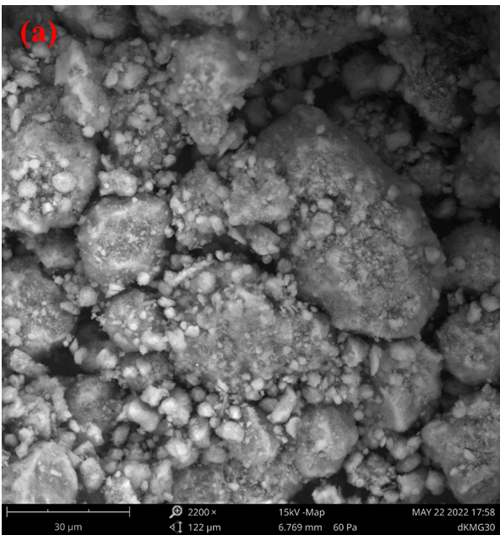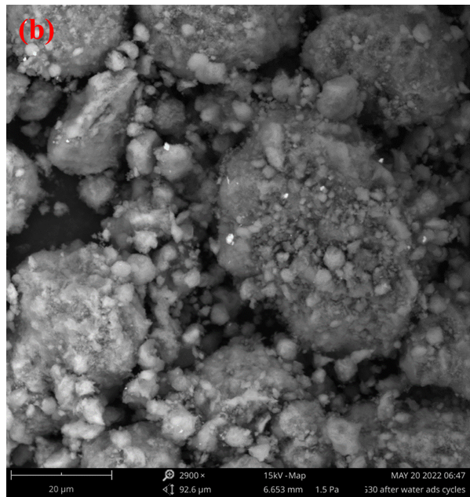

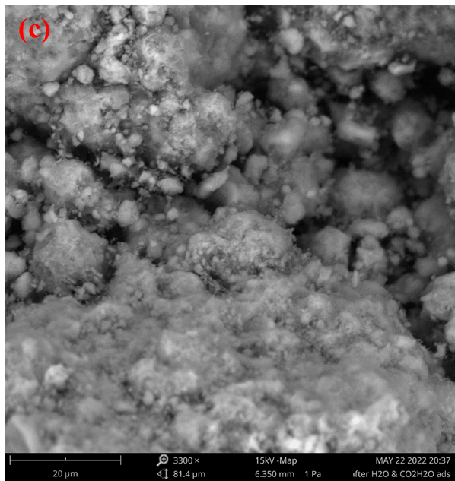 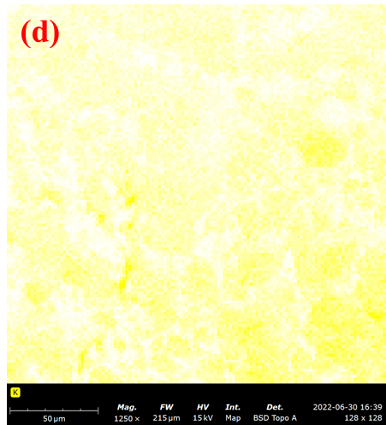

Fig. S7. SEM images of treated KMG30, including samples of (a) KMG30 after heat treatment, (b) KMG30 after heat treatment ⇨ [H2O→N2]×10, (c) KMG30 after heat treatment ⇨ [H2O→N2]×10 ⇨ [CO2/H2O→N2]×10. (d) EDX maps of potassium for the sample (KMG30 after heat treatment).

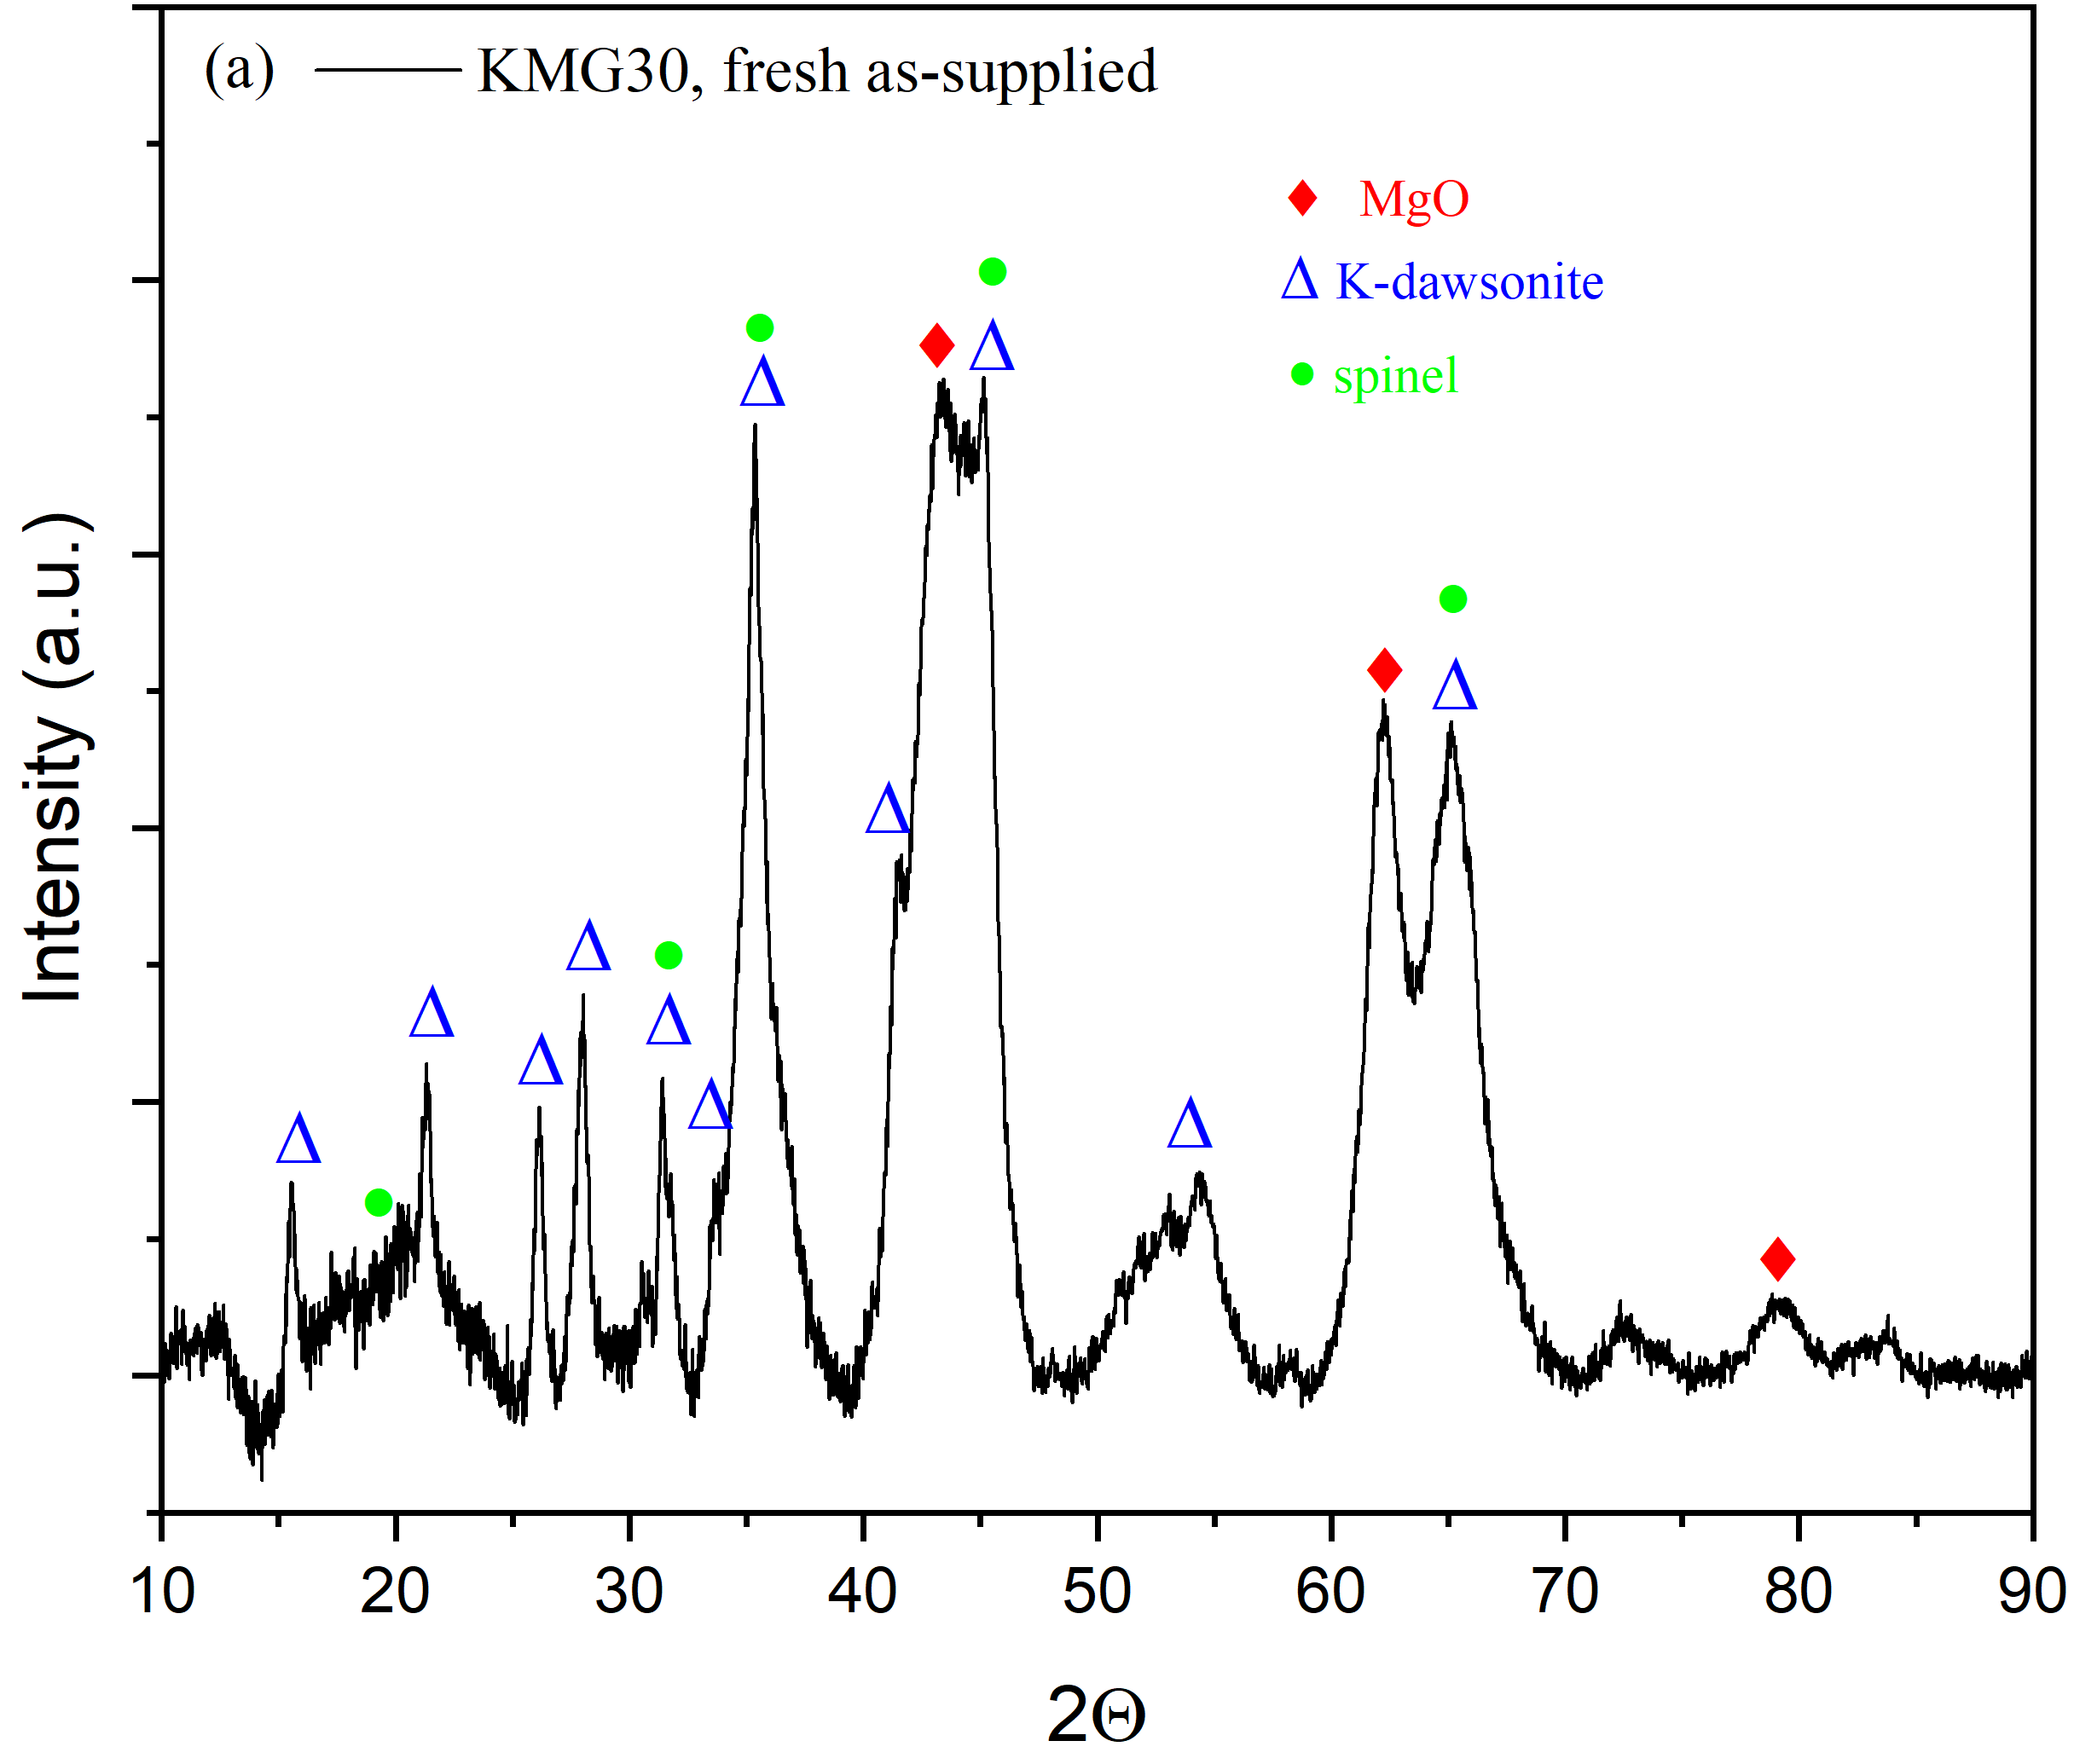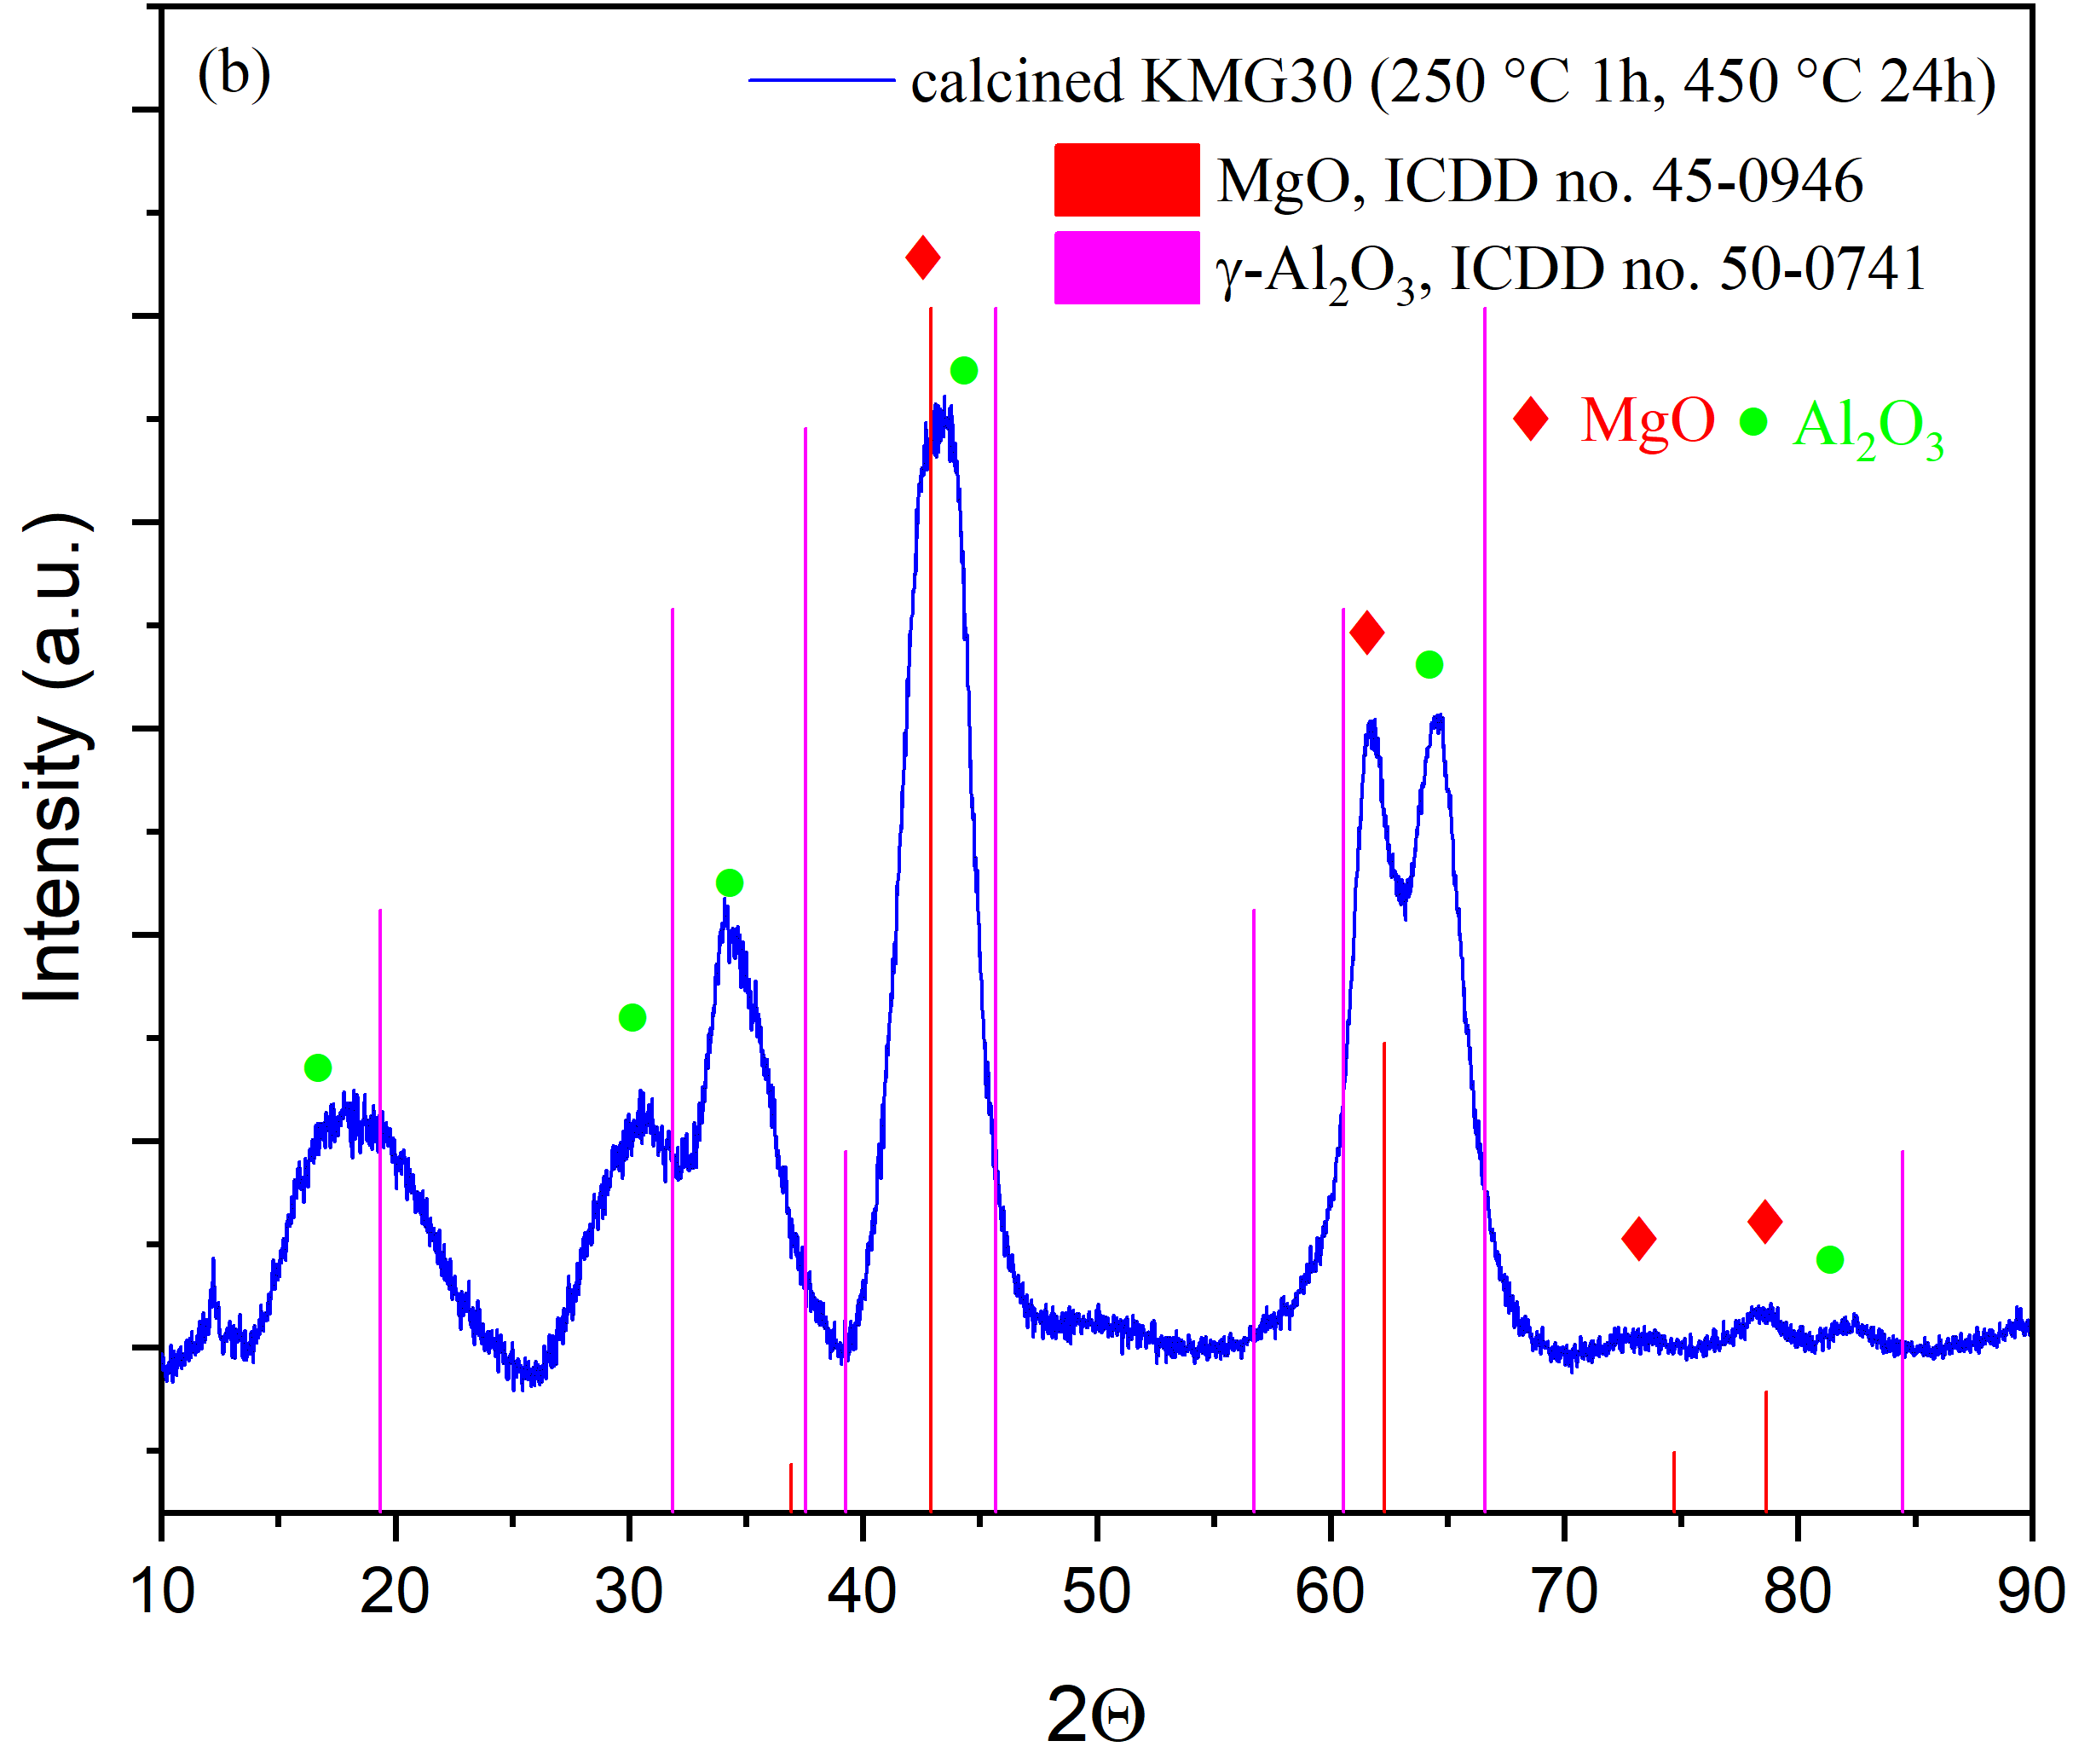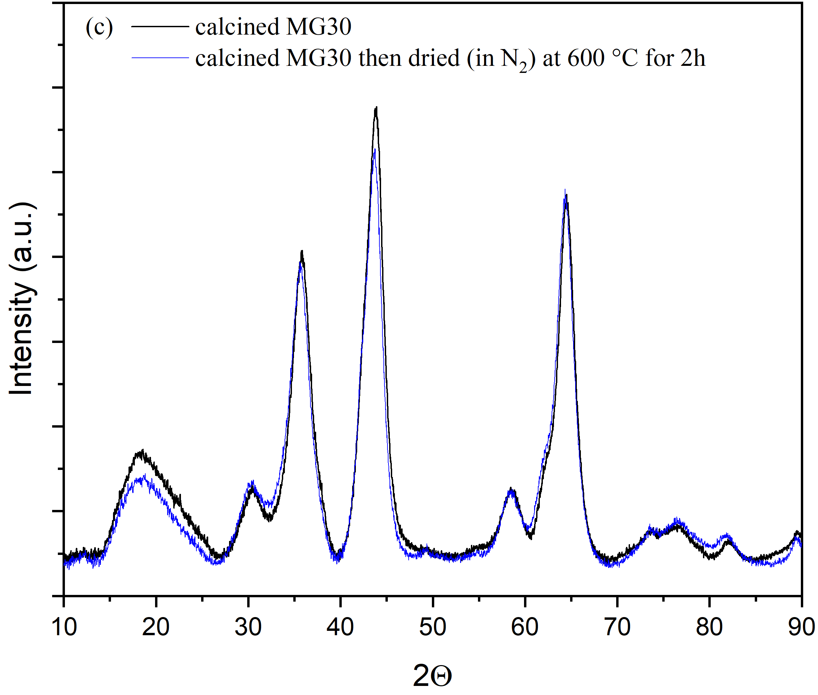

Fig. S8. XRD patterns for (a) KMG30 before calcined, (b) KMG30 after heat treatment and (c) calcined MG30 before and after heat treatment.

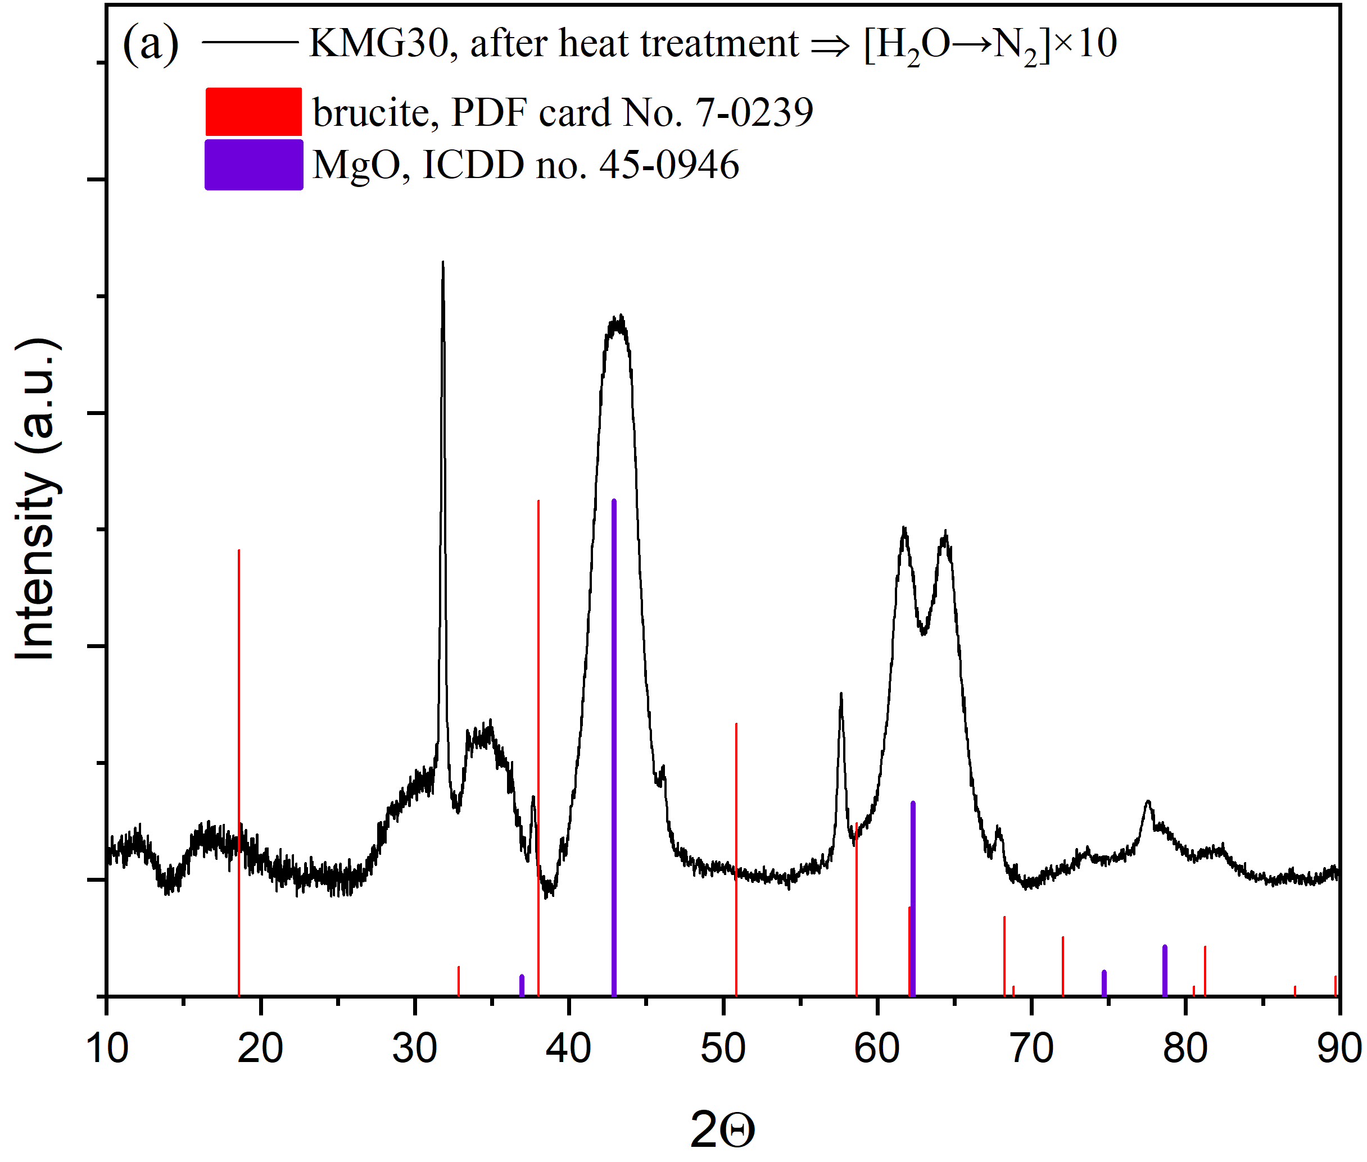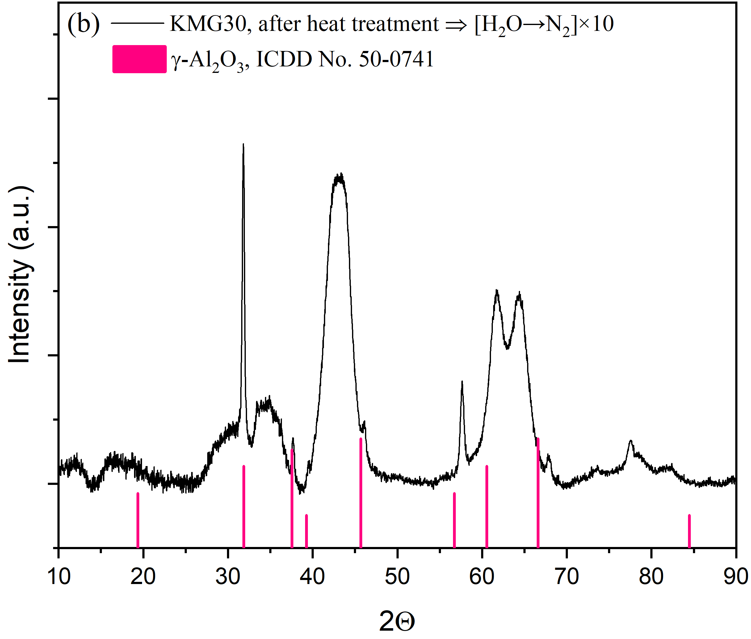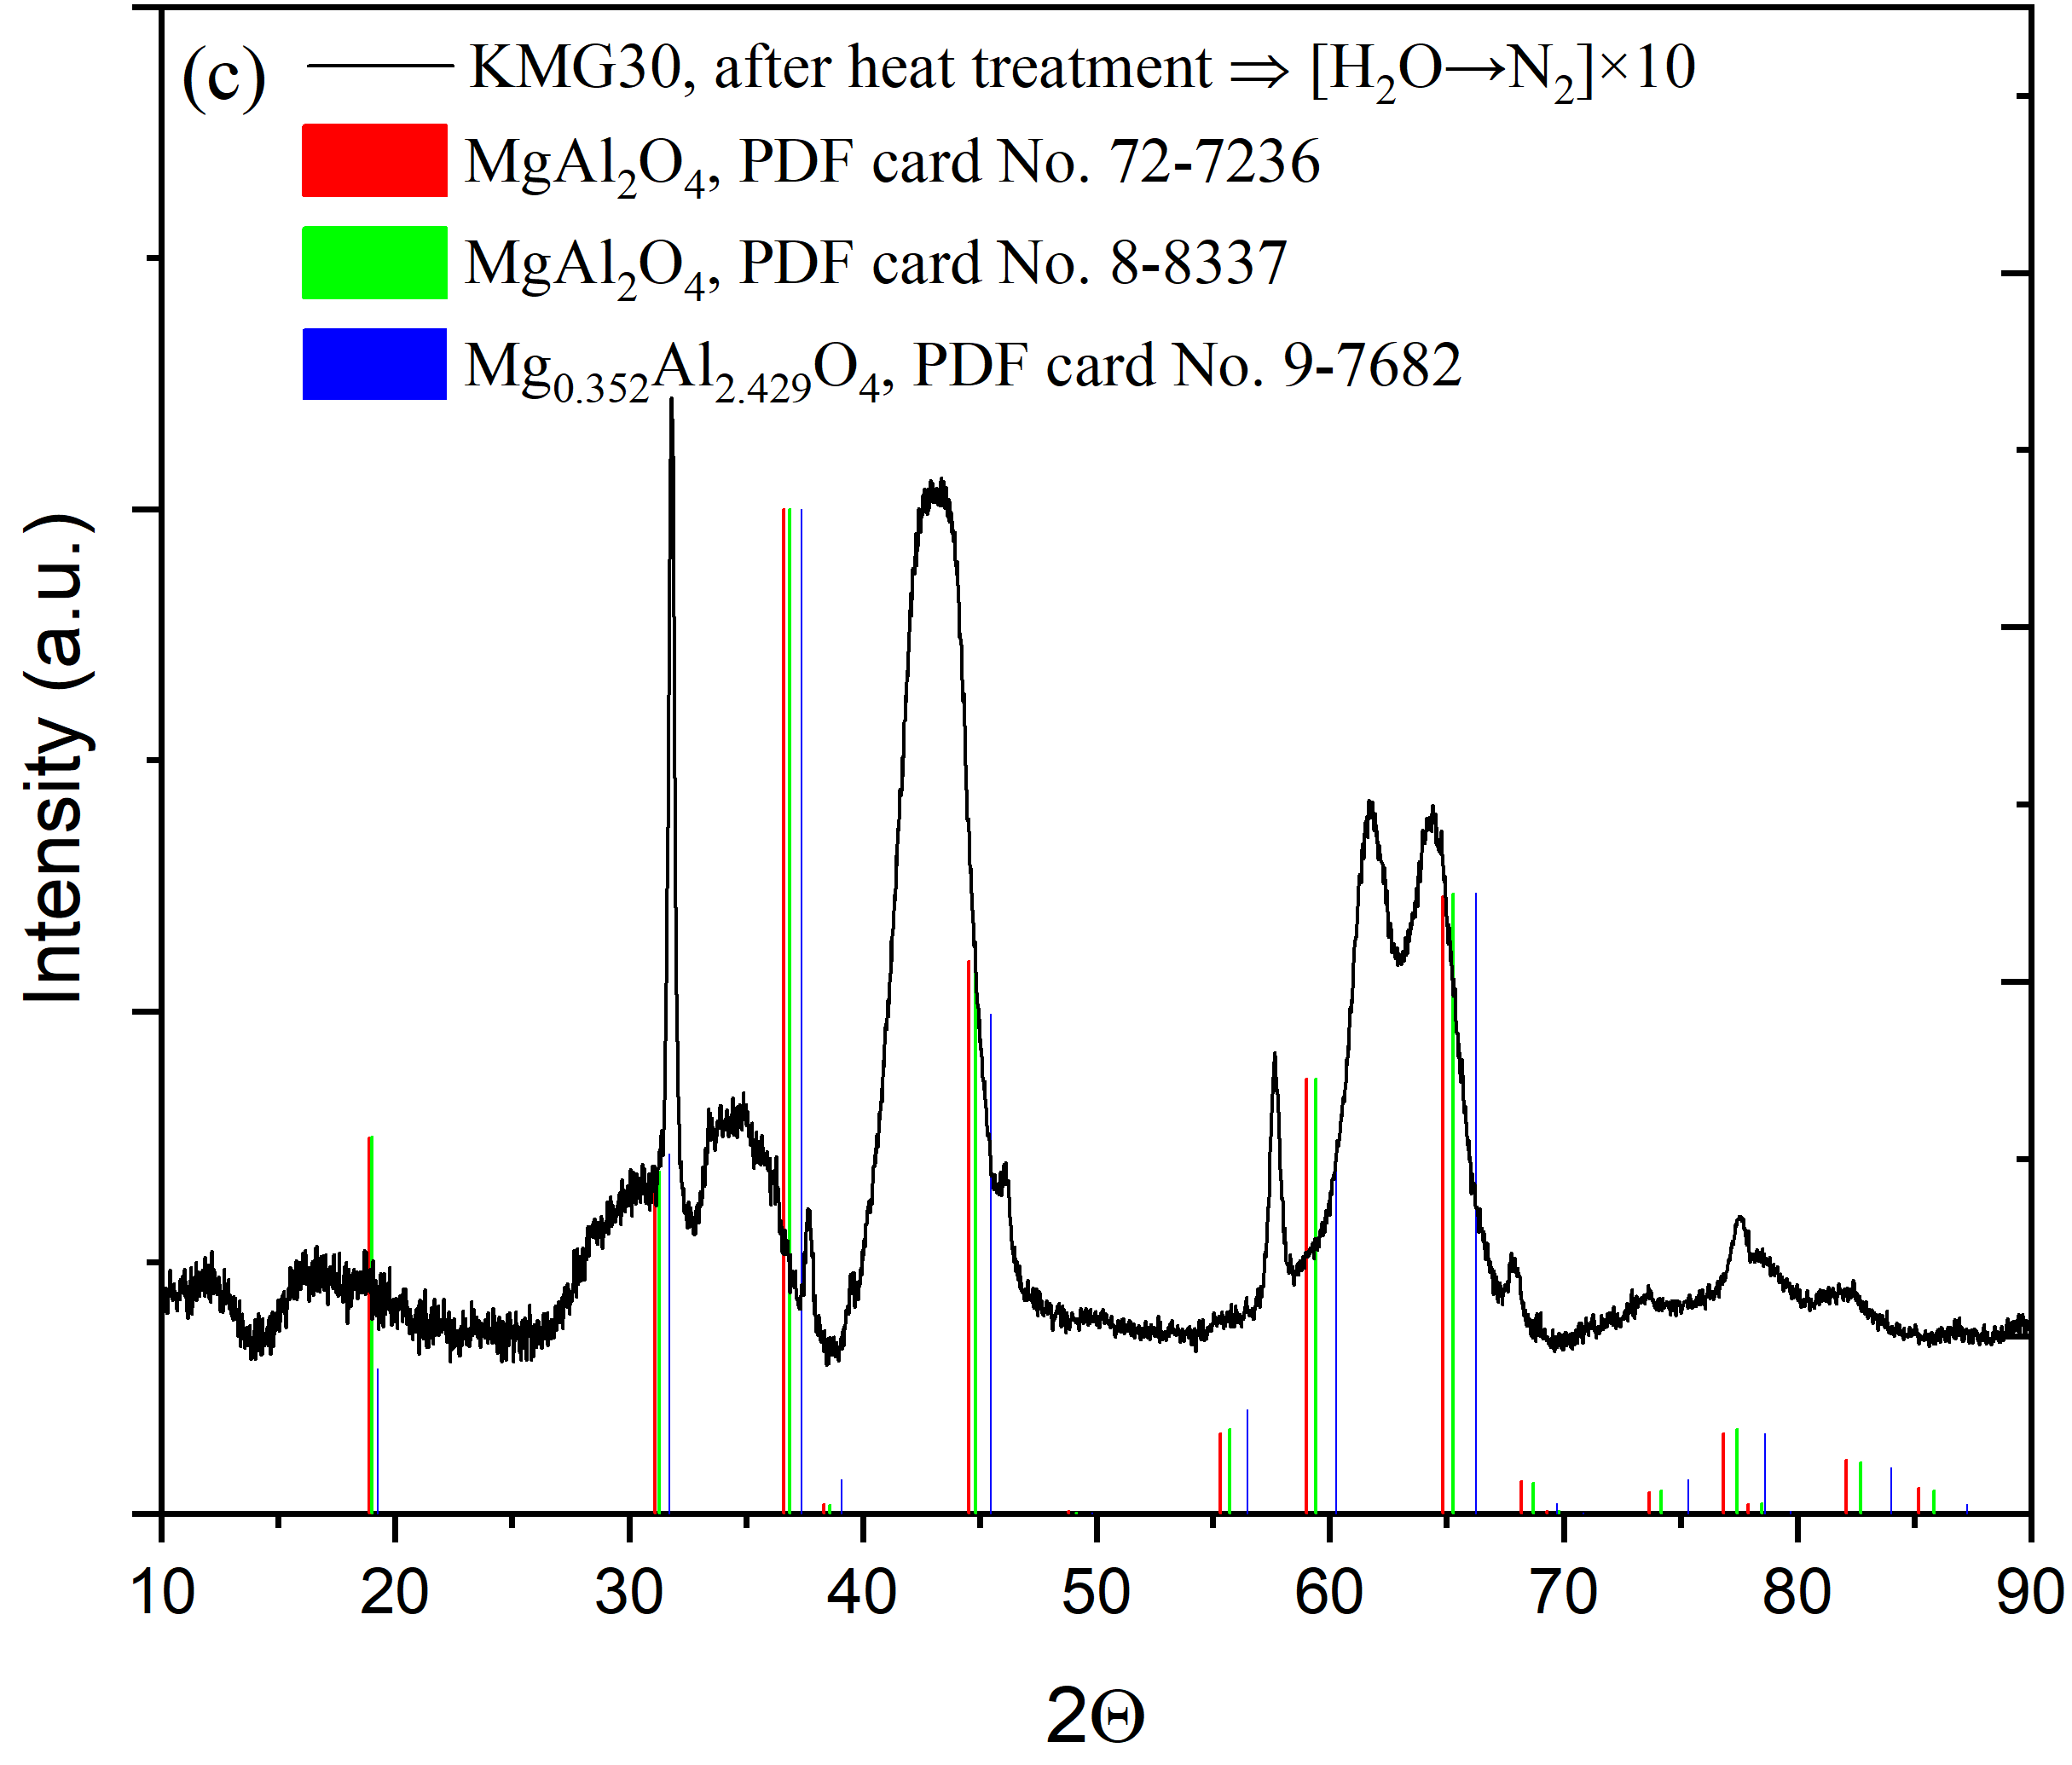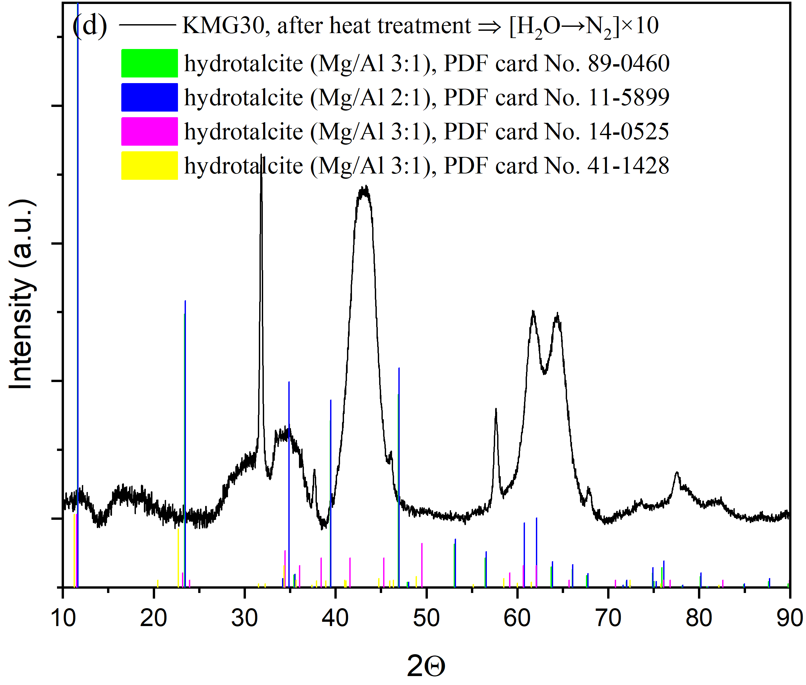

Fig. S9. The comparison of new peaks on KMG30 after H2O adsorption/N2 flushing cycles with the XRD patterns of other promising candidates such as brucite and MgO (subfigure (a)), Al2O3 (subfigure (b)), spinel (MgAl2O4) (subfigure (c)) and hydrotalcite (subfigure (d)).

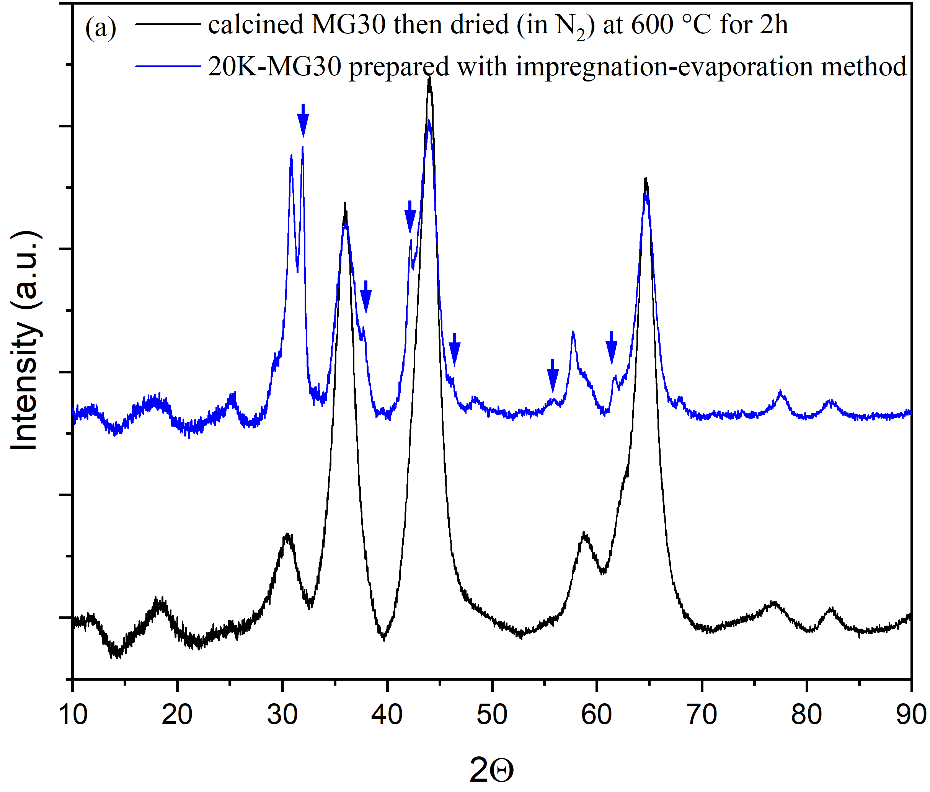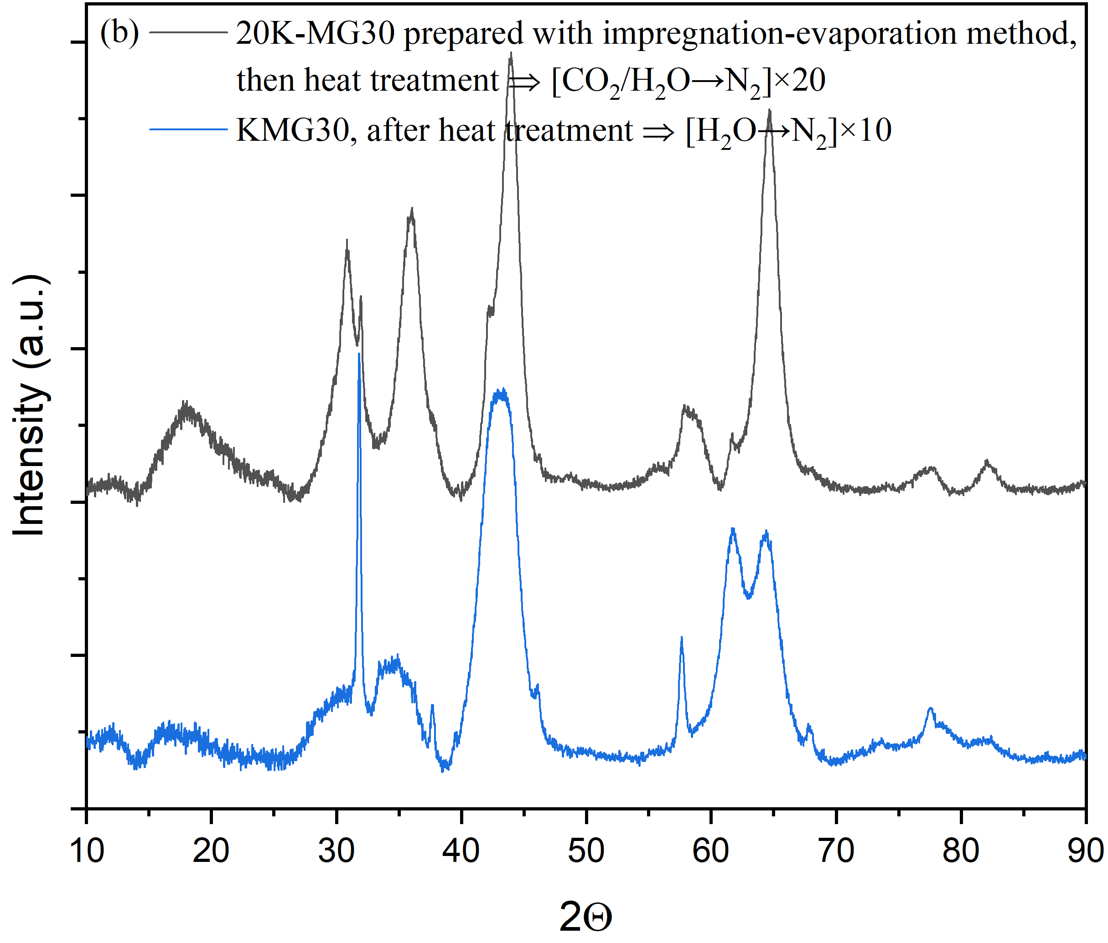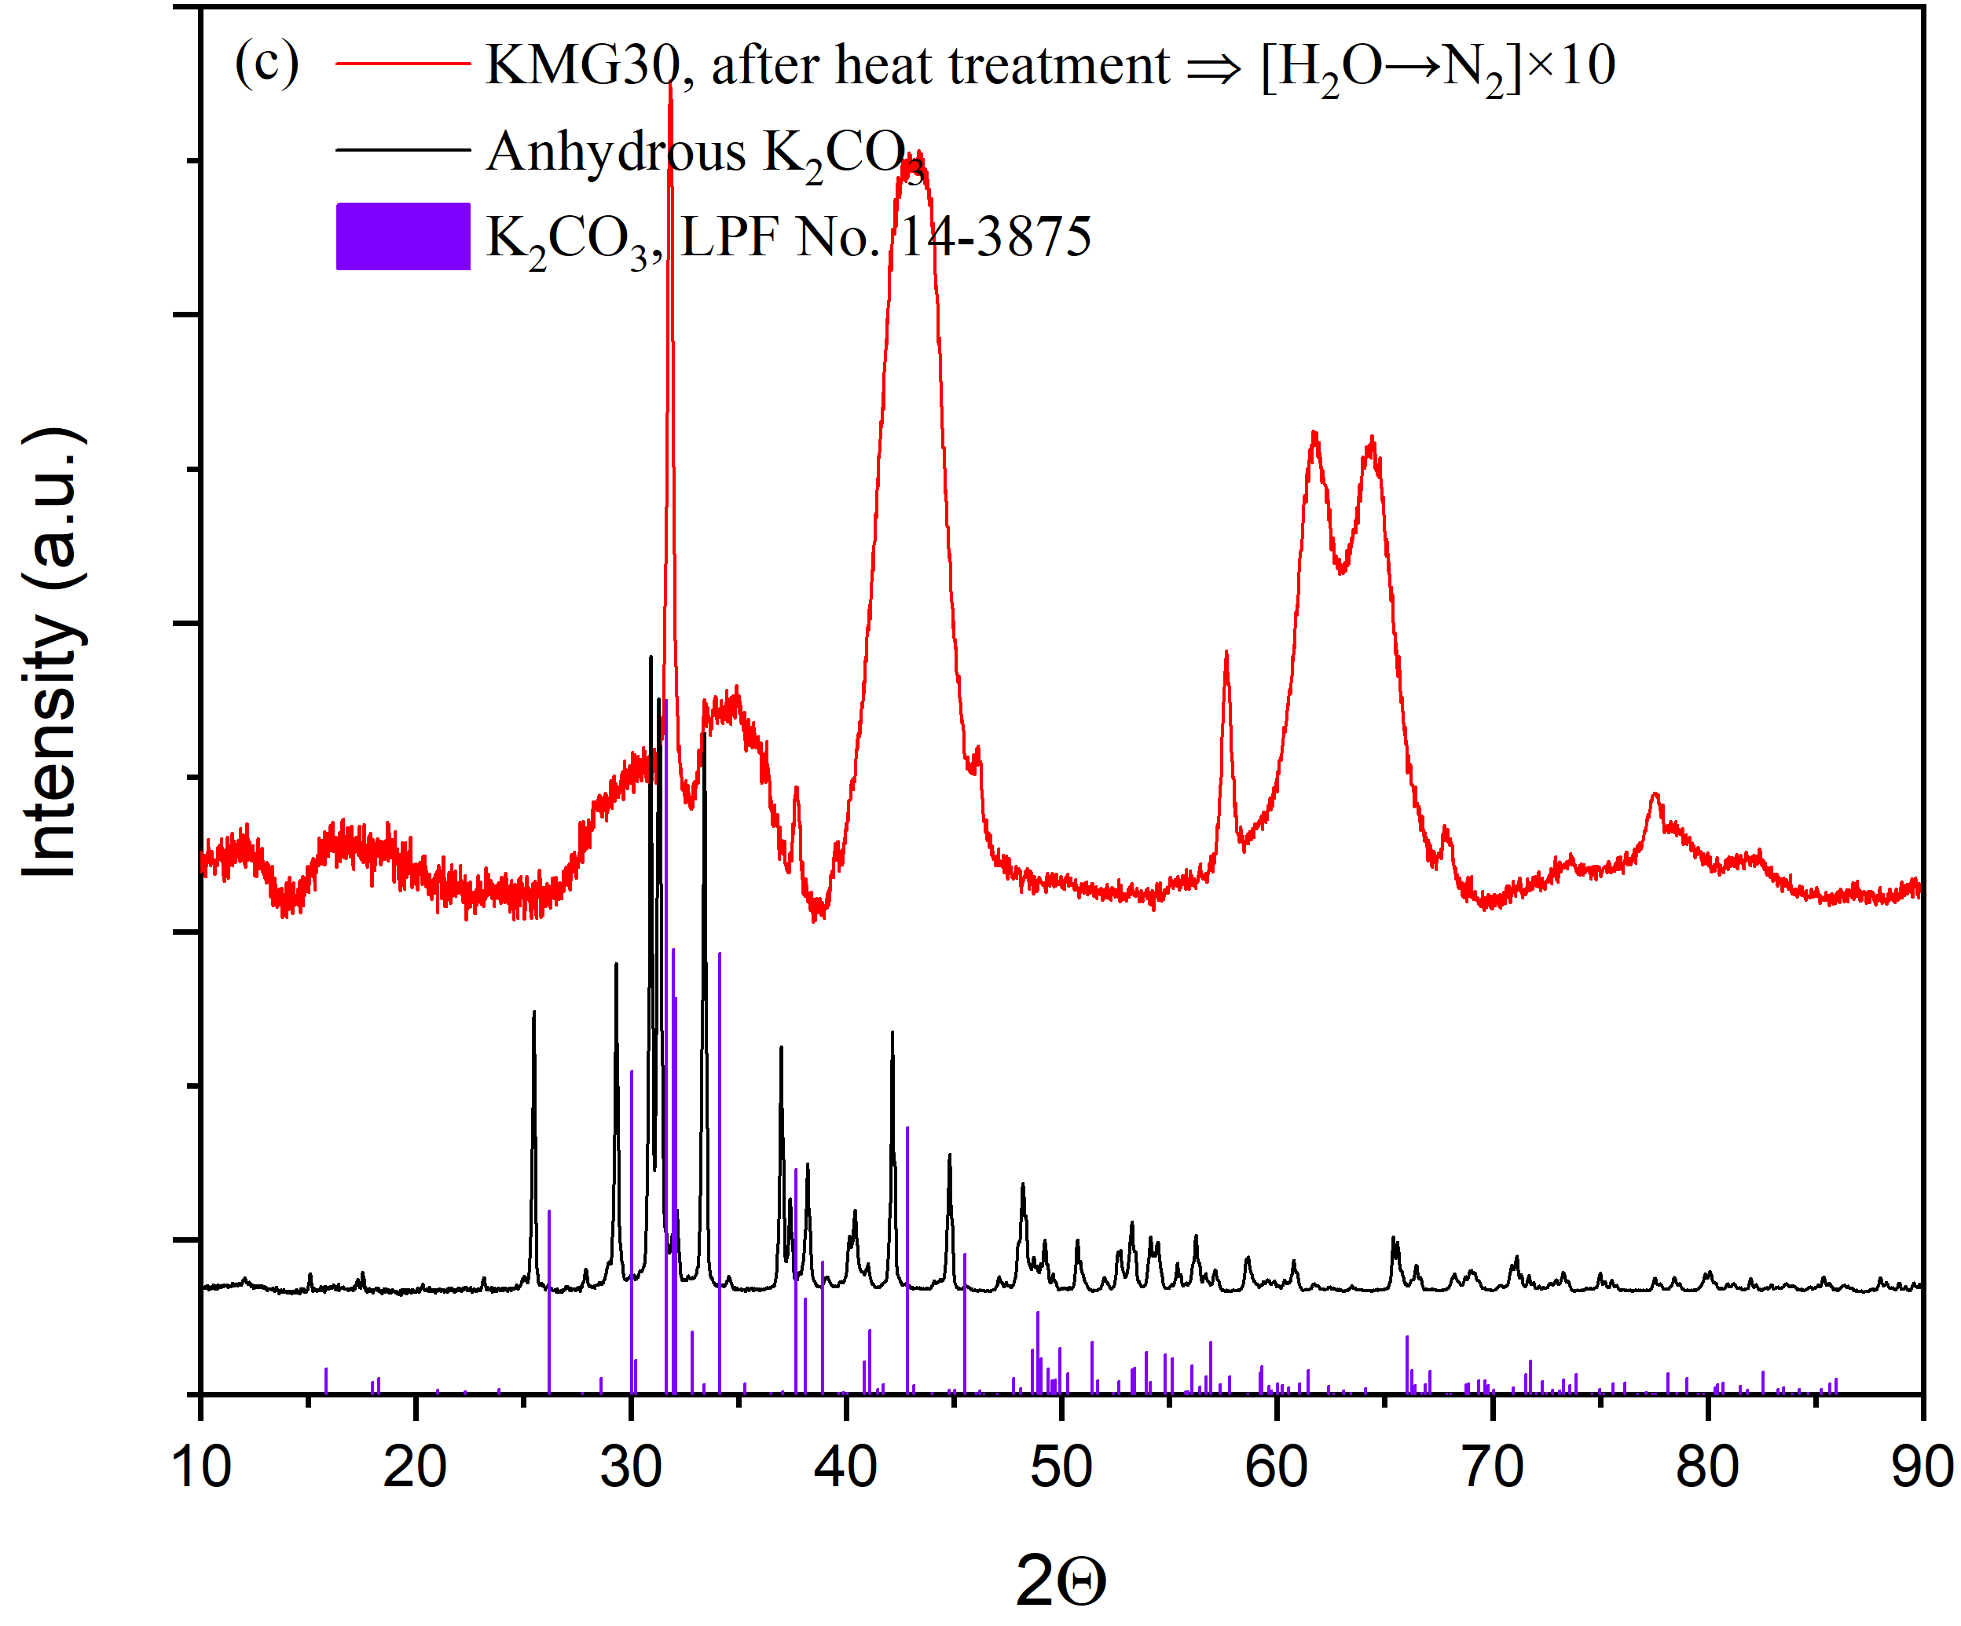

Fig. S10. (a) XRD patterns for the 20K-MG30 prepared with impregnation-evaporation method in comparison with the ones for the calcined MG30 after heat treatment. (b) XRD patterns for the treated 20K-MG30 (prepared with impregnation-evaporation method, after heat treatment and 20 cycles of CO2 and H2O co-adsorption/N2 flushing) in comparison with the ones for the KMG30 after heat treatment and H2O adsorption/N2 flushing cycles. (c) XRD patterns for the anhydrous K2CO3 in comparison with the ones for the treated KMG30 (after 10 cycles of H2O adsorption/N2 flushing).

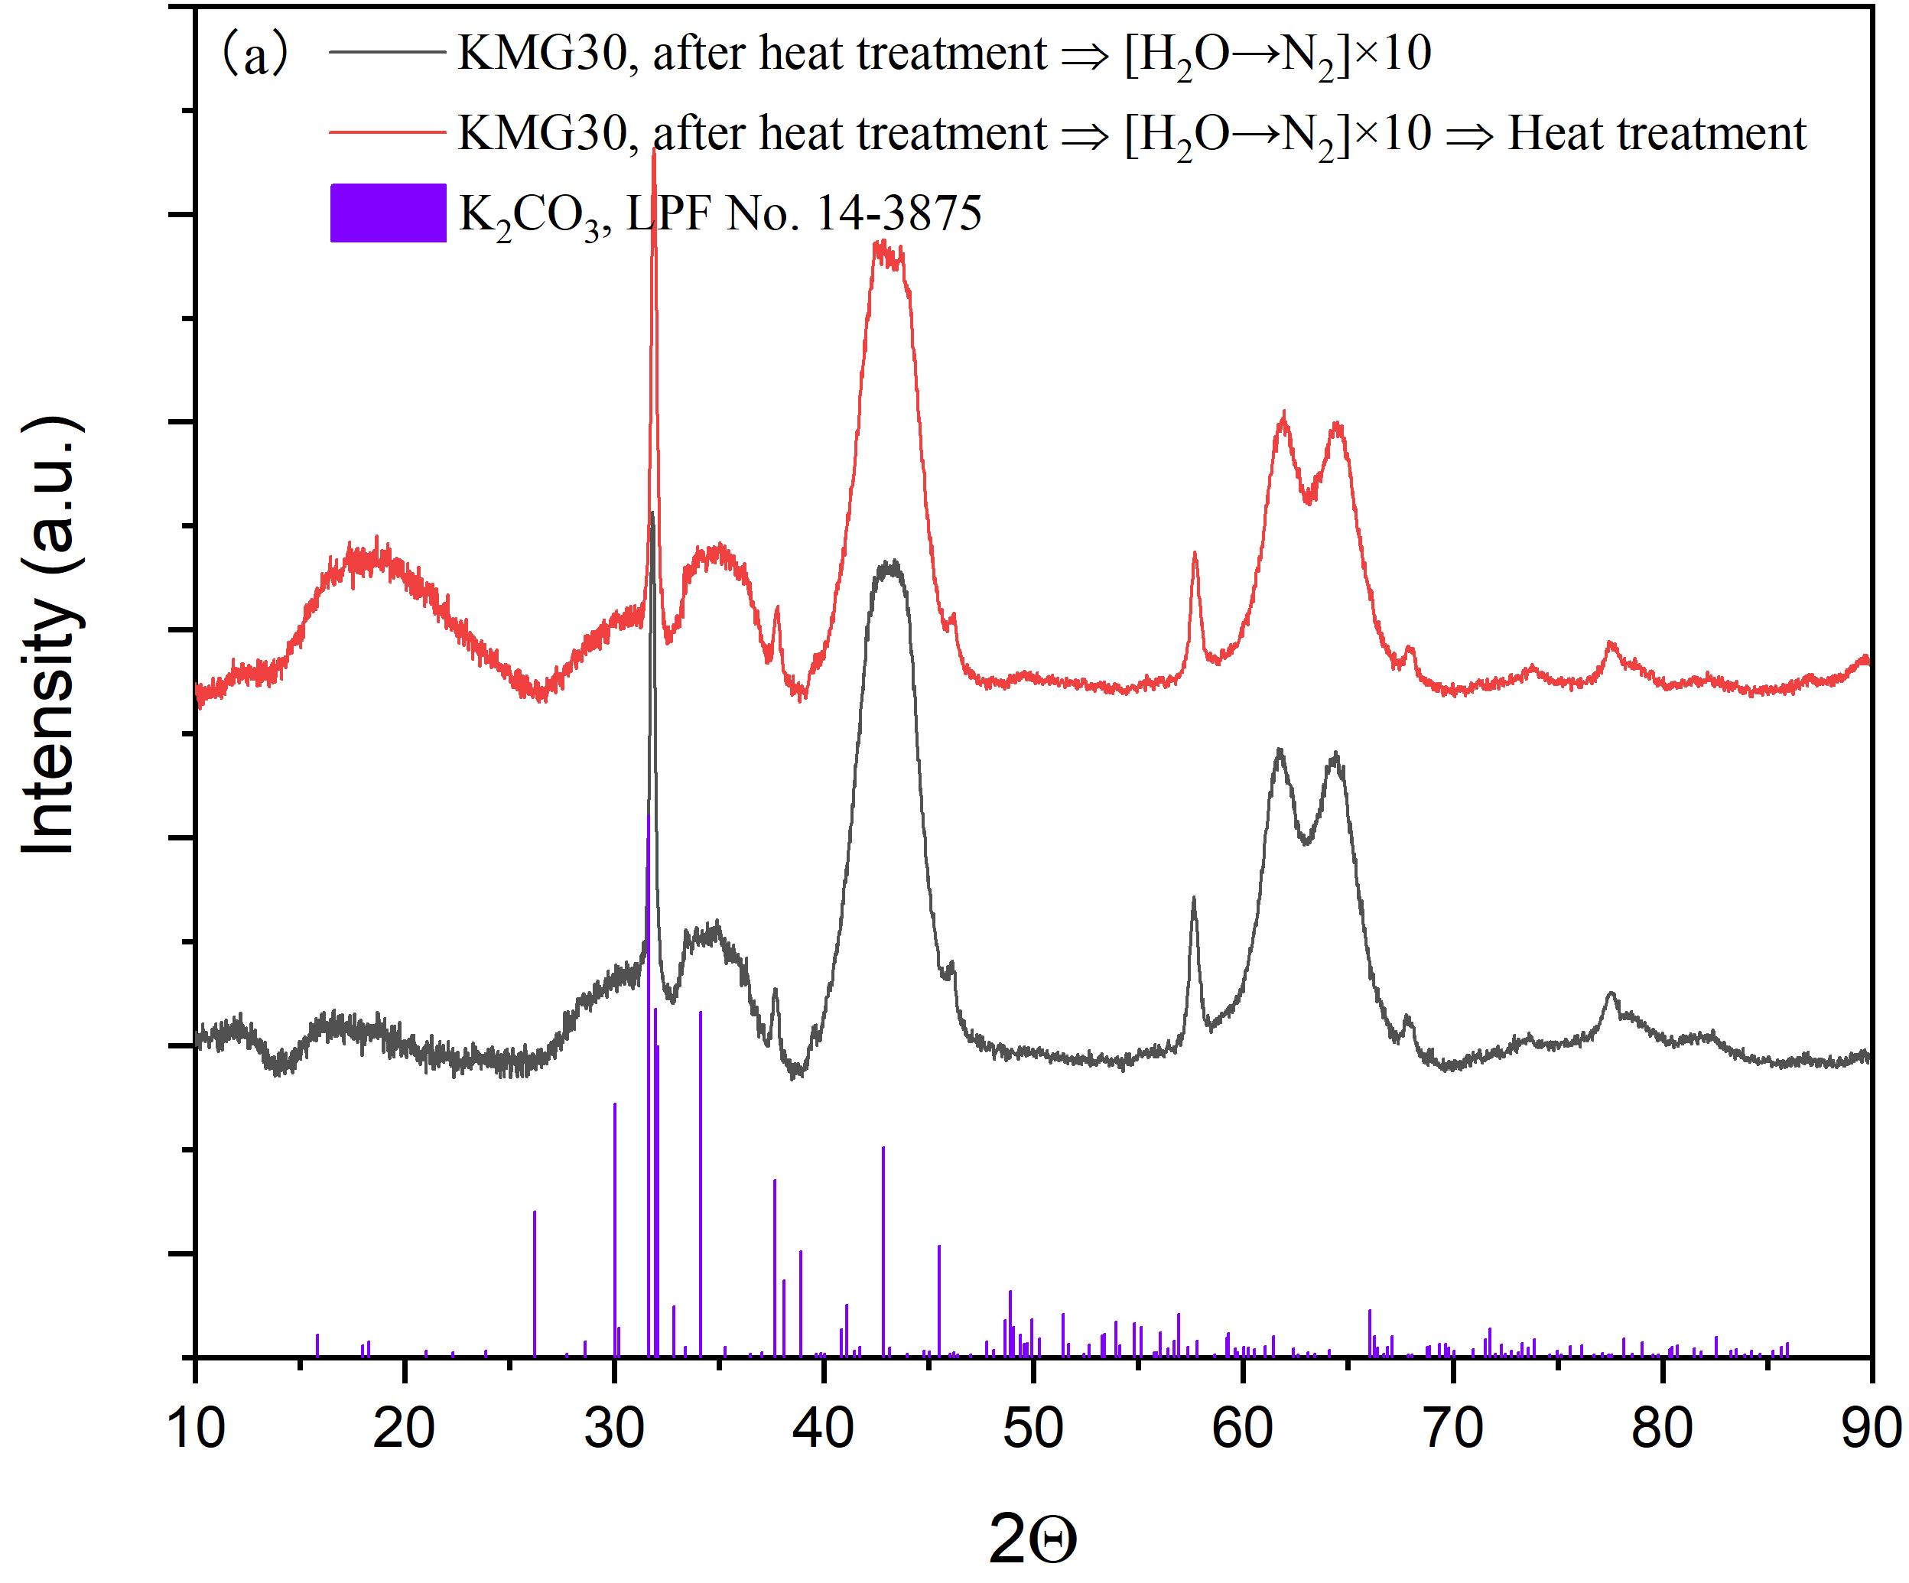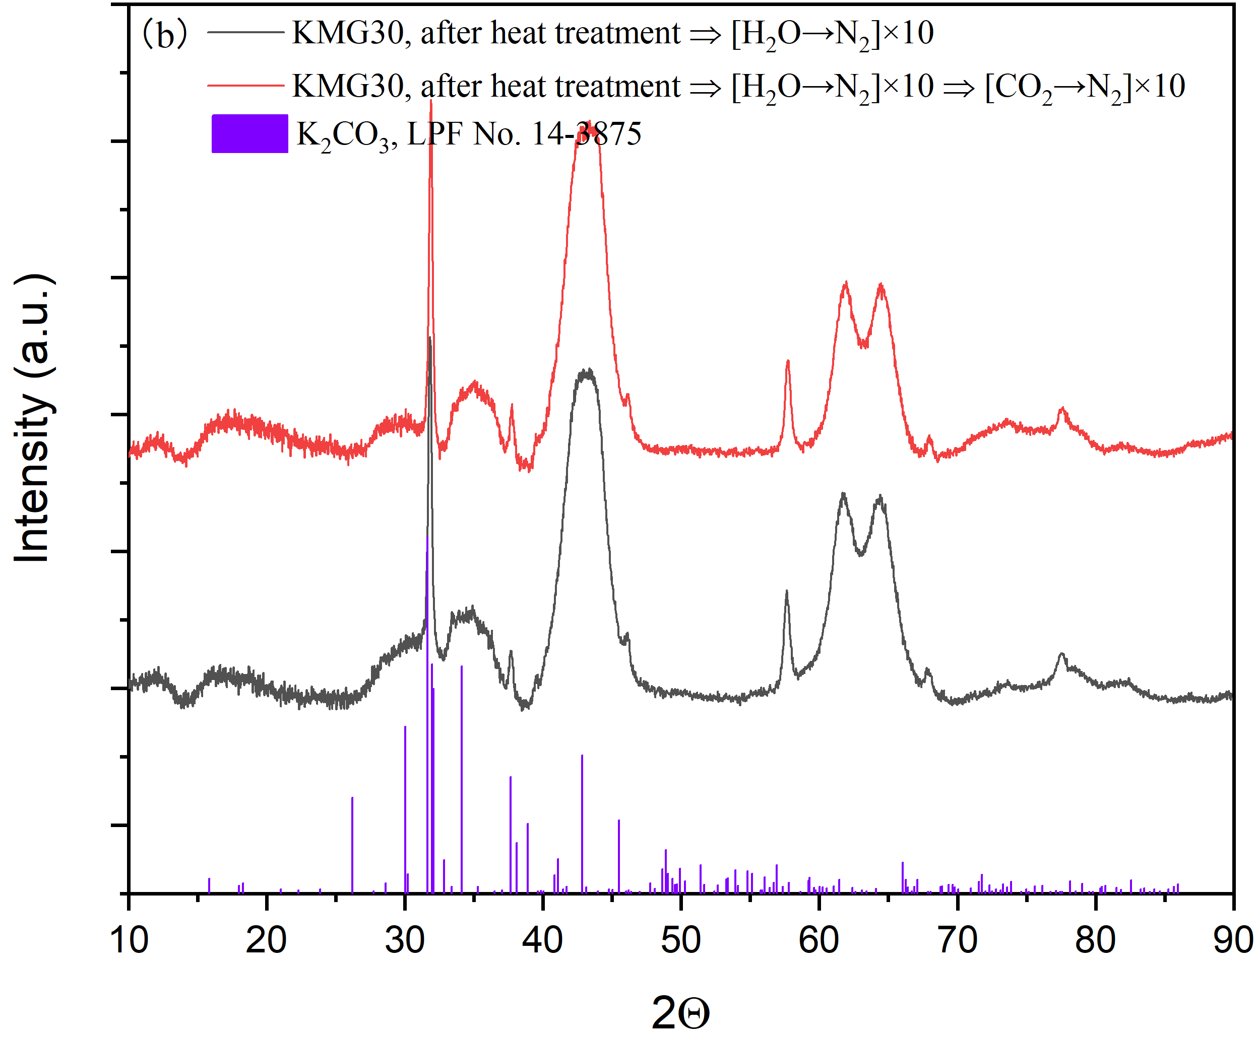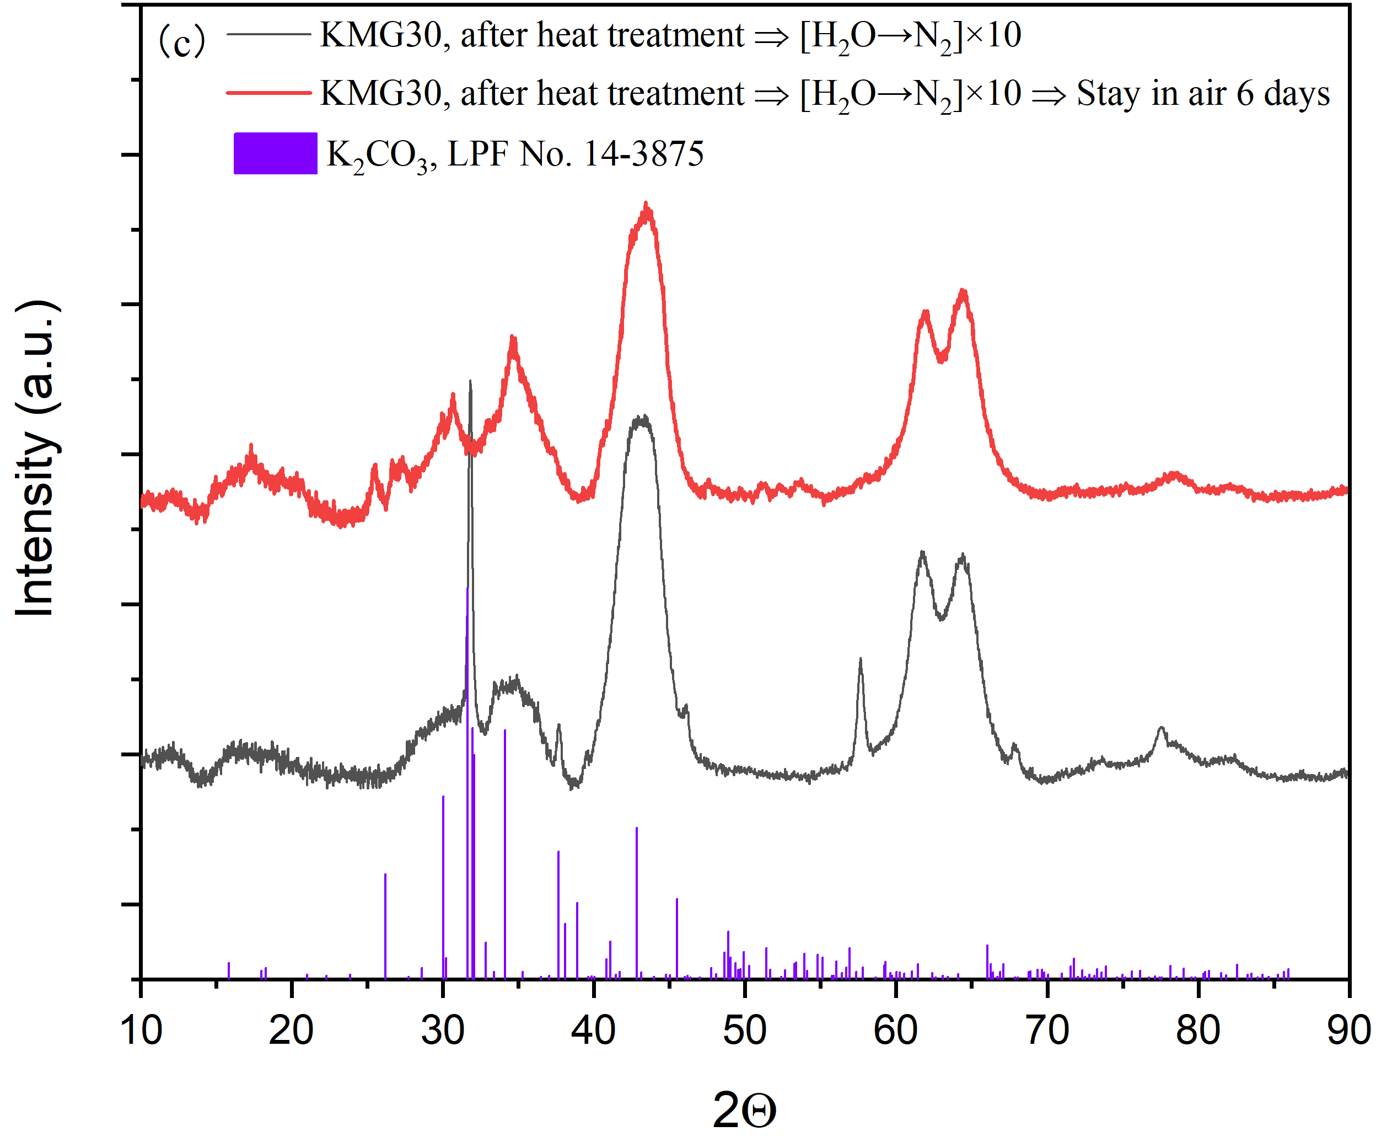

Fig. S11. Comparisons of XRD patterns for the treated samples of KMG30. (a) one with heat treatment ⇨ [H2O→N2]×10, the other one with heat treatment ⇨ [H2O→N2]×10 ⇨ heat treatment. (b) one with heat treatment ⇨ [H2O→N2]×10, the other one with heat treatment ⇨ [H2O→N2]×10 ⇨ [CO2→N2]×10. (c) one with heat treatment ⇨ [H2O→N2]×10, the other one with heat treatment ⇨ [H2O→N2]×10 ⇨ Stay in air 6 days.



Fig. S12. Pore size distributions for KMG30 treated with different working cycles, calculated with BJH method. The samples include heat-treated KMG30 before and after (a) [H2O→N2]×40, (b) [CO2→H2O]×40, (c) [CO2/H2O→N2]×40, (d) [CO2/H2O→H2O]×64, (e) [CO2→N2]×60, and (f) Exp. 6.

Table S1. Different characterization techniques used to analyze a pre-treated hydrotalcite-based material aiming to understand the aggregation of K2CO3 on the substrate.

|  |  |  |  |
| --- | --- | --- | --- |
| Description of preparation procedure in TGA setup | | Sample | Characterization techniques |
| Identification of K2CO3 dispersion on MG30 and selection of characterization technique | No treatment | 5K-MG30, KMG30 | XRD, BET, SEM-EDX, MP-AES |
| Pretreatment (N2 flushing at 893.15 K for 2 h) | KMG30, MG30, 20K-MG30 | XRD |
| Pretreatment  ⇨ [CO2/H2O→N2]×20 | 20K-MG30 (solid-solid mixing method) | XRD |
| Pretreatment ⇨ one cycle from Exp. 3 (in Table 2) | 5K-MG30, KMG30 | XRD, BET, SEM-EDX, MP-AES |
| K2CO3 aggregation on KMG30 within H2O→N2 cycles and its reversibility | Pretreatment ⇨ [H2O→N2]×10 | KMG30, MG30 | XRD, SEM-EDX |
| Pretreatment ⇨ [H2O→N2]×10 ⇨ [CO2→N2]×10 | KMG30 | XRD |
| Pretreatment ⇨ [H2O→N2]×10 ⇨ N2 flushing at 873.15 K for 3 h | KMG30 | XRD |
| Pretreatment ⇨ [H2O→N2]×10 ⇨ [CO2/H2O→N2]×10 | KMG30 | XRD, SEM-EDX |
| Pretreatment ⇨ [H2O→N2]×10 ⇨ stay in air 6 days (room temp.) | KMG30 | XRD |
| Pretreatment ⇨ [H2O→N2]×20 ⇨ stay in N2 5 days (room temp.) | KMG30 | XRD |
| Pore size distribution from BET adsorption analysis: try to find out the reason for K2CO3 aggregation | Pretreatment ⇨ [H2O→N2]×40 | KMG30 | XRD, BET |
| Pretreatment ⇨ [H2O→N2]×40 ⇨ [CO2→H2O]×15 | KMG30 | XRD, BET |
| Pretreatment ⇨ [CO2→H2O]×40 | KMG30 | XRD, BET |
| Pretreatment ⇨ [CO2/H2O→N2]×40 | KMG30 | XRD, BET |
| Pretreatment ⇨ [CO2/H2O→H2O]×64 | KMG30 | XRD, BET |
| Pretreatment ⇨ [CO2→N2]×60 | KMG30 | BET |
| Pretreatment ⇨ Exp. 6 (in Table 2) | KMG30 | BET |

Under the partial pressures of 15 and 30 kPa for CO2 and H2O, respectively, the sorption capacities were 4.4 (Site A), 9.5 (Site B), 12.7 (CO2 in Site C) and 5.2 (H2O in Site C) mg/g. With the co-feeding H2O with CO2, the equilibrium CO2 and H2O capacities in Site C were 8.6 and 3.5 mg/g, respectively. The summary of sorption capacities for different adsorption/desorption cycles was presented in Table S2.

Table S2. The summary of sorption capacities for different adsorption/desorption cycles.

|  |  |  |
| --- | --- | --- |
| Cycle description | Detailed sorption capacities for different sites | Apparent sorption capacity |
| Figs. 2–4, dry adsorption/N2 flushing | 8.2 mg/g (first 2 cycles) for CO2 in Site B | 8.2 mg/g |
| Figs. 5 and 6, dry adsorption/steam purge | adsorption: 9.5 and 12.7 mg/g CO2 were adsorbed in Sites B and C, respectively, meantime 4.4 and 5.2 mg/g H2O were desorbed from Site A and Site C, respectively.  desorption: reverse process of adsorption | 9.5+12.7-(5.2+4.4)=12.6 mg/g |
| Fig. 7, H2O→[CO2→N2→H2O→N2] ×6 | CO2 feed: CO2 adsorption and H2O desorption happen, apparent sorption capacity of 12.6 mg/g  N2 flushing: CO2 desorption from Site B, 9.5 mg/g  Steam purge: CO2 desorption from Site C, H2O adsorption in Sites B and C, net change of 4.4+5.2-12.7=-3.1 mg/g  N2 flushing: H2O desorption from Site A, 4.4 mg/g |  |
| Fig. 8, CO2 and steam co-adsorption/N2 flushing | adsorption: 4.4 mg/g H2O and 9.5 mg/g CO2 were adsorbed in Site A and B, respectively | 15.1 mg/g |
| Fig. 9, CO2 and steam co-adsorption/steam purge | adsorption: CO2 adsorption in Sites B and C, H2O desorption from Site C, net change of 9.5+8.6-3.5=14.6 mg/g | 14.6 mg/g |

Table S3. Comparison of the analyzed results from EDX and ICP-MS techniques for KMG30.

|  |  |  |  |  |
| --- | --- | --- | --- | --- |
| Sample | Method | Mass fraction (%) | | |
| K2CO3 | Al2O3 | MgO |
| KMG30 | theoretical | 17.0 | 58.1 | 24.9 |
|  | ICP-MS | 16.1 ± 0.1 | 56.3 ± 0.4 | 27.6 ± 0.2 |
|  | EDX | 16.5 ± 0.7 | 54.8 ± 0.6 | 28.7 ± 0.2 |

Note: KMG30 is assumed to be only composed of K2CO3, Al2O3 and MgO. For EDX analysis, average value of ≥ 3 mapping analyses (most scale up magnification ×1200–2400, ruler of 20–50 μm) using backscattered electron detector2 were adopted.

Table S4. Results of the EDX point analyses (10 points, ruler about 10 μm for the analyzed region) on treated KMG30.

|  |  |  |  |
| --- | --- | --- | --- |
| Sample | Mass fraction in point analysis (%) | | |
| K2CO3 | Al2O3 | MgO |
| KMG30–theoretical | 17.0 | 58.1 | 24.9 |
| KMG30, after heat treatment | 28.5 ± 7 (35.0) | 47.4 ± 5 (42.2) | 24.1 ± 2 (22.8) |
| KMG30, after heat treatment ⇨ [H2O→N2]×10 | 15.7 ± 12 (42.7) | 54.5 ± 8 (37.0) | 29.8 ± 4 (20.3) |
| KMG30, after heat treatment ⇨ [H2O→N2]×10 ⇨ [CO2/H2O→N2]×10 | 36.4 ± 15 (64.0) | 42.4 ± 13 (23.0) | 21.2 ± 5 (13.0) |

Numbers in parentheses stand for the composition for the point with maximum concentration of K2CO3 among the 10 points.

Table S5. BET surface areas for the KMG30 after different treatment procedures.

|  |  |
| --- | --- |
| Treatment procedures on KMG30 | BET surface area, m­2/g |
| KMG30 | 83.5 |
| KMG30, after heat treatment | 93.5 |
| KMG30, after heat treatment ⇨ [H2O→N2]×40 | 87.2 |
| KMG30, after heat treatment ⇨ [CO2→H2O]×40 | 88.9 |
| KMG30, after heat treatment ⇨ [CO2/H2O→N2]×40 | 89.2 |
| KMG30, after heat treatment ⇨ [CO2/H2O→H2O]×64 | 80.9 |
| KMG30, after heat treatment ⇨ [CO2→N2]×60 | 93.2 |
| KMG30, after Exp.6 | 86.8 |