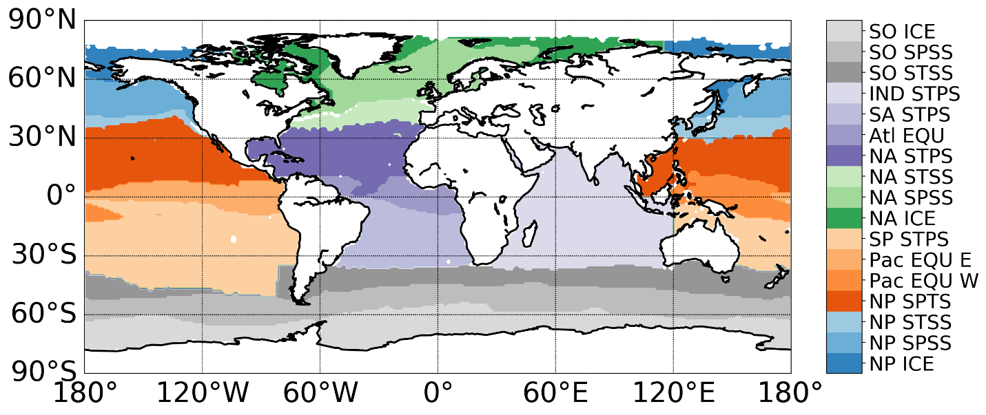

Supplementary Figure 1. Mean biome map created from mean climatologies of maxMLD, SST, summer Chl a, and maximum ice fraction. The acronyms include ice biome (ICE), subpolar seasonally stratified biome (SPSS), subtropical seasonally stratified biome (STSS),subtropical permanently stratified biome (STPS), equatorial biome (EQU). The super-biome we defined and used in the tagged simulations are aggregated based on these open-ocean biomes.

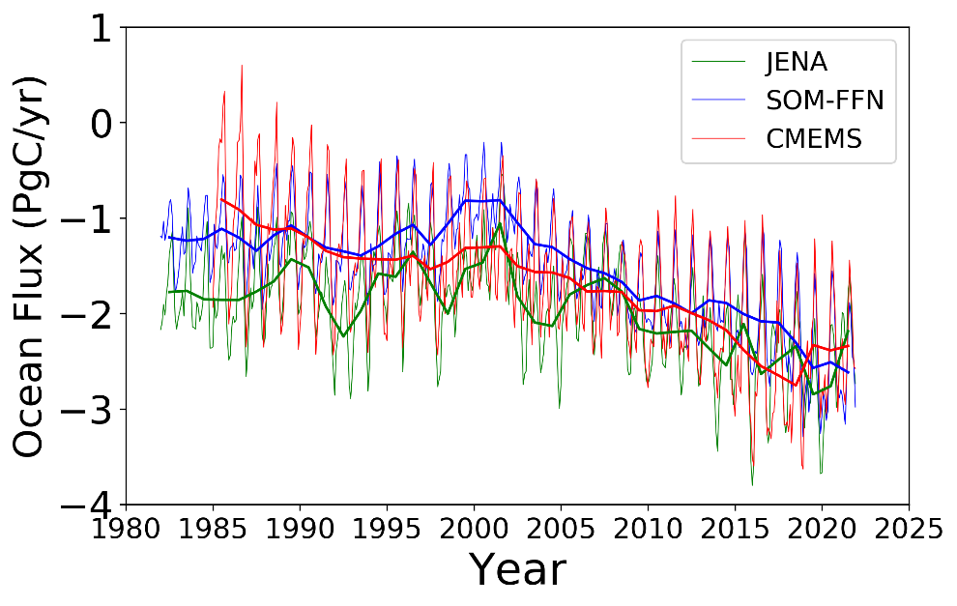
Supplementary Figure 2. The global CO₂ fluxes between the ocean and atmosphere based on three different products.

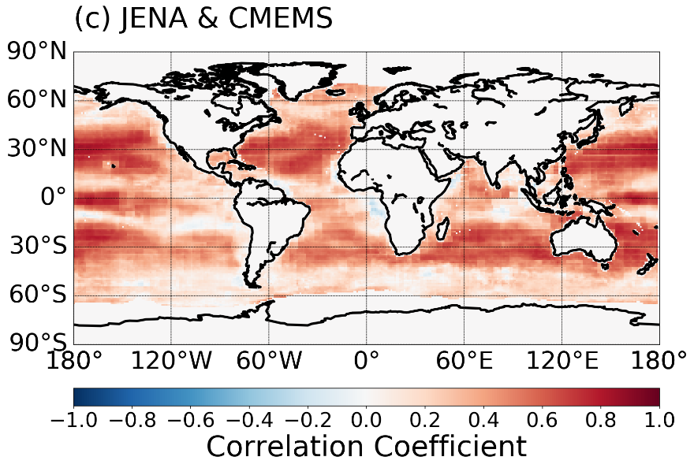
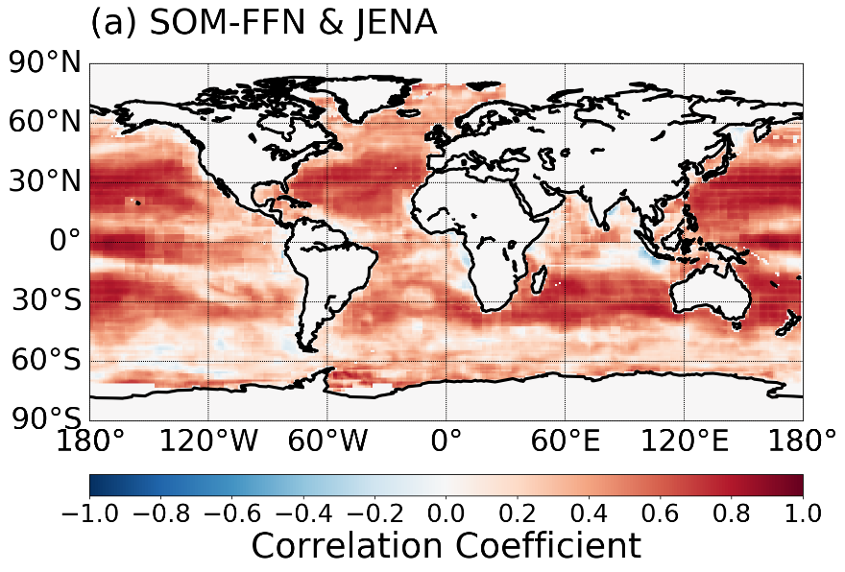
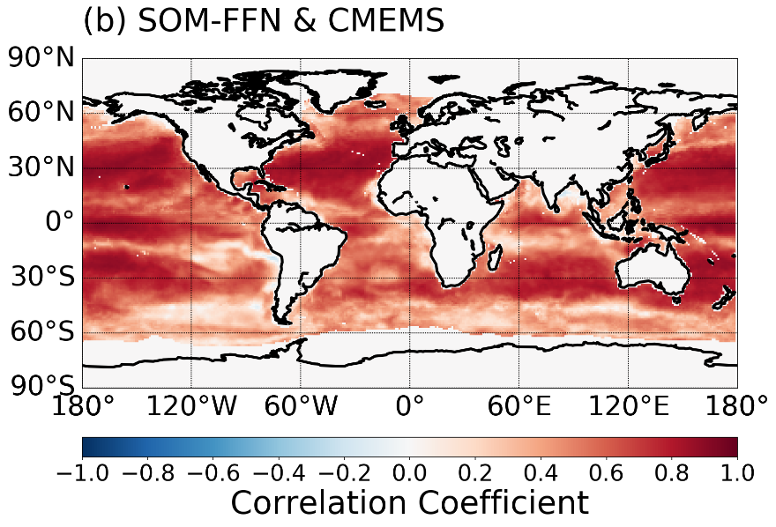

Supplementary Figure 3. The correlation coefficient between the CO₂ fluxes based on different products. (a) between SOM-FFN and JENA, (b) between SOM-FFN and CMEMS, (c) between CMEMS and JENA

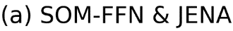
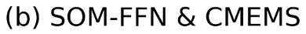
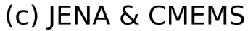
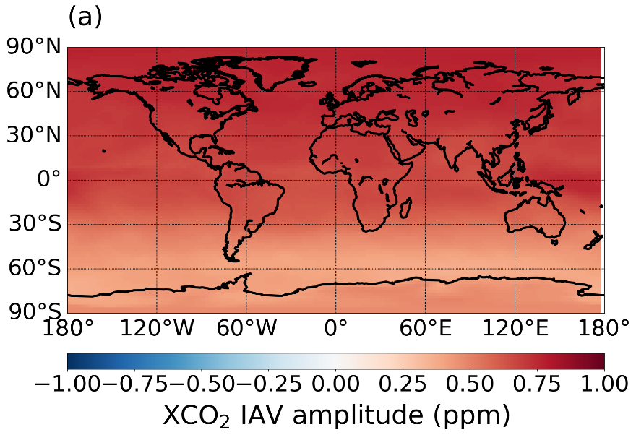
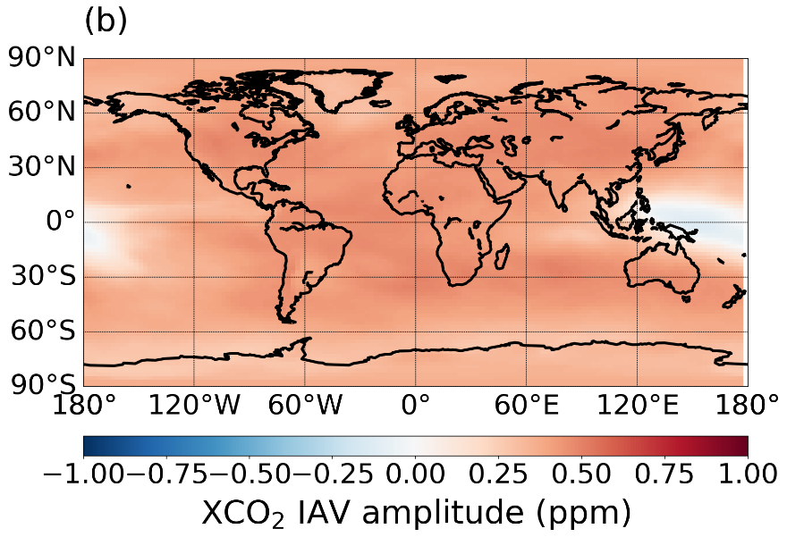
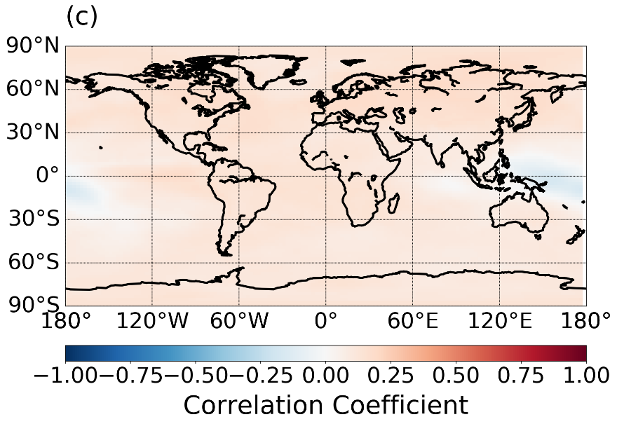

Supplementary Figure 4. Correlation coefficient between the modeled XCO₂ IAV based on dynamic simulation using different products.(a) between SOM-FFN and JENA, (b) between SOM-FFN and CMEMS, (c) between CMEMS and JENA
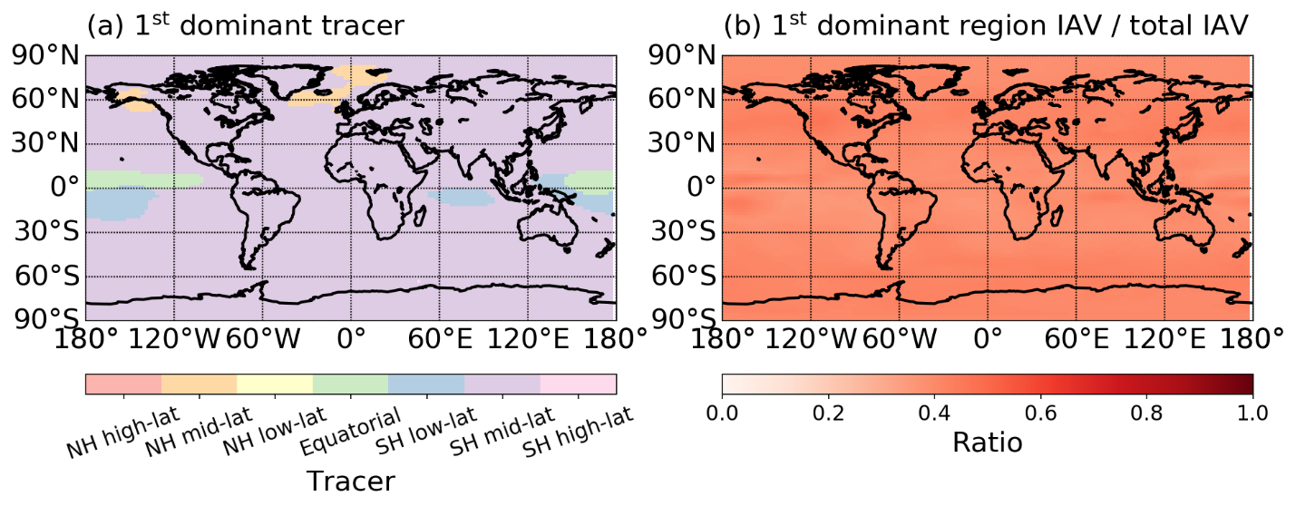
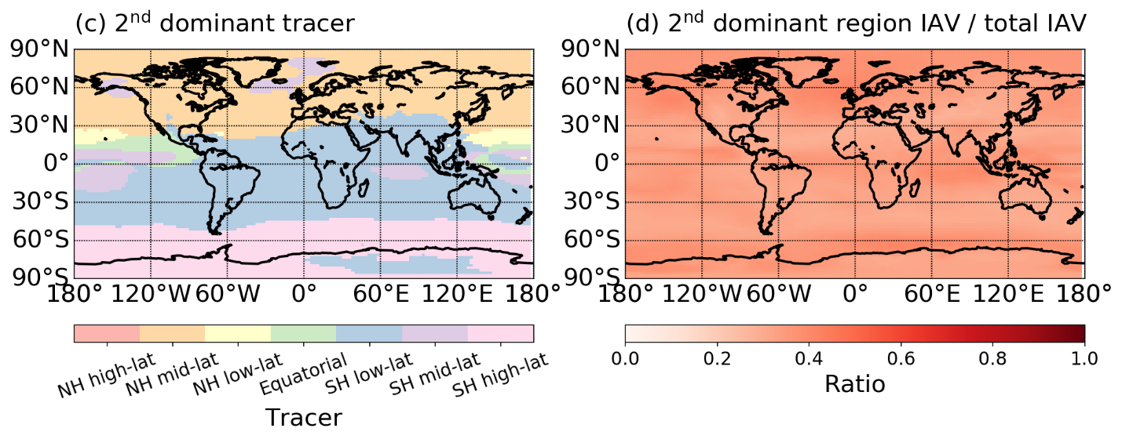
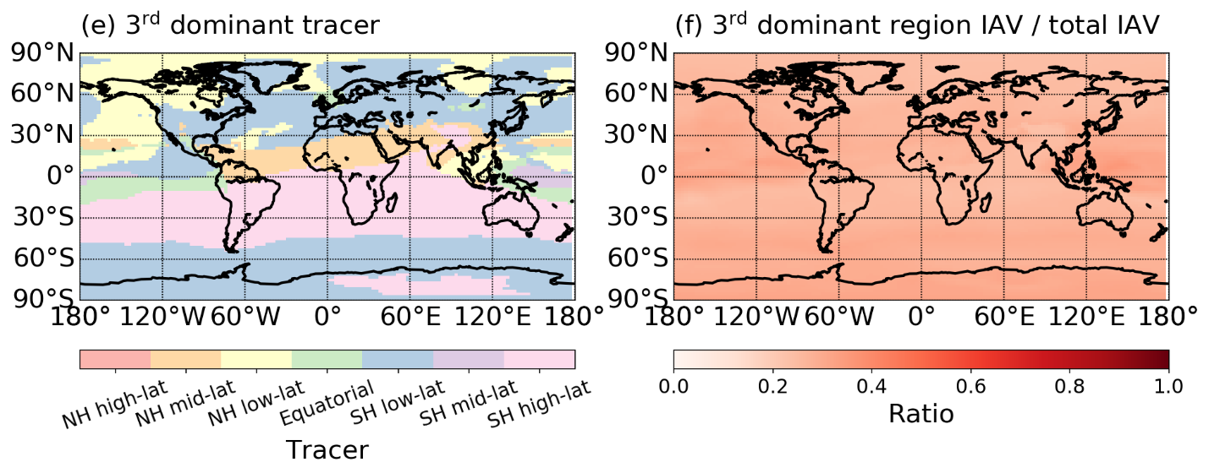
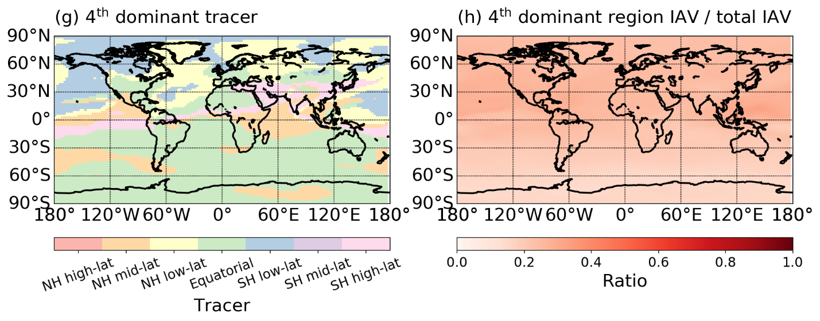
Supplementary Figure 5. First four most important tracers contributing to XCO₂ IAV based on time-varying fluxes from SOMFFN and time-varying transport. The tracers in the left column are determined by calculating XCO₂ IAV amplitude for each gridcell caused by each single tracer and ranking them relative to other tracers. The ‘right column shows the ratio of modelled XCO₂ IAV amplitude of the tracer to that of the whole ocean. (a)(b) for first most important tracer,(c)(d) for second most important,(e)(f) for third most important tracer,(g)(h) for fourth most important tracer.

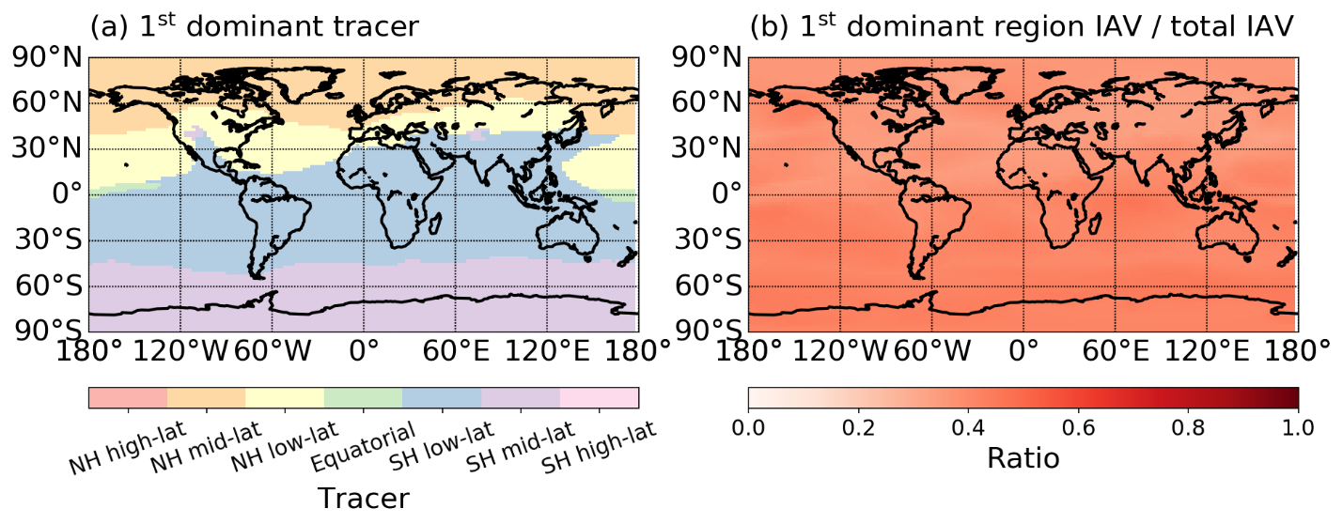
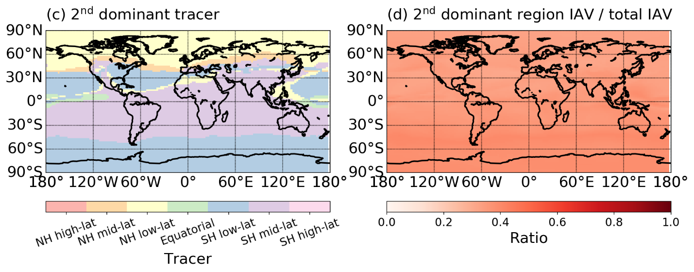
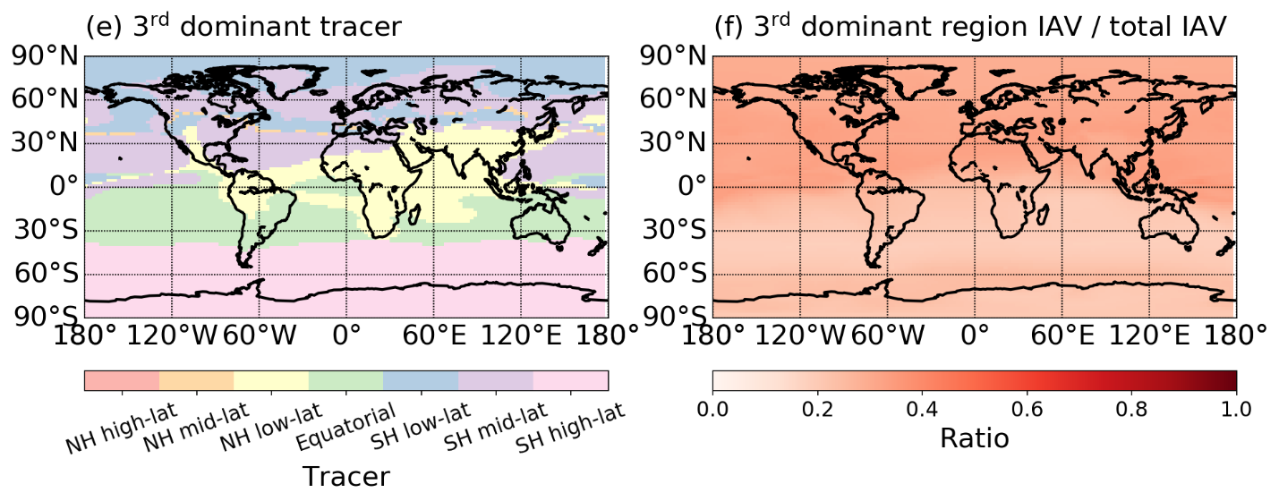
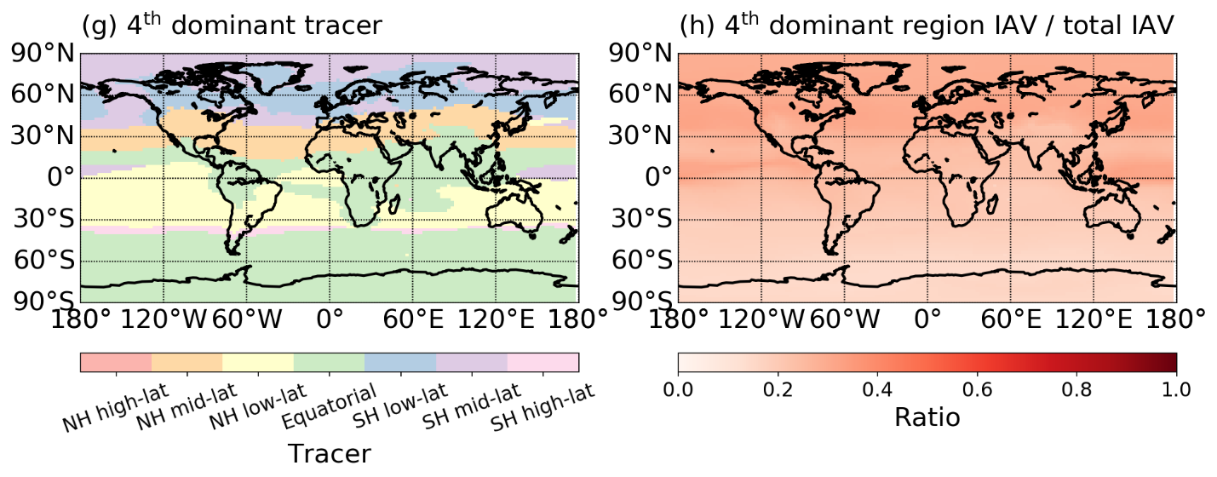
Supplementary Figure 6. First four most important tracers contributing to XCO₂ IAV based on time-varying fluxes from Jena and time-varying transport. The tracers in the left column are determined by calculating XCO₂ IAV amplitude for each gridcell caused by each single tracer and ranking them relative to other tracers. The ‘right column shows the ratio of modelled XCO₂ IAV amplitude of the tracer to that of the whole ocean. (a)(b) for first most important tracer,(c)(d) for second most important,(e)(f) for third most important tracer,(g)(h) for fourth most important tracer.tracer,(k)(l) for sixth most important tracer,(m)(n) for seventh most important tracer.

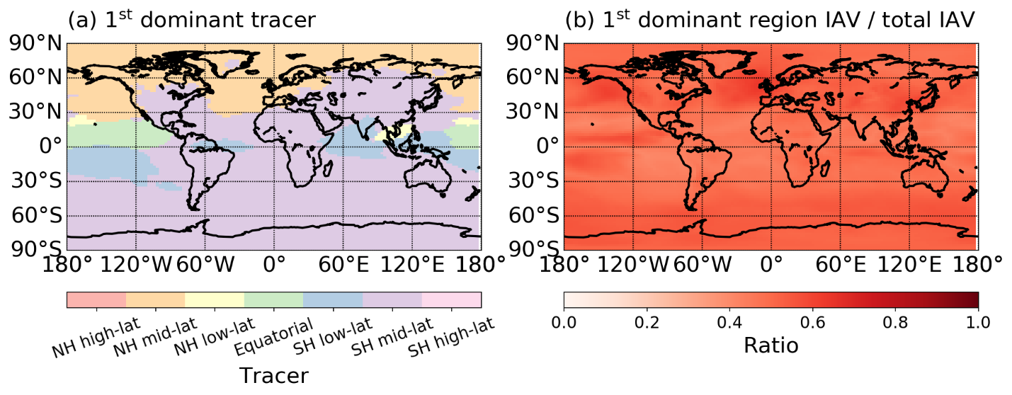
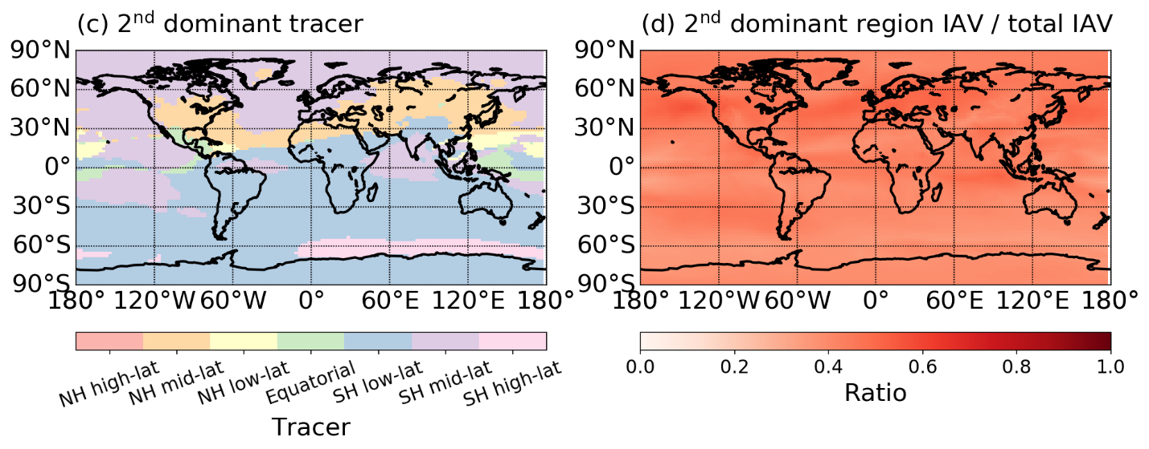
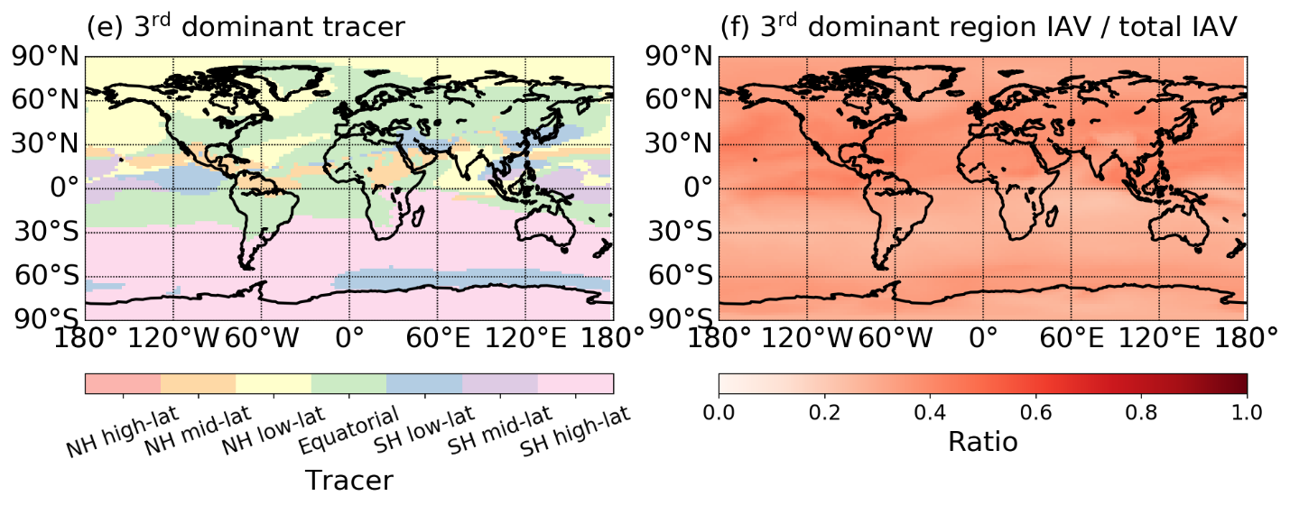
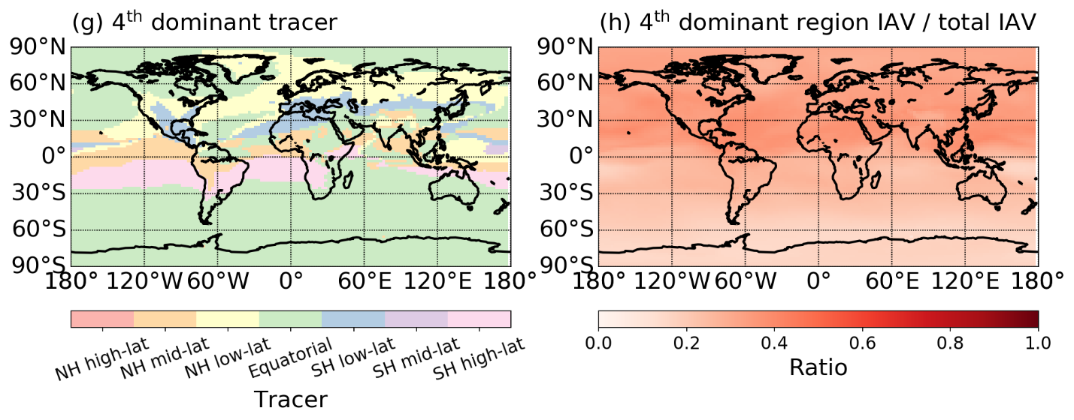
Supplementary Figure 7. First four most important tracers contributing to XCO₂ IAV based on time-varying fluxes from CMEMS and time-varying transport. The tracers in the left column are determined by calculating XCO₂ IAV amplitude for each gridcell caused by each single tracer and ranking them relative to other tracers. The ‘right column shows the ratio of modelled XCO₂ IAV amplitude of the tracer to that of the whole ocean. (a)(b) for first most important tracer,(c)(d) for second most important,(e)(f) for third most important tracer,(g)(h) for fourth most important tracer.

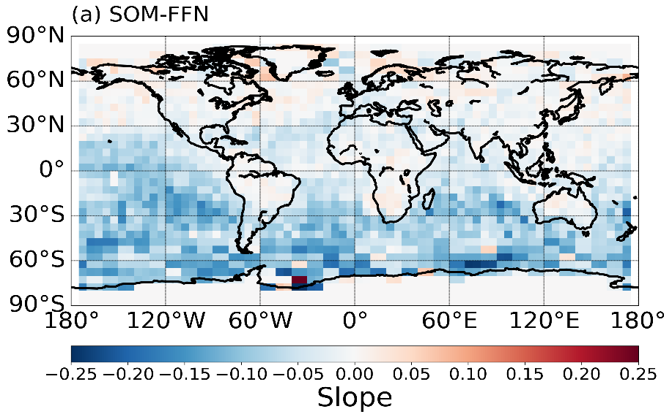
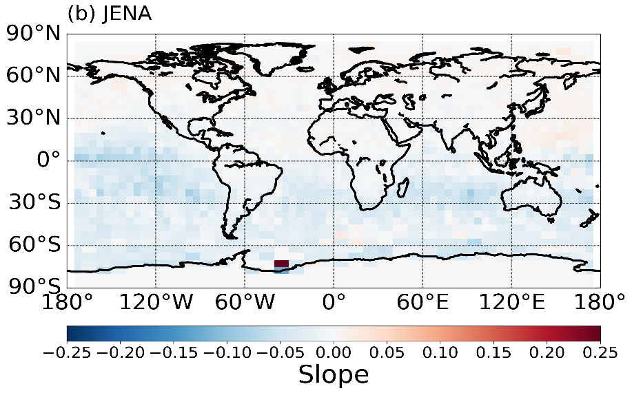
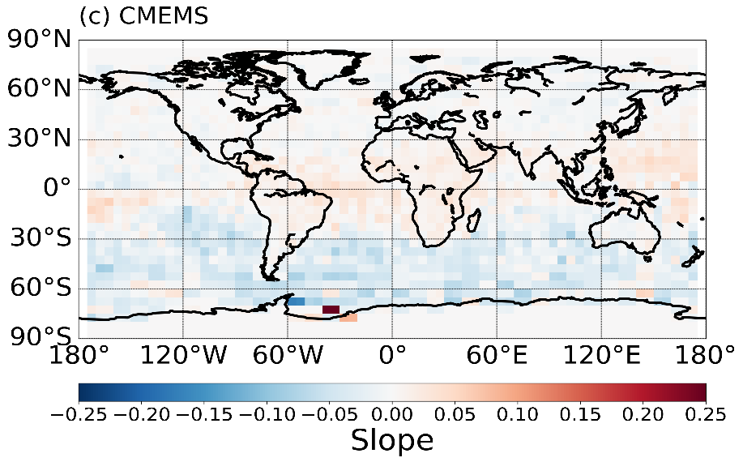

Supplementary Figure 8. The slope of regression between simulated oceanic XCO₂ IAV and OCO-2 detected XCO₂ IAV, (a) for SOMFFN, (b) for JENA, (c) for CMEMS

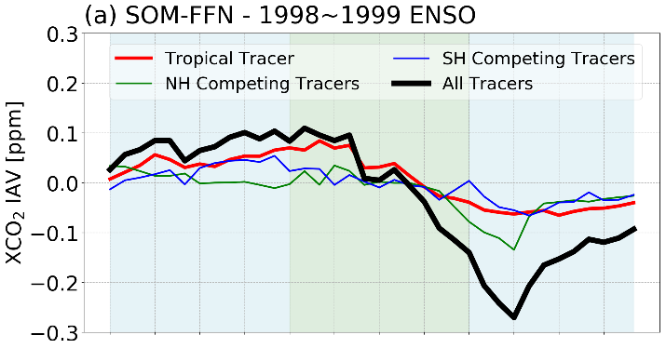
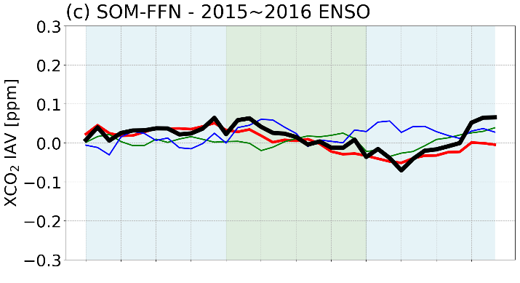
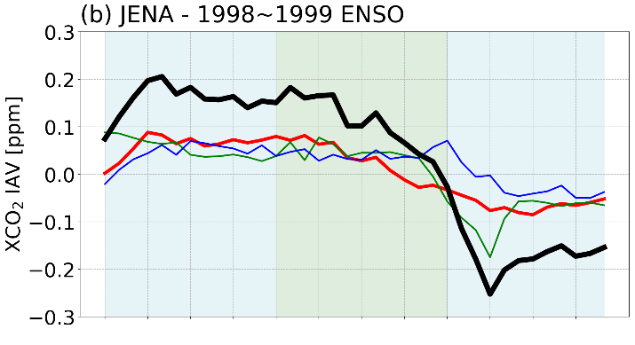
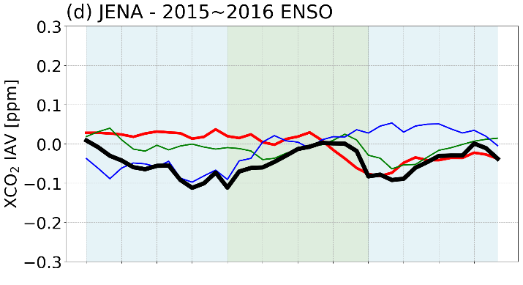
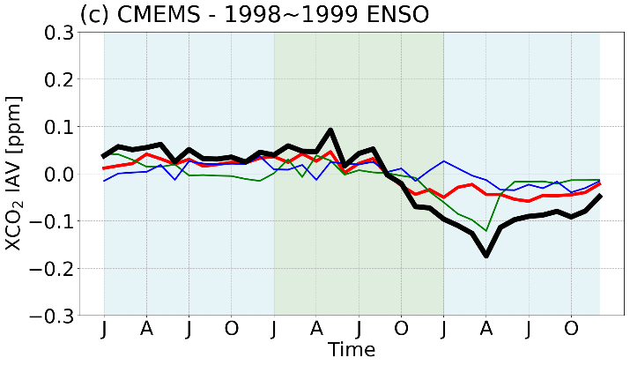
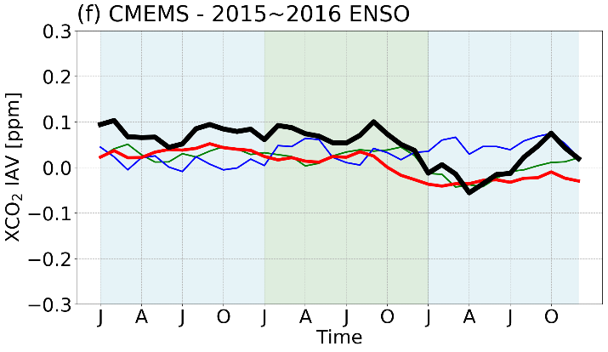

Supplementary Figure 9. The IAV timeseries averaged over the Nino 3.4 region of the key contributing tracers (NH mid-lat, NH low-lat, SH mid-lat, SH low-lat) in driving the XCO₂ IAV during 2 strong ENSO events: 1997-1998 and 2015-2016 - Year1 and Year3 are shaded with blue, Year2 is shaded with green. Tropical Tracer is in red, NH Key Competing Tracers is in green, SH Key Competing Tracers is in Blue, and Sum of All Tracers in black. Left Column is for the 1997-1998 ENSO, Right Column is for the 2015-2016 ENSO. (a)(d)for SOMFFN, (b)(e) for JENA, (c)(f) for CMEMS.

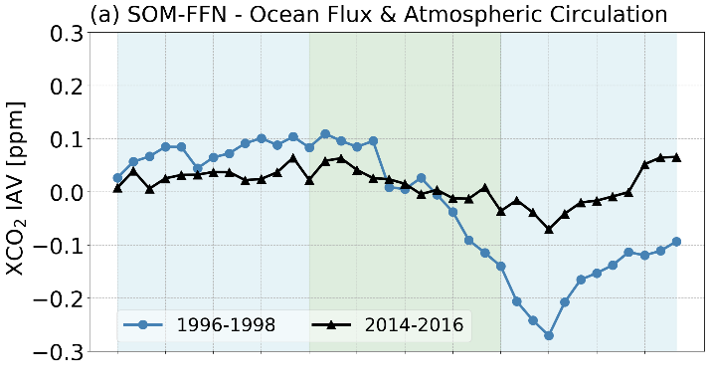
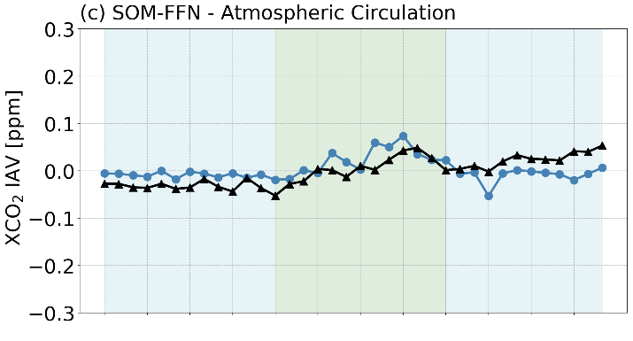
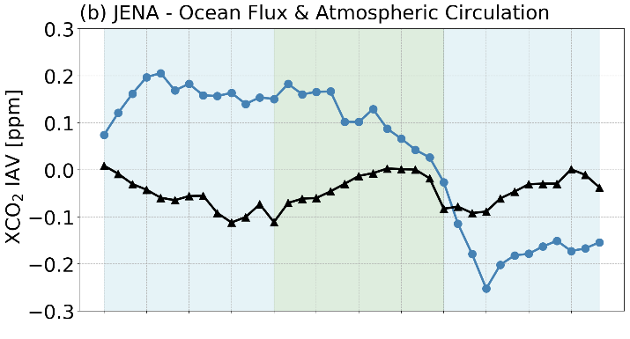
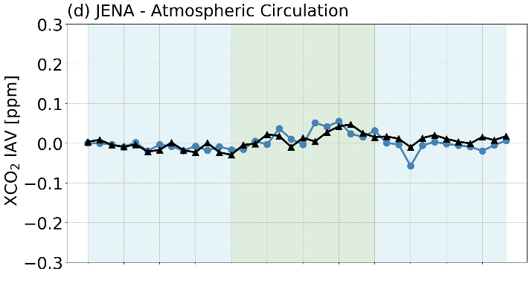
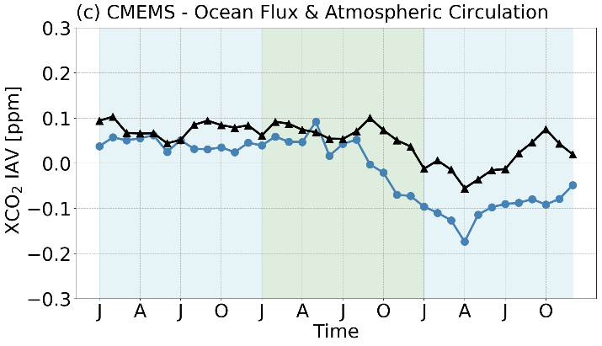
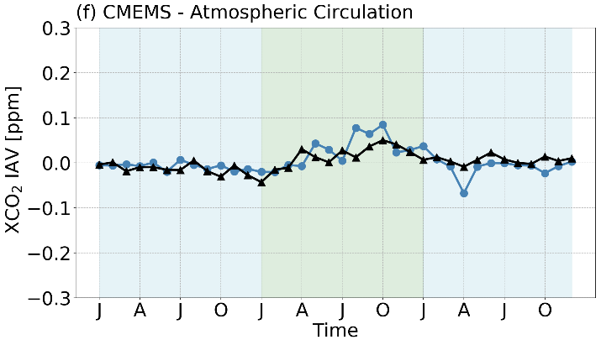
Supplementary Figure 10. The XCO₂ IAV timeseries averaged over the Nino 3.4 region of the key during 2 strong ENSO events: 1997-1998 and 2015-2016 - Year1 and Year3 are shaded with blue, Year2 is shaded with green. The left column is based on the simulation with varying fluxes. The right column is based on the simulation with cyclostationary fluxes. (a)(d)for SOM-FFN, (b)(e) for JENA, (c)(f) for CMEMS.

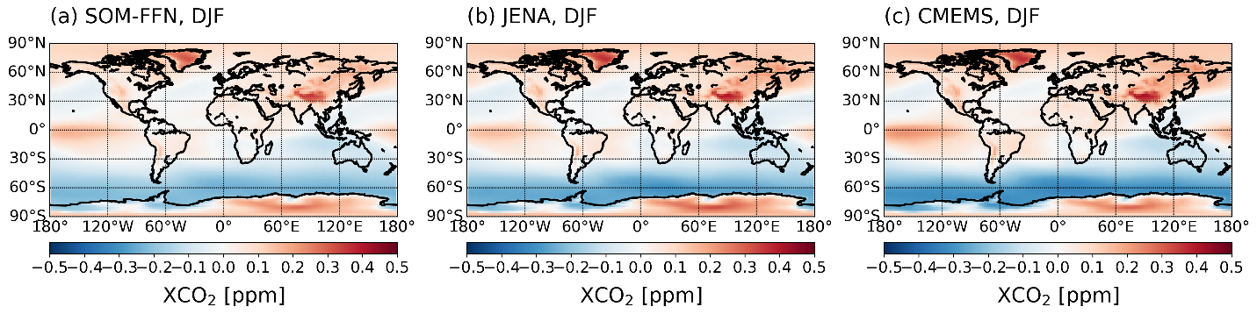
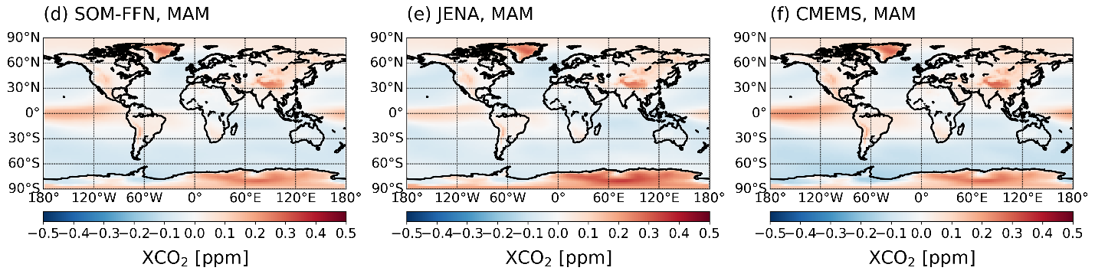
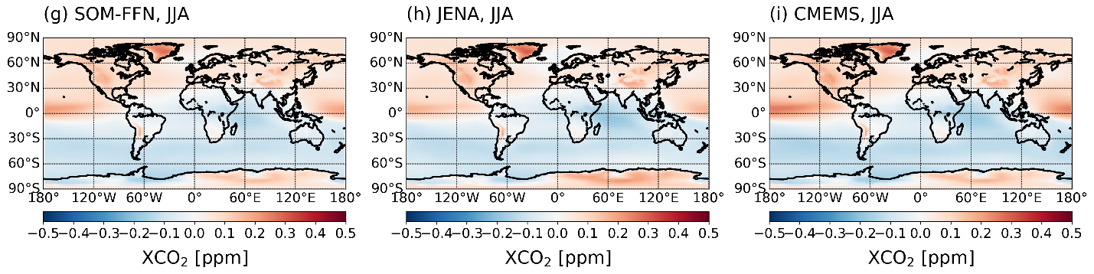
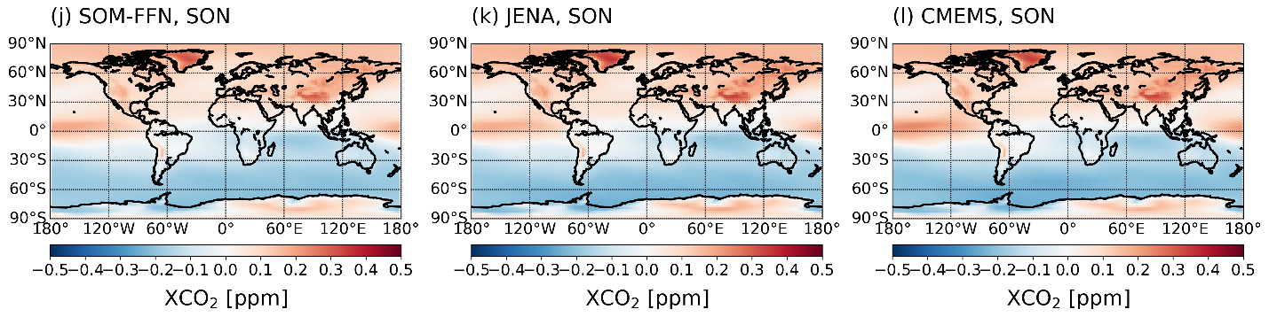
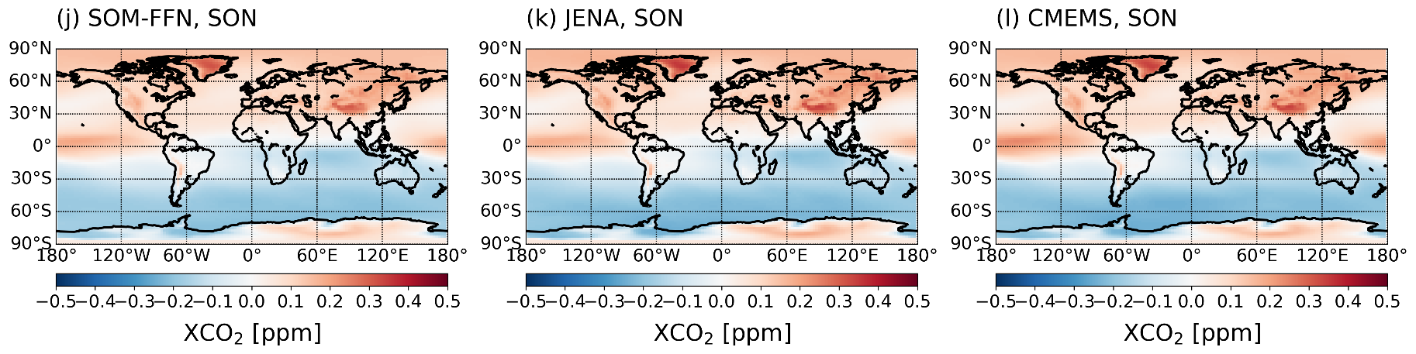

Supplementary Figure 11. Climatological XCO₂ gradients simulated for each observation-based flux product across four seasons. The gradient is calculated by subtracting the global mean seasonal XCO₂ from the simulated XCO₂ at every gridcell averaged over three months. The left column shows results for SOM-FFN, the middle column shows results for JENA, and the right column shows results for CMEMS. The first row shows results for winter (DJF), second row for spring (MAM), third row for summer (JJA) and fourth row for autumn (SON).

