Supplementary Material

Supplementary Figure
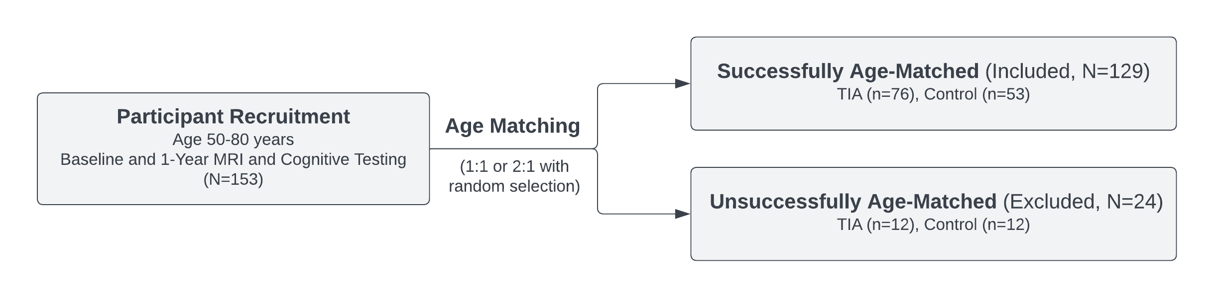
Supplementary Figure 1. Flow chart describing the age matching procedure and sample characteristics of included and excluded participants following matching.

