SUPPLEMENTARY TABLE 2 Atypical phenotypes in individuals from O. longistaminata accessions, such as lack of rhizomes, short stature, short stamens, and filled grains produced by selfing. Images of the phenotype are provided where available, or presence of the phenotype is noted. Lack of recorded atypical phenotype does not imply normal phenotype. Not all interspecific hybrids had an atypical phenotype, consistent with reports by Kanya (2010) and Kilewa (2014).
Study_sampleid | Lack of rhizomes | Short stature |  | Short stamens; filled grains produced by selfing
83826.001 | 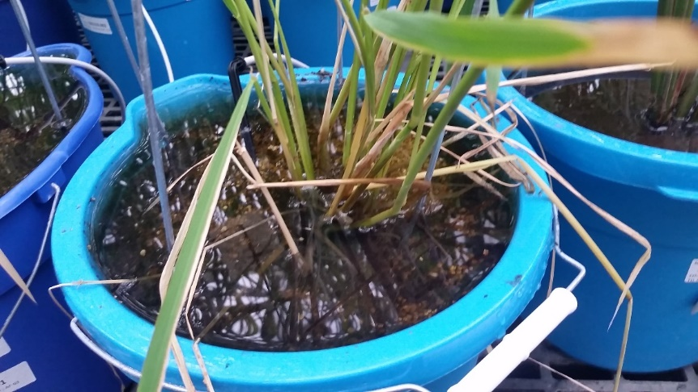 |  | 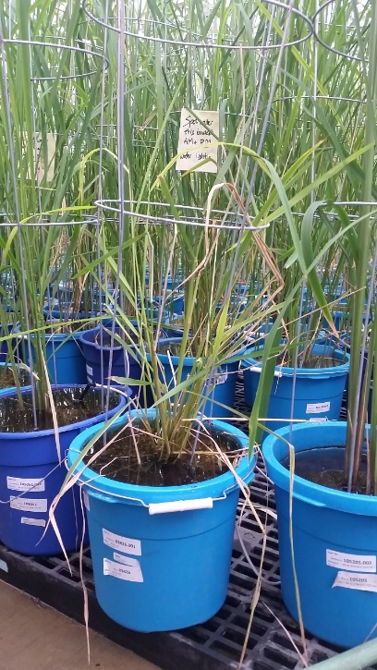 |  | 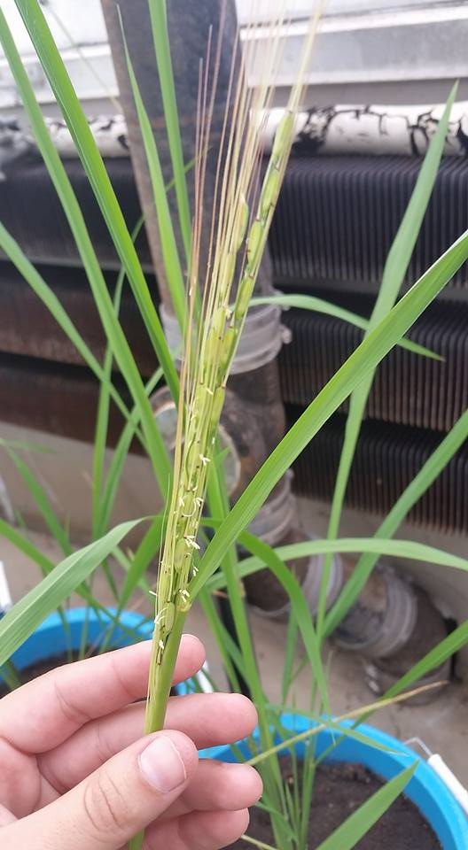
83826.002 | 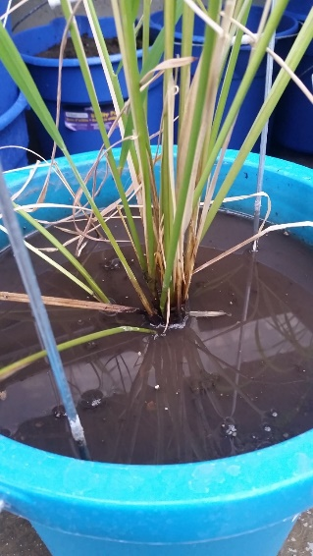 |  | 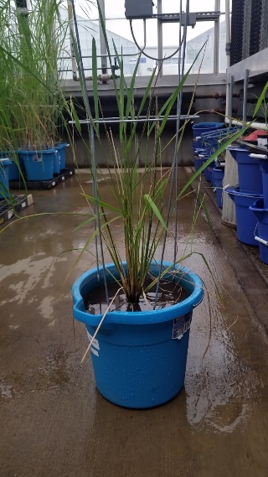 |  | 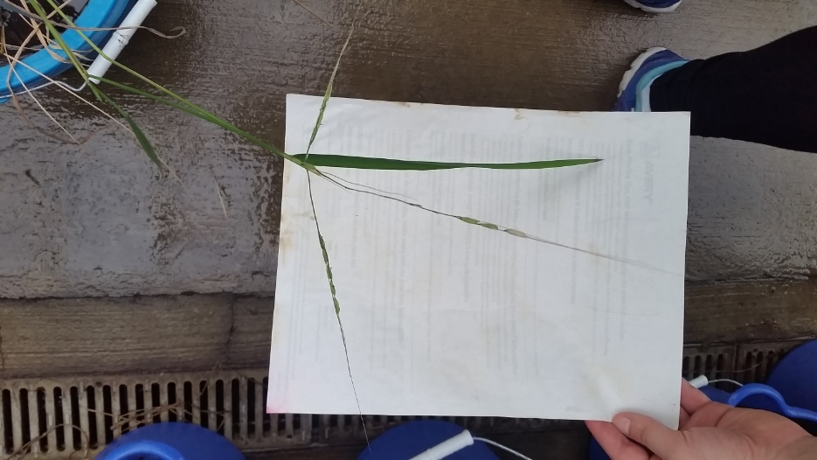
100930.001 | 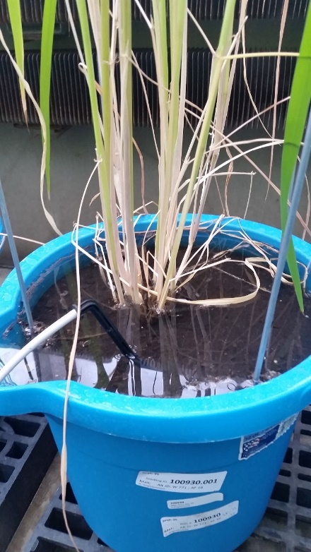 |  | NA |  | 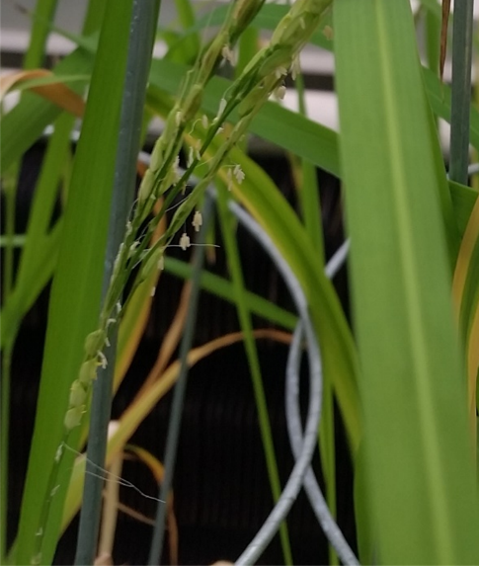
100930.002 | 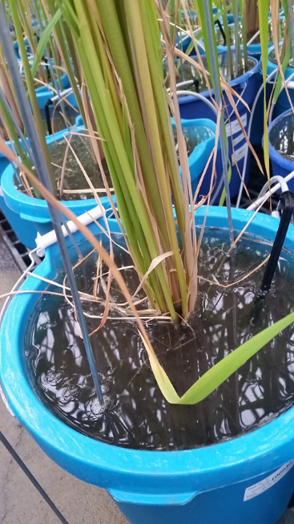 |  | NA |  | 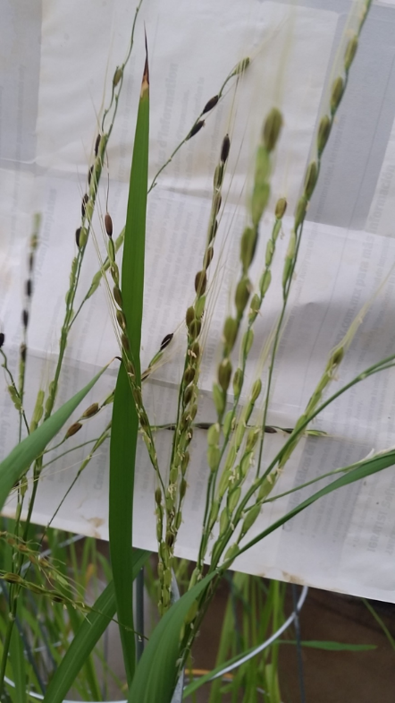
86483.002 | 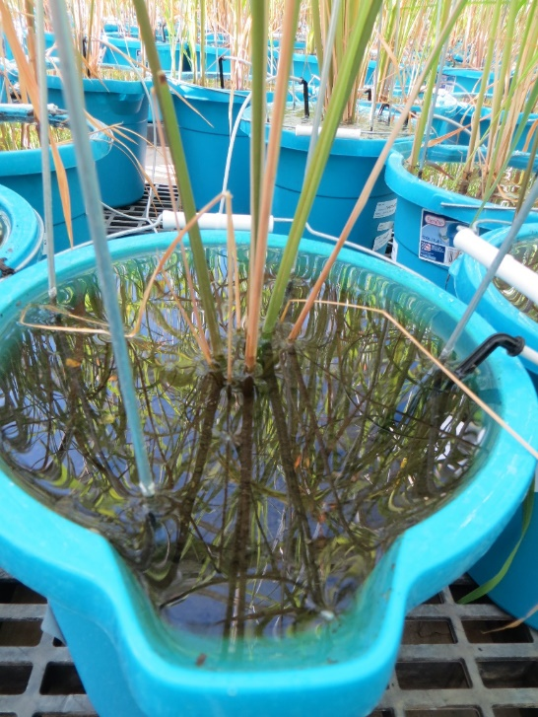 |  | NA |  | NA
104300.002 | 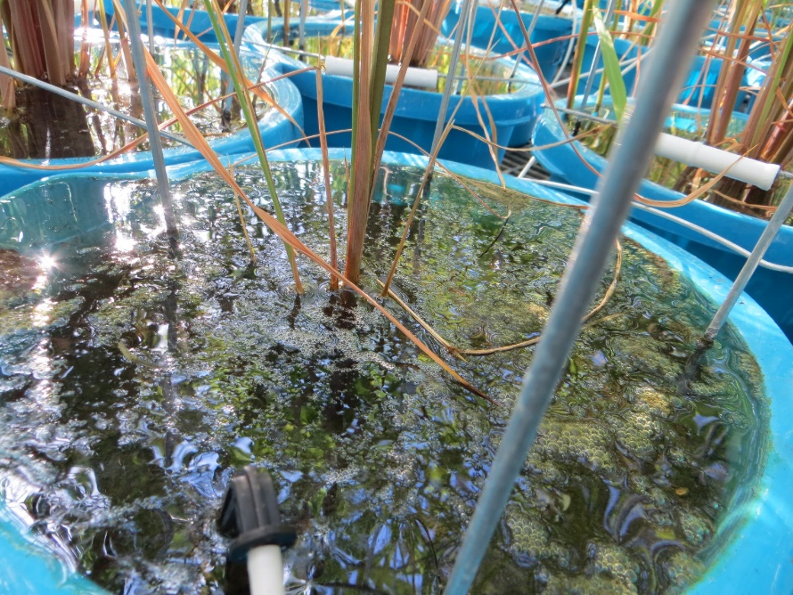 |  | NA |  | NA
103886.001 | 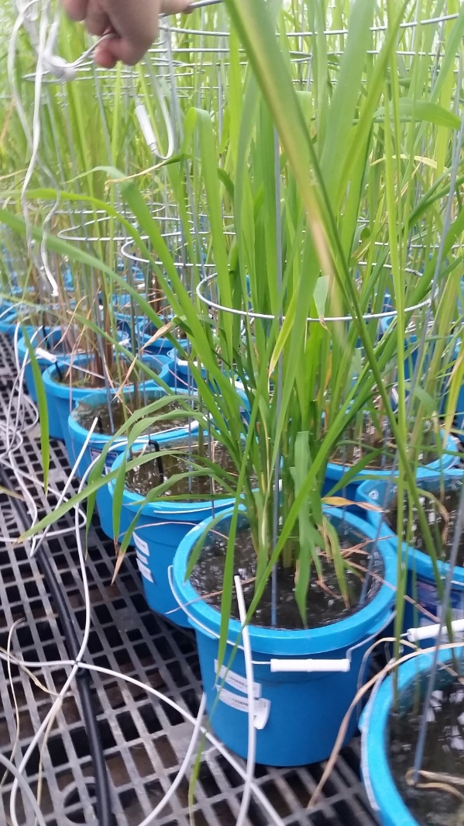 |  |  |  | NA
101211.001 | 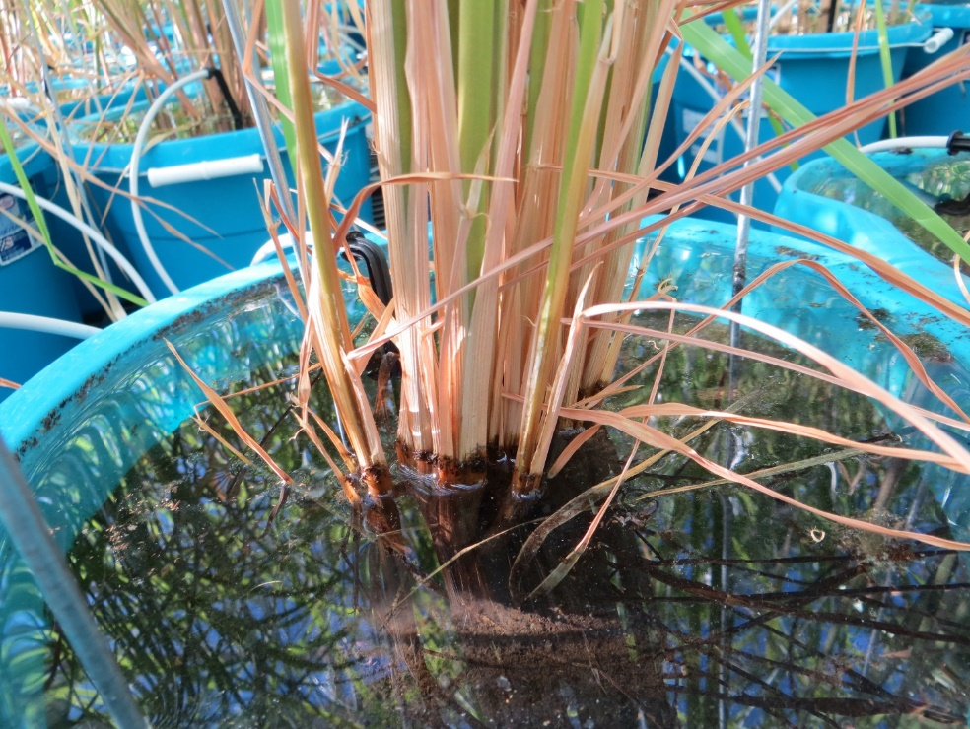 |  | NA |  | NA
101211.002 | 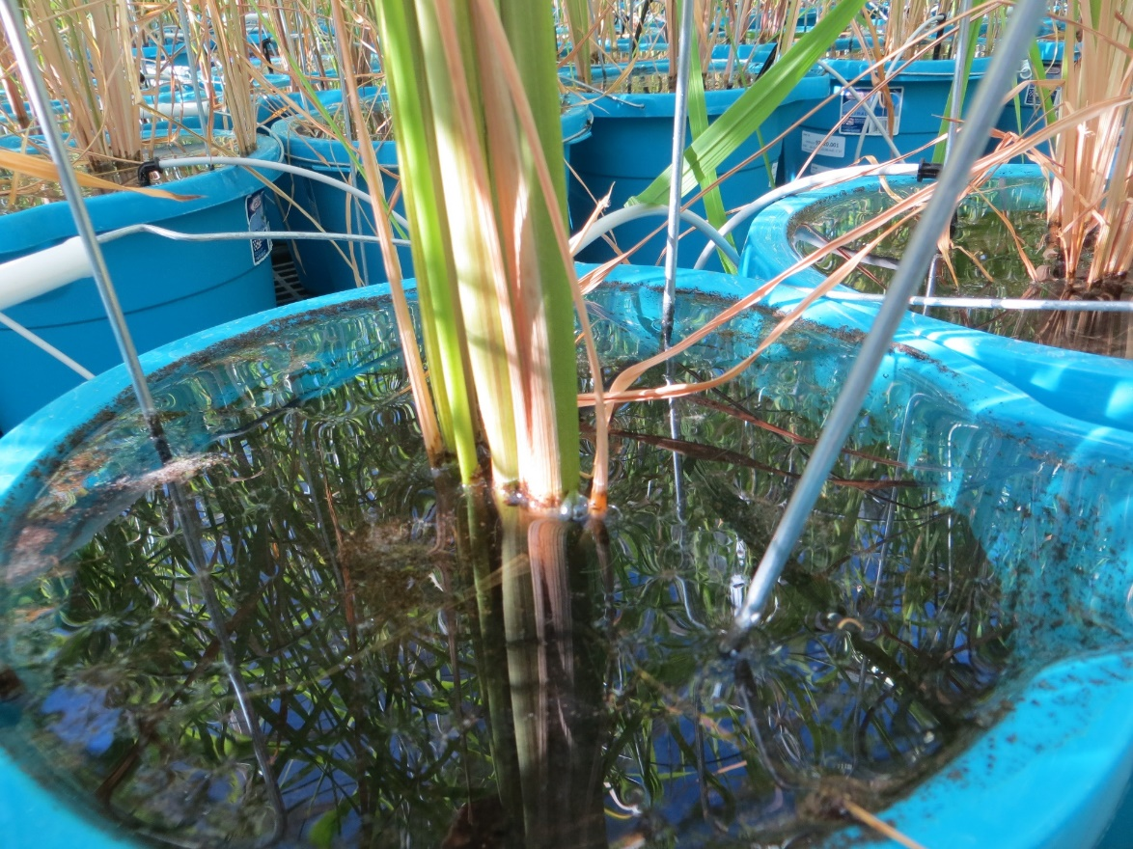 |  | NA |  | NA
101436.001 | 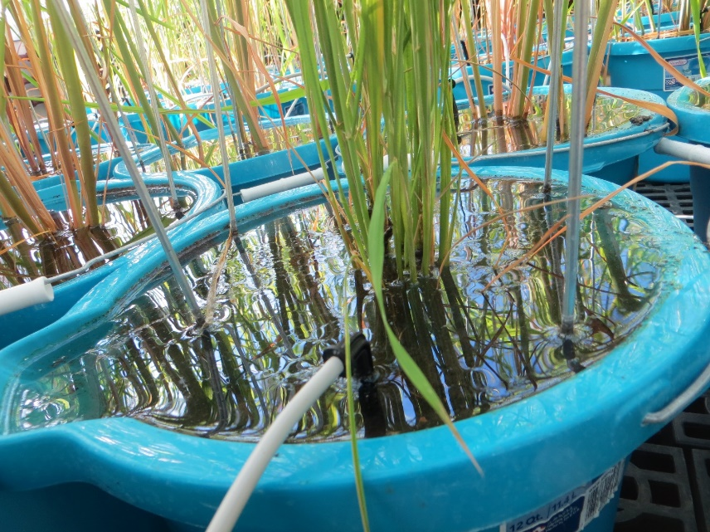 |  | NA |  | NA
101222.002 | 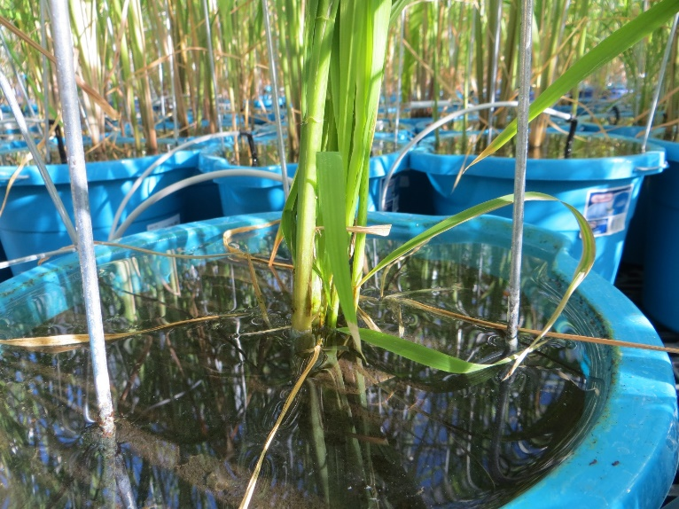 |  | Short stature noted |  | NA
101741.002 | 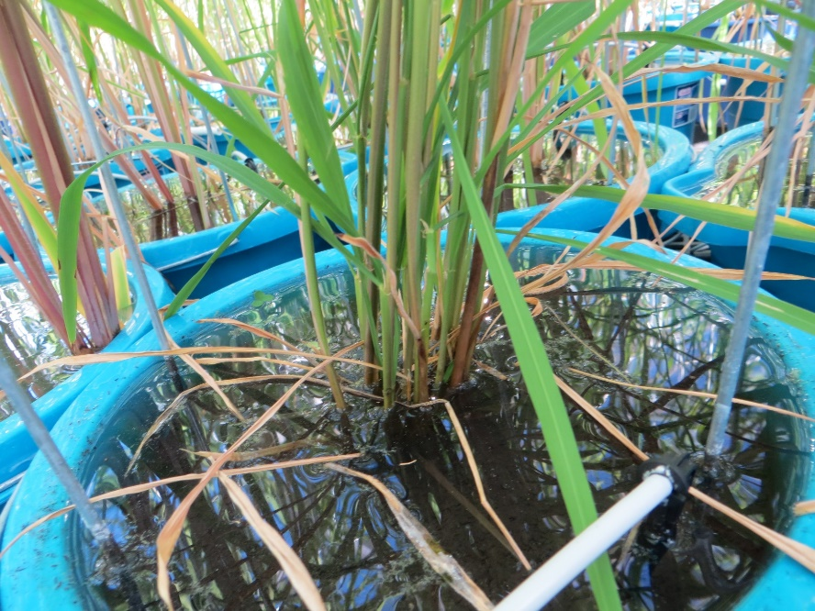 |  | Short stature noted |  | NA

