Platelet-lymphocyte ratio predicts chemotherapy response and prognosis in patients with gastric cancer undergoing radical resection
Qingnuo Zeng¹, Danfang Wang², Shilong Wang¹, Zilong Bai¹, Yuanhua Nie¹, Longwen Xu¹, Dongmin Chang^{1, #} and Dongmei Diao^{1, #}
¹Department of Oncology Surgery, First Affiliated Hospital of Xi’an Jiaotong University, Xi’an, China;
²Department of Xi'an Medical University, Xi’an, China;
#Corresponding Author: Dr. Dongmei Diao and and Prof. Dongmin Chang, Department of Surgical Oncology, First Affiliated Hospital Medical college Xi'an Jiaotong University, 277 West Yanta Road, Xi’an, Shaanxi 710061, P.R. China. Tel: 86-29-85324612, Fax: 86-29-85324612, E-mail: diaomei310@mail.xjtu.edu.cn; sdmqqw@126.com.

Supplementary Table 1. Univariate and multivariate analyses for disease-free survival of GC patients with low PLR (N=509).
Parameters | Univariate analysis |  |  | Multivariate analysis
Parameters | HR | 95%CI | P value | HR | 95%CI | P value
Gender | 1.151 | 0.8-1.655 | 0.449
Age | 1.618 | 1.203-2.175 | 0.001 |  |  | 0.257
FIB | 2.047 | 1.53-2.738 | <0.001 | 1.493 | 1.078-2.068 | 0.016
SIRI | 1.292 | 0.97-1.722 | 0.08
PNI | 0.537 | 0.389-0.741 | <0.001 |  |  | 0.352
SII | 1.386 | 1.006-1.909 | 0.046 |  |  | 0.842
NLR | 1.455 | 1.081-1.958 | 0.013 |  |  | 0.42
LPR | 4.849 | 3.42-6.877 | <0.001 | 2.149 | 1.403-3.292 | <0.001
Tumor size | 2.099 | 1.528-2.885 | <0.001 |  |  | 0.304
Tumor location
proximal stomach | 1
distal stomach | 0.604 | 0.431-0.845 | 0.003 |  |  | 0.525
full stomach | 1.417 | 0.954-2.105 | 0.084 |  |  | 0.171
Histology | 0.903 | 0.663-1.229 | 0.515
TNM stage
I | 1 |  |  | 1
II | 1.777 | 0.863-3.659 | 0.119 | 2.786 | 1.17-6.633 | 0.021
III | 7.679 | 4.651-12.679 | <0.001 | 10.094 | 4.432-22.992 | <0.001
Chemotherapy¹ | 2.973 | 2.101-4.205 | <0.001 | 0.402 | 0.245-0.66 | <0.001
HR, hazard ratio; CI, confidence interval. The reference of parameters was female, age<60 years, FIB<3.585, PLR<163.8, SIRI<0.665, PNI<40.06, SII<456.3, NLR<2.08, LNR<0.085, tumor size<5 cm, undifferentiated and without adjuvant chemotherapy, respectively. ¹In the univariate analysis considering only TNM stage II-III, the HR for adjuvant chemotherapy was 0.161 (95% CI: 0.113-0.228, P<0.001).

Supplementary Table 2. Univariate and multivariate analyses for disease-free survival of GC patients with high PLR (N=221).
Parameters | Univariate analysis |  |  | Multivariate analysis
Parameters | HR | 95%CI | P value | HR | 95%CI | P value
Gender | 1.4 | 0.922-2.126 | 0.114
Age | 1.634 | 1.105-2.416 | 0.014 | 1.601 | 1.044-2.457 | 0.031
FIB | 1.12 | 0.768-1.633 | 0.557
SIRI | 1.795 | 1.132-2.846 | 0.013 | 1.96 | 1.121-3.426 | 0.018
PNI | 0.495 | 0.314-0.78 | 0.002 |  |  | 0.168
SII | 1.247 | 0.751-2.068 | 0.393
NLR | 1.133 | 0.737-1.743 | 0.569
LNR | 3.569 | 2.292-5.559 | <0.001 | 3.314 | 2.125-5.168 | <0.001
Tumor size | 1.314 | 0.867-1.99 | 0.198
Tumor location
proximal stomach | 1
distal stomach | 0.876 | 0.556-1.379 | 0.567
full stomach | 1.571 | 0.88-2.803 | 0.127
Histology | 0.812 | 0.525-1.256 | 0.349
TNM stage
I | 1
II | 2.219 | 0.885-5.564 | 0.089 |  |  | 0.214
III | 4.224 | 1.954-9.133 | <0.001 |  |  | 0.634
Chemotherapy¹ | 1.525 | 0.991-2.347 | 0.055 |  |  | 0.055
The reference of parameters was female, age<60 years, FIB<3.585, PLR<163.8, SIRI<0.665, PNI<40.06, SII<456.3, NLR<2.08, LNR<0.085, tumor size<5 cm, undifferentiated and without adjuvant chemotherapy, respectively. ¹In the univariate analysis considering only TNM stage II-III, the HR for adjuvant chemotherapy was 0.396 (95% CI: 0.254-0.616, P<0.001).

Figure legends
Supplementary Figure 1. ROC curves of inflammation factors. (a) ROC curve for PLR; (b) ROC curve for SIRI; (c) ROC curve for PNI; (d) ROC curve for SII; (e) ROC curve for NLR; (f) ROC curve for LNR; (g) ROC curve for FIB.
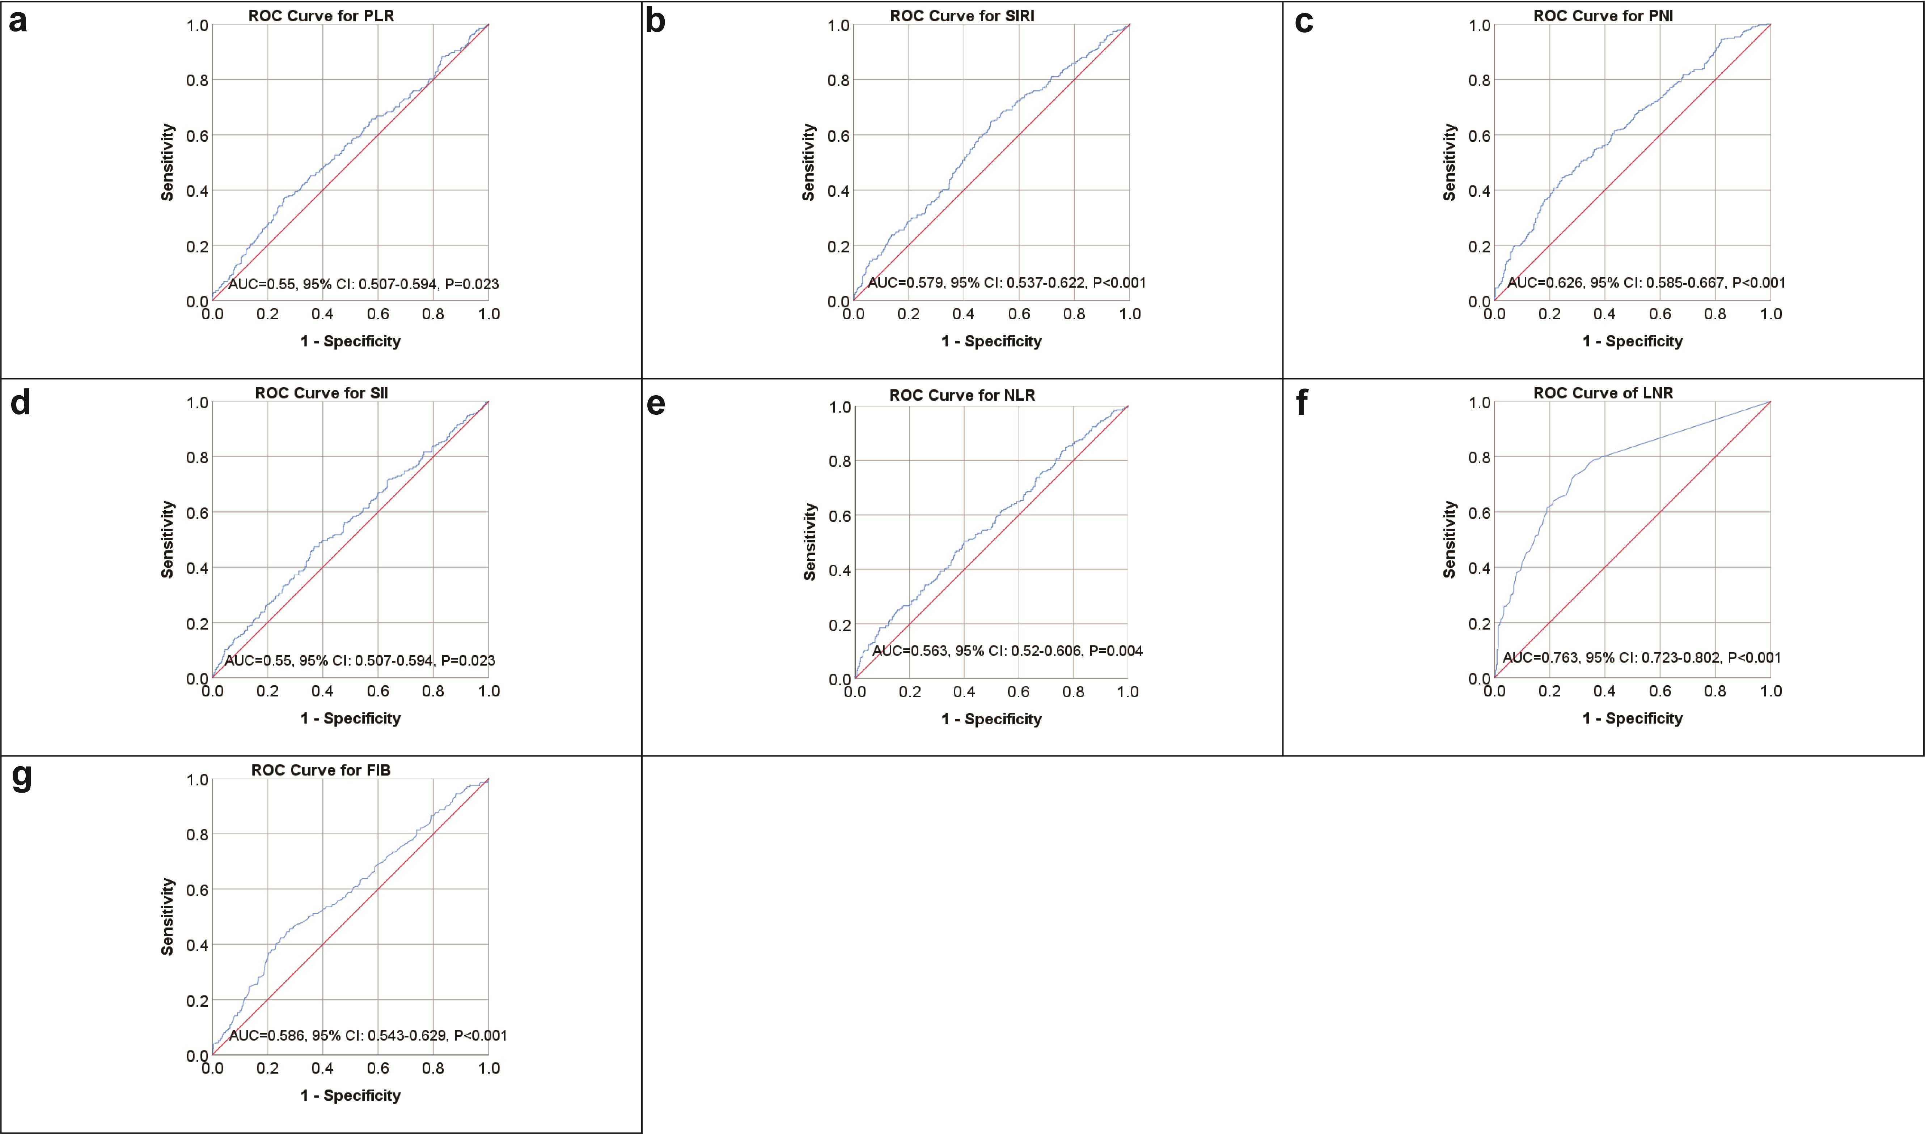
Supplementary Figure 2. Kaplan-Meier survival curves of patients with gastric cancer. (a) Survival curves of FIB for OS; (b) survival curves of FIB for DFS; (c) survival curves of SIRI for OS; (d) survival curves of SIRI for DFS; (e) survival curves of PNI for OS; (f) survival curves of PNI for DFS; (g) survival curves of SII for OS; (h) survival curves of SII for DF; (i) survival curves of NLR for OS; (j) survival curves of NLR for DFS.
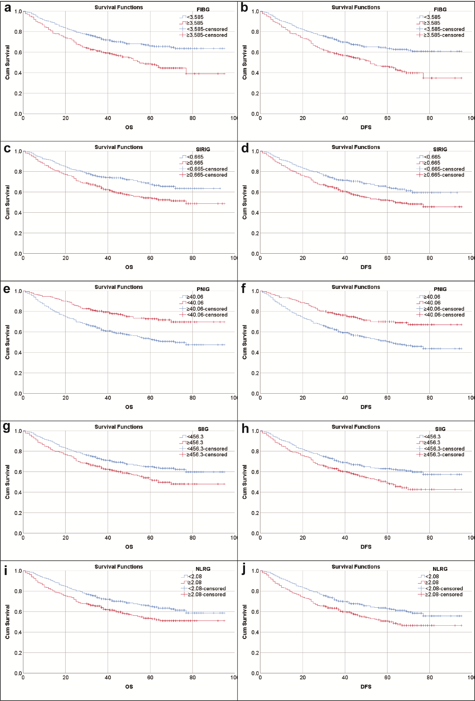
Supplementary Figure 3. Kaplan-Meier survival curves between PLR groups in patients receiving adjuvant chemotherapy. (a) Survival curve for OS of all patients receiving chemotherapy; (b) survival curve for DFS of all patients receiving chemotherapy; (c) survival curve for OS of stage II patients receiving chemotherapy; (d) survival curve for DFS of stage II patients receiving chemotherapy; (e) survival curve for OS of stage III patients receiving chemotherapy; (f) survival curve for DFS of stage III patients receiving chemotherapy.

