Supplementary Material
Functional evaluation of complement factor I variants by immunoassays and SDS-PAGE
Alexandra Gerogianni†, Laura M. Baas†, Dick J. Sjöström, Nicole C.A.J van de Kar, Marit Pullen, Siem J. van de Peppel, Per H. Nilsson‡, Lambertus P. van den Heuvel‡*.
*Correspondence: Lambertus P. van den Heuvel, bert.vandenheuvel@radboudumc.nl

Supplementary Figures and Tables

Supplementary Figures

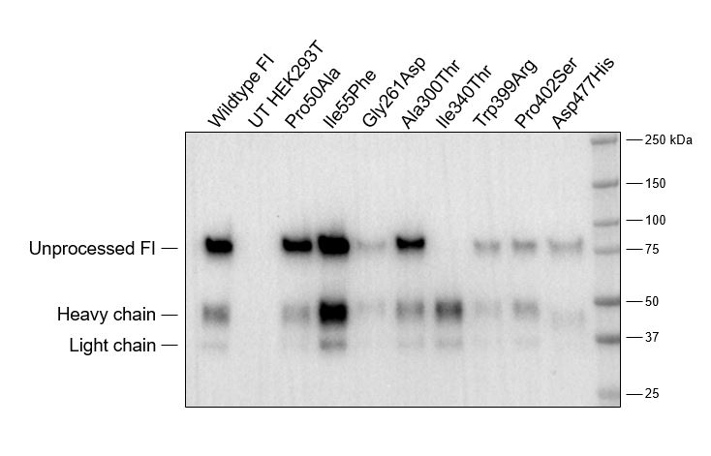
Supplementary Figure 1. Western blot analysis of recombinant proteins. Proteins were run on SDS-PAGE under reducing conditions and presence of unprocessed FI (88kDa), the FI heavy chain (50 kDa) and the FI light chain (38 kDa) were confirmed with a polyclonal goat anti-human FI antibody. Abbreviations used: FI; Factor I, UT; Untreated

Supplementary Tables
Supplementary Table 1. Primer sequences used for point mutagenesis. Primer sequences used for point mutagenesis. Protein numbering includes the signal peptide. The base altered by site-directed mutagenesis is indicated in red. For the reverse primer, either overlapping primers (two altered bases/primer set; indicated by *) or non-overlapping primers (one altered base/primer set; indicated by **) was used.

