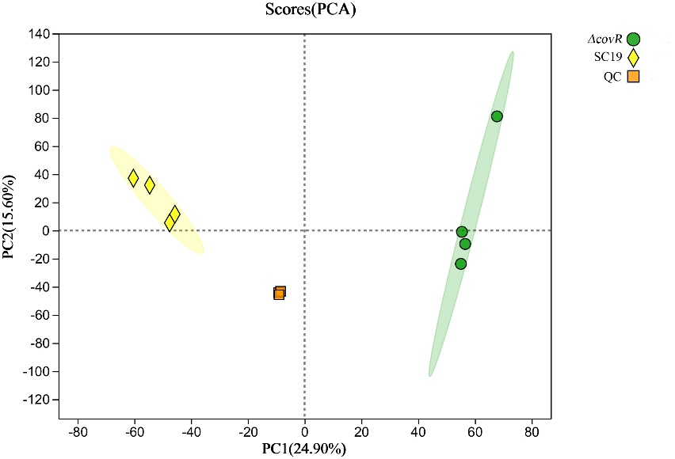

**Supplementary figure S1** Principal component analysis of metabolites identified from Δ *covR* and SC19. Equal volumes of Δ *covR* and SC19 samples were mixed to generate a quality control (QC）