A1. Anomaly of annual extreme precipitation frequency

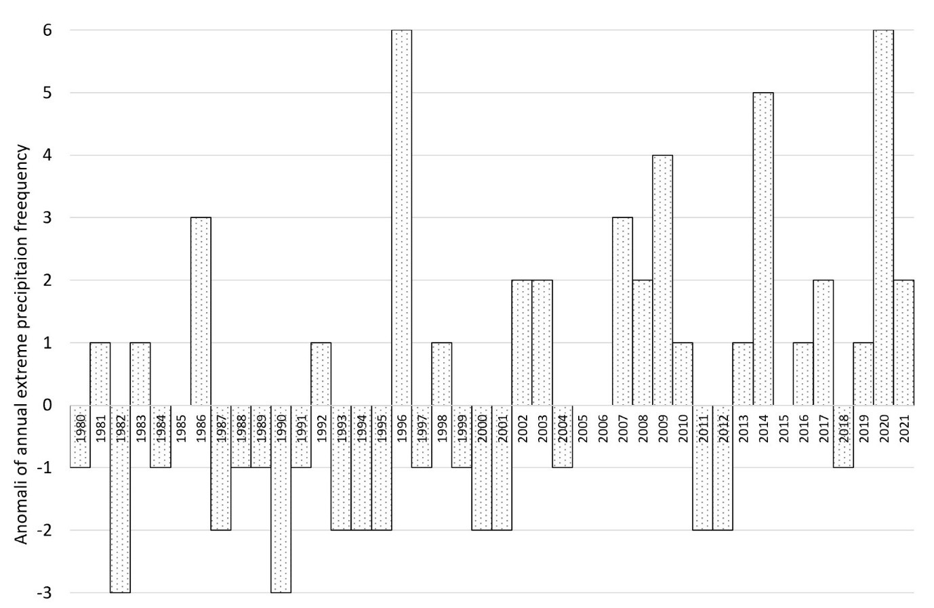

A2. List of Climate-Related Hazards from 2015-2022 in the Seribu Islands

|  |  |  |  |  |
| --- | --- | --- | --- | --- |
| Year | Location | Time | Note | Source |
| 2022 | Pari Island  Rob: 15-30 cm | 25 December 2022 | Depth range of tidal flooding: 15-30 cm  Based on interviews conducted by Mashabi in 2022,  Flooding in a year can be 18-15 times. Every season there are at least eight floods. | <https://pulauseribu.jakarta.go.id/post/12674/Tiga-Titik-di-Kelurahan-Pulau-Pari-Tergenang-Rob>  Mashabi,S. 2022. Banjir Rob di Kepulauan Seribu, Wagub DKI: Bertahap Kami Atasi. Access on Jan 4, 2023. Available online at https://megapolitan.kompas.com/read/2022/09/23/11122311/banjir-rob-di-kepulauan-seribu-wagub-dki-bertahap-kami-atasi. |
| 2022 | Pari Island | October 2022 | Forest fire; It burned a forest area of up to 500 square meters.  It was presumably triggered by burning garbage that spread to the forest, and strong winds accelerated the burning process. | <https://pulauseribu.jakarta.go.id/post/Petugas-Sudin-Gulkarmat-Berhasil-Padamkan-Kebakaran-Hutan-di-Kelurahan-Pulau-Pari> |
| 2021 | Kelapa Island,  Lancang Island | 4-5 December 2021 | Flood Depth in Kelapa Island: 40 cm  Flood Depth in Lancang Island: 30- 130 cm  Ardian said the sea water level reached 50 centimeters to 1.3 meters from 08.00 a.m - 10.50 a.m local time (Wiryono, 2021) | <https://megapolitan.kompas.com/read/2021/12/05/13585261/1-rt-di-kepulauan-seribu-dilanda-banjir-rob-hingga-40-sentimeter#:~:text=JAKARTA%2C%20KOMPAS.com%20%2D%20Kepulauan,terjadi%20di%20Kelurahan%20Kepulauan%20Kelapa>.  Wiryono, S. 2021. 1 RT di Kepulauan Seribu Dilanda Banjir Rob hingga 40 Sentimeter. Access on Jan 4, 2023. Available online at <https://megapolitan.kompas.com/read/2021/12/05/13585261/1-rt-di-kepulauan-seribu-dilanda-banjir-rob-hingga-40-sentimeter>. |
| 2020 | Pari Island | November 2020 | Edi claimed that until then, tidal floods had only ever reached the shoreline and had never made it inland. An elderly Pari Island resident named Rohany acknowledged the island's flooding problem. The 65-year-old man said he had only witnessed and experienced flooding all his life due to the rob until he came ashore this year (Wuragil, 2020). | Wuragil, Z. 2020. Banjir Rendam Pulau Pari di Kepulauan Seribu, Warga: Tambah Parah. Access on January 19, 2023. Available at  <https://tekno.tempo.co/read/1406393/banjir-rendam-pulau-pari-di-kepulauan-seribu-warga-tambah-parah> |
|  | Southern part of Seribu Islands:  Lancangisland, Pari Island, Tidung Island | 4 June 2020 | Flood Depth: 10-30 cm | https://pulauseribu.jakarta.go.id/post/8689/Puluhan-Rumah-di-Kelurahan-Pulau-Pari-Diterjang-Banjir-Rob |
| 2019 | Untung  Island | 6 September 2019 | Coastal flooding  Three people pass away | https://pusatkrisis.kemkes.go.id/Banjir-di-ADM.-KEPULAUAN-SERIBU-DKI-JAKARTA-06-09-2019-98 |
| 2019 | Pari Island | 16 Oktober 2019 | The forest fire, which spread over area of around 4,000 meters, is believed to have been started by cigarettes that were left burning in the trash. | <https://pulauseribu.jakarta.go.id/post/Sudin-Gulkarmat-Berhasil-Padamkan-Kebakaran-Hutan-di-Pulau-Pari> |
| 2019 | Tidung Kecil  Island | 12 September 2019 | Two hectares of peatland were burned. | <https://pulauseribu.jakarta.go.id/post/Kebakaran-Hutan-Gambut-di-Pulau-Tidung-Kecil-Berhasil-Dipadamkan> |
| 2018 | Northern Part of Seribu Islands | 2 February 2018 | Tornados on February 2, 2018:  The incident caused damage to dozens of homes. According to the initial information we received from BPBD, 3 government buildings and 72 housing units were damaged. Although 288 people were impacted by this tragedy, there were no fatalities. | https://penanggulangankrisis.kemkes.go.id/Angin%20Puting%20Beliung-di-ADM.%20KEPULAUAN%20SERIBU-DKI%20JAKARTA-02-02-2018-0 |
| 2018 | Pari Island | 1 January 2018 | The location of the weeds forest fire covers an area of 4 hectares. This incident was caused by Cigarette butt | <https://pulauseribu.jakarta.go.id/post/Kebakaran-Hutan-Ilalang-di-Pulau-Pari-Berhasil-Dipadamkan-> |
| 2017 | Panggang Island, Harapan Island, Kelapa Island, Tidung Island, Untung Jawa Island and Lancang Island | 5 December 2017 | Flood Depth: 30-45 cm  Six islands in the Seribu Islands were flooded during high tide. | https://pulauseribu.jakarta.go.id/post/4234/Air-Laut-Pasang,-Enam-Pulau-di-Kepulauan-Seribu-Tergenang-Banjir-Rob- |
| 2017 | Pari Islands | 14 October 2017 | On Pari Island, there is a 2-hectare weed forest fire. | <https://pulauseribu.jakarta.go.id/post/Kebakaran-Hutan-Ilalang-Di-Pulau-Pari-Berhasil-Dipadamkan-> |
| 2017 | Kelapa dua Island | 15 November | The tornado damaged 34 residences. | <https://www.polreskepulauanseribu.com/2017/11/puting-beliung-melanda-pulau-kelapa-dua.html> |
| 2016 | Tidung Island | 22 September 2016 | Tornados   * Damage to houses totaled 177 houses, with details of 28 homes with heavy damage, 149 with light damage * Two power poles collapsed * The public cemetery boundary wall collapsed for about 12 meters * Two repeater poles/antenna towers collapsed belonging to the Tidung Island sub-district and the Dishub antenna tower * Approximately 45 (forty-five) trees fell. * One unit of the teacher's official residence was slightly damaged. | https://bnpb.go.id/berita/177-rumah-rusak-diterjang-puting-beliung-di-pulau-tidung-kepulauan-seribu |
| 2015 | Tidung  Islands  Pari Island | 2015 | The wildfire destroyed ten thousand square meters of Tidung's vegetation. This first instance was a human-induced case brought on by smoking or disposing of cigarette ends. Moreover, a 20,000 m2 tract of vegetated land in Pari was burned at the same time in 2015 due to open rubbish-burning activities in a location close to the bushes. | Lestari, F., Adiwibowo, A., Kadir, A.M., & Ramadhan, N.A. (2022). Validating the 6 year (2016–2021) anthropogenic induced small island wildfire hazards in Pulau Seribu archipelago, Indonesia. Progress in Disaster Science, 14,100236. <https://doi.org/10.1016/j.pdisas.2022.100236> |
| 2015 | Seribu Islands | February 19, 2015 | Storm surge  1 ship (KM Aditya) sunk | <https://digilib.esaunggul.ac.id/public/UEU-Research-9746-16_0102.pdf> |
| 2014 | Panggang Island | January 16, 2014 | Tornadoes  Damaging 40 residents | <https://digilib.esaunggul.ac.id/public/UEU-Research-9746-16_0102.pdf>  <https://www.polreskepulauanseribu.com/2014/01/polres-kep-seribu-beserta-pemda-kep.html> |
| 2012 | Northern part of Seribu Islands | January 25, 2012 | The tornado damaged 500 residences. | <https://pulauseribu.jakarta.go.id/file/1.%20RENSTRA%20Kabupaten%20Tahun%202017-2022.pdf> |
| 2008 | Harapan Island  Kelada Island | January 5, 2008 | Tornados  Damaging 275 and 13 residents in Kelada Island and Harapan Island | <https://digilib.esaunggul.ac.id/public/UEU-Research-9746-16_0102.pdf>  page 33 |

**A3. Man Kendall Test**

|  |
| --- |
| **Minimum Temperature**  z = 19.415, n = 491, p-value < 2.2e-16  Alternative hypothesis: true S is not equal to 0  sample estimates:  S varS tau  7.051700e+04 1.319227e+07 5.863907e-01 |
| **Average Temperature**  z = 8.9722, n = 362, p-value < 2.2e-16  Alternative hypothesis: true S is not equal to 0  sample estimates:  S varS tau  2.064200e+04 5.292573e+06 3.160207e-01 |
| **Maximum Temperature**  z = 3.6493, n = 503, p-value = 0.000263  Alternative hypothesis: true S is not equal to 0  sample estimates:  S varS tau  1.374400e+04 1.418236e+07 1.088862e-01 |
| **Frequency of Extreme Temperature**  z = 2.0498, n = 42, p-value = 0.04039  Alternative hypothesis: true S is not equal to 0  sample estimates:  S varS tau  190.0000000 8502.0000000 0.2220969 |
| **Sea Level Rise**  z = 8.4778, n = 353, p-value < 2.2e-16  alternative hypothesis: true S is not equal to 0  sample estimates:  S varS tau  1.878300e+04 4.908111e+06 3.023299e-01 |
| **SPI**  z = 3.0602, n = 492, p-value = 0.002212  alternative hypothesis: true S is not equal to 0  sample estimates:  S varS tau  1.115000e+04 1.327303e+07 9.231584e-02 |

A4. Self-reclamation by reef stone

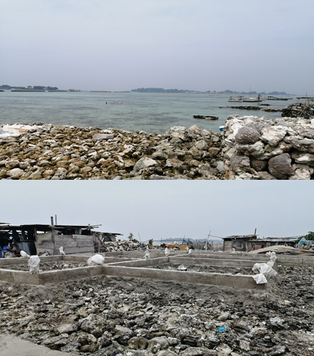

A5. Resume on deep interview with local stakeholder

|  |  |  |  |
| --- | --- | --- | --- |
| Topic | Local Stakeholder | Number of participant | Response |
| Have you noticed a difference in the climate between past and present? Please explain | National Authorities | 1 representative of the Seribu Island National Park | * Yes, there was a massive abrasion in Pramuka Island before the year of 2004. * The weather is getting hot. * Shifting season- the weather becomes unpredictable * In the Northern part of Seribu Islands tornados become a severe issues; therefore mangrove conservation becomes crucial |
| Local Authorities in Seribu Island Regencis | 3 representative district regional secretary of Seribu Islands  1 representative from village head | * Yes, climate hazards is serious issues in Seribu islands particularly flooding and tornados * In 2012, 500 houses in Seribu Islands was destroyed by tornados (The worst climate disaster within the region). Last year tornados hit Kelapa and Harapan Island and destroyed 77 houses and 2 ship was sunk. * Abrasion was the serious problems, particularly in the inhabitant islands * The weather is getting hot * Unwillingness of migration and high population growth with limited land size is another social issues that Seribu Islands need to consider |
| Local communities in Pramuka Island | 5 representative by considering gender, age and type of job | * Four of them experience the changing of climate * Extreme event tend to be frequent * The weather is getting hotter, even at the night time * AC is necessry * Shifting season- the weather becomes unpredictable * Finding fish is already challenging, and it is becoming increasingly tougher. * Climate related hazard hit a big impact for tourism hospitality industry |
| Local communities in Panggang Island | 6 representative by considering gender, age and type of job | * All of them experience the changing of climate * The weather is getting hotter; Every morning there used to be dew, but not any more. * Shifting season- the weather becomes unpredictable * The direction of ocean currents is becoming more unpredictable; due to climate change or reclamation * Tornadoes frequently occur * It has an impact on the manufacturing of processed goods (fish crackers), whose production is uncertain because drying is largely dependent on the weather * failing seaweed harvest * Change in employment |
| Local communities in Kelapa Island | 5 representative by considering gender, age and type of job | * All of them experience the changing of climate * The weather is getting hotter; so AC is becoming necessary * Wind and weather are unpredictable. * Tornados is the main climate disaster in this region * Houses fall during tornadoes, and some are even uprooted. * Because of the erratic seasons, processed foods are pricey and difficult to sell for a profit. * Heat interferes with both daytime and nighttime sleep. * The distance to capture fish is increasing to the east of Kalimantan, but income is falling. * Income decreases during the rainy season * Flooding interfered various activities |
| Local Communities in Pari Island | 5 representative by considering gender, age and type of job | * All of them experience the changing of climate * There are substantial variations in wind direction * Weather and wind cannot be anticipated * The heat is increasing * There may be regular rain throughout the dry season. * Waves and currents have been rising and more erratic * Abrasion-related damage at Bintang Beach * Tidal floods frequently occurred. * Seaweed and fish farming are becoming tough to do. * Tidal flooding caused trees to perish * The once-fresh well has turned saline. * The house was submerged to its knees during the tidal flood. * Fishing demands journeying an extensive distance. * Red snapper used to be common near Pari Island, but they are now non-existent. |
| How do you adapt with those change? | National Authorities | 1 representative of the Seribu Island National Park | * Since 2004 together with local communities, we decided to plant the mangrove along the Pramuka Island coastline * The mangrove area was expanded significantly |
|  | Local Authorities in Seribu Island Regencis | 3 representative district regional secretary of Seribu Islands  1 representative from village head | Most adaptation effort on hard infrastructure which described as follow:   * Construction of a 15,357.01 meter long of sea wall with progress reaching 66.3% of the target of 23,161 meters * Construction of a Wave Breaker along 11,905.56 meters with progress achieved at 19.5% of the target of 61,114 meters * Construction of 387 units of absorption wells (biopori) in 2022 total up to December 2022 1,266 units * Construction of 2,961.29 meter water channels in 2022 with the total water channel until December 2022 is 24,015.76 meters * Construction of rainwater reservoirs with a total of up to 116 units have been built * Preparation of Portable Pumps on 11 inhabitant islands as many as 30 units for overcoming tidal flooding * Creation of Vertical Drainage on 11 residential islands to overcome local rain in the form of biopores at 419 point. * Construction of sluice gates on Lancang Island, Panggang Island, Harapan Island, Tidung Island to control tides |
|  | Local communities in Pramuka Island | 5 representative by considering gender, age and type of job | * In the past, together with the national and local authorities, they planting mangrove * Since Pramuka Island was located in the capital city of Seribu Islands, most of adaptation effort was conducted by the government |
|  | Local communities in Panggang Island | 6 representative by considering gender, age and type of job | * Collects rainwater * Increasing alternative livelihoods * Self-reclamation of the land area using reef stone |
|  | Local communities in Kelapa Island | 5 representative by considering gender, age and type of job | * Inform and appeal to residents by distributing Community Early Awareness Forum (FKDM) members in each community unit (RW) |
|  | Local Communities in Pari Island | 5 representative by considering gender, age and type of job | * The local communities established The Pari Island Concern Forum in 2014 with the aim of preventing erosion (waves and tidal waves have eroded half the island) - Plant mangroves because they absorb   carbon and effectively slow climate change and a habitat for fish and other wildlife creatures- Greater independence in society's response to climate change   * Build a home with a sturdy foundation. |

A6. List of Satellite Image for Landuse dataset in Seribu Islands complex

|  |  |  |  |
| --- | --- | --- | --- |
| **Island Name** | **Date**  **(Day/Month/Year)** | **Source** | **Spatial Resolution** |
| Pari | 10/3/2022 | Google Earth Pro  Maxar Technology @2023  Possible satellite imagery  World View-3/ GeoEye-1 | Very High Resolution (0-5m) |
| Lancang Besar | 25/4/2022 |
| Untung Jawa | 17/8/2022 |
| Tidung Besar | 10/3/2022 |
| Pramuka | 10/3/2022 |
| Kelapa dan Harapan | 10/3/2022 |
| Panggang | 10/3/2022 |
| Payung Besar | 10/3/2022 |
| Kelapa Dua | 10/3/2022 |
| Pabelokan | 12/9/2015 |