Table 2. Studies of Metabolites Isolated from Erythrina Genus Plants on Different Pharmacological Assays
 | Name of Metabolite isolated from Erythrina Genus Plants | Chemical Structure  (Molecular Formula; PubChem CID) | Pharmacological Assay Method | Reference
 | Flavonoids
 | 5-Hydroxysophoranone | 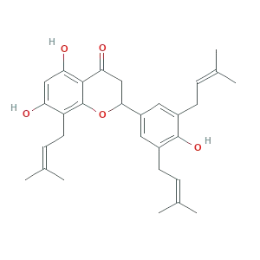  (C₃₀H₃₆O₅; PubChem CID 42607927) | In vitro α-glucosidase inhibitory assay using acarbose as a positive control. | [5]
 |  |  | In vitro glycation inhibitory assay using quercetin as a positive control. | [5]
 |  |  | In vitro antiplasmodial activity against P. falciparum | [52]
 | 4′-hydroxy-6,3′,5′-triprenylisoflavanone | The chemical structure is not available in PubChem. | In vitro glycation inhibitory assay using quercetin as a positive control. | [5]
 |  |  | In vitro α-glucosidase inhibitory assay using acarbose as a positive control. | [5]
 | Pinocembrin | 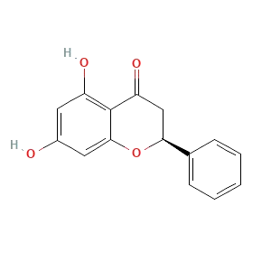  (C₁₅H₁₂O₄; PubChem CID 68071) | In vitro α-glucosidase inhibitory assay using acarbose as a positive control. | [5]
 |  |  | In vitro glycation inhibitory assay using quercetin as a positive control. | [5]
 | 3,6,4′-trihydroxy flavone | The chemical structure is not available in PubChem. | In vitro α-glucosidase inhibitory assay using acarbose as a positive control. | [5]
 |  |  | In vitro glycation inhibitory assay using quercetin as a positive control. | [5]
 | 3,6-dihydroxyflavone | 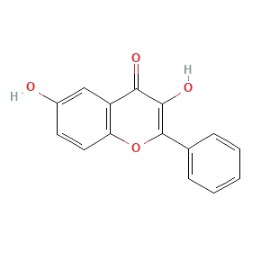  (C₁₅H₁₀O₄; PubChem CID 688659) | In vitro α-glucosidase inhibitory assay using acarbose as a positive control. | [5]
 |  |  | In vitro glycation inhibitory assay using quercetin as a positive control. | [5]
 | 5-methoxy-7-hydroxy flavone | The chemical structure is not available in PubChem. | In vitro α-glucosidase inhibitory assay using acarbose as a positive control. | [5]
 |  |  | In vitro glycation inhibitory assay using quercetin as a positive control. | [5]
 | Lupalbigenin | 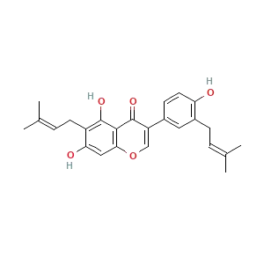  (C₂₅H₂₆O₅; PubChem CID 10001388) | In vitro α-glucosidase inhibitory assay using acarbose as a positive control. | [5]
 |  |  | In vitro glycation inhibitory assay using quercetin as a positive control. | [5]
 | Erysubin F | 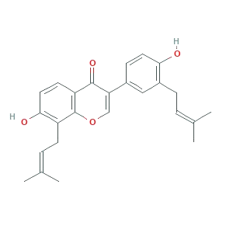  (C₂₅H₂₆O₄; PubChem CID 12051847) | In vitro α-glucosidase inhibitory assay using acarbose as a positive control. | [5]
 |  |  | In vitro glycation inhibitory assay using quercetin as a positive control. | [5]
 | Genistein | 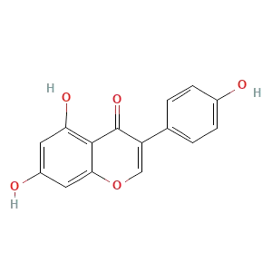  (C₁₅H₁₀O₅; PubChem CID 5280961) | In vitro α-glucosidase inhibitory assay using acarbose as a positive control. | [5]
 |  |  | In vitro glycation inhibitory assay using quercetin as a positive control. | [5]
 |  |  | Estrogenic activity on 1-month-old immature female CD-1 mice (Mus musculus) | [42]
 | 8-prenyl genistein | The chemical structure is not available in PubChem. | Estrogenic activity on 1-month-old immature female CD-1 mice (Mus musculus) | [42]
 | 7,2′,4′-trihydroxy-8,3′,5′-(3″-methyl-but-2″-enyl) flavanone | The chemical structure is not available in PubChem. | In vitro α-glucosidase inhibitory assay using acarbose as a positive control. | [5]
 |  |  | In vitro glycation inhibitory assay using quercetin as a positive control. | [5]
 | Abyssinone V | 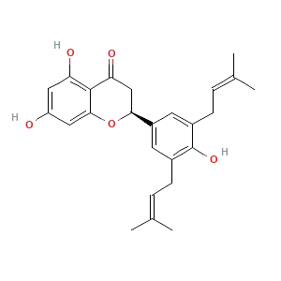  (C₂₅H₂₈O₅; PubChem CID 442153) | In vitro α-glucosidase inhibitory assay using acarbose as a positive control. | [5]
 |  |  | In vitro glycation inhibitory assay using quercetin as a positive control. | [5]
 | Abyssinone V-4′ methyl ether | 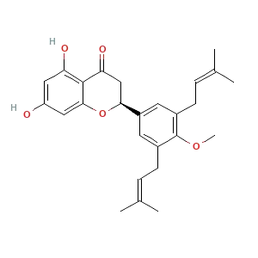  (C₂₆H₃₀O₅; PubChem CID 6548074) | Antibacterial activity on Gram-negative and Gram-positive strains. | [18]
 | Eryzerin C | 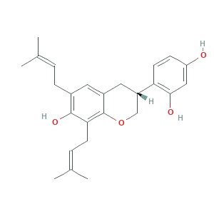  (C₂₅H₃₀O₄; PubChem CID 10092034) | Antibacterial activity on Gram-negative and Gram-positive strains. | [18]
 | Lysisteisoflavone | 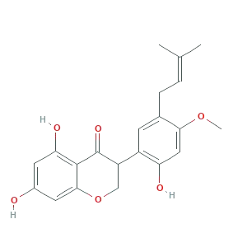  (C₂₁H₂₂O₆; PubChem CID 5319135) | Antibacterial activity on Gram-negative and Gram-positive strains. | [18]
 | Wighteone (synonym = erythrinin B) | 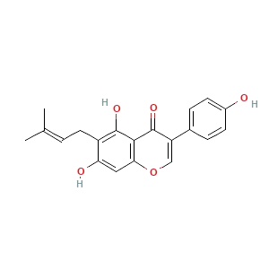  (C₂₀H₁₈O₅; PubChem CID 5281814) | Antidiabetic and antiobesity by inhibiting PTP1B activity | [31]
 | Alpumisoflavone | 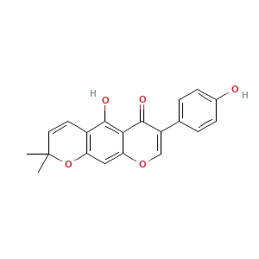  (C₂₀H₁₆O_{5;} PubChem CID 5490139) | Antibacterial activity on Gram-negative and Gram-positive strains. | [18]
 |  |  | Anticancer activity on human leukemia HL-60 cells | [24]
 |  |  | Anticancer activity on human lung cancer cell lines H2108 and H1299 | [25]
 | 4'-methoxy licoflavanone | The chemical structure is not available in PubChem. | Anticancer activity on human leukemia HL-60 cells | [24]
Licoflavanone-4’-O-methyl ether |  | The chemical structure is not available in PubChem. | Antidiabetic and antiobesity by inhibiting PTP1B activity | [31]
2’,7-dihydroxy-4’-methoxy-5’-(3-methyl but-2-enyl) isoflavone |  | The chemical structure is not available in PubChem. | Antidiabetic and antiobesity by inhibiting PTP1B activity | [31]
Parisoflavone B |  | The chemical structure is not available in PubChem. | Antidiabetic and antiobesity by inhibiting PTP1B activity | [31]
Derrone |  | 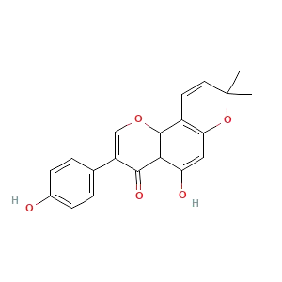  (C₂₀H₁₆O_{5;} PubChem CID 14704457) | Aurora kinase inhibitor on recombinant Aurora A, Aurora B, Aurora A domain, and histone H3 proteins expressed as N-terminal His6-tagged fusion proteins in E. coli | [50]
 | Pterocarpans
 | Eryvarin E | 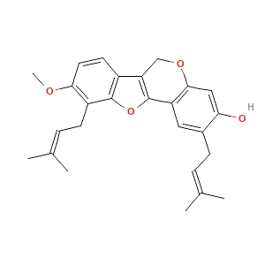  (C₂₆H₂₈O₄; PubChem CID 15546809) | In vitro α-glucosidase inhibitory assay using acarbose as a positive control. | [5]
 |  |  | In vitro glycation inhibitory assay using quercetin as a positive control. | [5]
 | Coumestrol | 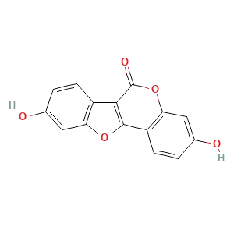  (C₁₅H₈O₅; PubChem CID 5281707) | In vitro α-glucosidase inhibitory assay using acarbose as a positive control. | [5]
 |  |  | In vitro glycation inhibitory assay using quercetin as a positive control. | [5]
 | Eryvarin D | 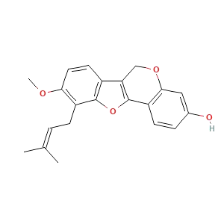  (C₂₁H₂₀O₄; PubChem CID 15546808) | In vitro α-glucosidase inhibitory assay using acarbose as a positive control. | [5]
 |  |  | In vitro glycation inhibitory assay using quercetin as a positive control. | [5]
 | 1-methoxyerythrabyssin II | 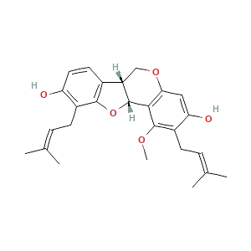  (C₂₆H₃₀O₅; PubChem CID 24761044) | In vitro α-glucosidase inhibitory assay using acarbose as a positive control. | [5]
 |  |  | In vitro glycation inhibitory assay using quercetin as a positive control. | [5]
 | Erythrabyssin II | 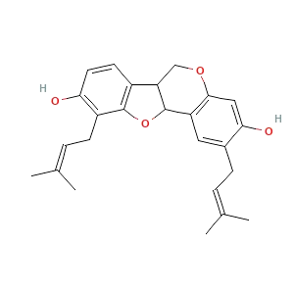  (C₂₅H₂₈O₄; PubChem CID 5086400) | In vitro α-glucosidase inhibitory assay using acarbose as a positive control. | [5]
 |  |  | In vitro glycation inhibitory assay using quercetin as a positive control. | [5]
 | Erycristagallin | 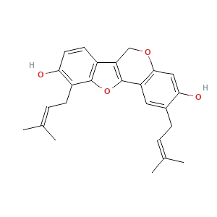  (C₂₅H₂₆O₄; PubChem CID 10362969) | In vitro α-glucosidase and α-amylase inhibitory assay using acarbose as a positive control. | [5]
 |  |  | In vitro glycation inhibitory assay using quercetin as a positive control. | [5]
 | Erythribyssin N | 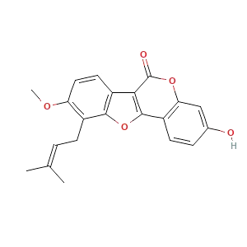  (C₂₁H₁₈O₅; PubChem CID 46210318) | In vitro α-glucosidase and α-amylase inhibitory assay using acarbose as a positive control. | [5]
 |  |  | In vitro glycation inhibitory assay using quercetin as a positive control. | [5]
 | Erycristin | 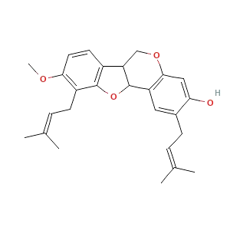  (C₂₆H₃₀O₄; PubChem CID 13994537) | In vitro α-glucosidase and α-amylase inhibitory assay using acarbose as a positive control. | [5]
 |  |  | In vitro glycation inhibitory assay using quercetin as a positive control. | [5]
 | Sandwicensin | 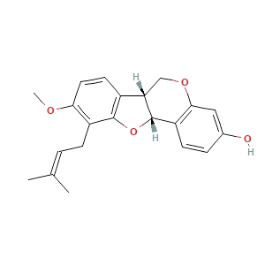  (C₂₁H₂₂O₄; PubChem CID 467498) | In vitro α-glucosidase and α-amylase inhibitory assay using acarbose as a positive control | [5]
 |  |  | In vitro glycation inhibitory assay using quercetin as a positive control. | [5]
 | Gangetin | 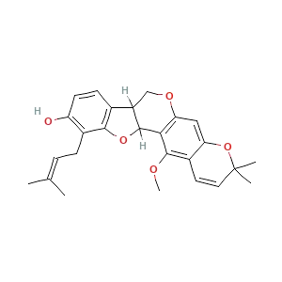  (C₂₆H₂₈O₅; PubChem CID 317611) | In vitro α-glucosidase and α-amylase inhibitory assay using acarbose as a positive control | [5]
 |  |  | In vitro glycation inhibitory assay using quercetin as a positive control. | [5]
 | Erypoegin J | 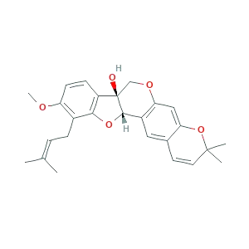  (C₂₆H₂₈O₅; PubChem CID 11133568) | In vitro α-glucosidase and α-amylase inhibitory assay using acarbose as a positive control | [5]
 |  |  | In vitro glycation inhibitory assay using quercetin as a positive control. | [5]
 | Erybraedin A | 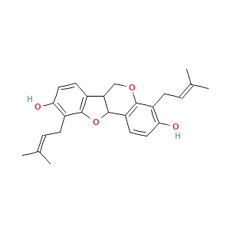  (C₂₅H₂₈O₄; PubChem CID 362562) | Antibacterial activity on Gram-negative and Gram-positive strains. | [18]
 | Phaseollidin | 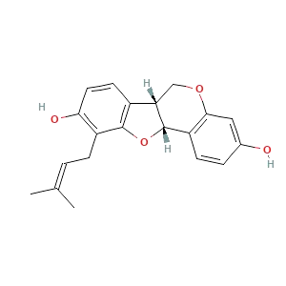  (C₂₀H₂₀O₄; PubChem CID 119268) | In vitro α-glucosidase and α-amylase inhibitory assay using acarbose as a positive control | [5]
 |  |  | Antibacterial activity on Gram-negative and Gram-positive strains. | [18]
 |  |  | Cytotoxicity activity using brine shrimp lethal toxicity assay | [54]
 | Orientanol C | 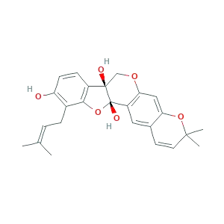  (C₂₅H₂₆O₆; PubChem CID 42607512) | Anticancer activity on H4IIE hepatoma cells. | [26]
 |  |  | In vitro α-glucosidase and α-amylase inhibitory assay using acarbose as a positive control | [5]
 | Cristacarpin | 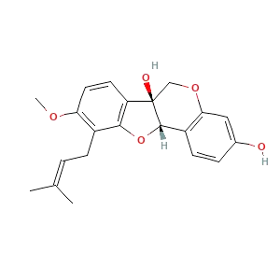  (C₂₁H₂₂O₅; PubChem CID 126540) | Antibacterial activity on Gram-negative and Gram-positive strains. | [18]
 |  |  | Anticancer activity on H4IIE hepatoma cells. | [26]
 | Calopocarpin | 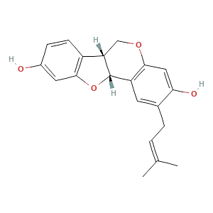  (C₂₀H₂₀O₄; PubChem CID 11709595) | Anticancer activity on H4IIE hepatoma cells. | [26]
 | Isoneorautenol | 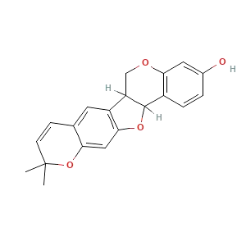  (C₂₀H₁₈O₄; PubChem CID 73649) | Anticancer activity on H4IIE hepatoma cells. | [26]
 | Neorautenol | 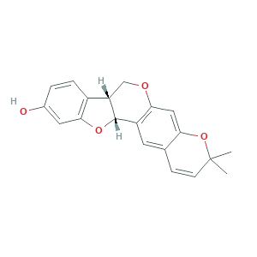  (C₂₀H₁₈O₄; PubChem CID 11500744) | Anticancer activity on H4IIE hepatoma cells. | [26]
 | Phaseollin | 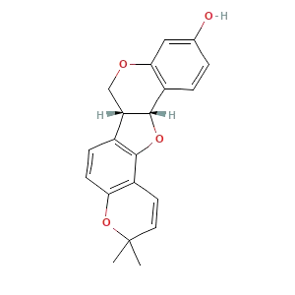  (C₂₀H₁₈O₄; PubChem CID 91572) | Anticancer activity on H4IIE hepatoma cells. | [26]
 | Alkaloids
 | Hydroxyerysotrine | 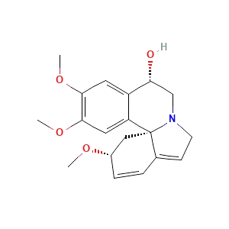  (C₁₉H₂₃NO₄; PubChem CID 91572) | Anticancer activity on human leukemia HL-60 cells | [24]
 | Erythraline | 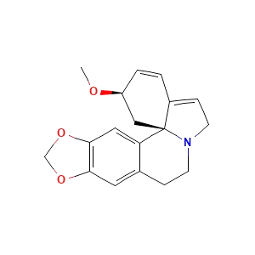  (C₁₈H₁₉NO₃; PubChem CID 5317205) | Anti-inflammatory by inhibiting NO production on RAW264.7 cells | [41]
 |  |  | Leishmanicidal activity against the promastigote forms of L. amazonensis obtained from infected mice | [45]
 |  |  | Curare-like action on frogs | [55]
 | Erythrinine | 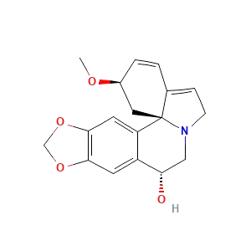  (C₁₈H₁₉NO₄; PubChem CID 3084503) | Anti-inflammatory by inhibiting NO production on RAW264.7 cells | [41]
 | Hypaphorine | 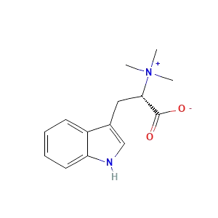  (C₁₄H₁₉N₂O₂; PubChem CID 442106) | Anti-inflammatory by inhibiting NO production on RAW264.7 cells | [41]
 | Erythramine | 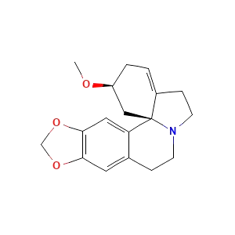  (C₁₈H₂₁NO₃; PubChem CID 101289752) | Curare-like action on frogs | [55]
 | Erythratine | 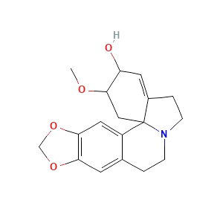  (C₁₈H₂₁NO₄; PubChem CID 617879) | Curare-like action on frogs | [55]
 | Beta-erythroidine | 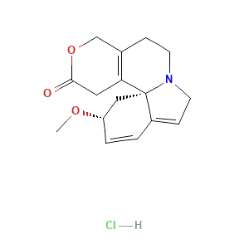  (C₁₆H₂₀ClNO₃; PubChem CID 54601205) | Curare-like action on frogs | [55]
 | Glycosides
 | Vitexin | 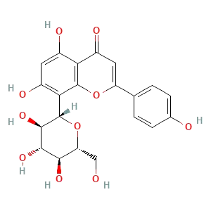  (C₂₁H₂₀O₁₀; PubChem CID 5280441) | Modulator of fear memory on male Wistar rats (Rattus norvegicus) | [49]
 | Isovitexin | 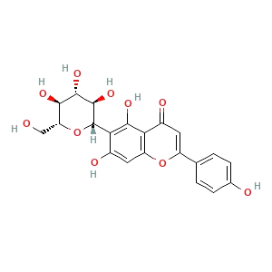  (C₂₁H₂₀O₁₀; PubChem CID 162350) | Modulator of fear memory on male Wistar rats (Rattus norvegicus) | [49]
 | Diosmetin-6-C-glucoside | 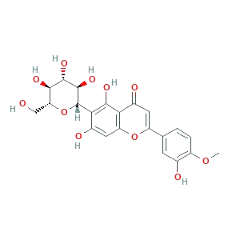  (C₂₂H₂₂O₁₁; PubChem CID 162350) | Modulator of fear memory on male Wistar rats (Rattus norvegicus) | [49]
 | Vicenin 2 | 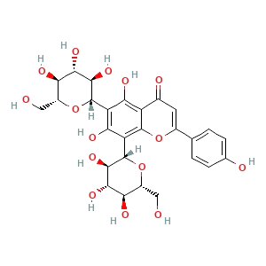  (C₂₇H₃₀O₁₅; PubChem CID 442664) | Modulator of fear memory on male Wistar rats (Rattus norvegicus) | [49]
 | Coumarins
 | Xanthoxyletin | 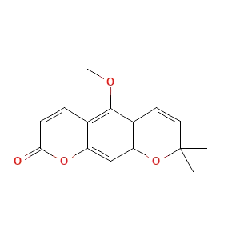  (C₁₅H₁₄O₄; PubChem CID 66548) | Anticancer activity on SGC-7901 cells. | [27]
 | Triterpenoids
 | Sophoradiol | 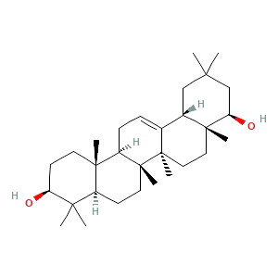  (C₃₀H₅₀O₂; PubChem CID 9846221) | In vitro antiplasmodial activity against P. falciparum | [52]
 | Lupeol | 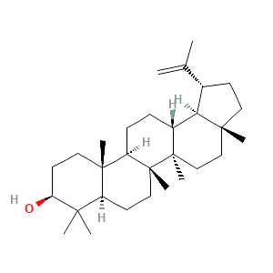  (C₃₀H₅₀O; PubChem CID 259846) | In vitro antiplasmodial activity against P. falciparum | [52]
 | Cycloeucalenol | The chemical structure is not available in PubChem. | In vitro antiplasmodial activity against P. falciparum | [52]
 | Melilotigenin C | 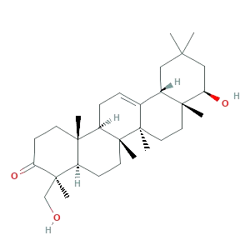  (C₃₀H₄₈O₃; PubChem CID 10551785) | In vitro antiplasmodial activity against P. falciparum | [52]
 | Chromenes
 | 2,2-dimethyl-2H-chromene-6-carboxaldehyde | The chemical structure is not available in PubChem. | In vitro glycation inhibitory assay using quercetin as a positive control. | [5]
 |  |  | In vitro α-glucosidase inhibitory assay using acarbose as a positive control. | [5]
 | Steroids
 | Stigmast-4-en-3-one | 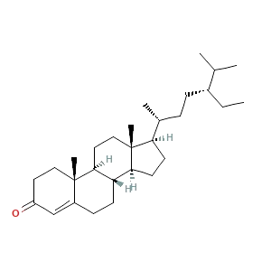  (C₂₉H₄₈O; PubChem CID 5484202) | In vitro antiplasmodial activity against P. falciparum | [52]
 | Stigmasta-4,22-dien-3-one | 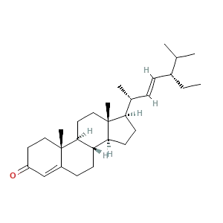  (C₂₉H₄₆O; PubChem CID 6442194) | In vitro antiplasmodial activity against P. falciparum | [52]
 | 3beta-hydroxystigmast-5-en-7-one | 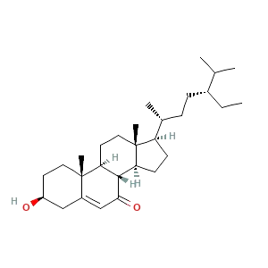  (C₂₉H₄₈O₂; PubChem CID 160608) | In vitro antiplasmodial activity against P. falciparum | [52]
 | 3beta-hydroxystigmast-5,22-dien-7-one | The chemical structure is not available in PubChem. | In vitro antiplasmodial activity against P. falciparum | [52]
 | Carboxylic Acids
 | 2-hydroxy-4-methoxy-cinnamic acid | 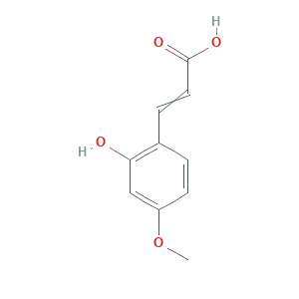  (C₁₀H₁₀O₄; PubChem CID 20985633) | In vitro glycation inhibitory assay using quercetin as a positive control. | [5]
 |  |  | In vitro α-glucosidase inhibitory assay using acarbose as a positive control. | [5]
 | Total = 63 metabolites

