**Supplementary material**

**Benefits and geography of international collaboration for PhD students in biology from four global south countries**

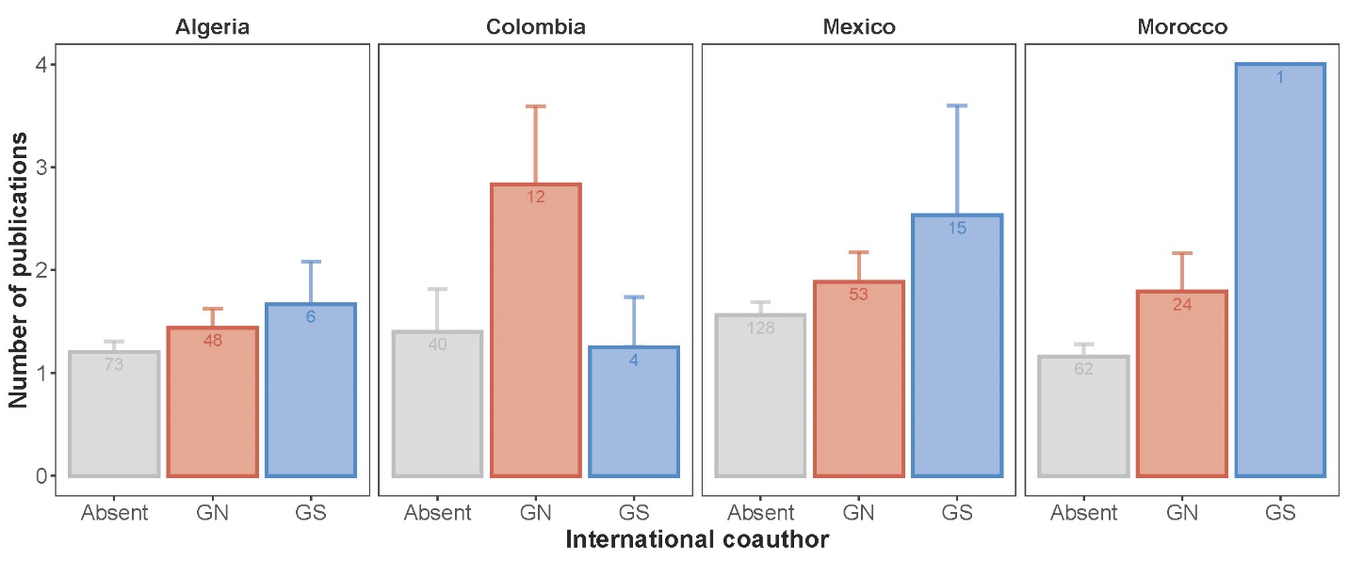

**Figure S1.** Number of published papers during the PhD of students in Algeria, Colombia, Mexico, and Morocco in the absence of international collaboration (grey), presence of international collaboration from the Global North (blue), presence of international collaboration from the Global South (red). Error bars are 95% confidence intervals. Numbers on the bars are sample sizes. Summary statistics of the model are in Table S3. GN: Global North; GS: Global South.

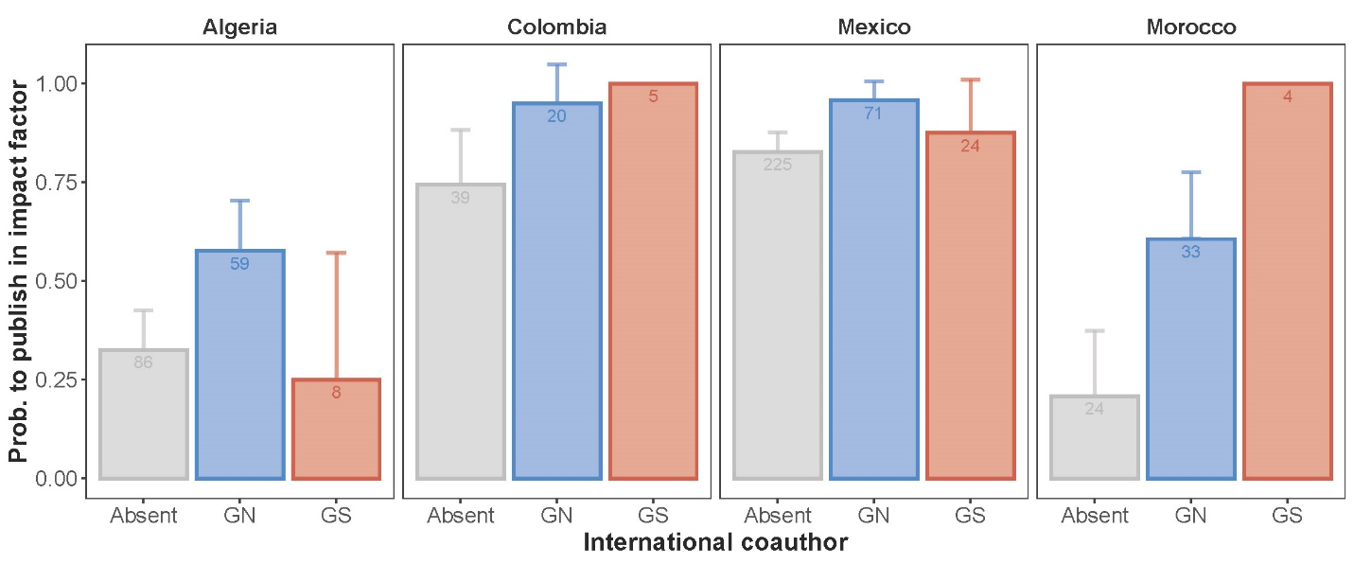

**Figure S2.** Probability of publishing in an impact factor journal during the PhD of students in Algeria, Colombia, Mexico, and Morocco in the absence of international collaboration (grey), presence of international collaboration from the Global North (blue), presence of international collaboration from the Global South (red). Error bars are 95% confidence intervals. Numbers on the bars are sample sizes. Summary statistics of the model are in Table S3. GN: Global North; GS: Global South.

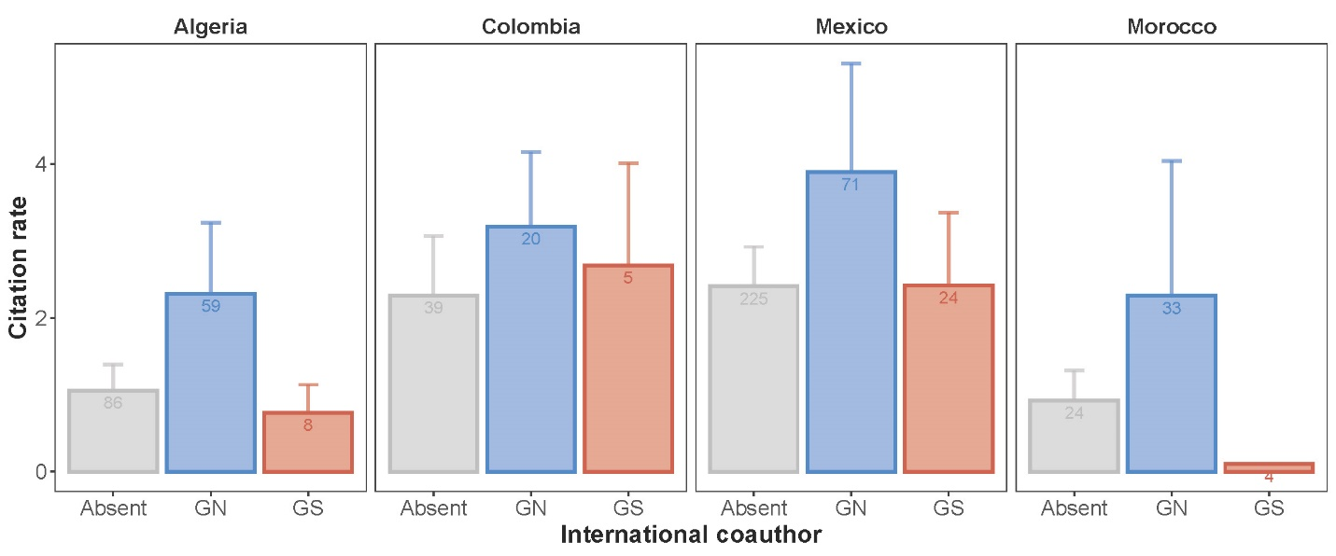

**Figure S3.** Citation rate of research paper published during the PhD of students in Algeria, Colombia, Mexico, and Morocco in the absence of international collaboration (grey), presence of international collaboration from the Global North (blue), presence of international collaboration from the Global South (red). Error bars are 95% confidence intervals. Numbers on the bars are sample sizes. Summary statistics of the model are in Table S3. GN: Global North; GS: Global South.

Table S1. Sample size of PhD students for each region, country and university used in the current study.

|  |  |  |  |
| --- | --- | --- | --- |
| Region | Country | University | N_students |
| North Africa | Algeria | Abou Bakr Belkaid Tlemcen | 26 |
|  | Algeria | Kasdi Merbeh Ouargla | 30 |
|  | Algeria | Université Badji Mokhtar Annaba | 26 |
|  | Algeria | Université Mohamed Seddik BenYahia, Jijel | 14 |
|  | Algeria | Université Mouloud Mammeri de Tizi-Ouzou | 31 |
|  | Morocco | Agadir | 12 |
|  | Morocco | El Jadida | 19 |
|  | Morocco | Hassan 2 | 19 |
|  | Morocco | Marrakesh | 19 |
|  | Morocco | Tétouan | 18 |
| Americas | Colombia | Antioquia | 8 |
|  | Colombia | Javeriana | 7 |
|  | Colombia | Los Andes | 12 |
|  | Colombia | Nacioanal De Columbia | 6 |
|  | Colombia | Quindio | 3 |
|  | Colombia | Rosario | 8 |
|  | Colombia | Utadeo | 3 |
|  | Colombia | Valle | 9 |
|  | Mexico | Ecosur | 28 |
|  | Mexico | Inecol | 23 |
|  | Mexico | Universidad Nacional Autónoma de México | 102 |
|  | Mexico | Universidad de Guadalajara | 21 |
|  | Mexico | Universidad Veracruzana | 22 |

Table S2. Summary statistics of the mixed effects models assessing the effect of the number of international coauthors on the number of publications, probability of publishing in an impact factor journal, and the number of citations for PhD students based in Algeria, Columbia, Mexico, and Morocco.

|  |  |  |  |  |
| --- | --- | --- | --- | --- |
| (a) No. Publications | Estimate | Std. Error | *z* | *P* |
| Intercept | -21.518174 | 13.935382 | -1.544 | 0.123 |
| N_International_collab | 0.027144 | 0.024915 | 1.089 | 0.276 |
| Year | 0.010885 | 0.006921 | 1.573 | 0.116 |
|  |  |  |  |  |
| (b) Impact factor occurrence | **Estimate** | **Std. Error** | ***z*** | ***P*** |
| Intercept | 0.3864 | 0.5964 | 0.648 | 0.52 |
| N_International_collab | 0.4638 | 0.1074 | 4.319 | <0.0001 |
|  |  |  |  |  |
| (c) No. Citations | **Estimate** | **Std. Error** | ***z*** | ***P*** |
| Intercept | 0.45193 | 0.20227 | 2.234 | 0.0255 |
| N_International_collab | 0.05766 | 0.03386 | 1.703 | 0.0886 |
| Impact_factor | 0.23957 | 0.02636 | 9.087 | <0.0001 |
| N_year since publication | 0.10744 | 0.01276 | 8.421 | <0.0001 |

Table S3. Summary statistics of the mixed effects models assessing the effect of the occurrence of international coauthors from the Global North (GN) and Global South (GS) on the number of publications (a), probability of publishing in an impact factor journal (b), and the number of citations for PhD students (c) based in Algeria, Columbia, Mexico, and Morocco.

|  |  |  |  |  |
| --- | --- | --- | --- | --- |
| (a) Number of publications | Estimate | Std. Error | *z* | *P* |
| Intercept | -17.907251 | 36.477571 | -0.491 | 0.6235 |
| Int_collab_[GS] | 0.418728 | 0.195528 | 2.142 | 0.0322 |
| Int_collab_[GN] | 0.283421 | 0.138039 | 2.053 | 0.0401 |
| Year | 0.009043 | 0.018094 | 0.500 | 0.6172 |
|  |  |  |  |  |
| (b) Occurrence of impact factor | **Estimate** | **Std. Error** | ***z*** | ***P*** |
| Intercept | 0.2700 | 0.6248 | 0.432 | 0.666 |
| Int_collab_[GS] | 0.7765 | 0.4756 | 1.633 | 0.103 |
| Int_collab_[GN] | 1.3813 | 0.2829 | 4.883 | <0.0001 |
|  |  |  |  |  |
| (c) Citation number | **Estimate** | **Std. Error** | ***z*** | ***P*** |
| Intercept | 0.38920 | 0.22019 | 1.768 | 0.077136 |
| Int_collab_[GS] | 0.03201 | 0.20510 | 0.156 | 0.875959 |
| Int_collab_[GN] | 0.40959 | 0.11770 | 3.480 | 0.000502 |
| Impact_factor | 0.22994 | 0.02592 | 8.872 | <0.0001 |
| N_year since publication | 0.10574 | 0.01275 | 8.296 | <0.0001 |