**Supporting Information**

**Simultaneous immobilization of lead, cadmium and arsenic in soil by iron-manganese modified biochar**

Zhihui Yang a,b, Gai Zeng a, Lin Liu a , Fangshu He a,Chukwuma Arinzechi a,

Qi Liao a,b, Weichun Yang a,b, Mengying Si a,b,⁎

1. Department of Environmental Engineering, School of Metallurgy and Environment, Central South University, Changsha 410083, People’s Republic of China;
2. Chinese National Engineering Research Center for Control and Treatment of Heavy Metal Pollution, Changsha 410083, People’s Republic of China

* Corresponding author: Mengying Si, E-mail address: simysmile@csu.edu.cn

**Content**

Fig. S1. Flow chart of the preparation of BC and modified BC.

Fig. S2. The remove rate of different modified biochar for water-soluble As, Cd, and Pb in soil with 5% addition of material as a function of time and material.

Fig. S3. SEM of different MP isolated from the soil after 90 days of reaction.

Fig. S4. XRD of different MP isolated from the soil after 90 days of reaction.

Table S1 Analysis of surface element content.

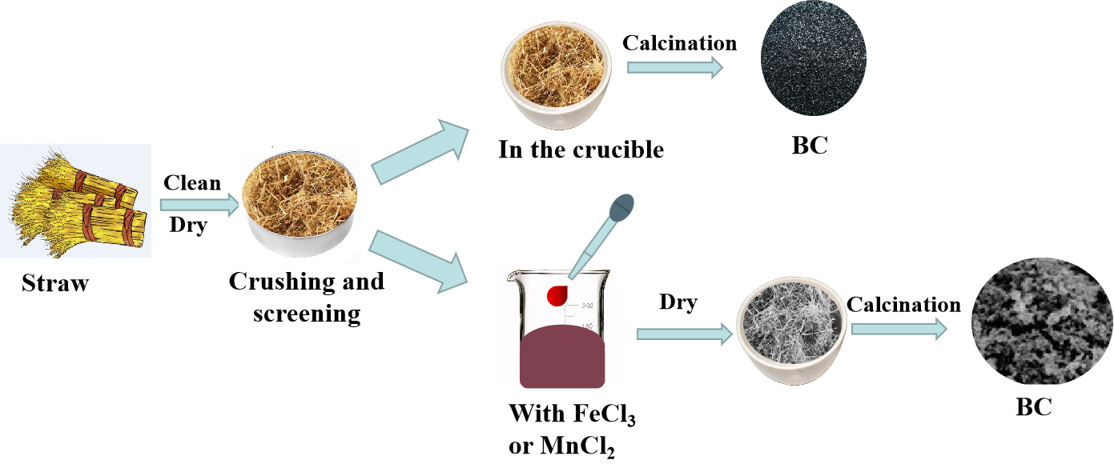

**Fig. S1.** Flow chart of the preparation of BC and modified BC.



**Fig. S2.** The remove rate of different modified biochar for water-soluble As, Cd, and Pb in soil with 5% addition of material as a function of time and material.

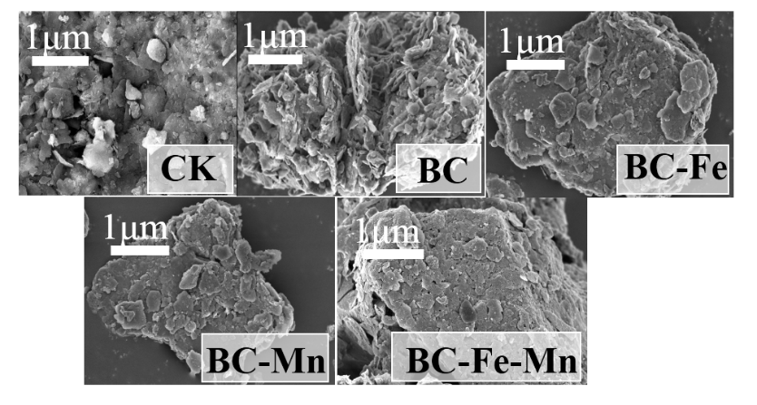

**Fig. S3.** SEM of different MP isolated from the soil after 90 days of reaction.

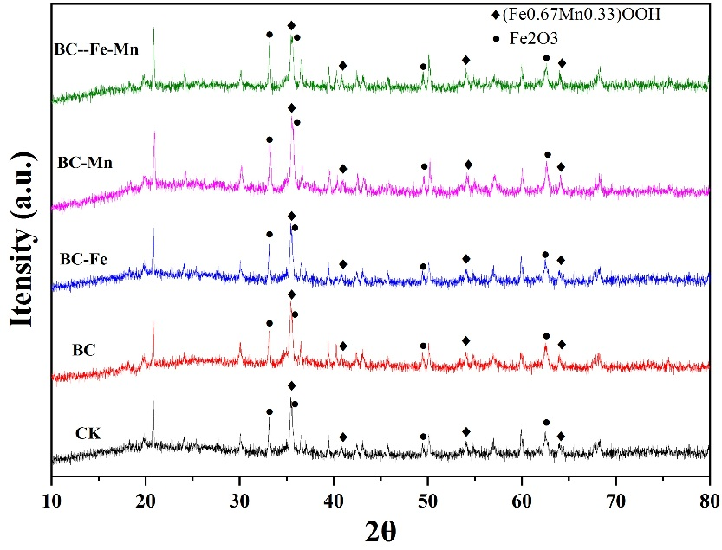

**Fig. S4.** XRD of different MP isolated from the soil after 90 days of reaction.

**Table S1** Analysis of surface element content

|  |  |  |  |  |  |  |
| --- | --- | --- | --- | --- | --- | --- |
|  | Soil | MP | Soil | MP | Soil | MP |
|  | Atomic %  As 2p | Atomic %  As 2p | Atomic %  Cd 3d | Atomic %  Cd 3d | Atomic %  Pb 4f | Atomic %  Pb 4f |
| CK | 2.3 | 2.51 | 0.01 | 0.3 | 0.3 | 0.09 |
| BC | 1.94 | 2.94 | 0.01 | 0.33 | 0.38 | 0.15 |
| BC-Fe | 1.82 | 4.78 | 0 | 0.31 | 0.77 | 0.1 |
| BC-Mn | 1.56 | 2.8 | 0.02 | 0.29 | 0.37 | 0.1 |
| BC-Fe-Mn | 1.97 | 4.38 | 0.01 | 0.41 | 0.32 | 0.2 |