Food and Mood Diary

Date & Time of Meal: [DD-MM-YYYY, Time HH:MM AM / PM]
Meal – [Breakfast, Lunch, Dinner, Dessert, Snack]
- Breakfast/Lunch Selected: What time did you go to bed last night? (time HH:MM AM/PM)
- Breakfast/Lunch Selected: How would you rate your sleep quality overall? (Very good, fairly good, fairly bad, Very bad)
- Breakfast/Lunch Selected: What time did you wake up today? (time HH:MM AM/PM)
Did you skip this meal? [Yes/No]
Can you please describe what you are eating – (I.e., a brief description of the type of food, include brand details if known and the quantity/how much food there is. If you do not have measuring cups or scales at home or are eating out, describe the food you eat using household measures)
[e.g. 1 medium slice Dominos pizza; 1 cup of veg and 200g beef rump steak, large glass of lemonade]
Did you consume any alcohol with this meal? - [No, 1 standard drink, 2-3 standard drinks, 4+ standard drinks]
- Alcohol option selected: Please describe your alcoholic drink (eg. 1 standard 350ml of Corona beer)
How was your meal prepared? [I prepared/cooked it, Someone else home-prepared/cooked it for me (e.g., Family member), I bought it from a grocery store (e.g., ALDI, Coles, Woolies), I bought from a café/restaurant, Bought fast food (e.g., McDonalds), Other (Please describe other)]
Where are you eating? – [Home, work, school/study, out socially (eg. at a café), other (Please describe other location)]
Is anyone with you? – [Family, friends, Eating alone out in public, No , other (Please describe other eating situation)]
Is this meal part of your diet plan – [Yes / No]
Which of the following best describes how you feel about this meal? [I didn’t eat enough, Just enough, I overate]
Did you want to eat because you were feeling hungry? [Yes/ No]
How motivated are you at the moment to stick to a diet – [1, Not at all – 4, Very much so]
These next questions are after you finish your meal
How anxious do you feel after eating? [Calm/Relaxed – Anxious]
How is your mood right now after eating – [Happy – Sad]
How guilty do you feel after eating? [Not guilty – Guilty]
Other mood: Please specify [free text]
How hungry are you right now – [1, Not hungry at all – 5, Very hungry]
Thank you, hope you enjoyed your meal!
Stool Diary
Please complete the following reporting symptoms with each bowel motion (stool/defecation) today.
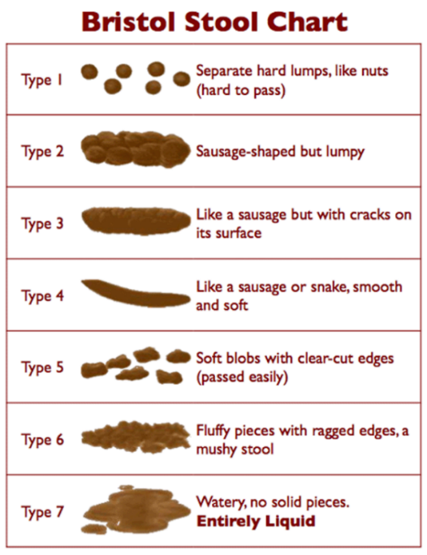
Bowel movements - Day 1
I didn’t poo TODAY :( No poop ☐
- Approximate time: (select one)
- Morning (eg. As you’ve woken up, before leaving home)
- During Daily Routine (eg. At lunch, at work, outside of home)
- Evening (eg. 6pm – midnight, before bedtime)
- Woke up from sleep to go

- What did your faeces look like – Use the Bristol stool chart supplied (please select the number)

- Were there any distinctive aspects of your faeces?
(e.g. Mucus, blood, pain, colour, etc)

 |  | (1) Not at all | (2) Slightly | (3) Moderately | (4) Significantly | (5) Unable to control / had an accident
4 | How much did you strain?
5 | Abdominal pain before poo?
6 | Did you feel the urge to go?

 |  | Yes | No | Not Applicable
7 | Abdominal pain relieved by bowel motion?
8 | Abdominal pain worsened by bowel motion?
9 | Use of laxatives?

10. Is this the stool/poo you’re bringing in for analysis? (Yes / Not Applicable)

 |  | (1) Never | (2) A little  (eg. only once or twice) | (3) Moderately  (eg. every 3-4 hours) | (4) A lot  (eg. Every 2hours, every hour)
11 | How often did you fart today?

12. Were they smelly? (Yes / No) *Not prompted if ‘Never’ selected
Fun fact: Any odour means amines or sulfate compounds are present and just means your gut microbes are working differently! If there’s no smell, there’s still gas present but just different types.

