Supplementary Material

Parkinson's Genetics Study in Luxembourg
Zied Landoulsi ^{1†}; Sinthuja Pachchek Peiris ^{1†}; Dheeraj Reddy Bobbili ¹, Lukas Pavelka^{2,3}, Patrick May^{1*}, and Rejko Krüger ^{1,2,3,*} on behalf of the NCER-PD Consortium
* Correspondence:
Patrick May: patrick.may@uni.lu, Rejko Krüger: rejko.krueger@uni.lu

Supplementary Figures:

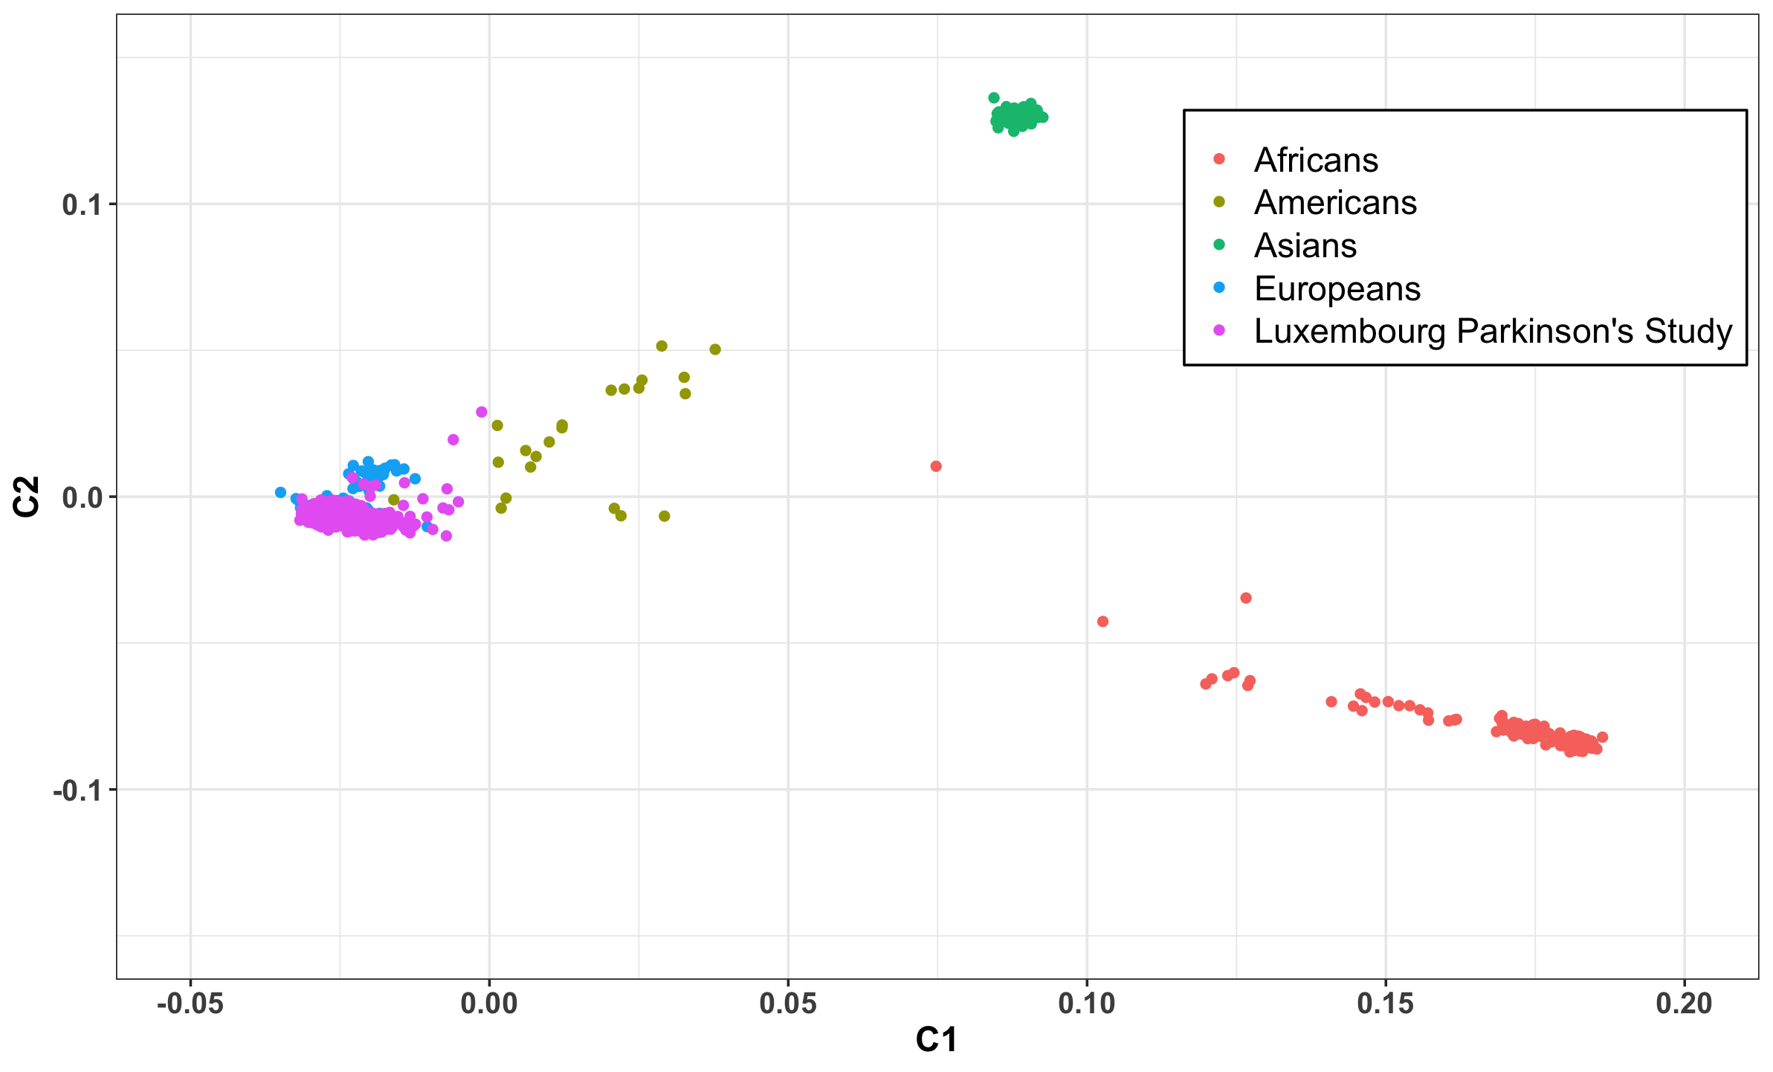
Supplementary Figure 1. PCAs of the Luxembourg Parkinson’s Study individuals (in purple) and the 1000 Genomes population for comparison (color-coded by different populations).

Supplementary Table 1: Association of MAPT H1/H2 haplotypes and H1c sub-haplotype with PD and atypical Parkinsonism risk. Genotypic and allelic frequency distribution of the SNP rs1800547 tagging the H1/H2 haplotype and the sub-haplotype H1c.

 | H1/H1 | H1/H2 | H2/H2 | chi-squared test p-value | H1 frequency | Allelic OR [95 CI] | Fisher's test p-value | H1c/H1c | H1c/H2 | H1c frequency | Allelic OR [95 CI] | Fisher's test p-value
Controls | 432 | 249 | 43 |  | 0.76 |  |  | 20 | 40 | 0.05
PD | 436 | 203 | 28 | 0.062 | 0.8 | 1.24 [1.03-1.50] | 0.018 | 15 | 29 | 0.04 | 0.79 [0.55-1.13] | 0.192
PSP | 39 | 10 | 1 | 0.036 | 0.88 | 2.20 [1.18-4.48] | 0.008 | 1 | 2 | 0.04 | 0.71 [0.19-1.96] | 0.651
LBD | 9 | 15 | 1 | 0.033 | 0.66 | 0.58 [0.31-1.13] | 0.088 | 1 | 0 | 0.04 | 0.71 [0.08-2.81] | 1
MSA | 7 | 5 | 1 | 0.717 | 0.73 | 0.81 [0.32-2.32] | 0.641 | 0 | 2 | 0.07 | 1.42 [0.16-5.91] | 0.652
CBS | 6 | 3 | 1 | 0.736 | 0.75 | 0.91 [0.30-3.19] | 0.793 | 0 | 1 | 0.05 | 0.9 [0.02-5.81] | 1
FTD-P | 0 | 1 | 0 | NA | NA | NA | NA | 0 | 0 | 0 | NA | NA

Supplementary Table 2: Canonical pathways significantly associated with PD risk in the Luxembourg Parkinson’s study. PRS R2: variance explained by polygenic risk score, SE: standard error, P-value (after Bonferroni correction), N SNP: Number of SNPs included in each gene-set analysis

Gene set | N genes | Beta | SE | P-value | PRS R2 | N SNPs
PARKINSONS DISEASE PATHWAY (WP) | 71 | 0.344278 | 0.060147 | 3.10E-05 | 0.025608 | 16
ALZHEIMERS DISEASE (KEGG) | 166 | 0.316265 | 0.059383 | 3.10E-04 | 0.023056 | 11
PARKINSONS DISEASE (KEGG) | 129 | 0.313221 | 0.059654 | 4.60E-04 | 0.026692 | 42
N GLYCAN TRIMMING IN THE ER AND CALNEXIN CALRETICULIN  CYCLE (REACTOME) | 34 | 0.286283 | 0.058815 | 3.40E-03 | 0.020331 | 356
ECTODERM DIFFERENTIATION (WP) | 139 | 0.285898 | 0.05872 | 3.40E-03 | 0.017453 | 5
MAPK SIGNALING PATHWAY (WP) | 244 | 0.282071 | 0.058492 | 4.30E-03 | 0.015836 | 33
NAD BIOSYNTHETIC PATHWAYS (WP) | 22 | 0.284523 | 0.059372 | 4.90E-03 | 0.012237 | 9
PTK6 PROMOTES HIF1A STABILIZATION (REACTOME) | 6 | 0.280816 | 0.058907 | 5.90E-03 | 0.017434 | 7
ALPHA SYNUCLEIN PATHWAY (PID) | 31 | 0.279482 | 0.05915 | 7.10E-03 | 0.017014 | 17
AMYLOID FIBER FORMATION (REACTOME) | 105 | 0.269046 | 0.058621 | 1.40E-02 | 0.015743 | 4
PARKIN-UBIQUITIN PROTEASOMAL SYSTEM PATHWAY (WP) | 71 | 0.269046 | 0.058621 | 1.40E-02 | 0.015743 | 4
SIGNALING BY PTK6 (REACTOME) | 53 | 0.268987 | 0.058748 | 1.50E-02 | 0.016014 | 5
ALZHEIMERS DISEASE (WP) | 261 | 0.268217 | 0.058881 | 1.60E-02 | 0.018947 | 7
ALZHEIMERS DISEASE AND MIRNA EFFECTS (WP) | 320 | 0.268217 | 0.058881 | 1.60E-02 | 0.018947 | 7
POST TRANSLATIONAL PROTEIN MODIFICATION (REACTOME) | 1419 | 0.26604 | 0.059004 | 2.00E-02 | 0.016832 | 66
PARKIN PATHWAY (BIOCARTA) | 8 | 0.263226 | 0.058883 | 2.40E-02 | 0.016246 | 10
METABOLISM OF AMINO ACIDS AND DERIVATIVES (REACTOME) | 366 | 0.252922 | 0.058534 | 4.90E-02 | 0.010947 | 6

