Supplementary Material

Life cycle exposure to 2-phenylbenzimidazole-5-sulfonic acid (PBSA) impairs reproductive endocrine functions and induces adverse transgenerational effects

Junyan Tao1,**✝**,*, Qinyuan Yang1,**✝**, Xiaowei Sun1, Linxuan Tian1, Yuanzhi Deng2, Yumei Wang2, Weiwei Wang1, **Xiaoming Fan3**

1School of Public Health, the Key Laboratory of Environmental Pollution Monitoring and Disease Control, Ministry of Education, Guizhou Medical University, Guiyang, China

2Clinical Medical College, Guizhou Medical University, Guiyang, China

3Department of Human Anatomy, School of Basic Medicine, Guilin Medical University, Guangxi Zhuang Autonomous Region, China.

**\* Correspondence:** Corresponding Author: junyanwmu@163.com (J. Tao)

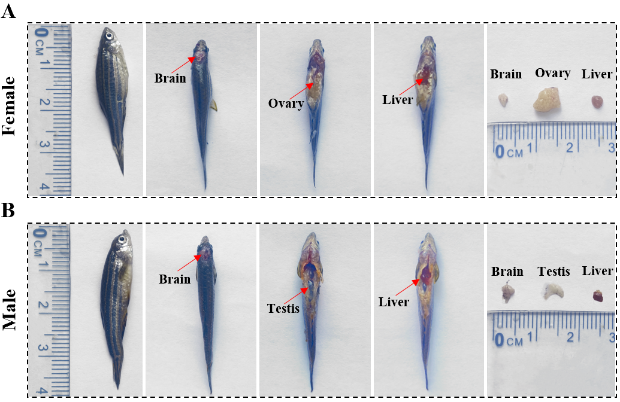

Fig. S1**.** Method to sample ovary, liver, and brain, and three tissues isolated from female (A) and male (B) adult zebrafish.

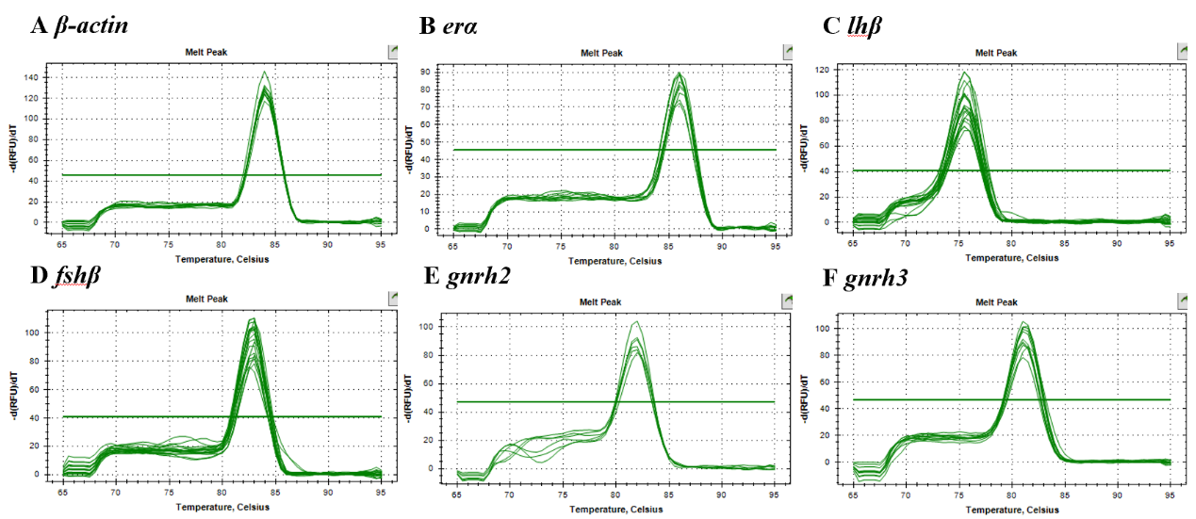

Fig. S2 The melt curves of *β-actin* (A), *erα* (B), *lhβ* (C), *fshβ* (D), *gnrh2* (E) and *gnrh3* (F) in zebrafish brains

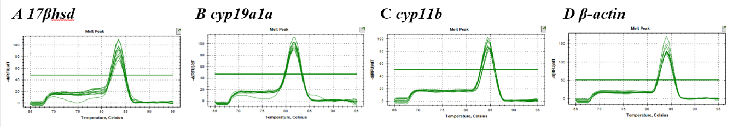

Fig S3. The melt curves of *17βhsd* (A), *cyp19a1a* (B), *cyp11b* (C) and *β-actin* (D) in zebrafish gonads

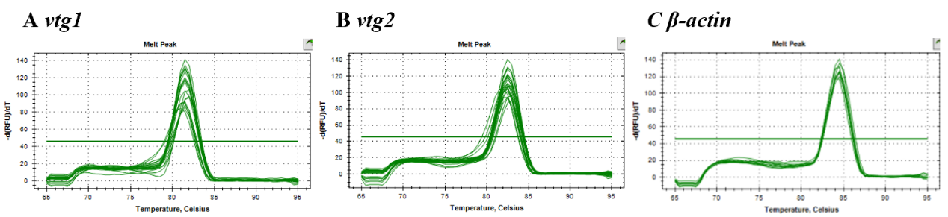

Fig. S4 The melt curves of *vtg1* (A), *vtg2* (B), and *β-actin* (C) in zebrafish livers

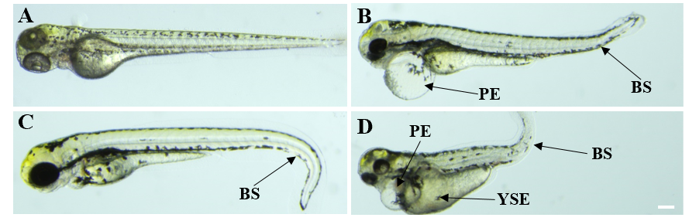

Fig. S5 Representative images showing normal (A) and deformed (B, C and D) larvae. BS, bent spine; PE, pericardial edema; YSE, yolk-sac edema. Scale bars, 100 µm

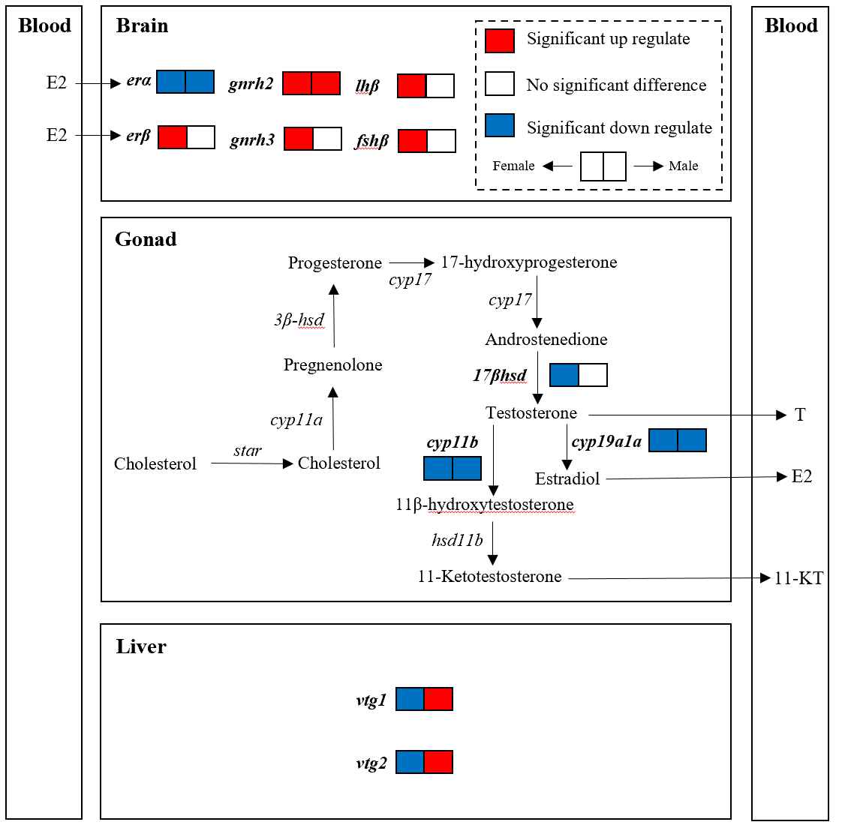

Fig. S6 Effects of PBSA exposure on the expression levels of HPGL axis-related genes. Trends are expressed in different colors, with red for up-regulation and blue for down-regulation

补充材料-拉氏图片-01

Fig. S7 An analysis of the protein structure through Ramachandran revealed that the protein structure was successfully constructed.

BP3-ERα BPA-ERα PBSA-ERα

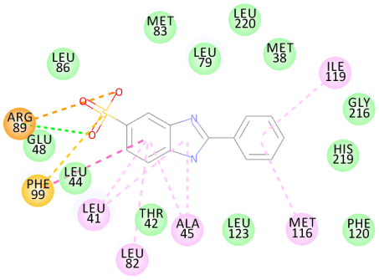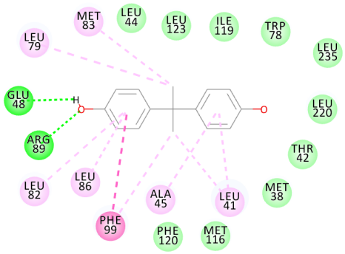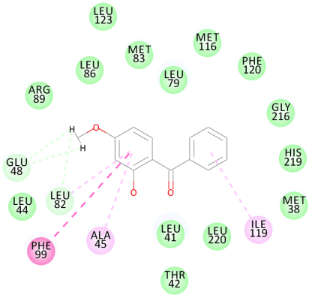

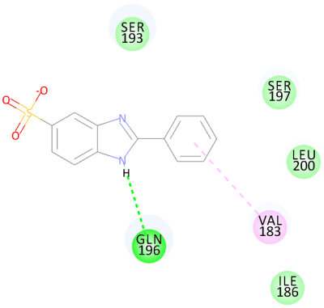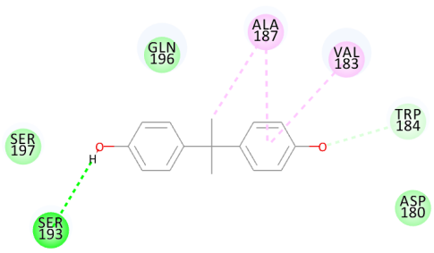BP3-ERβ BPA-ERβ PBSA-ERβ

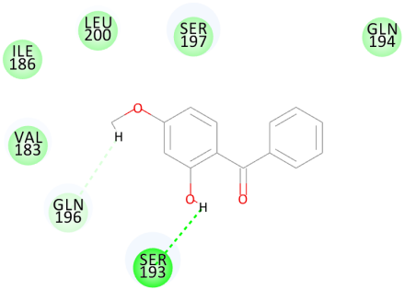

Fig. S8 Molecular interactions between BP3, BPA, PBSA and ERα, ERβ