Title page- supplementary information
Nighttime warming promotes copper translocation from root to shoot of wheat (Triticum aestivum L.) through shifting root morphology
Lin Qi, Chunxia Li, Lukuan Lai, Taiji Kou*, Yi Deng, Zhiqiang Shen

Agricultural College, Henan University of Science and Technology, 263 Kaiyuan Avenue. Luoyang 471003, China

Corresponding Author
*Taiji Kou, E-mail: tjkou@haust.edu.cn

The supplementary information has 8 pages including 3 tables, and 2 figures.

Table S1. The basic properties of soils used in this study.
Soil property | Value
pH | 8.05 ± 0.03
Cation exchange capacity (cmol/kg) | 19.23±2.13
Organic matter (g/kg) | 12.85±1.32
Total carbon (g/kg) | 7.23 ± 0.15
Total nitrogen (g/kg) | 0.96 ± 0.21
NH₄⁺-N (mg/kg) | 2.01 ± 0.51
NO₃⁻-N (mg/kg) | 9.11 ± 0.24
Cu concentration (mg/kg) | 5.32 ±0.98
Values represent mean ± s.d., n=4.
Table S2. Effects of warming treatment, Cu pollution and their interactions on plant growth, root morphology, Cu bioaccumulation, and antioxidant resistance examined by two-way ANOVA.
Classification | Variety | Nighttime  warming | Cu  pollution | W×P
Plant growth | Root biomass | 0.723 | ＜0.001*** | 0.212
 | Stem biomass | 0.187 | ＜0.001*** | 0.555
 | Leaf biomass | 0.336 | ＜0.001*** | 0.980
 | Glumes biomass | 0.049* | ＜0.001*** | 0.238
 | Grain biomass | 0.145 | 0.004** | 0.703
 | Shoot biomass | 0.921 | ＜0.001*** | 0.606
 | Root to shoot ratio | 0.749 | ＜0.001*** | 0.502
Root morphology | Length | 0.537 | ＜0.001*** | 0.240
 | Surface area | 0.797 | 0.010* | 0.824
 | Average diameter | 0.205 | 0.007** | 0.024*
 | Volume | 0.584 | 0.907 | 0.317
 | Specific area | 0.902 | 0.018* | 0.073
Cu bioaccumulation | Root concentration | ＜0.001*** | ＜0.001*** | 0.001**
 | Stem concentration | 0.871 | 0.001** | 0.002**
 | Leaf concentration | 0.916 | 0.008** | 0.493
 | Husk concentration | 0.558 | ＜0.001*** | 0.001**
 | Grain concentration | 0.001** | ＜0.001*** | 0.095
 | Shoot concentration | 0.937 | 0.001** | 0.068
 | TF | 0.842 | ＜0.001*** | 0.484
Antioxidant defense | MDA content | 0.042* | ＜0.001*** | 0.022*
 | SOD activity | 0.792 | 0.003** | 0.017*
 | POD activity | 0.493 | 0.891 | 0.904
The values in the table are the P-value exported from the two-way ANOVA.
Bold values indicate a significant differences: *P < 0.05, **P < 0.01, and ***P < 0.001.
W×P means the interaction of nighttime warming and Cu pollution.
Nighttime warming refers to non-nighttime warming versus nighttime warming; Cu pollution refers to non-Cu addition, 100 mg/kg, 400 mg/kg, and 800 mg/kg. TF: Translocation factor; MDA: malondialdehyde; SOD: Superoxide dismutase; POD: Peroxidase.
Table S3. Regression of the promotion rates of plant growth, root morphology, Cu bioaccumulation, and antioxidant resistance illustrated by the [(nighttime warming – non-nighttime warming) / non-nighttime warming] × 100% and Cu pollution.
Classification | Promotion rate | Cu pollution
Classification | Promotion rate | R² | P
Plant growth | Root biomass | 0.420 | 0.046*
 | Stem biomass | 0.247 | 0.202
 | Leaf biomass | 0.007 | 0.958
 | Glume biomass | 0.366 | 0.074
 | Grain biomass | 0.151 | 0.424
 | Shoot biomass | 0.226 | 0.238
 | Root to shoot ratio | 0.135 | 0.482
Root morphology | Length | 0.604 | 0.006**
 | Surface area | 0.030 | 0.808
 | Average diameter | 0.508 | 0.018*
 | Volume | 0.226 | 0.238
 | Specific area | 0.508 | 0.018*
Cu bioaccumulation | Root concentration | 0.268 | 0.708
 | Stem concentration | ＜0.001 | 0.998
 | Leaf concentration | 0.105 | 0.608
 | Husk concentration | 0.091 | 0.680
 | Grain concentration | 0.187 | 0.322
 | Shoot concentration | 0.017 | 1.336
 | TF | 0.780 | ＜0.001***
Antioxidant defense | MDA content | 0.105 | 0.608
 | SOD activity | 0.420 | 0.046*
 | POD activity | 0.004 | 0.682
Bold values indicate a significant differences: *P < 0.05, **P < 0.01, and ***P < 0.001.
Cu pollution refers to non-Cu addition, 100 mg/kg, 400 mg/kg, and 800 mg/kg. TF: Translocation factor; MDA: malondialdehyde; SOD: Superoxide dismutase; POD: Peroxidase.
Table S4. Grain Cu concentrations in the Cu contaminated soil under nonnighttime warming (CK), and nighttime warming (NW).
Cu pollution | Grain Cu concentration (mg/kg)
Cu pollution | CK | NW
Control | 3.67±0.38b | 6.17±0.21a
L | 7.70±0.31a | 6.48±0.56a
M | 5.43±0.26a | 5.13±0.37a
H | 6.57±0.47b | 8.48±0.18a
Values represent mean ± s.d., n=4. Cu pollution refers to non-Cu addition (Control), 100 mg/kg (L), 400 mg/kg (M), and 800 mg/kg (H). Statistically significant differences for each determination between CK and NW in the same Cu pollution are indicated by different letters (P < 0.05).
Table S5. Soil Cu concentrations in the Cu contaminated soil under nonnighttime warming (CK), and nighttime warming (NW) before planting and after harvest.
Cu pollution |  | Soil Cu concentration (mg/kg)
 |  | CK |  |  | NW
 |  | Before planting | After harvest |  | Before planting | After harvest
Control |  | 5.32±0.98 | 4.98±0.87 |  | 5.31±0.13 | 4.78±0.45
L |  | 104.12±11.31 | 94.12±8.25 |  | 105.12±12.58 | 98.87±9.12
M |  | 402.21±21.47 | 357.42±32.23 |  | 404.41±31.31 | 364.75±43.11
H |  | 803.74±51.43 | 727.98±62.23 |  | 811.53±67.23 | 733.11±52.15
Values represent mean ± s.d., n=4. Cu pollution refers to non-Cu addition (Control), 100 mg/kg (L), 400 mg/kg (M), and 800 mg/kg (H).
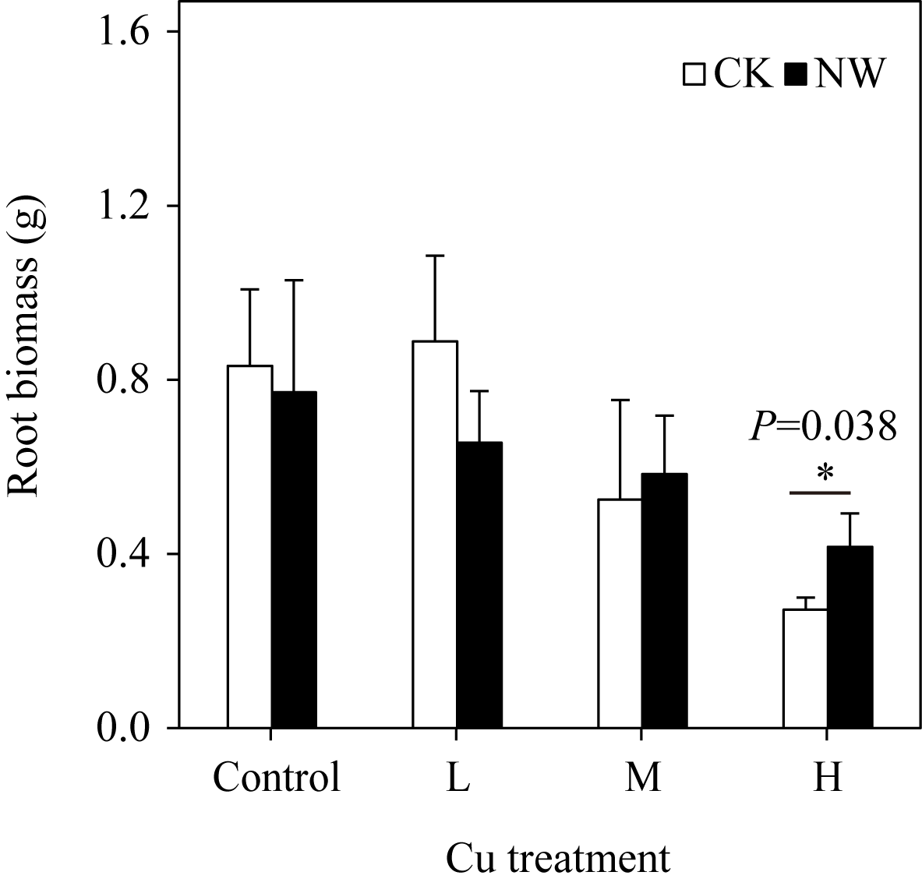
Figure S1 The effects of nighttime warming on root biomass illustrated by one way ANOVA. Warming treatments refers to nonnighttime warming (CK), and nighttime warming (NW). Cu treatments refers to non-Cu addition (Control), 100 mg/kg (L), 400 mg/kg (M), and 800 mg/kg (H). *P < 0.05.
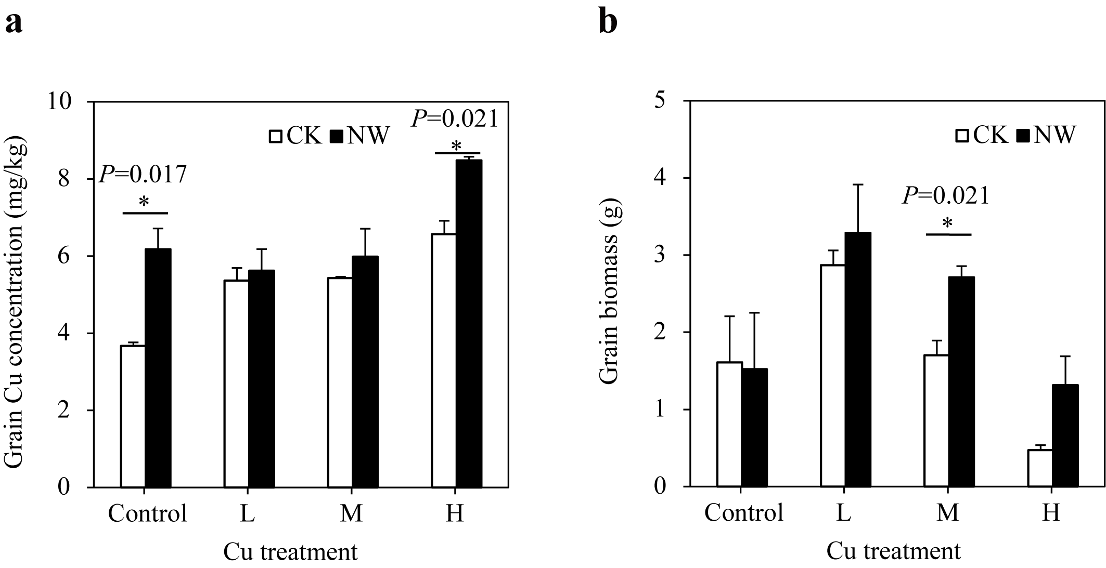
Figure S2 The effect of nighttime warming on the grain quality of wheat. a) The effects of nighttime warming on grain Cu concentration illustrated by one way ANOVA. b) The effects of nighttime warming on grain biomass illustrated by one way ANOVA. Warming treatments refers to nonnighttime warming (CK), and nighttime warming (NW). Cu treatments refers to non-Cu addition (Control), 100 mg/kg (L), 400 mg/kg (M), and 800 mg/kg (H). *P < 0.05.

