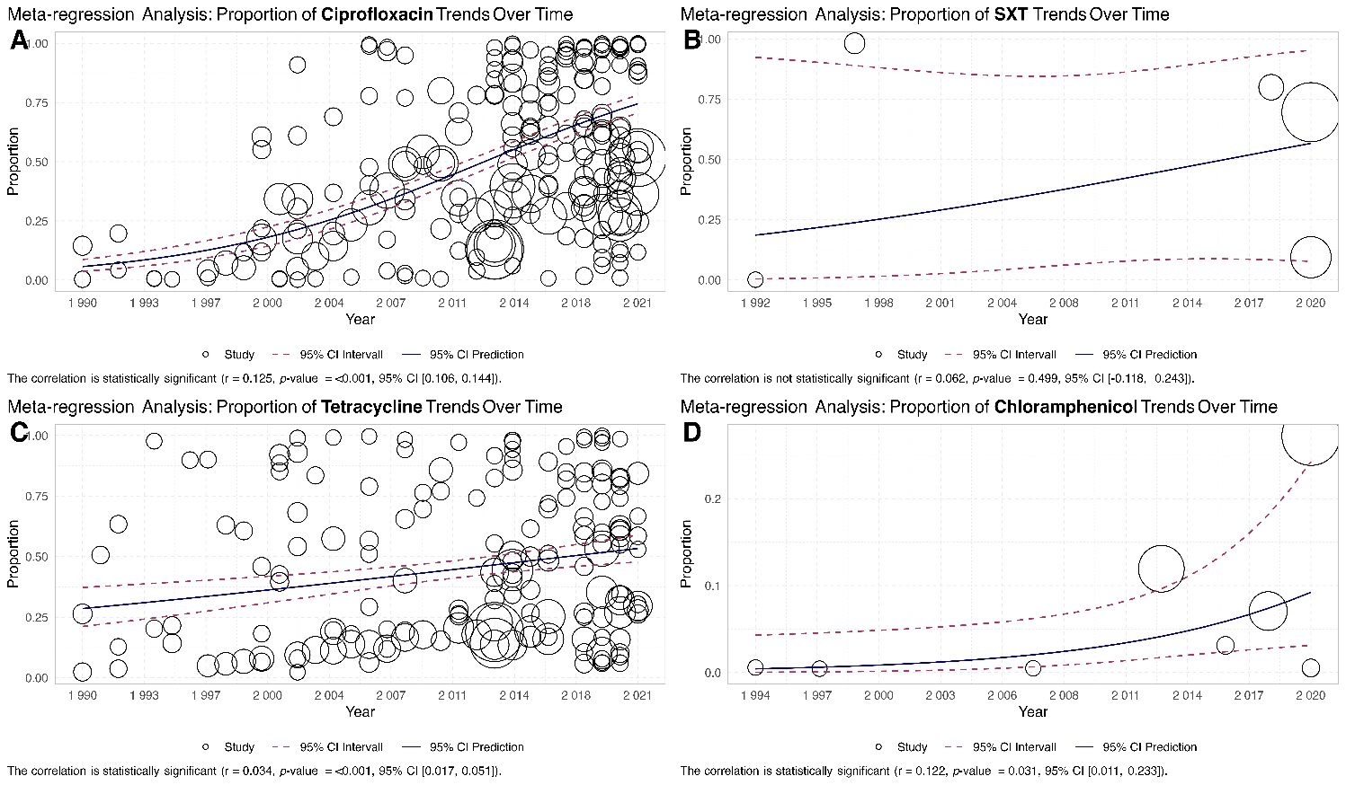

**Figure. Meta-regression results for changing antibiotic resistance rate over time.**

Regression of rates of Ciprofloxacin, Tetracycline, Spectinomycin resistance in China, Australia, and USA over time.

# China

### Ciprofloxacin

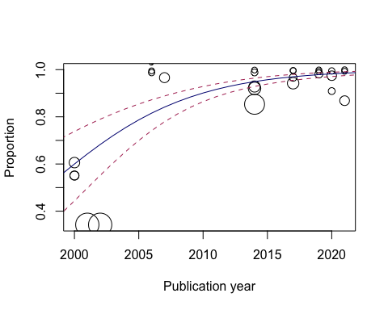

### 

# China

### Tetracycline

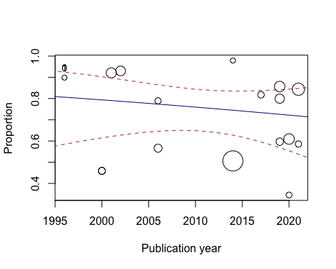

# China

### Spectinomycin

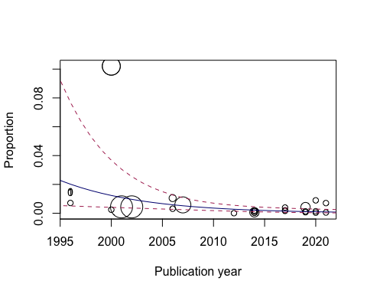

# Australia

### Ciprofloxacin

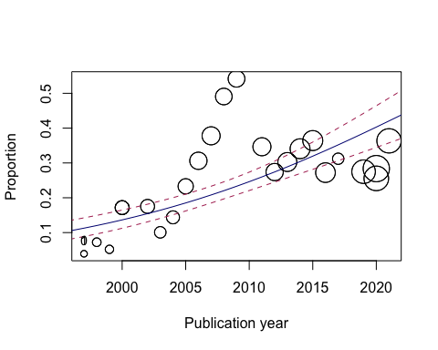

# Australia

### Tetracycline

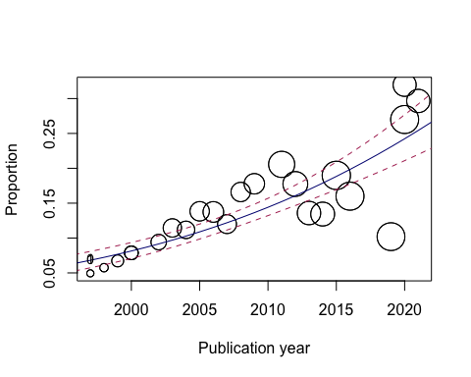

# Australia

### Spectinomycin

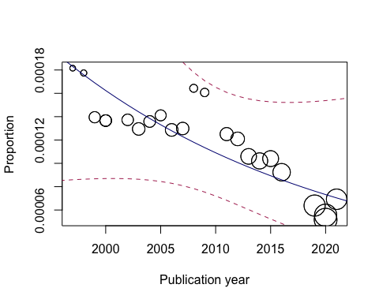

# USA

### Ciprofloxacin

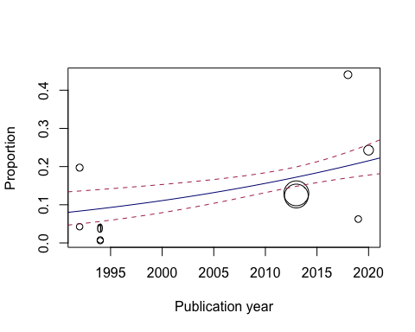

# USA

### Tetracycline

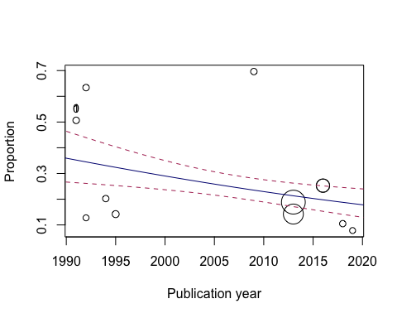

# USA

**Spectinomycin**

