**Supplementary Figure S2.**

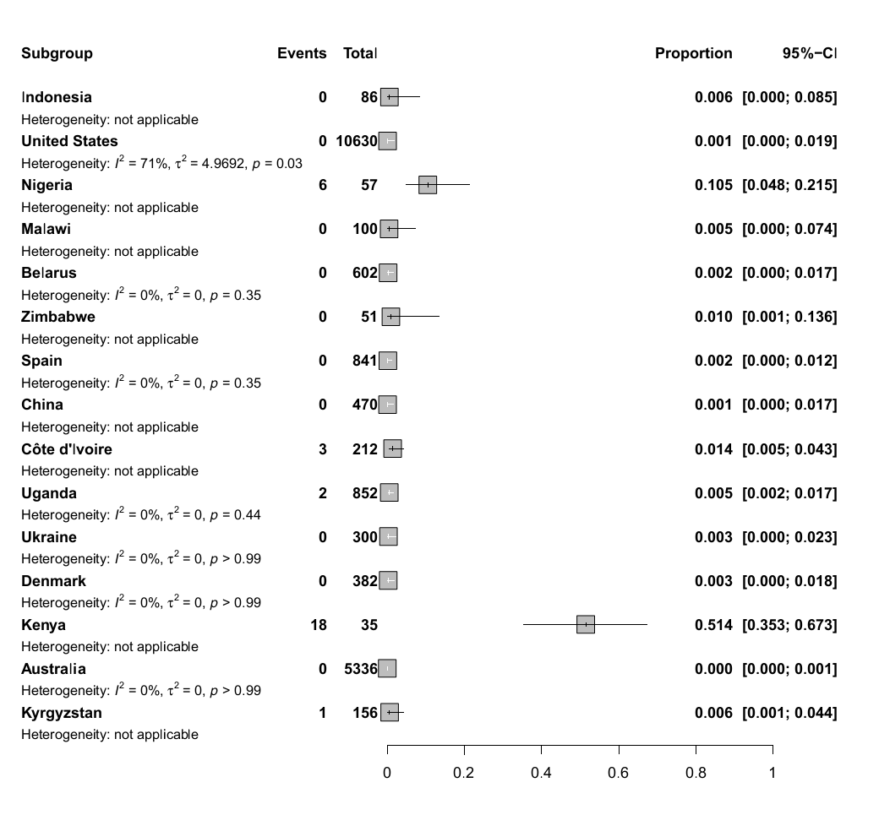

Forest plot for the gentamicin resistance rate stratified by countries.

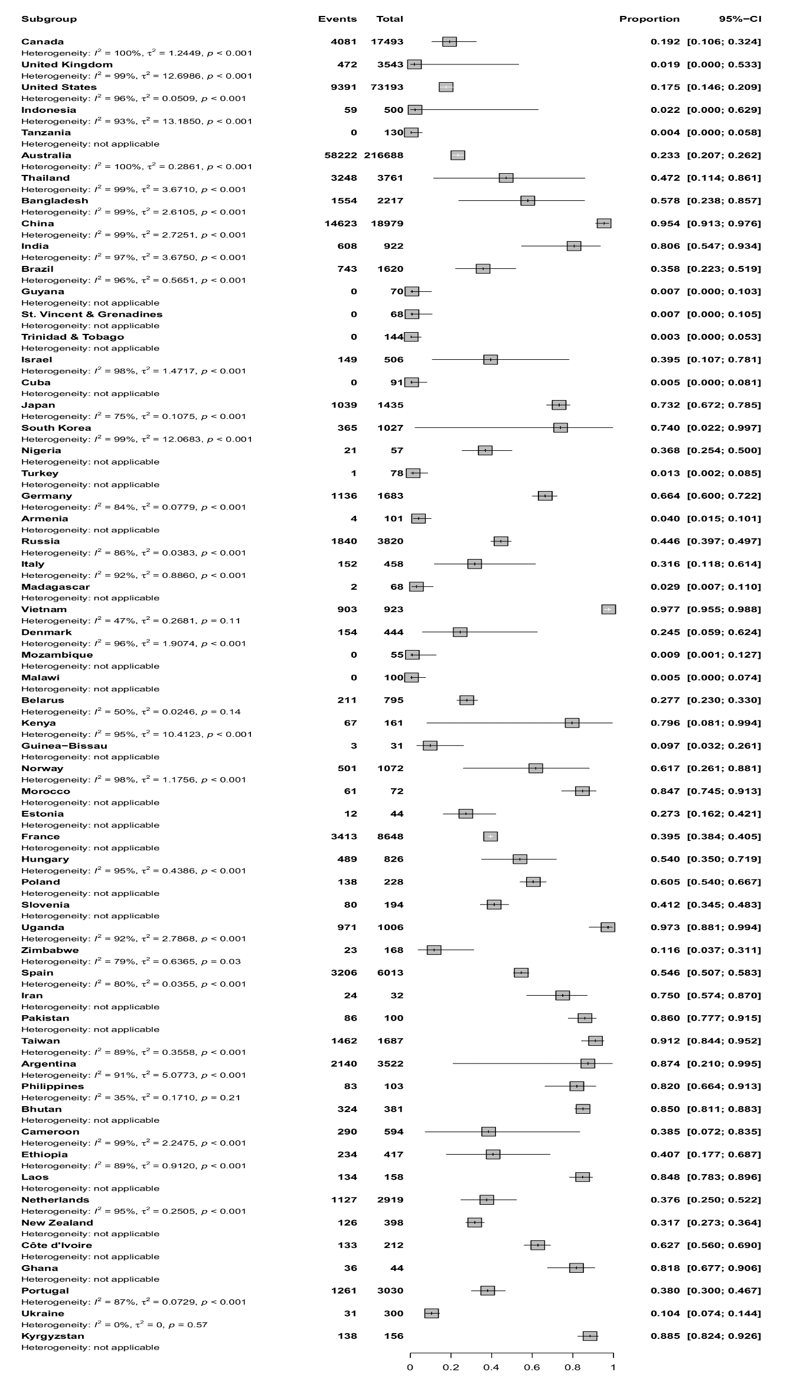

Forest plot for the ciprofloxacin resistance rate stratified by countries.

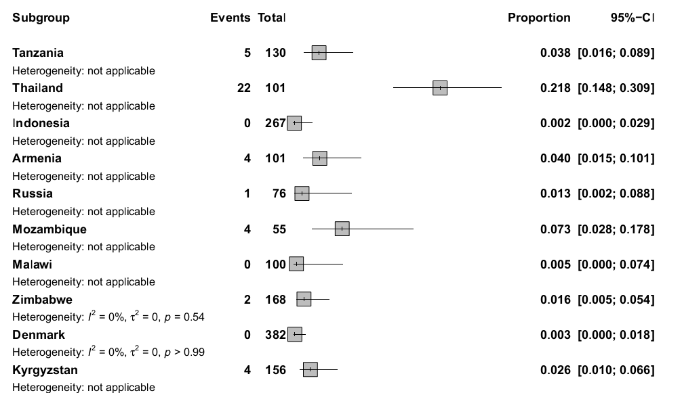

Forest plot for the kanamycin resistance rate stratified by countries.

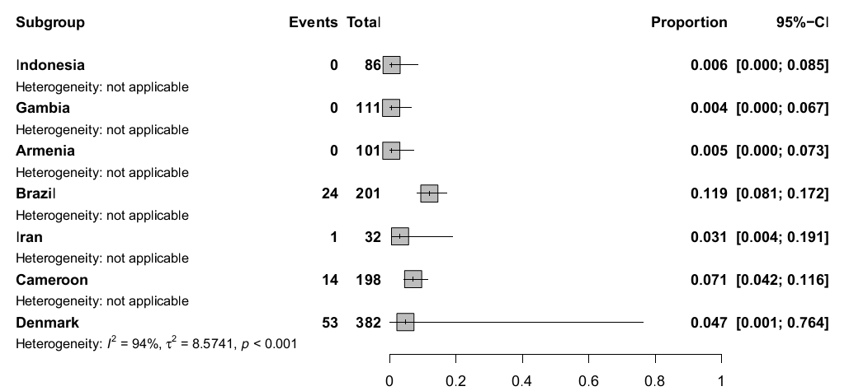

Forest plot for the chloramphenicol resistance rate stratified by countries.

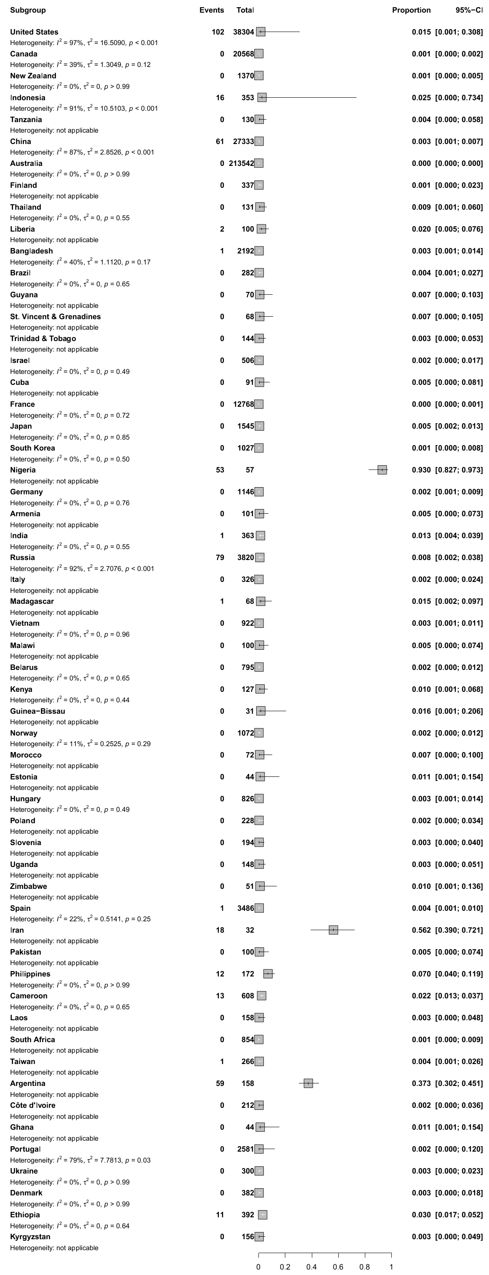

Forest plot for the spectinomycin resistance rate stratified by countries.

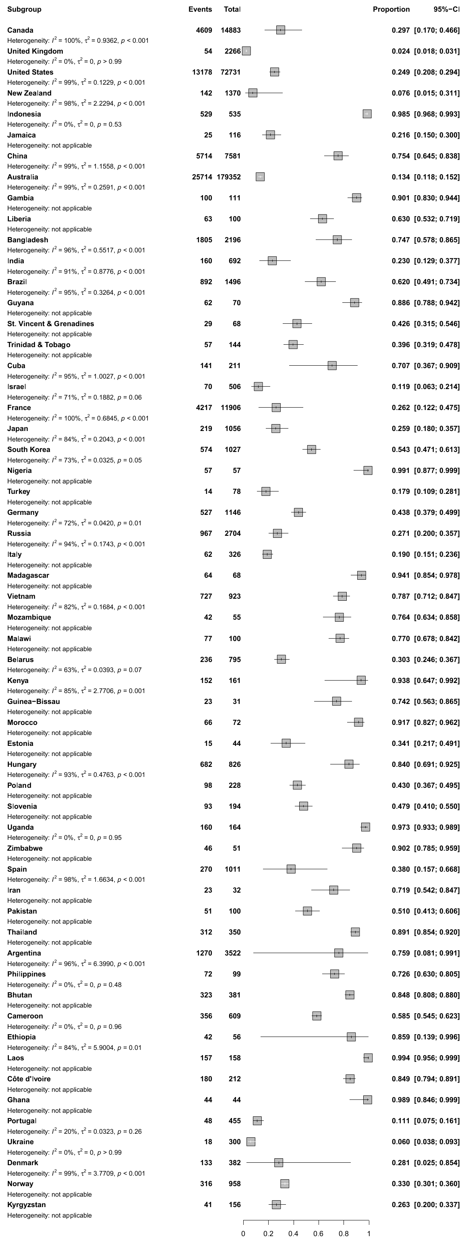

Forest plot for the tetracycline resistance rate stratified by countries.

* **Funnel plots depicts publication bias of included studies on antibiotic resistance**



