Supplementary Material

Supplementary Table 1. Mean values from measurements taken in each plot.

| **Variable** | **Ghost Forest (n=18)** | **Live Mangrove (n=18)** | **Seagrass**  **(n=18)** |
| --- | --- | --- | --- |
| **Air Temperature (°C)** | 19.4 ± 2.4 (16.5 - 25.2) | 18.1 ± 1.6 (14.5 - 20) | 19.4 ± 2.3 (14.2 - 23.3) |
| **Sea Temperature (°C)** | 20.4 ± 4.2 (17.3 - 29.2) | 20.3 ± 2.9 (15.7 - 24.1) | 18.6 ± 4.2 (14.3 - 26.6) |
| **Canopy Cover (%)** | 14.6 ± 21.2 (0 - 58.2) | 74.7 ± 14.4 (34.8 - 91) | 0 |
| **Stem Density (no. of stems per 7 m radial plot)** | 30.1 ± 16.7 (4 - 67) | 30.3 ± 13.5 (9 - 53) | 0 |
| **Sediment Size (µm)** | 127.4 ± 114.3 (28.5 - 317.9) | 111.6 ± 83.8 (35.2 - 294.8) | 167.0 ± 80.4 (58 - 295.1) |
| **Turbidity (NTU)** | 27.9 ± 46.7 (0.9 - 128) | 16.4 ± 12.2 (1.8 - 33.8) | 13.2 ± 5.3 (2.8 - 19.2) |
| **DBH (cm)** | 7.33 ± 5 (4 – 16.33) | 9.1 ± 4.2 (2.84 – 15.8) | 0 |
| **Seagrass Abundance (%)** | 8.02 ± 15.8 (0 - 42.5) | 0.1 ± 0.2 (0 - 0.05) | 32.5 ± 22.5 (5.9 - 97.3) |
| **Number of Sites with Seagrass Present** | 5 | 1 | 18 |
| **Number of Sites with Seagrass Absent** | 13 | 17 | 0 |
| **Number of Sites with Seagrass Wrack** | 12 | 11 | 3 |

Supplementary Figure 1. Correlation matrix of biophysical variables and seagrass presence (“Seagrass”).

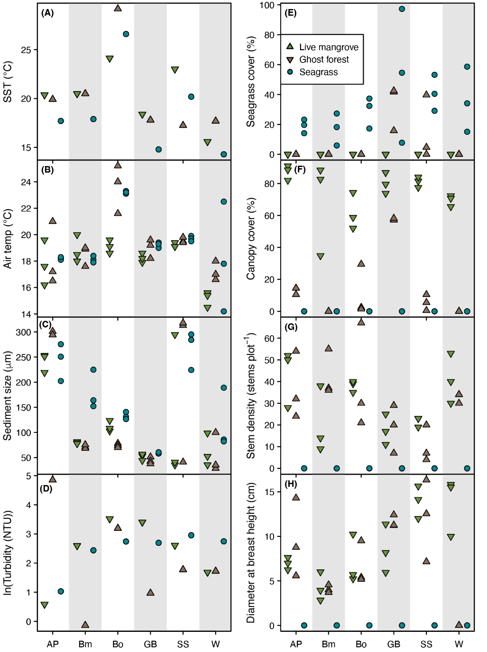

**Supplementary Figure 2:** Raw observations for eight biophysical variables measured in the study region, separated into the six study sites: Amity Point (“AP”), Beachmere (“Bm”), Boondall Wetlands (“Bo”), Godwin Beach (“GB”), South Stradbroke (“SS”) and Wynnum Wetlands (“W”), for live mangroves ghost forest and seagrass plots. All variables, except for turbidity and sea surface temperature (SST), were measured at the plot level; turbidity and SST were measured once per habitat type.

Supplementary Figure 3. Seagrass presence in dead mangrove survey plots, with mean seagrass cover in adjacent plots and the year of forest death. Plot points have been moved slightly for visual clarity; all plots from a single site share the same x and y values.

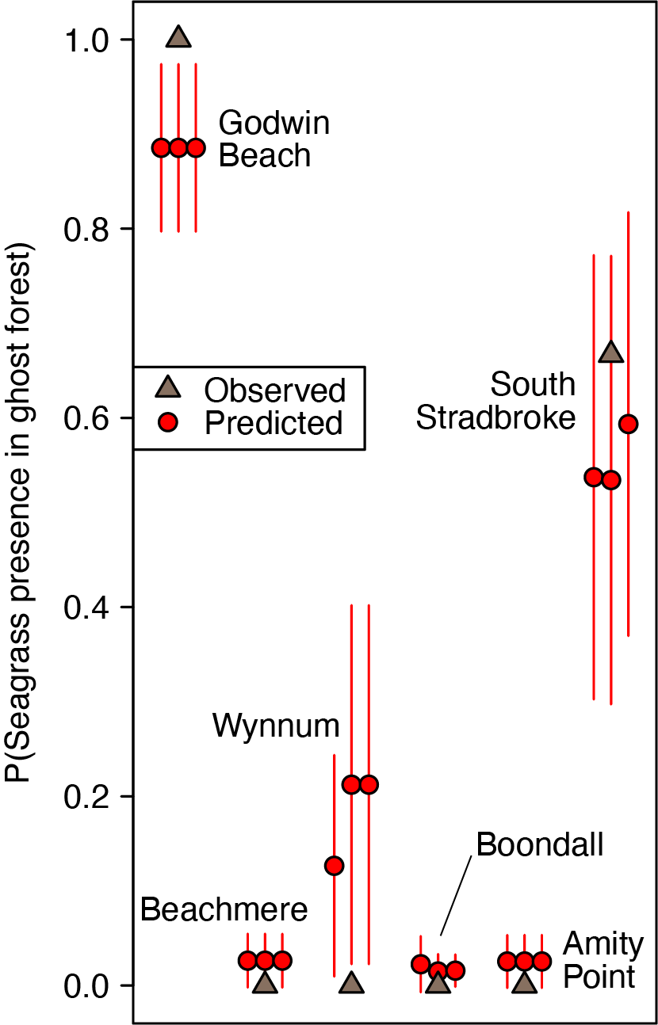

**Supplementary Figure 4**: Plot-level predictions of seagrass colonization into ghost forests (red points and accompanying standard errors), compared with the observed proportion of ghost forest plots with seagrass presence (brown points).

Supplementary Figure 5. Seagrass cover at each site, visualised as the seagrass area in a 250 m radius (x-axis), seagrass as a proportion of marine environment in a 250 m radius (y-axis), and seagrass cover in each of three sample plots (point size). Plot points have been moved slightly for visual clarity; all plots from a single site share the same x and y values.