Supplementary Material

# Supplementary Figures and Tables

## Supplementary Tables

**Supplementary Table S1** List of recorded shredder species, frequency of their occurrence in studied ponds (freq) and functional traits (BL –maximum body length, G – number of generations per year). Sources of trait information are listed below the table.

|  |  |  |  |
| --- | --- | --- | --- |
| Taxa | Freq | BL (mm) | G |
| Crustacea |  |  |  |
| *Gammarus balcanicus* Schäferna, 1922 | 2 | 18.0f | 1c |
| Coleoptera |  |  |  |
| *Anacaena globulus* (Paykull, 1798) | 2 | 3.5a | 1j |
| *Anacaena limbate* (Fabricius, 1792) | 1 | 3.2a | 1j |
| *Anacaena lutescens* (Stephens, 1829) | 4 | 3.2i | 1j |
| *Bagous longitarsis* Thomson, 1868 | 1 | 2.9h | 1j |
| *Berosus luridus* (Linnaeus, 1761) | 1 | 4.6a | 1j |
| *Dryops anglicanus* Edwards, 1909 | 1 | 5.0b | <1j |
| *Enochrus bicolor* (Fabricius, 1792) | 1 | 6.5a | 1j |
| *Enochrus coarctatus* (Gredler, 1863) | 1 | 4.0a | 1j |
| *Enochrus fuscipennis* (Thomson, 1884) | 2 | 5.6d | 1j |
| *Enochrus melanocephalus* (Olivier, 1792) | 1 | 4.8a | 1j |
| *Enochrus quadripunctatus* (Herbst, 1797) | 1 | 5.7a | 1j |
| *Enochrus ochropterus* (Marsham, 1802) | 1 | 5.5a | 1j |
| *Helophorus aquaticus* (Linnaeus, 1758) | 1 | 6.0a | 1j |
| *Helophorus flavipes* Fabricius, 1792 | 2 | 4.2a | 1j |
| *Helophorus granularis* (Linnaeus, 1761) | 1 | 3.0a | 1j |
| *Helophorus griseus* Herbst, 1793 | 1 | 3.6a | 1j |
| *Hydrochara caraboides* (Linnaeus, 1758) | 2 | 19.0a | 1j |
| *Laccobius minutus* (Linnaeus, 1758) | 2 | 3.4a | 1j |
| *Microcara testacea* (Linnaeus, 1767) | 2 | 10.0g | 1e |
| Trichoptera |  |  |  |
| *Oligotricha striata* (Linnaeus, 1758) | 2 | 22.0g | 1j |
| *Anabolia furcata* (Brauer, 1857) | 1 | 23.0g | 1j |
| *Chaetopteryx* sp. | 1 | 15.0g | 1j |
| *Limnephilus* cf. *auricula* (Curtis 1834) | 1 | 12.0g | 1j |
| *Limnephilus ignavus* (Mclachlan, 1865) | 1 | 16.0g | 1j |
| *Limnephilus lunatus* (Curtis, 1834) | 1 | 17.0g | 1j |
| *Limnephilus rhombicus* (Linnaeus, 1758) | 1 | 25.0g | 1j |
| *Leptocerus tineiformis* (Curtis, 1834) | 1 | 8.0g | 1j |
| Diptera |  |  |  |
| *Cricotopus sylvestris* gr. | 1 | 8.0g | (>)2j |
| Tipulidae indet. | 1 | 60.0g | 1j |

Sources:

a) Freude, H., K. W. Harde, and Lohse, G. A. (1971). Die Käfer Mitteleuropas. Bd 3, Adephaga 2, Palpicornia, Histeroidea, Staphylinoidea 1. Goecke and Evers, Krefeld.

b) Freude, H., K. W. Harde and Lohse, G. A. (1979). Die Käfer Mitteleuropas. Bd 6, Diversicornia. Goecke and Evers, Krefeld.

c) Grabowski, M., K. Bacela and Konopacka, A. (2007). How to be an invasive gammarid (Amphipoda: Gammaroidea)-comparison of life history traits. Hydrobiologia 590, 75–84.

d) İncekara, Ü., Mart, A., and Erman, O. (2005). Studies on Turkish Hydrophilidae (Coleoptera) I. Genus Enochrus Thomson, 1859. Turk J Zool29, 155–158.

e) Janz, P. (2016). Risikobewertung von Chemikalien mit Fließgewässermodellökosystemen: die Entwicklung eines Mesokosmos-Testsystems und eine Pilotstudie mit dem Tierarzneimittel Ivermectin. Justus-Liebig-Universität Gießen, Gießen.

f) Kriska, G. (2013). Freshwater invertebrates in Central Europe: a field guide. Springer Science and Business Media, Vienna.

g) Rozkošný, R. (1980). Klíč vodních larev hmyzu. Československá Akadémie Ved. Prague.

h) Skuhrovec, J., Gosik, R., Stejskal, R., Sprick, P., Caldara, R., and East CURCULIO Team. (2011). Digital–Weevil-Determination for Curculionoidea of West Palaearctic. Transalpina: Bagous (Bagoinae). Snudebiller 12, 39–56.

i) Straka, M., and Sychra, J. (2007). Determinační kurz makrozoobentosu: Coleoptera. Ústav botaniky a zoologie PřF Masarykovy univerzity a VÚV TG Masaryka, Brno.

j) Šporka, F. (2003). Vodné bezstavovce (makroevertebráta) Slovenska, súpis druhov a autekologické charakteristiky. Slovenský hydrometeorologický ústav, Bratislava.

**Supplementary Table S2** Breakdown rates (*k*) calculated for eight studied ponds as exponential decay per degree-day and day. Standard errors of the rates are given in brackets.

|  |  |  |
| --- | --- | --- |
| Pond | *k* (degree-day-1) | *k* (day-1) |
| Banská Belá | 0.00097 [0.00014] | 0.01273 [0.00303] |
| Detvianska Huta | 0.00078 [0.00018] | 0.00976 [0.00222] |
| Dvory nad Žitavou | 0.00123 [0.00017] | 0.02146 [0.00389] |
| Horný Badín | 0.00103 [0.00010] | 0.01410 [0.00149] |
| Koš | 0.00080 [0.00012] | 0.00918 [0.00173] |
| Kunerád 1 | 0.00094 [0.00022] | 0.01032 [0.00254] |
| Kunerád 3 | 0.00099 [0.00037] | 0.01106 [0.00521] |
| Poltár | 0.00085 [0.00019] | 0.01257 [0.00404] |

**Supplementary Table S3** Diversity characteristics of shredder communities in studied ponds.

|  |  |  |  |
| --- | --- | --- | --- |
| Pond | Abundance  (ind/sample) | Speciesrichness  (number of species) | Functional diversity  (length of dendrogram branches) |
| Banská Belá | 4.13 | 9 | 4.07 |
| Detvianska Huta | 0.67 | 2 | 0.96 |
| Dvory nad Žitavou | 2.63 | 7 | 9.31 |
| Horný Badín | 1.17 | 5 | 3.20 |
| Koš | 1.25 | 2 | 2.44 |
| Kunerád 1 | 4.20 | 7 | 3.48 |
| Kunerád 3 | 2.17 | 2 | 2.44 |
| Poltár | 2.00 | 6 | 12.75 |

## Supplementary Figures

Obrázok, na ktorom je kruh, náčrt, dizajn, ilustrácia

Automaticky generovaný popis

**Supplementary Figure S1**. Schematic comparison of a heavily shaded small pond with allochthonous leaf litter as a dominant energy source (left) and a well-insolated large lake with autochthonous primary production as a dominant source of energy (right).

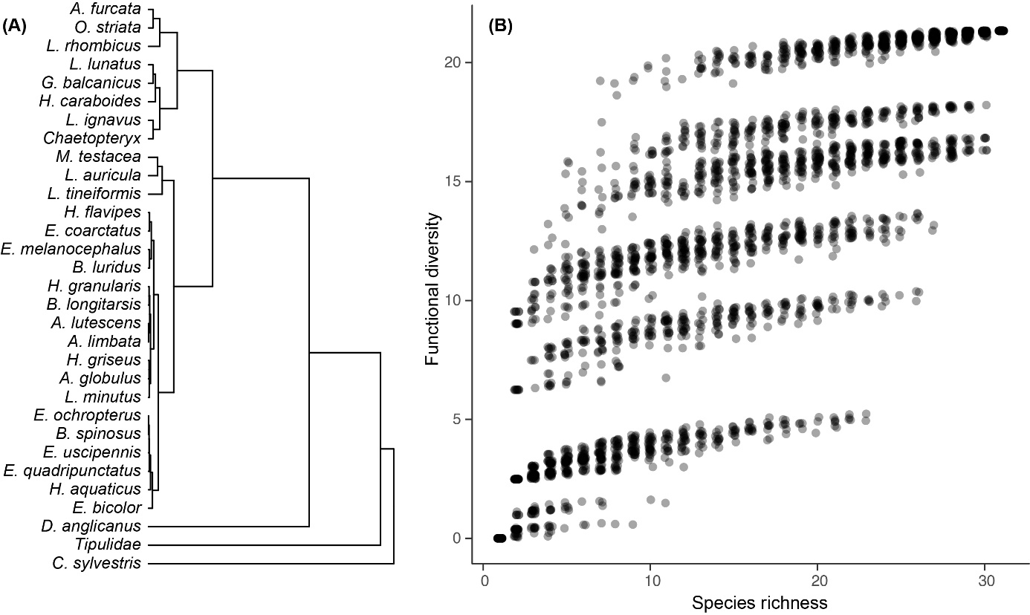

**Supplementary Figure** **S2** Functional dendrogram of species traits based on standardized Euclidean distances and the UPGMA method (A). Simulated relationship between species richness and functional diversity based on 100 unrestricted random samples of species at each richness level from the same functional dendrogram (B). Details on trait values are given in Table S1.

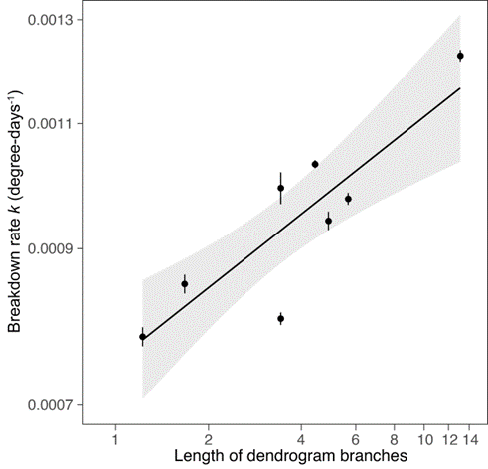

**Supplementary Figure** **S3** Relationship between black alder leaf litter breakdown rates in ponds and shredder functional diversity based on maximum body size. Expected breakdown rates based on the GLS models (line ± 95% conf. intervals in grey) are displayed along with observed values (circles ± 95% CI error bars). Note that even when excluding the pond with the highest functional diversity, the relationship remains significant (GLS: F = 9.28, p = 0.029).

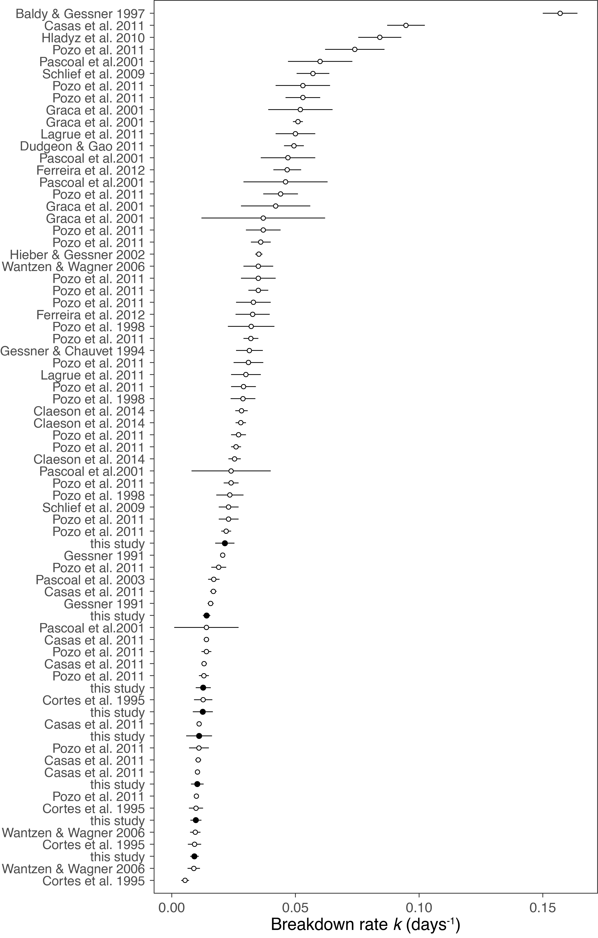

**Supplementary Figure S4** Comparison of black alder breakdown rates (*k*) recorded in coarse-mesh litter bags in headwater streams (open circles) and ponds examined in this study (full circles). Error bars represent standard errors of *k* estimates. The studies involved in the comparison reported exponential breakdown rates, measures of variance, stream order and litter bag mesh size ≥ 5 mm. References to the studies are given below.

Baldy, V. and Gessner, M. O. (1997). Towards a budget of leaf litter decomposition in a first-order woodland stream. Cr. Acad. Sci. Iii-Vie.320, 747–758.

Casas, J. J., Gessner, M. O., Lopez, D. and Descals, E. (2011). Leaf‐litter colonisation and breakdown in relation to stream typology: insights from Mediterranean low‐order streams. Freshwater. Biol.56, 2594–2608.

Claeson, S. M., LeRoy, C. J., Barry, J. R., and Kuehn, K. A. (2014). Impacts of invasive riparian knotweed on litter decomposition, aquatic fungi, and macroinvertebrates. Biol. Invasions 16, 1531–1544.

Cortes, R., Graça, M. A. S., Vingada, J., and Oliveira, S. V. (1995). Stream typology and dynamics of leaf processing. Annales de Limnologie-International Journal of Limnology 31, 119–131.

Dudgeon, D., and Gao, B. W. (2011). The influence of macroinvertebrate shredders, leaf type and composition on litter breakdown in a Hong Kong stream. Fund. Appl. Limnol./Arch. Hydrobiol., 178, 147–157.

Ferreira, V., Encalada, A. C., and Graça, M. A. (2012). Effects of litter diversity on decomposition and biological colonization of submerged litter in temperate and tropical streams. Freshw. Sci. 31, 945–962.

Gessner, M. O. (1991). Differences in processing dynamics of fresh and dried leaf litter in a stream ecosystem. Freshwater Biology 26, 387–398.

Gessner, M. O. and Chauvet, E. (1994). Importance of stream microfungi in controlling breakdown rates of leaf litter. Ecology 75, 1807–1817.

Graça, M. A. S., Ferreira, R. C. F., and Coimbra, C. N. (2001). Litter processing along a stream gradient: the role of invertebrates and decomposers. J. N. Am. Benthol. Soc.20, 408–420.

Hieber, M. and Gessner, M. O. (2002). Contribution of stream detrivores, fungi, and bacteria to leaf breakdown based on biomass estimates. Ecology 83, 1026–1038.

Hladyz, S., Tiegs, S. D., Gessner, M. O., Giller, P. S., Rîşnoveanu, G., Preda, E., Nistorescu, M., Schindler, M., and Woodward, G. (2010). Leaf‐litter breakdown in pasture and deciduous woodland streams: a comparison among three European regions. Freshwater. Biol.55, 1916–1929.

Lagrue, C., Kominoski, J. S., Danger, M., Baudoin, J. M., Lamothe, S., Lambrigot, D., and Lecerf, A. (2011). Experimental shading alters leaf litter breakdown in streams of contrasting riparian canopy cover. Freshwater. Biol. 56, 2059–2069.

Pascoal, C., Cássio, F., and Gomes, P. (2001). Leaf breakdown rates: a measure of water quality? International Review of Hydrobiology: A Journal Covering all Aspects of Limnology and Marine Biology 86, 407–416.

Pascoal, C., Pinho, M., Cássio, F., and Gomes, P. (2003). Assessing structural and functional ecosystem condition using leaf breakdown: studies on a polluted river. Freshwater. Biol.48, 2033–2044.

Pozo, J., Basaguren, A., Elosegui, A., Molinero, J., Fabre, E., and Chauvet, E. (1998). Afforestation with Eucalyptus globulus and leaf litter decomposition in streams of northern Spain. Hydrobiologia 373, 101.

Pozo, J., Casas, J., Menéndez, M., Mollá, S., Arostegui, I., Basaguren, A., Casado, C., Descals, E., García-Avilés, J., González, J.M., and Larrañaga, A. (2011). Leaf-litter decomposition in headwater streams: a comparison of the process among four climatic regions. J. N. Am. Benthol. Soc.30, 935–950.

Schlief, J., and Mutz, M. (2009). Effect of sudden flow reduction on the decomposition of alder leaves (Alnus glutinosa [L.] Gaertn.) in a temperate lowland stream: a mesocosm study. Hydrobiologia 624, 205–217.

Wantzen, K. M., and Wagner, R. (2006). Detritus processing by invertebrate shredders: a neotropical–temperate comparison. J. N. Am. Benthol. Soc.25, 216–232.