The databases used in this work: (1) catalog of thermal springs (after Waring, 1965; with modifications and updates); (2) location of seismic events with 4.0<M<9.2 (Storchak et al., 2013; http://www.isc.ac.uk/iscgem/, accessed on July 20, 2023); (3) catalog of "non-volcanic" (see text) manifestations and wells discharging fluids with ³He/⁴He > 1.22 Ra (after Abedini et al. (2006), with corrections and updates based on data published until 2022) are available upon request from the corresponding author. 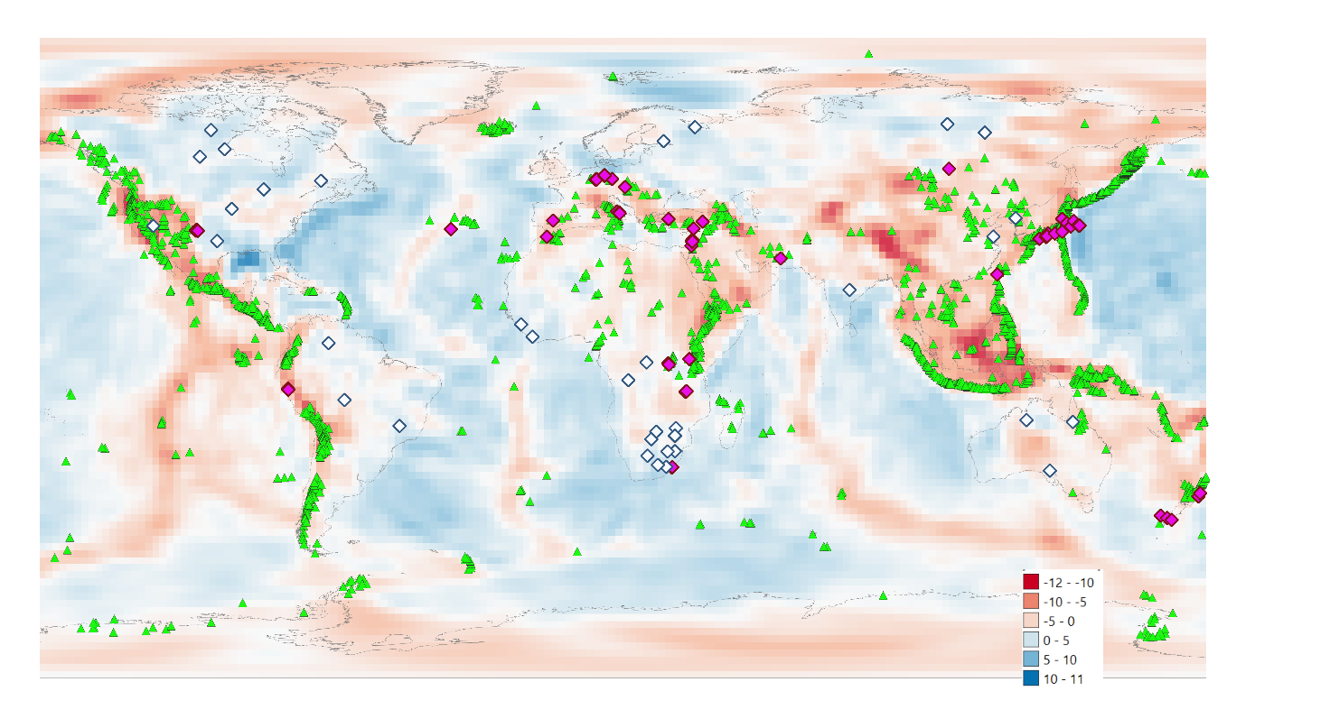
Fig. SM1 – Location map of non-volcanic geofluid emissions with ${}_{ }^{3}{He}/{}_{ }^{4}{He}$ > 1.22 Ra (Abedini et al., 2006, modified and updated) scarcely affected, or unaffected, by significant Vs (%) values (Debayle et al., 2016; Hasterok et al., 2022) (Purple rhombuses). Location map of lithospheric and superdeep diamonds (Shirey et al., 2013) (White rhombuses) as indicators of deep originated Carbon. Holocenic and Pleistocenic volcanoes (Global Volcanism Program, 2013) (green triangles).
Shirey, S. B., Cartigny, P., Frost, D. J., Keshav, S., Nestola, F., Nimis, P., ... & Walter, M. J. (2013). Diamonds and the geology of mantle carbon. Reviews in Mineralogy and Geochemistry, 75(1), 355-421.
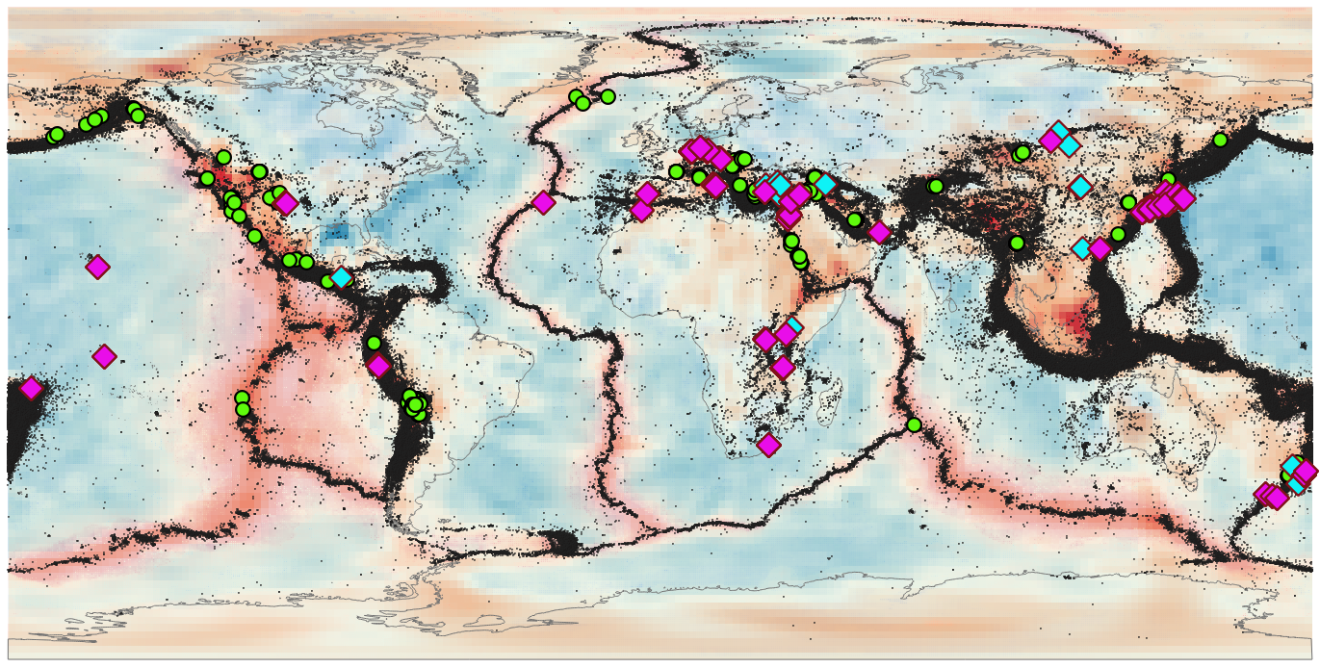
Fig. SM2 – Location map of non-volcanic geofluid emissions with ${}_{ }^{3}{He}/{}_{ }^{4}{He}$ > 1.22 Ra (Abedini et al., 2006, modified and updated). Green dots: ${}_{ }^{3}{He}/{}_{ }^{4}{He}$in high heat flow areas (Lucazeau, 2019), significantly affected by negative Vs (%) values (Debayle et al., 2016; Hasterok et al., 2022). Purple diamonds: ${}_{ }^{3}{He}/{}_{ }^{4}{He}$ in low heat flow areas (Lucazeau, 2019) scarcely affected, or unaffected, by significant Vs (%) values (Debayle et al., 2016; Hasterok et al., 2022). Blue diamonds: ${}_{ }^{3}{He}/{}_{ }^{4}{He}$ in low heat flow areas (Lucazeau, 2019) scarcely affected by Vs (%) values (> -3%) (Debayle et al., 2016; Hasterok et al., 2022).

