Supplementary Material

Supplementary Figures S1-S28. Distribution of cpDNA and nDNA alleles in 11 bryophyte and 17 spermatophyte species across western Europe.

S1. Antitrichia curtipendula
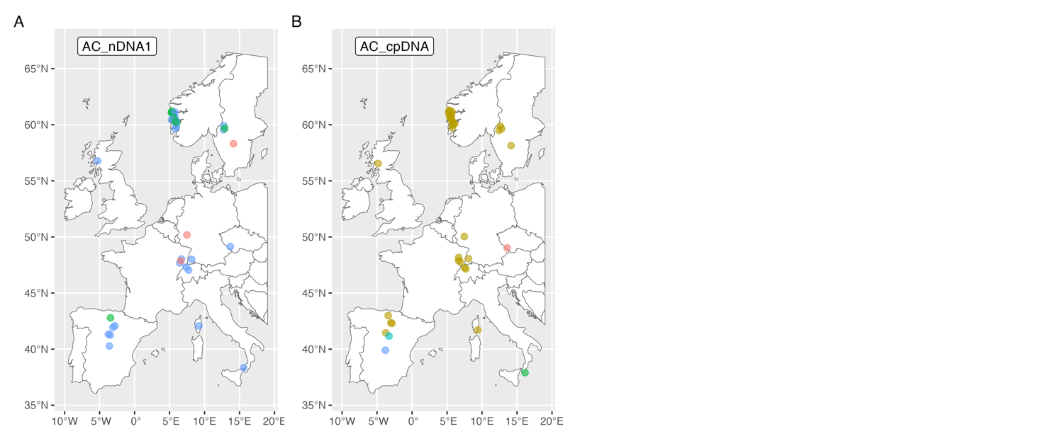
S2. Amphidium mougeotii
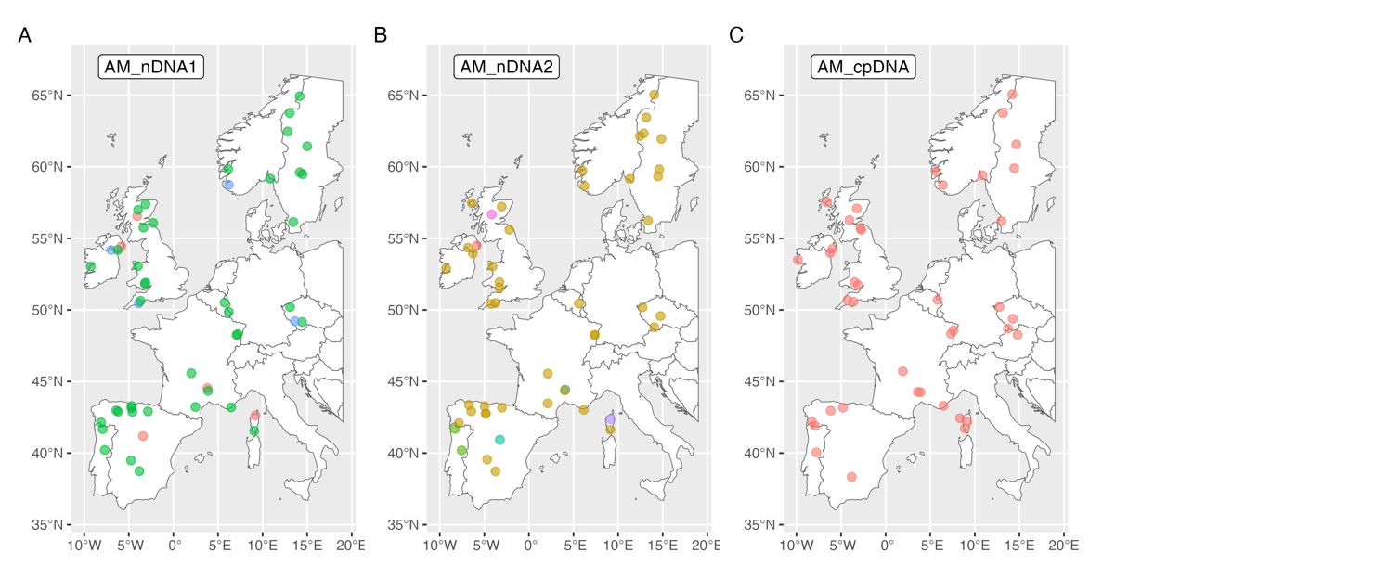
S3. Calypogeia fissa
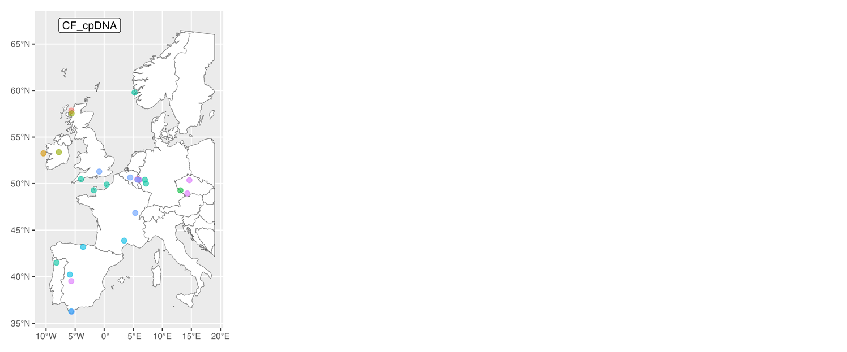

S4. Homalothecium sericeum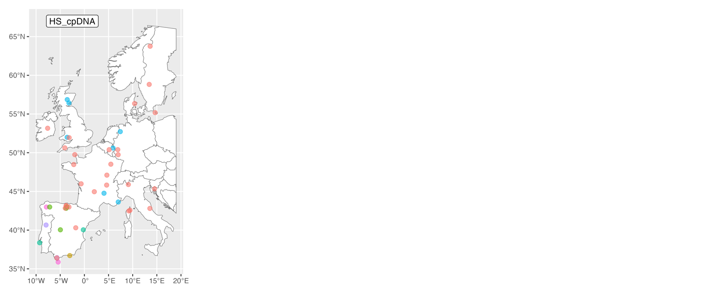

S5. Metzgeria furcata
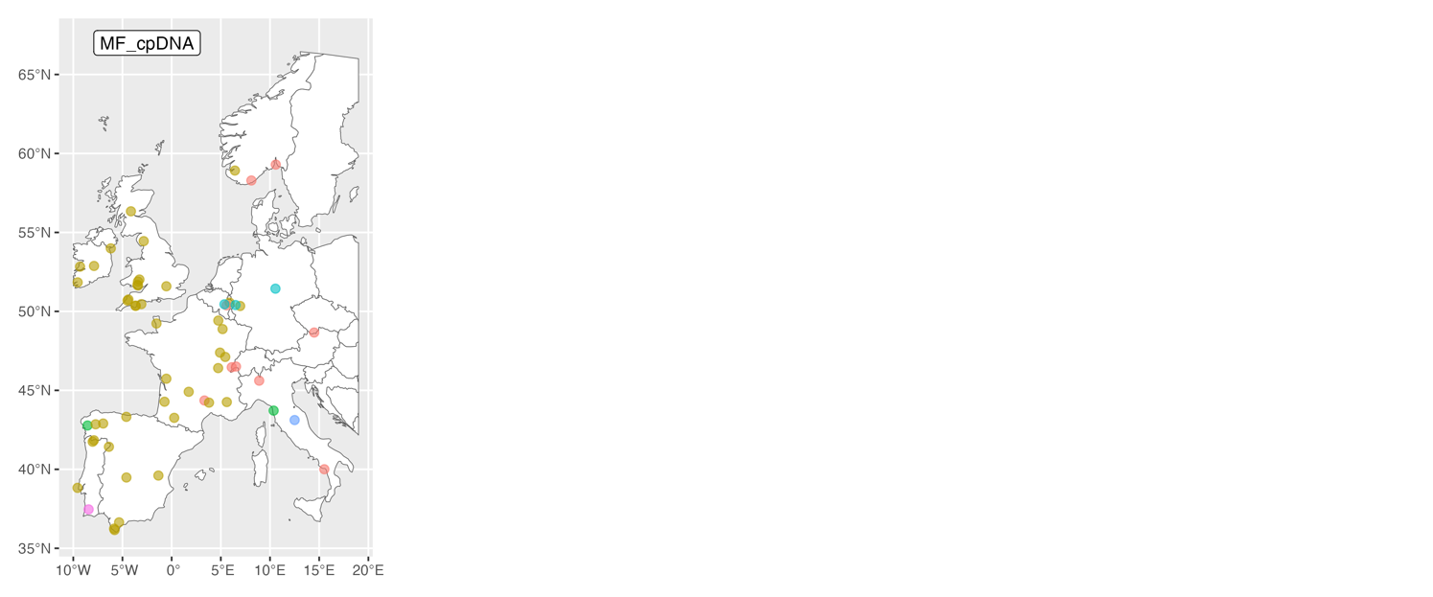
S6. Lewinskya affine (previously Orthotrichum affine)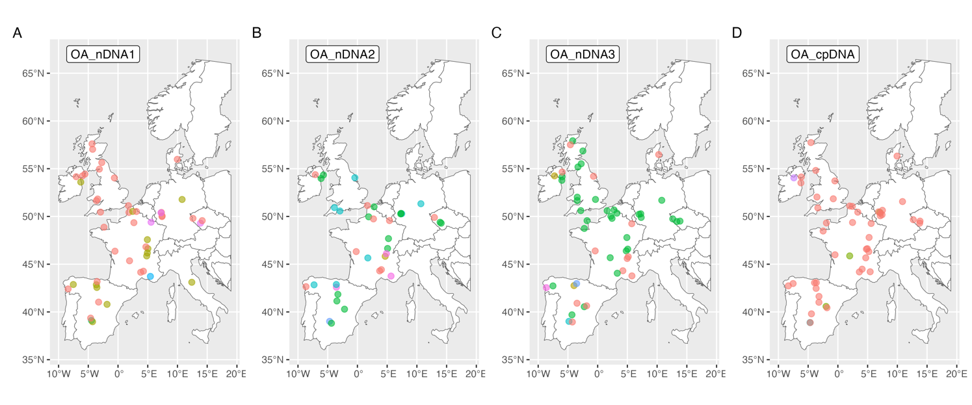
S7. Pulvigera lyellii (previously Orthotrichum lyellii)
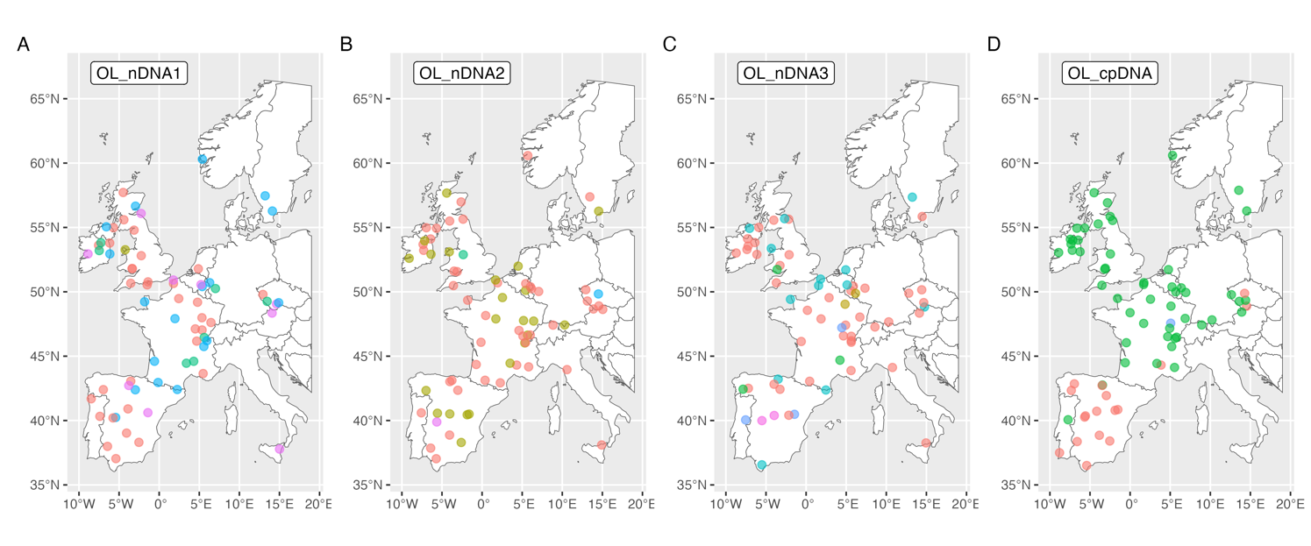
S8. Plagiomnium undulatum
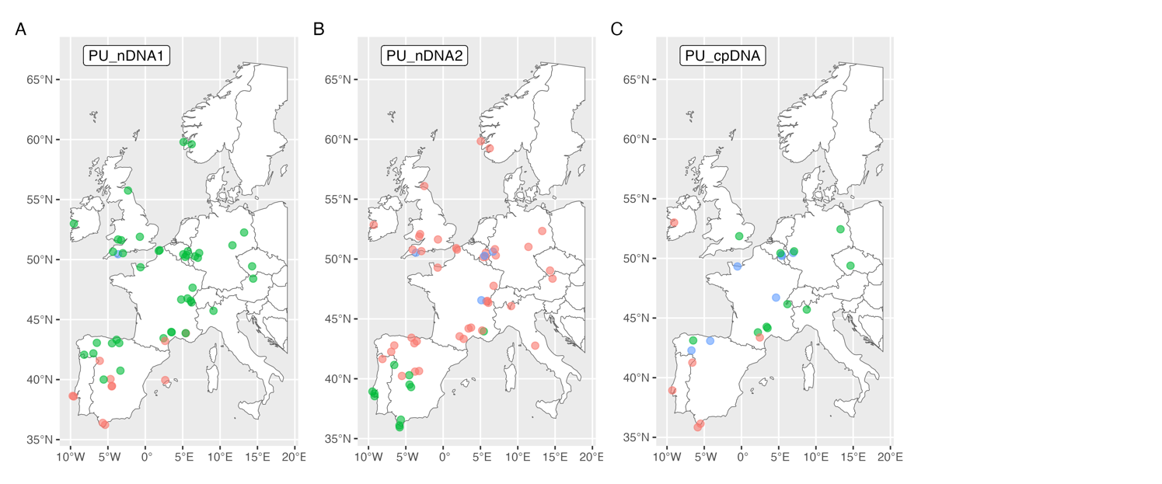
S9. Plagiothecium undulatum
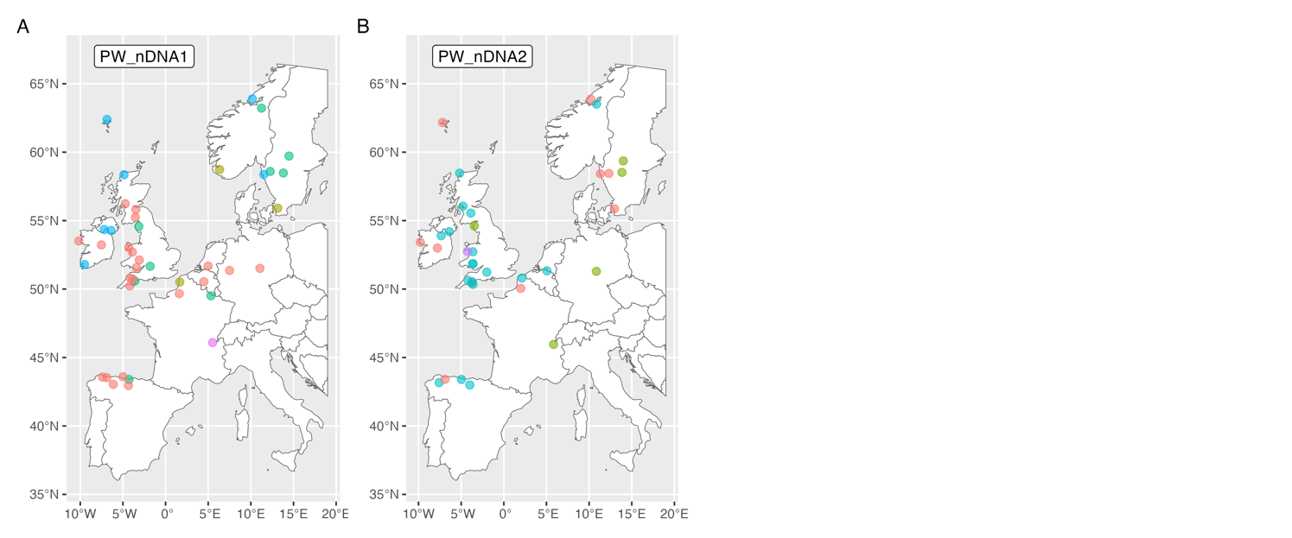
S10. Scorpiurium circinatum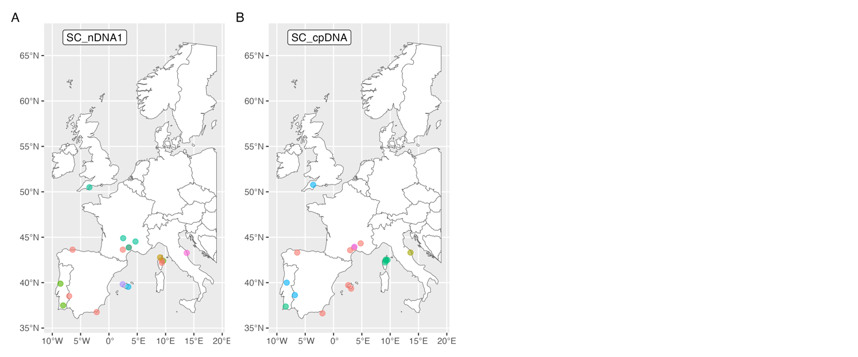
S11. Sphagnum fimbriatum
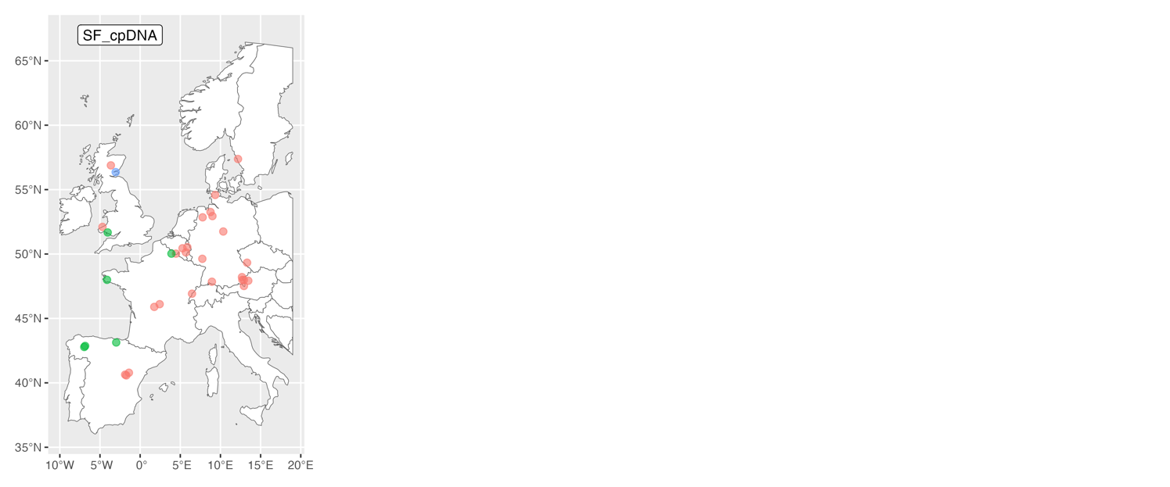

S12. Arabis alpina
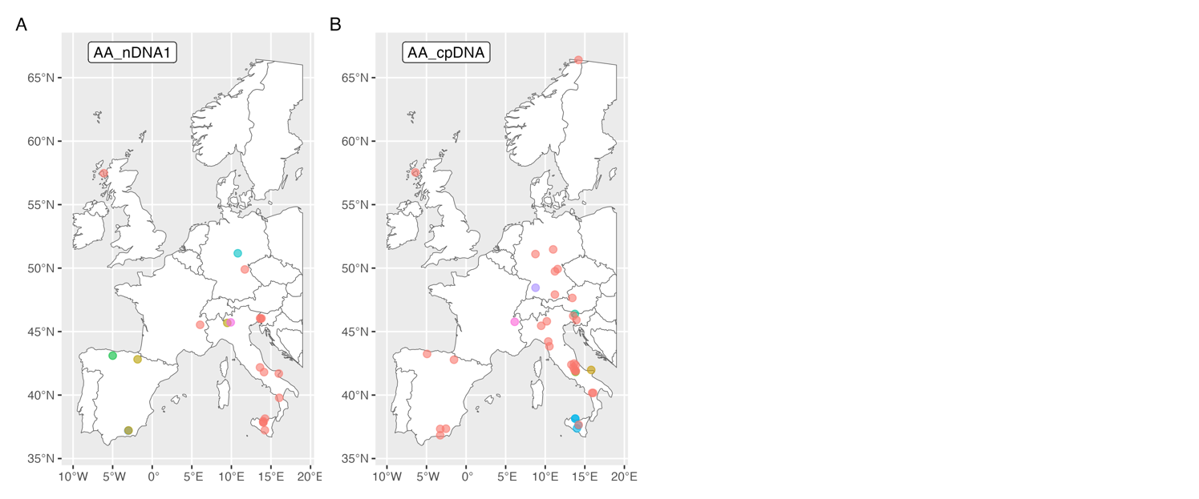
S13. Alnus glutinosa
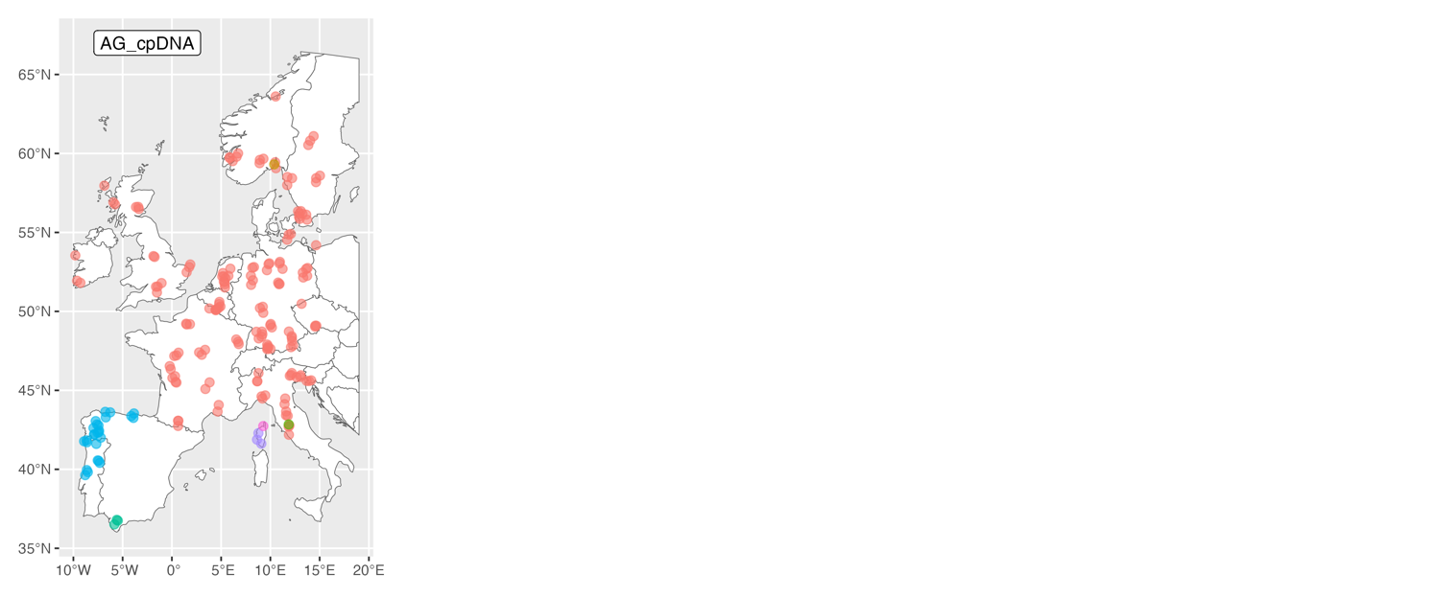
S14. Aegilops geniculata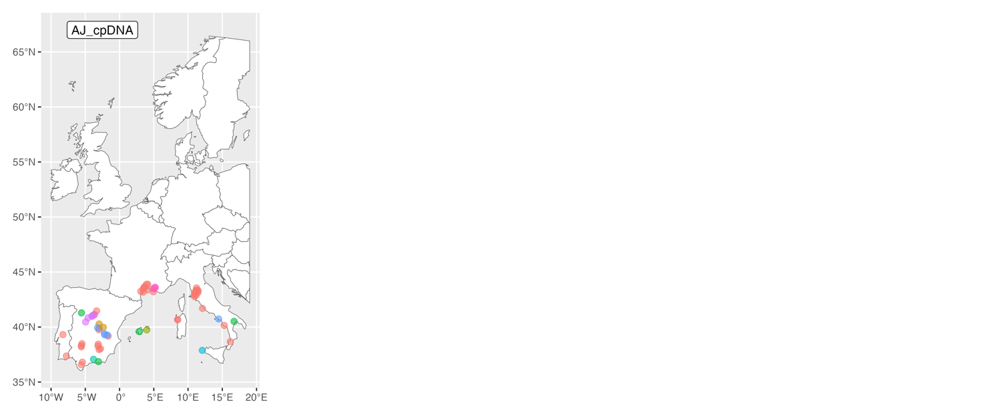
S15. Arabidopsis thaliana
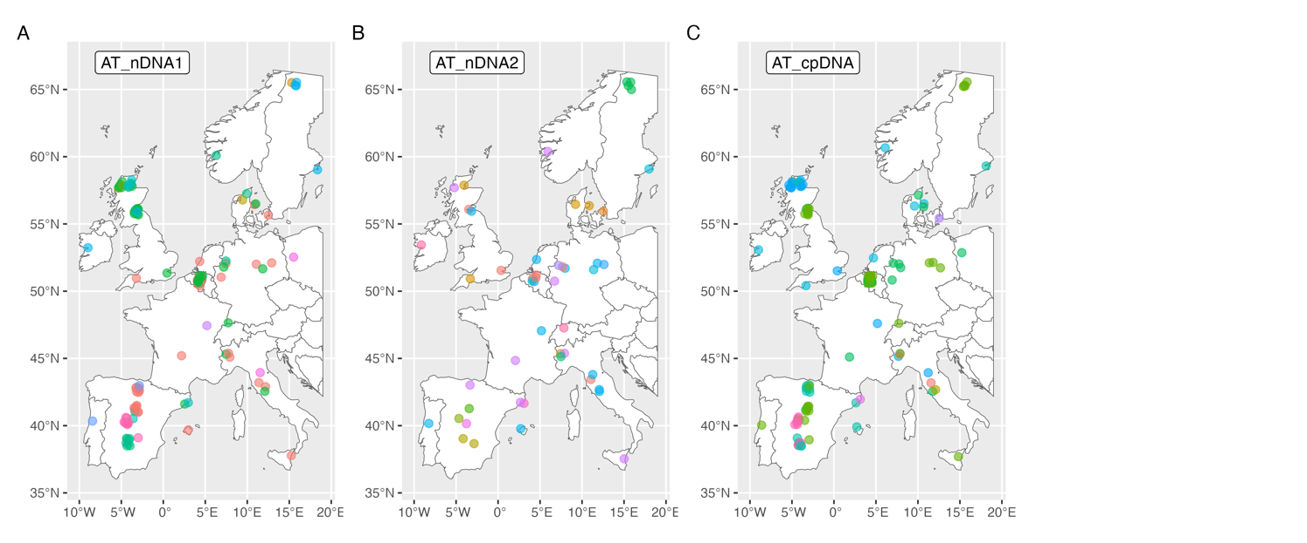
S16. Beta vulgaris maritima
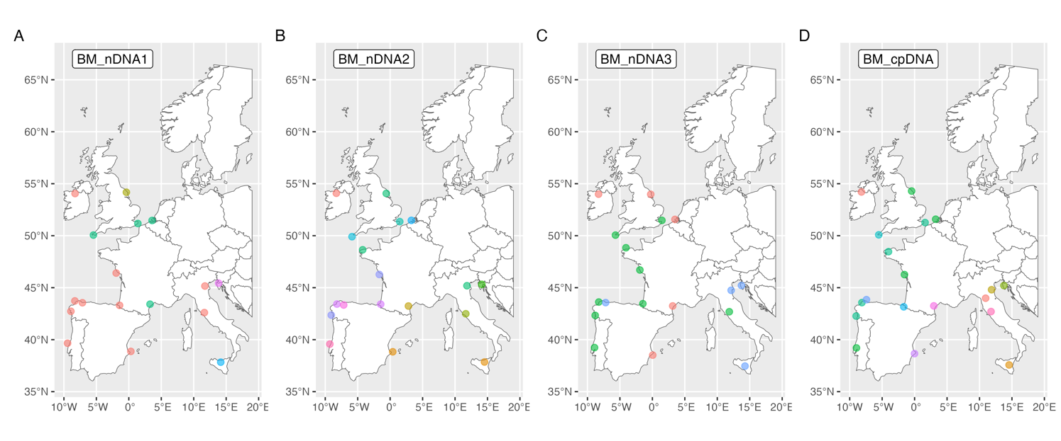
S17. Carex extensa
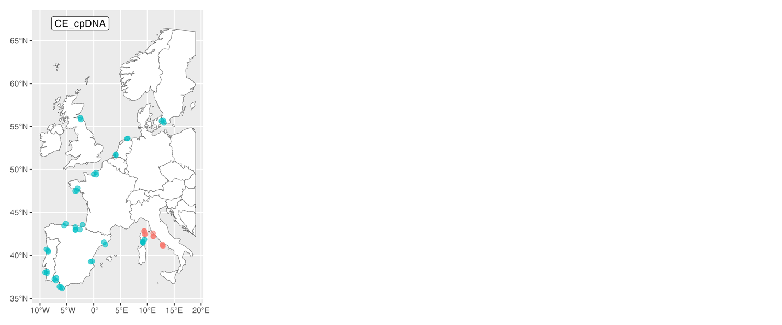
S18. Ceratonia siliqua
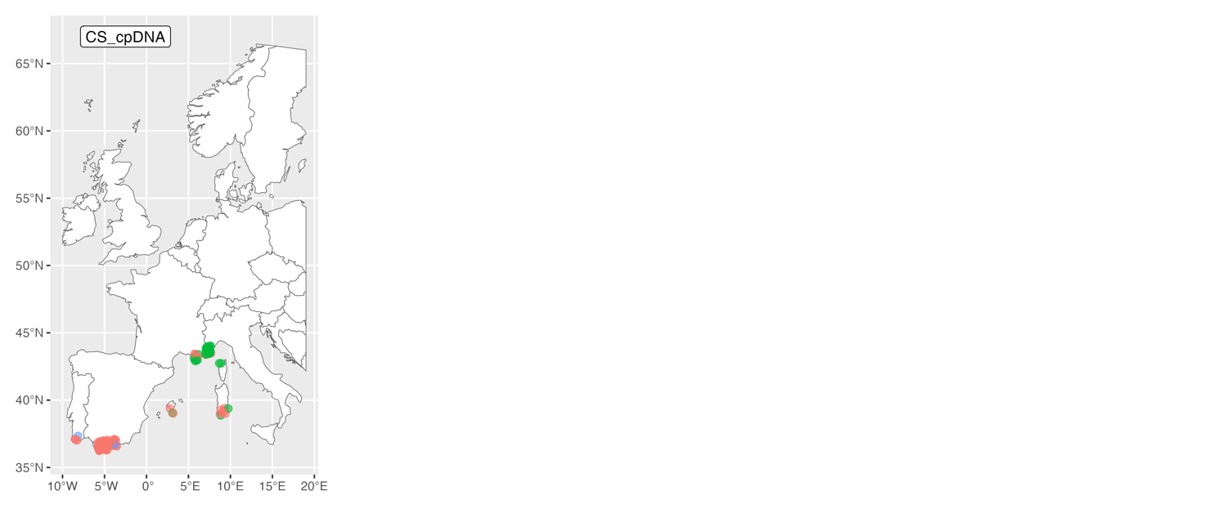
S19. Calluna vulgaris
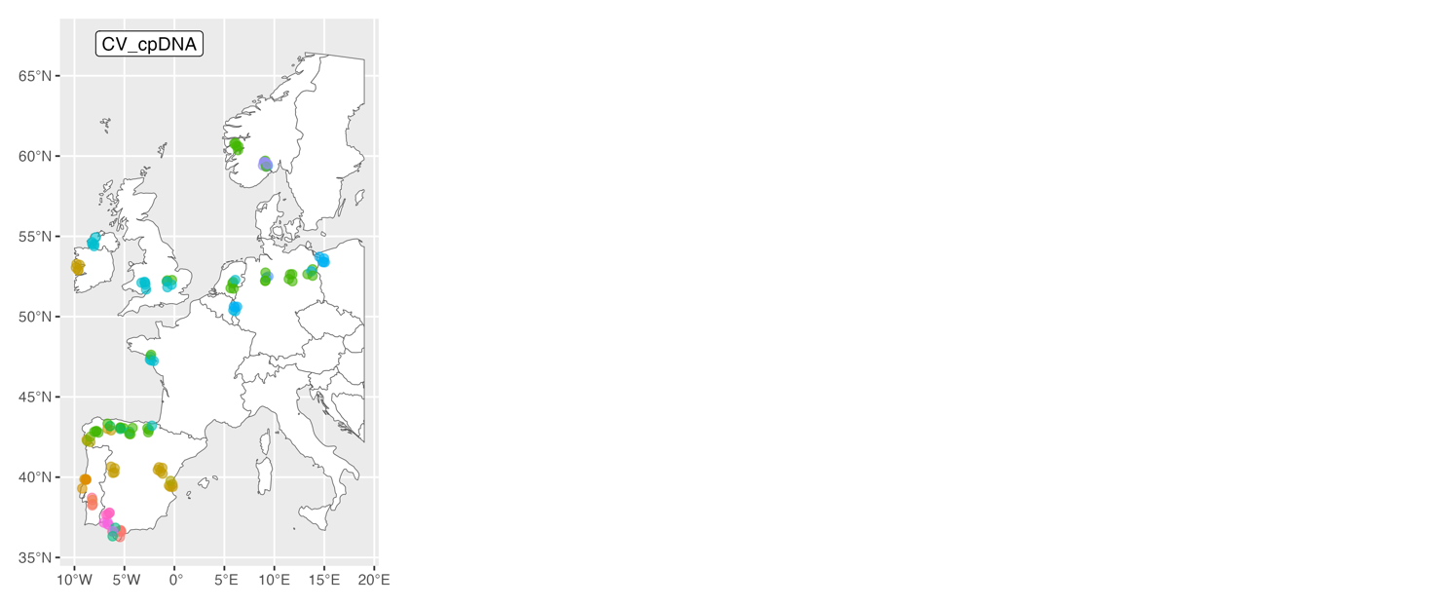
S20. Hedera helix
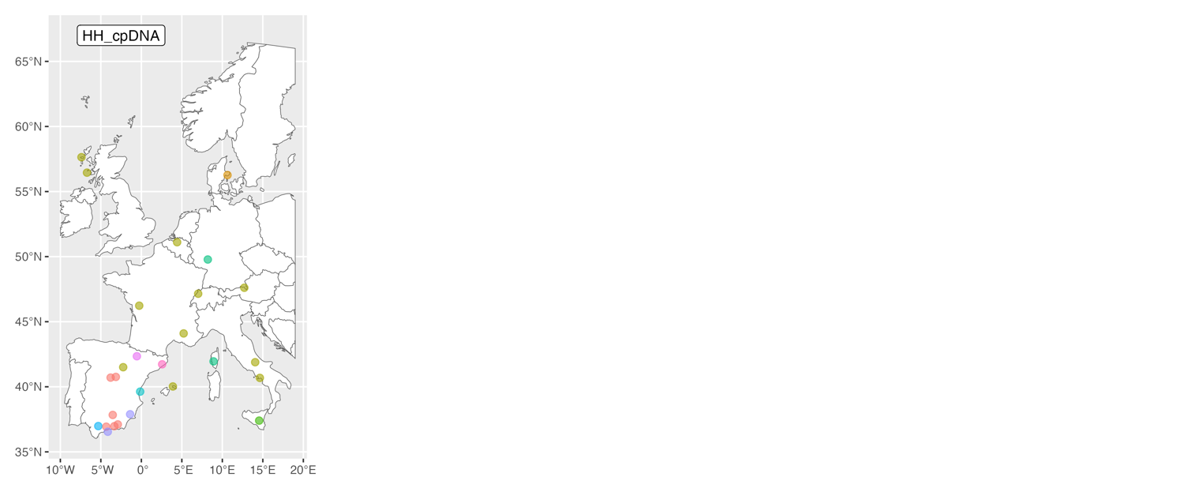
S21. Hordeum marinum
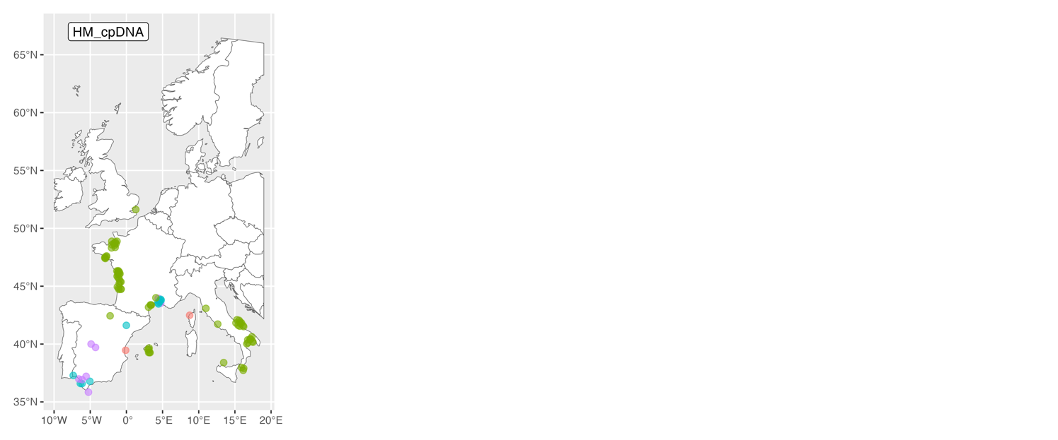
S22. Helianthemum nummularium
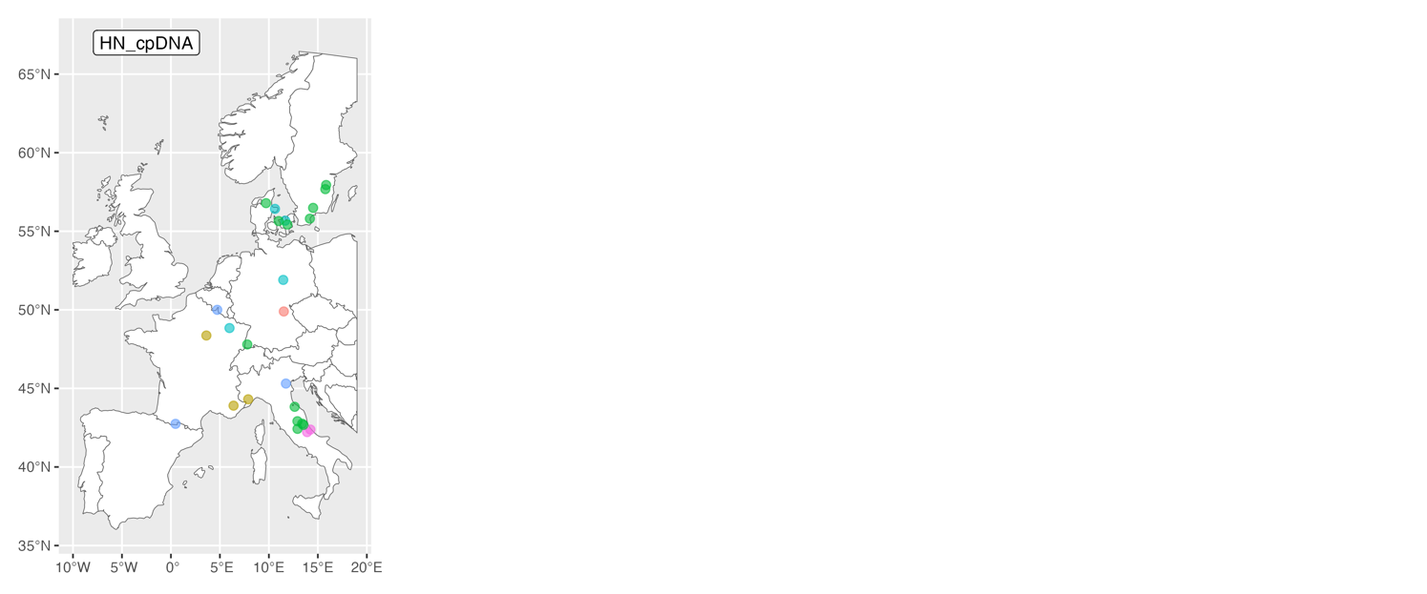
S23. Lavatera maritima
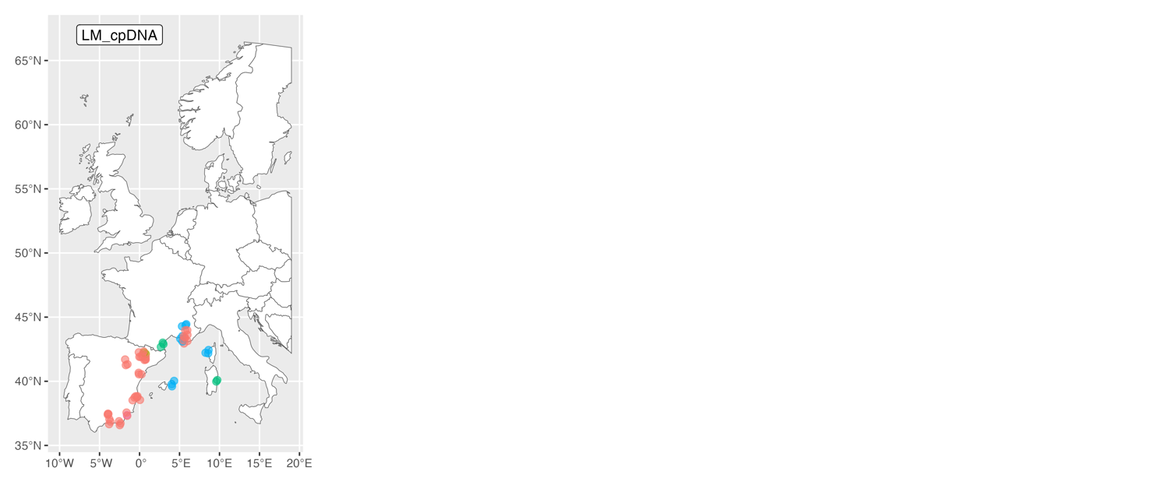
S24. Myrtus communis
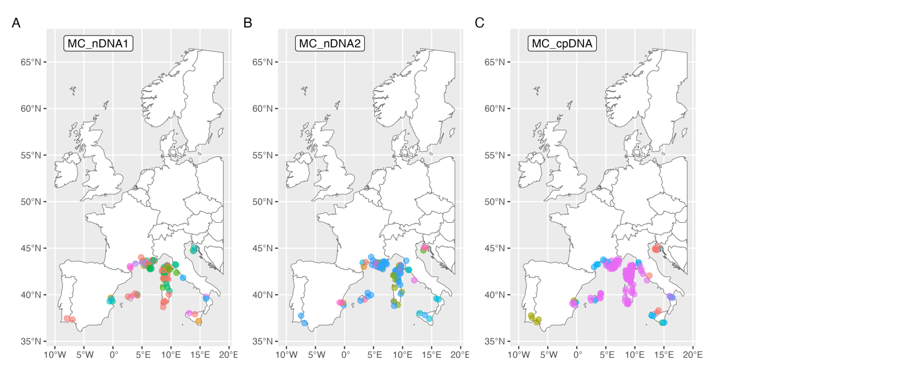
S25. Microthlaspi perfoliatum
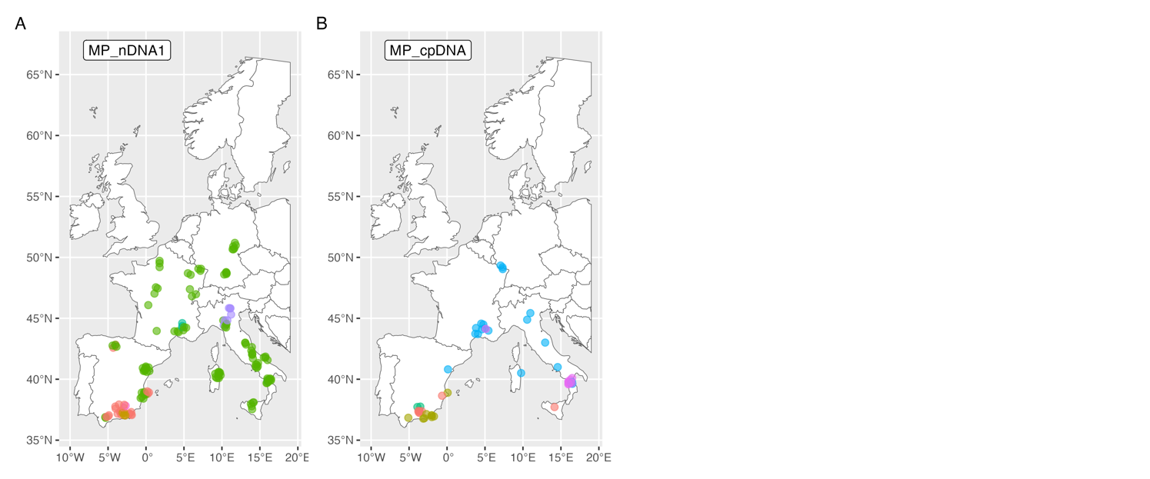
S26. Primula vulgaris
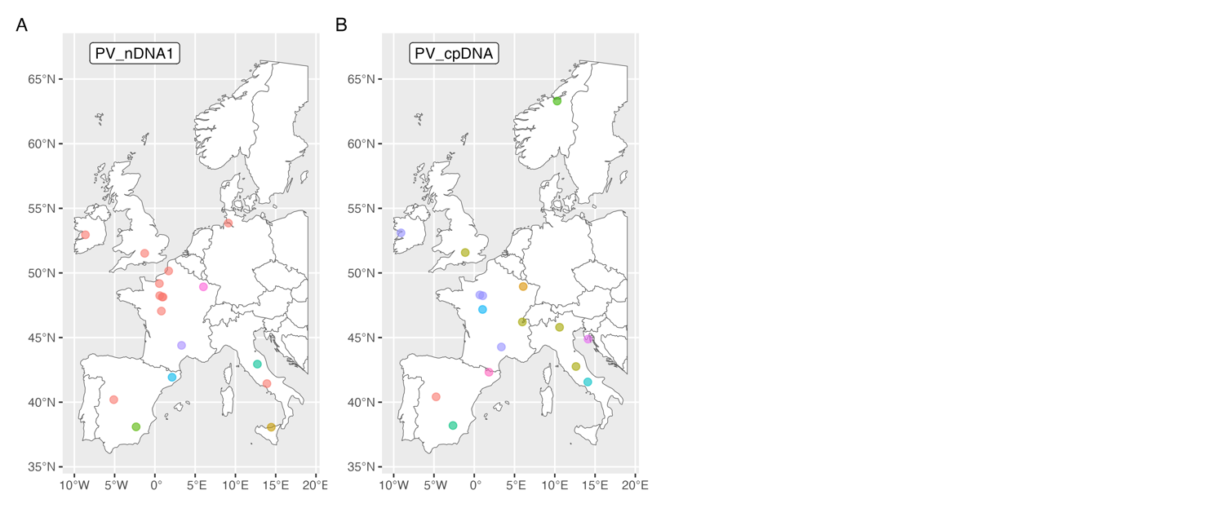
S27. Sedum album
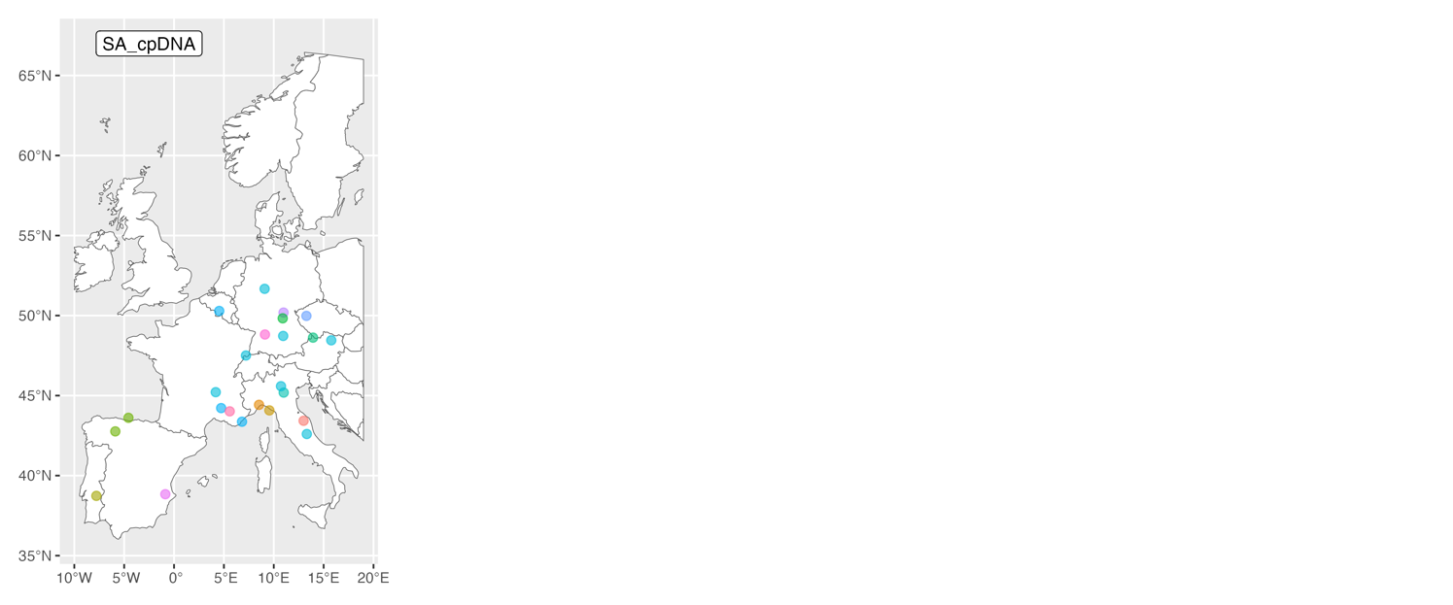
S28. Silene nutans
