Supplementary Material

Nitrogen enrichment alters phytoplankton biomass and composition via silicon limitation
Kriste Makareviciute-Fichtner^{1*}, Birte Matthiessen¹, Heike K. Lotze², Ulrich Sommer¹
¹ Marine Ecology, GEOMAR Helmholtz Centre for Ocean Research Kiel, Germany
² Department of Biology, Dalhousie University, Halifax, Canada
* Correspondence:
Kriste Makareviciute-Fichtner,
kmakareviciute@geomar.de

Supplementary Figures and Tables

Supplementary Tables
Supplementary Table 1. Treatment effects on dissolved nutrient concentrations and Si:N ratio on day 5 of the experiment. ² indicates that Si:N function was quadratic, arrows mark where the parameter decreased (↓) or increased (↑) with Si:N treatments. GLM model with Gamma link with log link was used for dissolved nitrogen and phosphorus data and identity link was used for estimating effects on dissolved silicon Si:N ratio.

Day 5 of the experiment
 | Factor | Df | χ2 | Pr(>χ2)
Dissolved | Si:N² | 2 | 2.440 | <0.001 | *** ↓
Nitrogen | cop | 1 | 39.837 | 0.288
 | Si:N²xcop | 2 | 2.375 | 0.800
Dissolved | Si:N² | 2 | 1.092 | <0.001 | *** ↓
Phosphorus | cop | 1 | 17.591 | 0.411
 | Si:N²xcop | 2 | 1.064 | 0.812
Dissolved | Si:N² | 2 | 1.119 | <0.001 | *** ↑
Silicon | cop | 1 | 7.191 | 0.001 | **
 | Si:N²xcop | 2 | 0.942 | 0.281
Si:N ratio | Si:N² | 2 | 1.705 | <0.001 | *** ↑
 | cop | 1 | 26.667 | 0.001 | **
 | Si:N²xcop | 2 | 1.204 | 0.052 | *

Supplementary Table 2. Effects of treatment manipulations on relative biomass (%) of plankton groups.

 |  | Bloom period |  |  |  | Post-bloom period
Functional group | Factor | Df | F value | Pr(>F) |  | Df | F value | Pr(>F)
Diatoms | Si:Nv2 | 2 | 9.599 | 0.002 | ** | 2 | 12.326 | 0.001 | ***
 | Cop | 1 | 17.640 | 0.001 | *** | 1 | 0.008 | 0.932
 | Si:N^2 X cop | 2 | 4.408 | 0.033 | * | 2 | 0.071 | 0.932
Dinoflagellates | Si:N^2 | 2 | 3.528 | 0.057 |  | 2 | 1.315 | 0.300
 | Cop | 1 | 52.711 | <0.001 | *** | 1 | 2.800 | 0.116
 | Si:N^2 X cop | 2 | 6.188 | 0.012 | * | 2 | 0.330 | 0.725
Picoplankton | Si:N^2 | 2 | 26.062 | <0.001 | *** | 2 | 9.393 | 0.003 | **
 | Cop | 1 | 6.483 | 0.023 | * | 1 | 0.139 | 0.715
 | Si:N^2 X cop | 2 | 0.924 | 0.420 |  | 2 | 0.315 | 0.735
Ciliates | Si:N^2 | 2 | 2.335 | 0.133 |  | 2 | 8.617 | 0.004 | **
 | Cop | 1 | 0.003 | 0.960 |  | 1 | 11.578 | 0.004 | **
 | Si:N^2 X cop | 2 | 0.845 | 0.450 |  | 2 | 1.287 | 0.307

Supplementary Table 3. ANCOVA results for the effects of changing Si:N ratio (Si:N), copepod grazing (Cop) and the interaction between these variables (Cop x Si:N) on carbon biomass of different groups of plankton during bloom and post-bloom periods. *p ≤ 0.05, **p < 0.01, ***p < 0.001.
Bloom period |  |  |  |  | Post-bloom period
 | Factor | Df | F value | Pr(>F) |  | Df | F value | Pr(>F)
Diatoms | Si:N | 1 | 7.457 | 0.014 | * | 1 | 14.779 | 0.001 | **
 | cop | 1 | 0.001 | 0.974 |  | 1 | 0.320 | 0.579
 | Si:Nxcop | 1 | 2.339 | 0.145 |  | 1 | 0.002 | 0.961
 |  | 16 |  |  |  | 16
Chlorophytes | Si:N | 1 | 32.820 | 3.11x10⁻⁵ | *** | 1 | 23.249 | 0.0001 | ***
 | cop | 1 | 5.262 | 0.035 | * | 1 | 0.170 | 0.685
 | Si:Nxcop | 1 | 1.022 | 0.326 |  | 1 | 0.059 | 0.809
 |  | 16 |  |  |  | 16
Ciliates | Si:N | 1 | 0.350 | 0.562 |  | 1 | 9.474 | 0.007 | **
 | cop | 1 | 0.489 | 0.494 |  | 1 | 5.478 | 0.039 | *
 | Si:Nxcop | 1 | 0.168 | 0.688 |  | 1 | 1.001 | 0.331
 |  | 16 |  |  |  | 16
Dinoflagellates | Si:N | 1 | 10.832 | 0.004 | ** | 1 | 0.453 | 0.510
 | cop | 1 | 46.25 | 4.28x10⁻⁶ | *** | 1 | 11.147 | 0.004 | **
 | Si:Nxcop | 1 | 0.036 | 0.851 |  | 1 | 3.358 | 0.085
 |  | 16 |  |  |  | 16
Picoplankton | Si:N | 1 | 96.800 | 3.44x10⁻⁸ | *** | 1 | 2.806 | 0.113
 | cop | 1 | 15.503 | 0.001 | * | 1 | 1.788 | 0.199
 | Si:Nxcop | 1 | 0.199 | 0.660 |  | 1 | 1.390 | 0.255
 |  | 16 |  |  |  | 16
Others | Si:N | 1 | 0.6308 | 0.438 |  | 1 | 7.147 | 0.016 | *
 | cop | 1 | 0.890 | 0.359 |  | 1 | 21.038 | 0.0003 | ***
 | Si:Nxcop | 1 | 0.364 | 0.554 |  | 1 | 7.819 | 0.012 | *
 |  | 16 |  |  |  | 16

Supplementary Table 4. ANCOVA model for the effects of initial Si:N ratio manipulation, copepod grazing and interaction between these terms on most common diatom species.
Bloom period |  |  |  |  |  | Post-bloom period
 | Factor | Df | F value | Pr(>F) |  |  | Df | F value | Pr(>F)
Cerataulina pelagica | Si:N | 1 | 8.291 | 0.011 | * |  | 1 | 4.347 | 0.063
 | cop | 1 | 0.274 | 0.608 |  |  | 1 | 0.804 | 0.391
 | Si:Nxcop | 1 | 0.786 | 0.389 |  |  | 1 | 0.017 | 0.898
 |  | 16 |  |  |  |  | 16
Dactyliosolen  fragilisimus | Si:N | 1 | 22.194 | <0.001 | *** |  | 1 | 5.894 | 0.027 | *
 | cop | 1 | 0.352 | 0.561 |  |  | 1 | 0.080 | 0.780
 | Si:Nxcop | 1 | 4.660 | 0.046 | * |  | 1 | 0.000 | 0.990
 |  | 16 |  |  |  |  | 16
Skeletonema costatum | Si:N | 1 | 65.386 | <0.001 | *** |  | 1 | 9.394 | 0.007 | **
 | cop | 1 | 4.148 | 0.059 | * |  | 1 | 5.948 | 0.027 | *
 | Si:Nxcop | 1 | 0.495 | 0.492 |  |  | 1 | 2.040 | 0.172
 |  | 16 |  |  |  |  | 16
Thalassionema nitzchioides | Si:N | 1 | 1.456 | 0.245 |  |  | 1 | 126.348 | <0.001 | ***
 | cop | 1 | 0.030 | 0.865 |  |  | 1 | 0.098 | 0.759
 | Si:Nxcop | 1 | 0.194 | 0.665 |  |  | 1 | 0.100 | 0.755
 |  | 16 |  |  |  |  | 16
Other diatoms | Si:N | 1 | 15.082 | 0.001 | ** |  | 1 | 0.358 | 0.558
 | cop | 1 | 0.238 | 0.632 |  |  | 1 | 0.302 | 0.590
 | Si:Nxcop | 1 | 1.090 | 0.312 |  |  | 1 | 0.658 | 0.429
 |  | 16 |  |  |  |  | 16

Supplementary Table 4. ANCOVA results for Si:N ratio effects on copepod abundance.
 | factor | Df | F value | Pr(>F)
Copepods+adults | Si:N ratio | 1 | 3.446 | 0.082
 | Cop | 1 | 21.252 | <0.001 | ***
 | Si:N X cop | 1 | 3.591 | 0.076
 | Residuals | 16
Nauplii | Si:N ratio | 1 | 0.013 | 0.909
 | Cop | 1 | 54.460 | <0.001 | ***
 | Si:N X cop | 1 | 0.095 | 0.761
 | Residuals | 16

Supplementary Figures
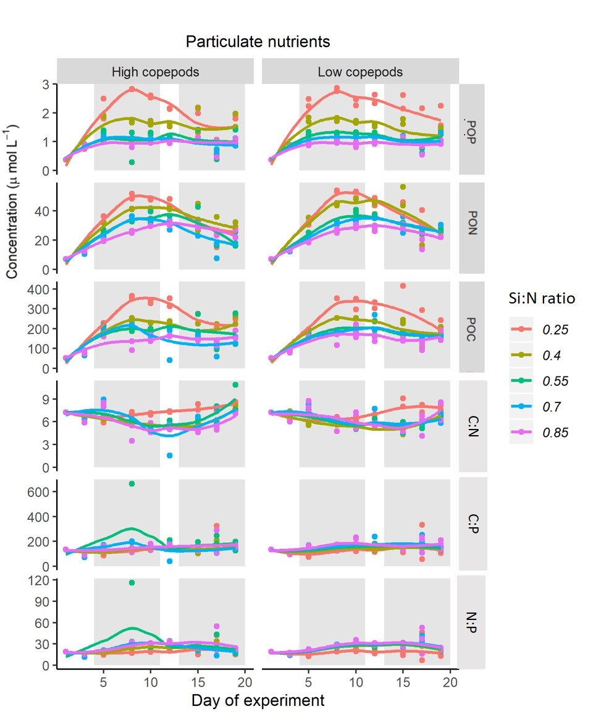
Supplementary Figure 1. Particulate nutrients and their ratios over the course of experiment. POP – particulate organic phosphorus, POC – particulate carbon, PON – particulate nitrogen.

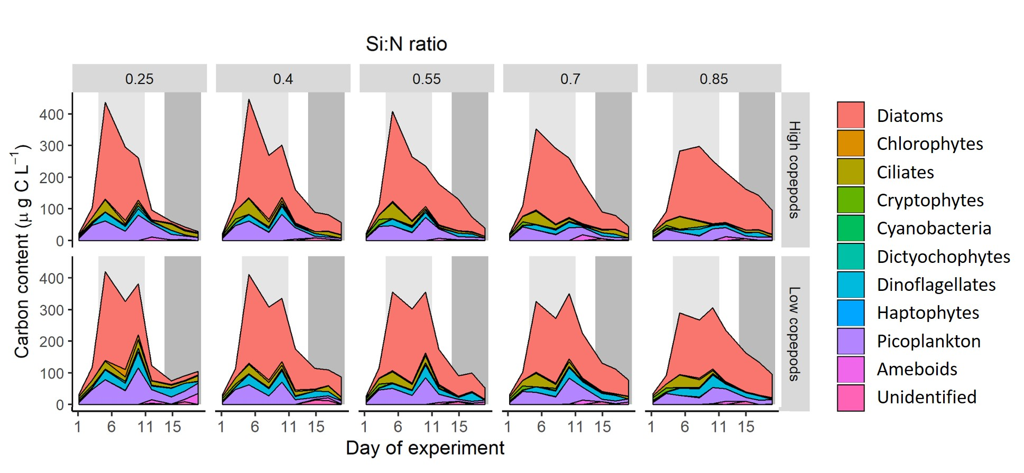
Supplementary Figure 2. Plankton functional group composition over the course of experiment.

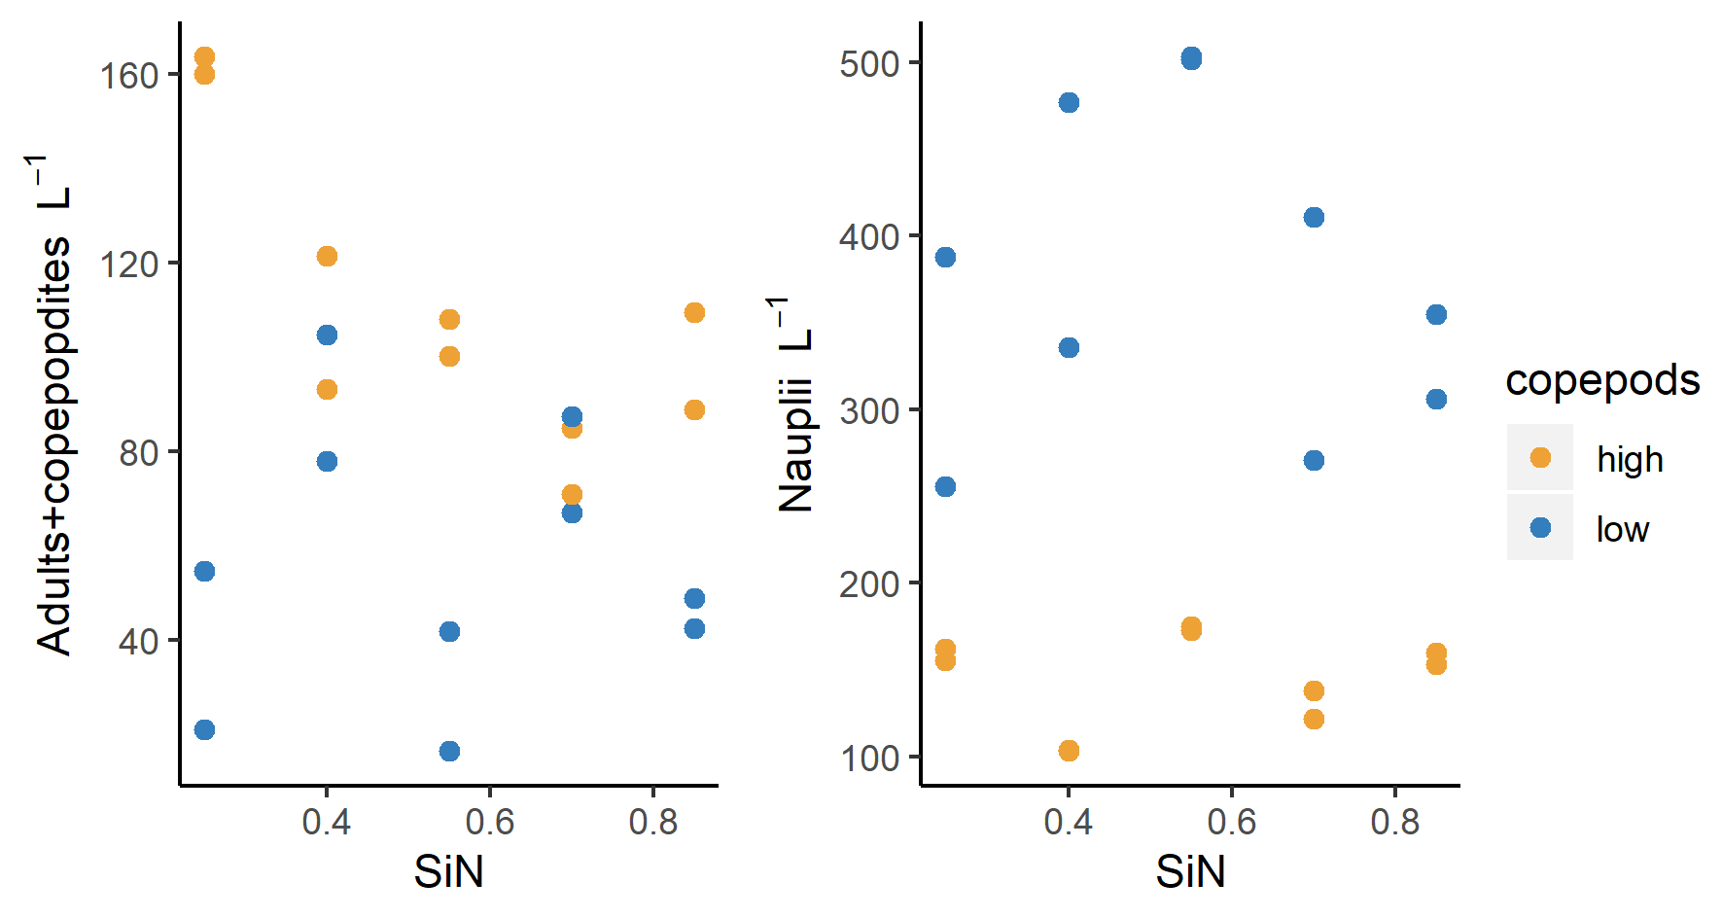
a) b)
Supplementary Figure 3. Abundance of copepods (a – adults and copepodites, b – nauplii) at the end of the experiment as a function of initial Si:N ratio.

