Supplementary Material

A negative trend in abundance and an exceeded mortality limit call for conservation action for the Vulnerable Belt Sea harbour porpoise population

Owen K, Gilles A, Authier M, Carlström J, Genu M, Kyhn LA, Nachtsheim D, Ramírez-Martínez NC, Siebert U, Sköld M, Teilmann J, Unger B, Sveegaard S

**\* Correspondence:** Corresponding Author: kylie.owen@nrm.se

# Supplementary Figures and Tables

**Supplementary Table 1**: Overview of MiniSCANS-II strata, realised survey effort, no. of sightings and mean group size. The management area of the Belt Sea population was divided into nine survey strata. An additional stratum in the Northern Kattegat (NK) was included to cover the transition zone towards the North Sea harbour porpoise population (modified from Unger et al. 2021).

|  |  |  |  |  |  |  |  |
| --- | --- | --- | --- | --- | --- | --- | --- |
| **Stratum** | **Name** | **Area (km2)** | **Survey effort (km)** | **No. of groups** | **No. of indiv.** | **No. of calves\*** | **Mean group size** |
| MSA | Western Kattegat | 6,177 | 607 | 34 | 43 | 3 | 1.26 |
| MSB | Eastern Kattegat | 5,842 | 606 | 67 | 85 | 8 | 1.27 |
| MSC | Southern Kattegat | 6,073 | 630 | 35 | 42 | 0 | 1.15 |
| MSD | Great Belt | 3,836 | 398 | 3 | 3 | 0 | 1.00 |
| MSE | The Sound | 5,157 | 485 | 2 | 2 | 0 | 1.00 |
| MSF | Kiel & Little Belt | 4,372 | 402 | 8 | 8 | 0 | 1.00 |
| MSG | Fehmarn | 3,592 | 705 | 33 | 46 | 5 | 1.39 |
| MSH | Kadet Trench | 3,144 | 325 | 20 | 22 | 0 | 1.10 |
| MSI | Ruegen | 4,067 | 375 | 0 | 0 | 0 | - |
| ***Σ Total Belt Sea population*** | | **42,260** | ***4,533*** | ***202*** | ***251*** | ***16*** | **1.22** |
| NK | Northern Kattegat | 7,979 | 825 | 22 | 27 | 4 | 1.23 |

*calves included in no. of individuals

**Supplementary Table 2:** MiniSCANS-II survey of the Belt Sea population of harbour porpoises (*Phocoena phocoena*) in 2020. Design-based estimates of abundance and density (ind./km2), along with 95% confidence intervals (CI) and coefficient of variation (CV) (modified from Unger et al. 2021).

|  |  |  |  |
| --- | --- | --- | --- |
| **Stratum** | **Abundance (95% CI)** | **Density**  **(95% CI)** | **CV** |
| MSA | 2,869  (1,389-5,001) | 0.46  (0.22-0.81) | 0.30 |
| MSB | 7,316  (3,768-12,861) | 1.25  (0.64-2.20) | 0.32 |
| MSC | 2,529  (1,594-3,671) | 0.42  (0.26-0.60) | 0.22 |
| MSD | 174  (0-628) | 0.05  (0-0.16) | 1.05 |
| MSE | 267  (0-626) | 0.05  (0-0.12) | 0.61 |
| MSF | 596  (216-1,228) | 0.14  (0.05-0.28) | 0.40 |
| MSG | 1,883  (1,190-2,847) | 0.53  (0.33-0.80) | 0.22 |
| MSH | 1,667  (170-3,282) | 0.53  (0.05-1.04) | 0.47 |
| MSI | 0 | - | - |
| ***Belt Sea population*** | **17,301**  **(11,695-25,688)** | **0.41**  **(0.28-0.61)** | **0.20** |
| NK | 1,892  (625-3,388) | 0.24  (0.08-0.42) | 0.38 |

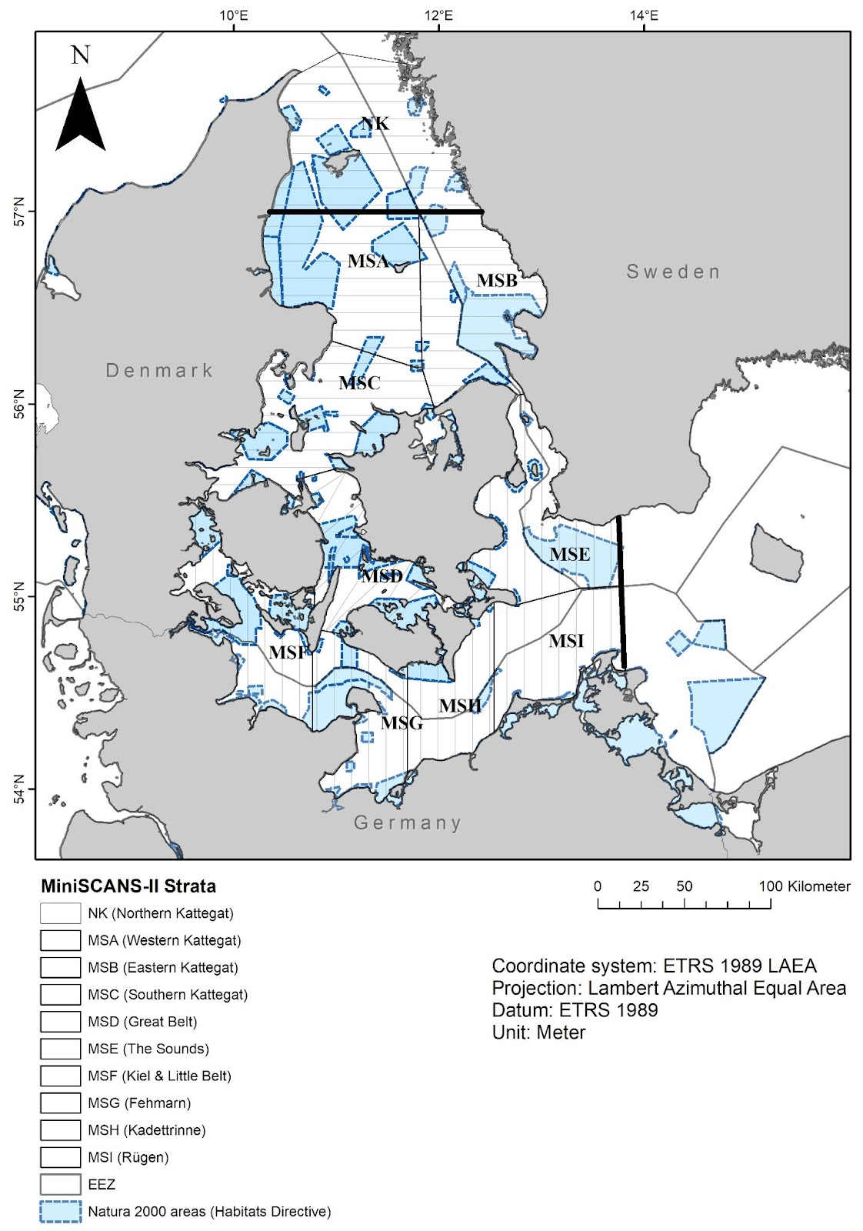

**Supplementary Figure 1:** MiniSCANS-II survey design. Parallel transects run perpendicular to the main depth gradient, spaced 10 km apart. A zigzag design was chosen over the narrow area of the Great Belt (MSD) to provide the most efficient coverage. NATURA 2000 areas, where the harbour porpoise is listed as protected species, are indicated. The management borders of the Belt Sea population (defined in Sveegaard et al. 2015) are shown as thick black lines.

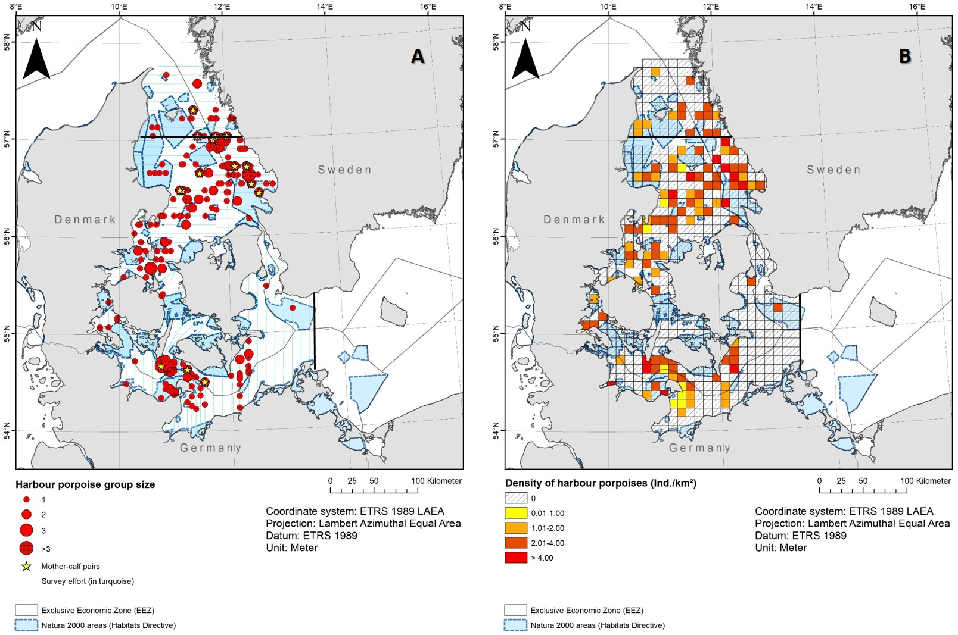

**Supplementary Figure 2:** MiniSCANS-II survey July 2020. (**A**) Distribution of harbour porpoise sightings with underlying survey effort. Only effort conducted under good or moderate conditions is shown. (**B**) The mean estimated harbour porpoise density (ind./km²) observed per grid cell (10x10 km). For both panels, all EU Natura 2000 areas that list the harbour porpoise as a protected species are shown. The management area of the Belt Sea population is shown by the thick black lines (defined in Sveegaard et al. 2015). Figure modified from Unger et al. (2021).