Supplementary Material

Supplementary Data

Supplementary Figures and Tables
For more information on Supplementary Material and for details on the different file types accepted, please see here.

Supplementary Figures
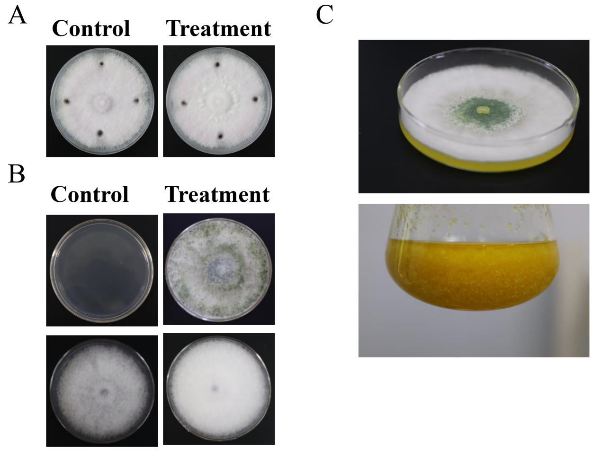
Supplementary Figure. 1 (A). Antagonistic test of N4-3 metabolites against Foc TR4. (B). antagonistic activity test of N4-3 volatile organic substances against Foc TR4. (C). growth status of N4-3 in PDA, PDB.
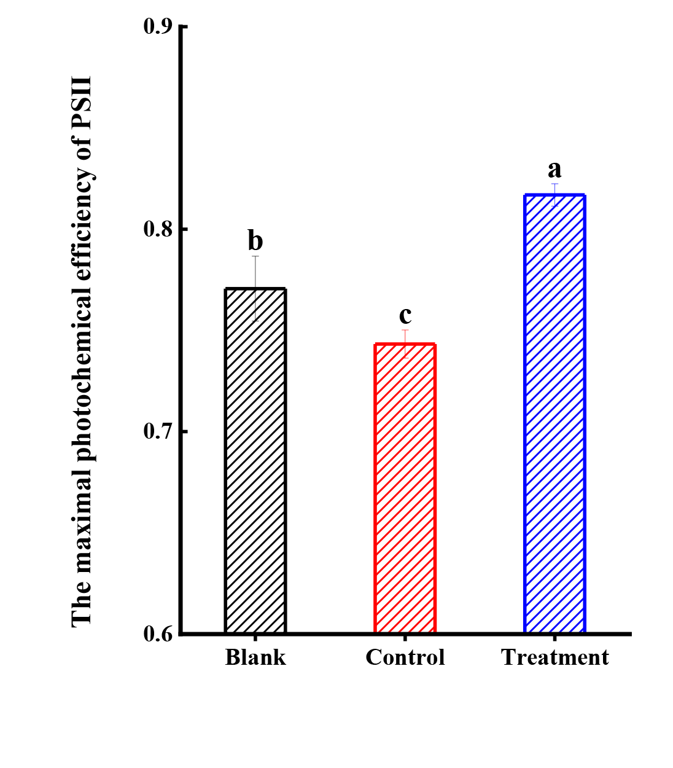
Supplementary Figure. 2. The maximal photochemical efficiency of PSⅡ.
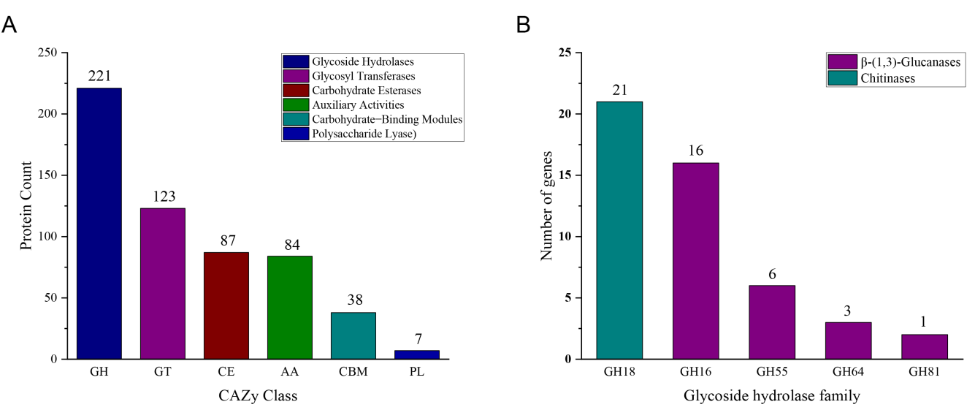
Supplementary Figure. 3. (A). CAZy functional classification statistics. (B). Number of annotations to the glycoside hydrolase family. All fungal chitinases described so far are members of GH family 18. β-1,3-glucanases have so far been described for GH families 16, 55, 64 and 81.

Supplementary Tables
Supplementary table 1. Strains used in phylogenetic analyses and their corresponding GenBank accession numbers.
Species | Strain | GenBank accession numbers
 |  | tef1 | rbp2
Trichoderma parareesei | CP55_3 | MW541129 | MW541109
Trichoderma aquatica | YMF1.04625 | MK775507 | MK775512
Trichoderma aquatica | YMF1.04624 | MK775506 | MK775511
Trichoderma rugosum | 11325 | MH612379 | MH612373
Trichoderma rugosum | 11139 | MH612378 | MH612372
Trichoderma citrinoviride | TRS745 | KP008894 | KP009188
Trichoderma longibrachiatum | Tloum3 | MT081437 | MT118251
Trichoderma longibrachiatum | HL167 | MZ241241 | MZ241240
Trichoderma orientale | S187 | JQ685868 | JQ685884
Trichoderma longibrachiatum | TLS6 | MT069951 | MT069959
Trichoderma reesei | CBS999.97 | CP020876.1 | CP017984.1
Trichoderma reesei | QM6a | CP016234.1 | CP016235.1
Trichoderma breve | T069 | OP913377.1 | OP913376.1
Trichoderma longibrachiatum | HL167 | MZ241241.1 | MZ241240.1
Trichoderma gamsii | TW20050 | KU523895.1 | KU523896.1
Trichoderma capillare | TW22166 | KT862524.1 | KT862525.1
Trichoderma istrianum | S310 | KJ665523.1 | KJ665281.1
Trichoderma attinorum | LESF236 | KT279039.1 | KT278971.1
Trichoderma viridialbum | S250 | KC285706.1 | KC285774.1
Trichoderma sempervirentis | S599 | KC285755.1 | KC285755.1
Trichoderma pholiotae | JZBQH12 | ON649919.1 | ON649972.1
Trichoderma istrianum | S123 | KJ665521.1 | KJ665280.1
Trichoderma confluens | 9649 | KT001959.1 | KT001964.1
Trichoderma viridarium | S136 | KC285658.1 | KC285760.1
Verticillium alfalfae | VaMs.102 | XM_003001642.1 | XM_003000681.1

Supplementary table 2. Carbon and nitrogen source utilization of strain N4-3.
Carbon source utilization | Result | Nitrogen source utilization | Result
D- Mannose | +++ | ammonium chloride | ++
D-Fruotose | +++ | Ammonium Sulfate | +++
D-Glucose | +++ | Glycine | +++
D-Melezitose | ++ | L-Arginine | -
D-Ribose | +++ | L-Cysteine | +
L-Arabinose | +++ | L-Methionine | +
L-Rhamnose | +++ | L-Tyrosine | ++
Myo-Inositol | +++ | L-Valine | +++
Raffinose | +++ | L-Hydroxyproline | +
Saccharose | +
D-Xylopyranose | ++++ | Growth pH | Result
Trehalose | +++ | 5 | ₊
D-Cellose | ++ | 6 | +++
Dextrin | +++ | 7 | +++
D- Galactose | +++ | 8 | +++
Xylan | + | 9 | +
Note: + + +, Good growth; ++, Moderate growth; +, Poor growth; -, No growth.

Supplementary table 3. gene prediction stats.
Class | Number
Size(base) | 32338354
Protein Coding Genes | 9271
Min length(base) | 120
Max length(base) | 68859
Average length(base) | 1522.08
Total coding gene(base) | 14111190
Coding ratio (%) | 43.64%
exon | 26026
CDS | 26026
Start codon | 9112
Stop codon | 9003
ncRNA
tRNA | 141
rRNA | 46
Repeat Region
Repeat Region Count | 16310
Total Repeat Region(base) | 671214
Repeat Ratio(%) | 2.08%
LINE | 84
Low complexity | 1782
Simple repeat | 14378
Unknown | 66

Supplementary table 4. Genetic database annotation rate statistics.
Database | Number of Unigenes | Percentage(%)
Annotated in CDD | 5955 | 64.23
Annotated in KOG | 4806 | 51.84
Annotated in NR | 9167 | 98.88
Annotated in PFAM | 4764 | 51.39
Annotated in Swissprot | 6372 | 68.73
Annotated in TrEMBL | 9167 | 98.88
Annotated in GO | 6320 | 68.17
Annotated in KEGG | 3261 | 35.17
Annotated in at least one database | 9167 | 98.88
Annotated in all database | 2315 | 24.97
Total Unigenes | 9271 | 100

