**Supplementary files**

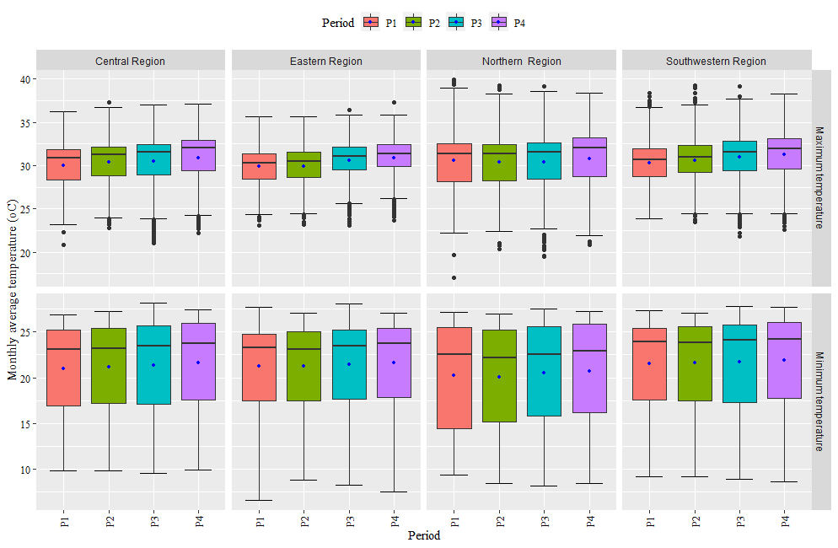

**Supplementary Figure S1.** Periodic distribution of monthly average minimum and maximum temperature in different regions of Bangladesh. Here P1 = 1970-1981, P2 = 1982-1993, P3 = 1994-2005, P4= 2006-2020

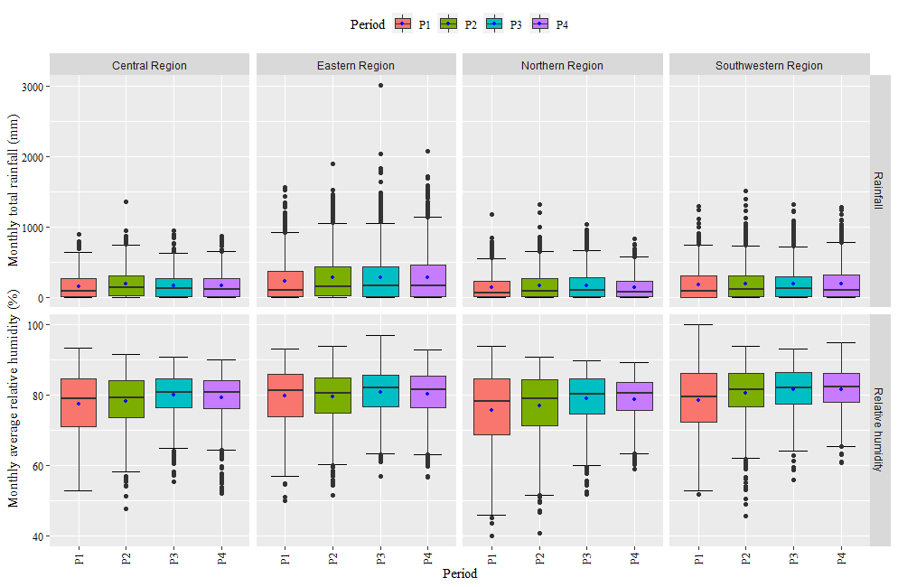

**Supplementary Figure S2.** Periodic distribution of monthly total rainfall and monthly average relative humidity in different regions of Bangladesh. Here, P= Period, P1 = 1970-1981, P2 = 1982-1993, P3 = 1994-2005, P4= 2006-2020