Supplementary Material

**Sample Questionnaire**

|  |
| --- |
| Note to readers:  Among the 8 surveys conducted in our study, this questionnaire is aimed at the Japanese treatment group who received health information and answered the comprehension test about the health information. Other than the part on choice sets, other treatment groups received the same questions, and the control group questionnaire was identical except for the health information and the comprehension test. |

Consumer Preference Survey on Alternative Meat Products

(Japanese treatment group; block 1)

1. Which of the following options best describes your dietary preferences?

✳Explanations:

Omnivore: a person who eats all types of food, especially both plants and meat.

Flexitarian: a person who has a primarily vegetarian diet but occasionally eats meat or fish.

Pescetarian: a person who does not eat meat but does eat fish.

Vegetarian: a person who does not eat meat or fish, and sometimes other animal products, especially for moral, religious, or health reasons.

Vegan: a person who does not eat any food derived from animals and who typically does not use other animal products.

1. Omnivore
2. Flexitarian
3. Pescetarian
4. Vegetarian
5. Vegan
6. Have you ever eaten meat alternatives?
7. Yes, I have, and I would like to eat meat alternatives again.
8. Yes, I have, but I don’t want to eat meat alternatives again.
9. No, I haven’t, but I would like to give it a try in the future.
10. No, I haven’t, and I don’t want to give it a try in the future.
11. When thinking about meat alternatives, what is the first thought, image, or word that crosses your mind? You can write down whole sentences or single words.

|  |
| --- |
|  |

1. Please judge whether the following statements are correct or not by choosing from "True", "False" or "I don't know".

|  |  |  |  |
| --- | --- | --- | --- |
|  | True | False | I don’t know |
| Currently, the main raw materials of plant-based meat are soybeans, wheat, and peas. |  |  |  |
| Cultured meat, a type of alternative meat product, is produced by extracting stem cells from animals. |  |  |  |

|  |
| --- |
| Note to readers:  The following health information and comprehension test are intended solely for the treatment groups. Respondents who answered the comprehension test incorrectly for the first time were asked to repeat the reading and were allowed to take a retest, and those who answered incorrectly again were excluded from this study. |

1. Next, please read the following material carefully. You will be asked to answer a comprehension test to confirm that you fully understand the content.

Intensive livestock production can lead to the transmission of zoonotic diseases, such as the mad cow disease, from animal hosts to human beings (Zinsstag et al., 2007). Plant-based and cultured meats can reduce the risk of contracting the diseases associated with the consumption of conventional meat. Moreover, they can be produced without the use of hormones or antibiotics (Wang et al., 2022).

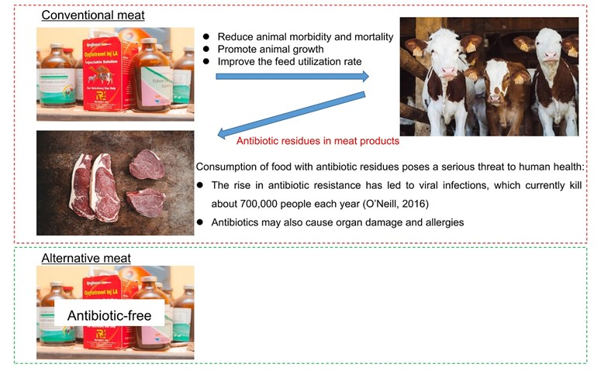

Adapted from Ghimpețeanu et al., 2022; Haiping et al., 2021; Hendrickson et al., 2020; O’Neill, 2016. Photos: Unsplash)

1. Based on the content of the material just presented, which of the following statements is true?
   1. Antibiotics do not cause allergies.
   2. The increase in antibiotic resistance is harmful to human health.
   3. Alternative meat products contain high levels of antibiotics.
2. Now, please imagine that you are buying a burger at a fast-food restaurant. In each of the following questions, you will be introduced to two products with different attributes. Please indicate which of the two products you prefer to buy, or you prefer not to buy either one. We will ask you 8 times with different combinations. These are very burdensome questions, but please check the attributes of each product before making your choices.

Source: Unsplash

The meanings of the terms used in the attributes are as follows.

Antibiotic claim: whether information is displayed indicating whether or not antibiotics were used.

Traceability: a system that allows consumers to verify for themselves where and how food was produced and along what routes it was transported

Carbon footprint: A system that displays the amount of greenhouse gas emissions throughout the entire life cycle from raw material procurement to disposal and recycling, converted into carbon dioxide (CO2).

[Combination 1] Which of the following burgers do you prefer to buy?

|  |  |  |
| --- | --- | --- |
| **Combination 1** | **Burger 1** | **Burger 2** |
| **Burger patty** | Conventional meat | Plant-based meat |
| **Price** | 625 Yen | 625 Yen |
| **Antibiotic claim** | Antibiotic-free | No claim |
| **Traceability**  **of the meat patty** | Traceable | Not Traceable |
| **Carbon footprint**  **(CO2eq)** | 7 kg | 1 kg |

1. I will buy Burger 1.
2. I will buy Burger 2.
3. I will not buy either.

|  |
| --- |
| Note to readers:  Seven more combinations are presented below. For the complete choice set, please see SM2 Data. |

1. Please assign a score from 1 to 7 to the following statements, where 1 is “strongly disagree” and 7 is “strongly agree.”
2. I am constantly sampling new and different foods.
3. I don’t trust new foods.
4. If I don’t know what is in a food, I won’t try it.
5. I like foods from different countries.
6. Ethnic food looks too weird to eat.
7. At dinner parties, I will try a new food.
8. I am afraid to eat things I have never had before.
9. I am very particular about the foods I will eat.
10. I will eat almost anything.
11. I like to try new ethnic restaurants.
12. Please assign a score from 1 to 7 to the following statements, where 1 is “strongly disagree” and 7 is “strongly agree.”
13. It is important to me that the products I use do not harm the environment.
14. I consider the potential environmental impact of my actions when making many of my decisions.
15. My purchase habits are affected by my concern for our environment.
16. I am concerned about wasting the resources of our planet.
17. I would describe myself as environmentally responsible.
18. I am willing to be inconvenienced in order to take actions that are more environmentally friendly.
19. What is your monthly discretionary amount (=disposable income)? The monthly discretionary amount is intended to be used for living expenses, see example below. Please note that this does not include fixed monthly expenses such as housing and utilities.

Examples of living expenses: food, medical care, leisure and recreation, other daily expenses (including communication costs)

1. Below 20,000 Yen
2. 20,000 Yen ~ below 50,000 Yen
3. 50,000 Yen ~ below 100,000 Yen
4. Above 100,000 Yen