Supplementary Materials: Supplementary figure 1-5
Supplementary figure 1: Plasmid map of SARS-CoV-2-Spike expression vector
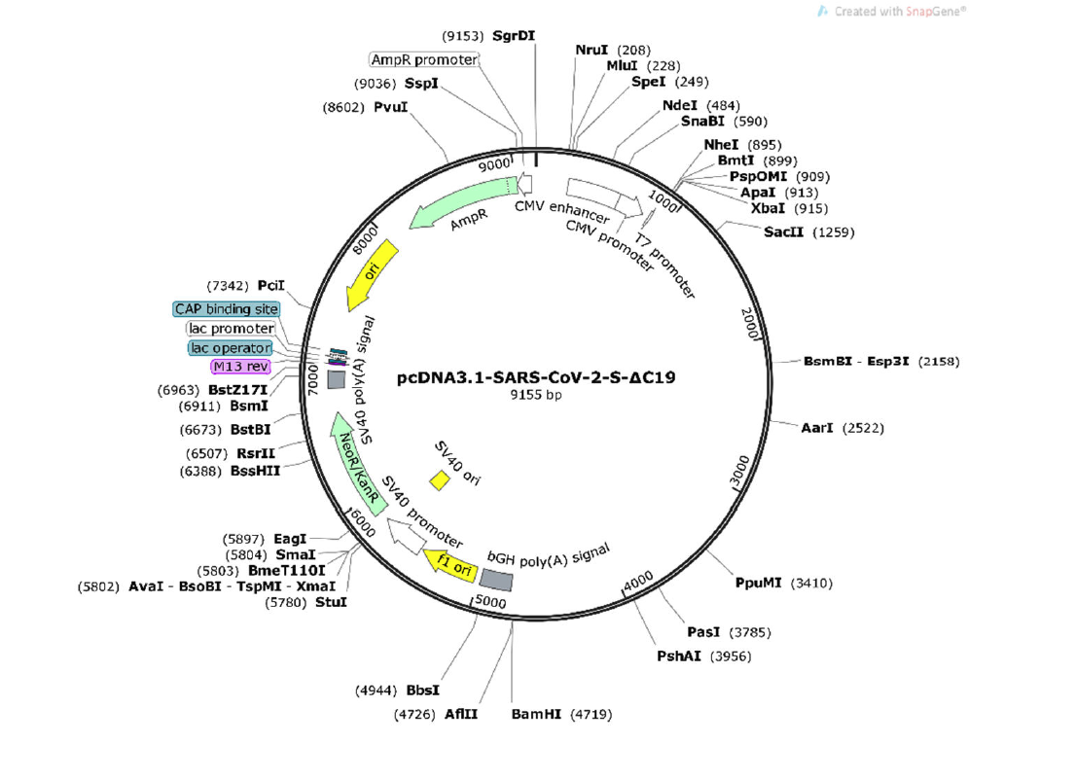

Supplementary Fig. 2 Protein sequence of SARS-CoV-2-614G Spike-ΔC19
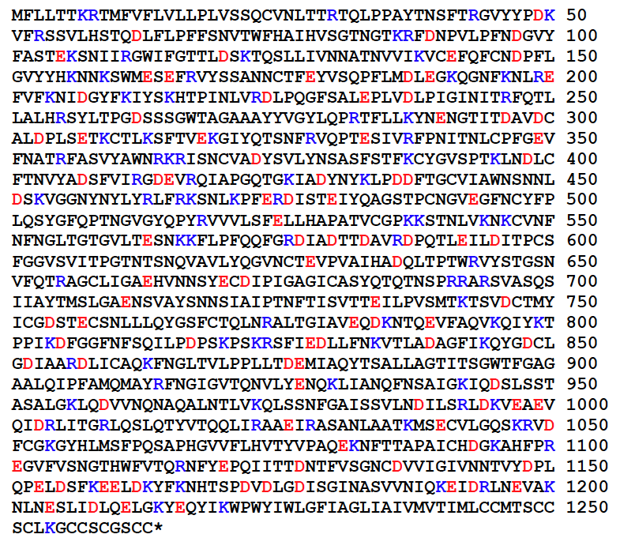
Supplementary Fig. 3 Protein sequence of SARS-CoV-2-UK variant Spike-ΔC19
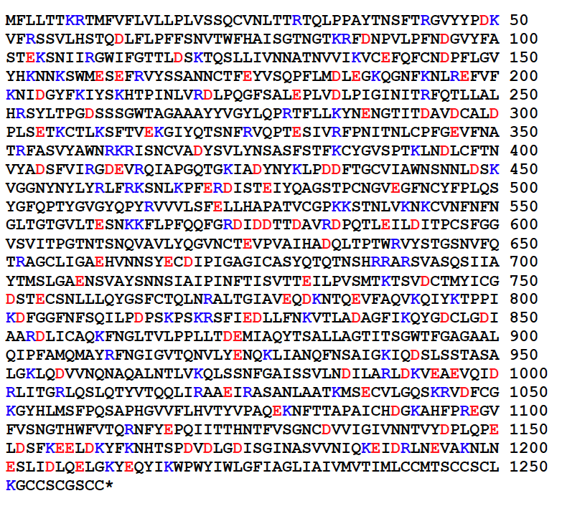

Supplementary Fig. 4 Protein sequence of SARS-CoV-2-Delta variant Spike-ΔC19
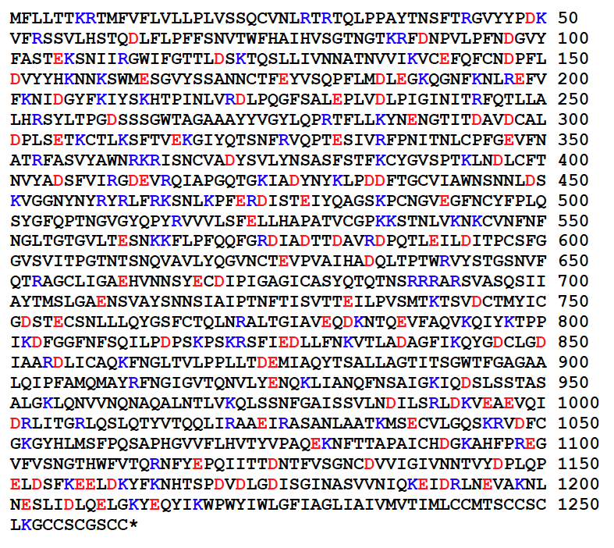

Supplementary Fig. 5 Protein sequence of SARS-CoV-2-Brazil variant Spike-ΔC19

