Simulating short-term Light Responses of Photosynthesis and Water Use Efficiency in Sweet Sorghum under Varying Temperature and CO₂ Conditions
Xiao-Long, Yang^{1,2}; Xiao-Fei, Ma³; Zi-Piao, Ye⁴*; Long-Sheng Yang¹; Jun-Bo Shi¹; Xun Wang¹; Bei-Bei Zhou¹; Fu-Biao, Wang⁴; Zi-Fa, Deng¹*
¹School of Life Sciences, Nantong University, Nantong, China, ²State Key Laboratory of Environmental Chemistry and Ecotoxicology, Research Center for Eco-Environmental Sciences, Chinese Academy of Sciences, Beijing, China, ³Key Laboratory of Ecological Safety and Sustainable Development in Arid Lands, Northwest Institute of Eco-Environment and Resources, Chinese Academy of Sciences, Lanzhou, China, ⁴Institute of Biophysics in Maths & Physics College, Jinggangshan University, Ji’an, China

* For Correspondence:
Zi-Piao, Ye, E-mail: yezp@jgsu.edu.cn; Zi-Fa, Deng, E-mail: dzf@ntu.edu.cn

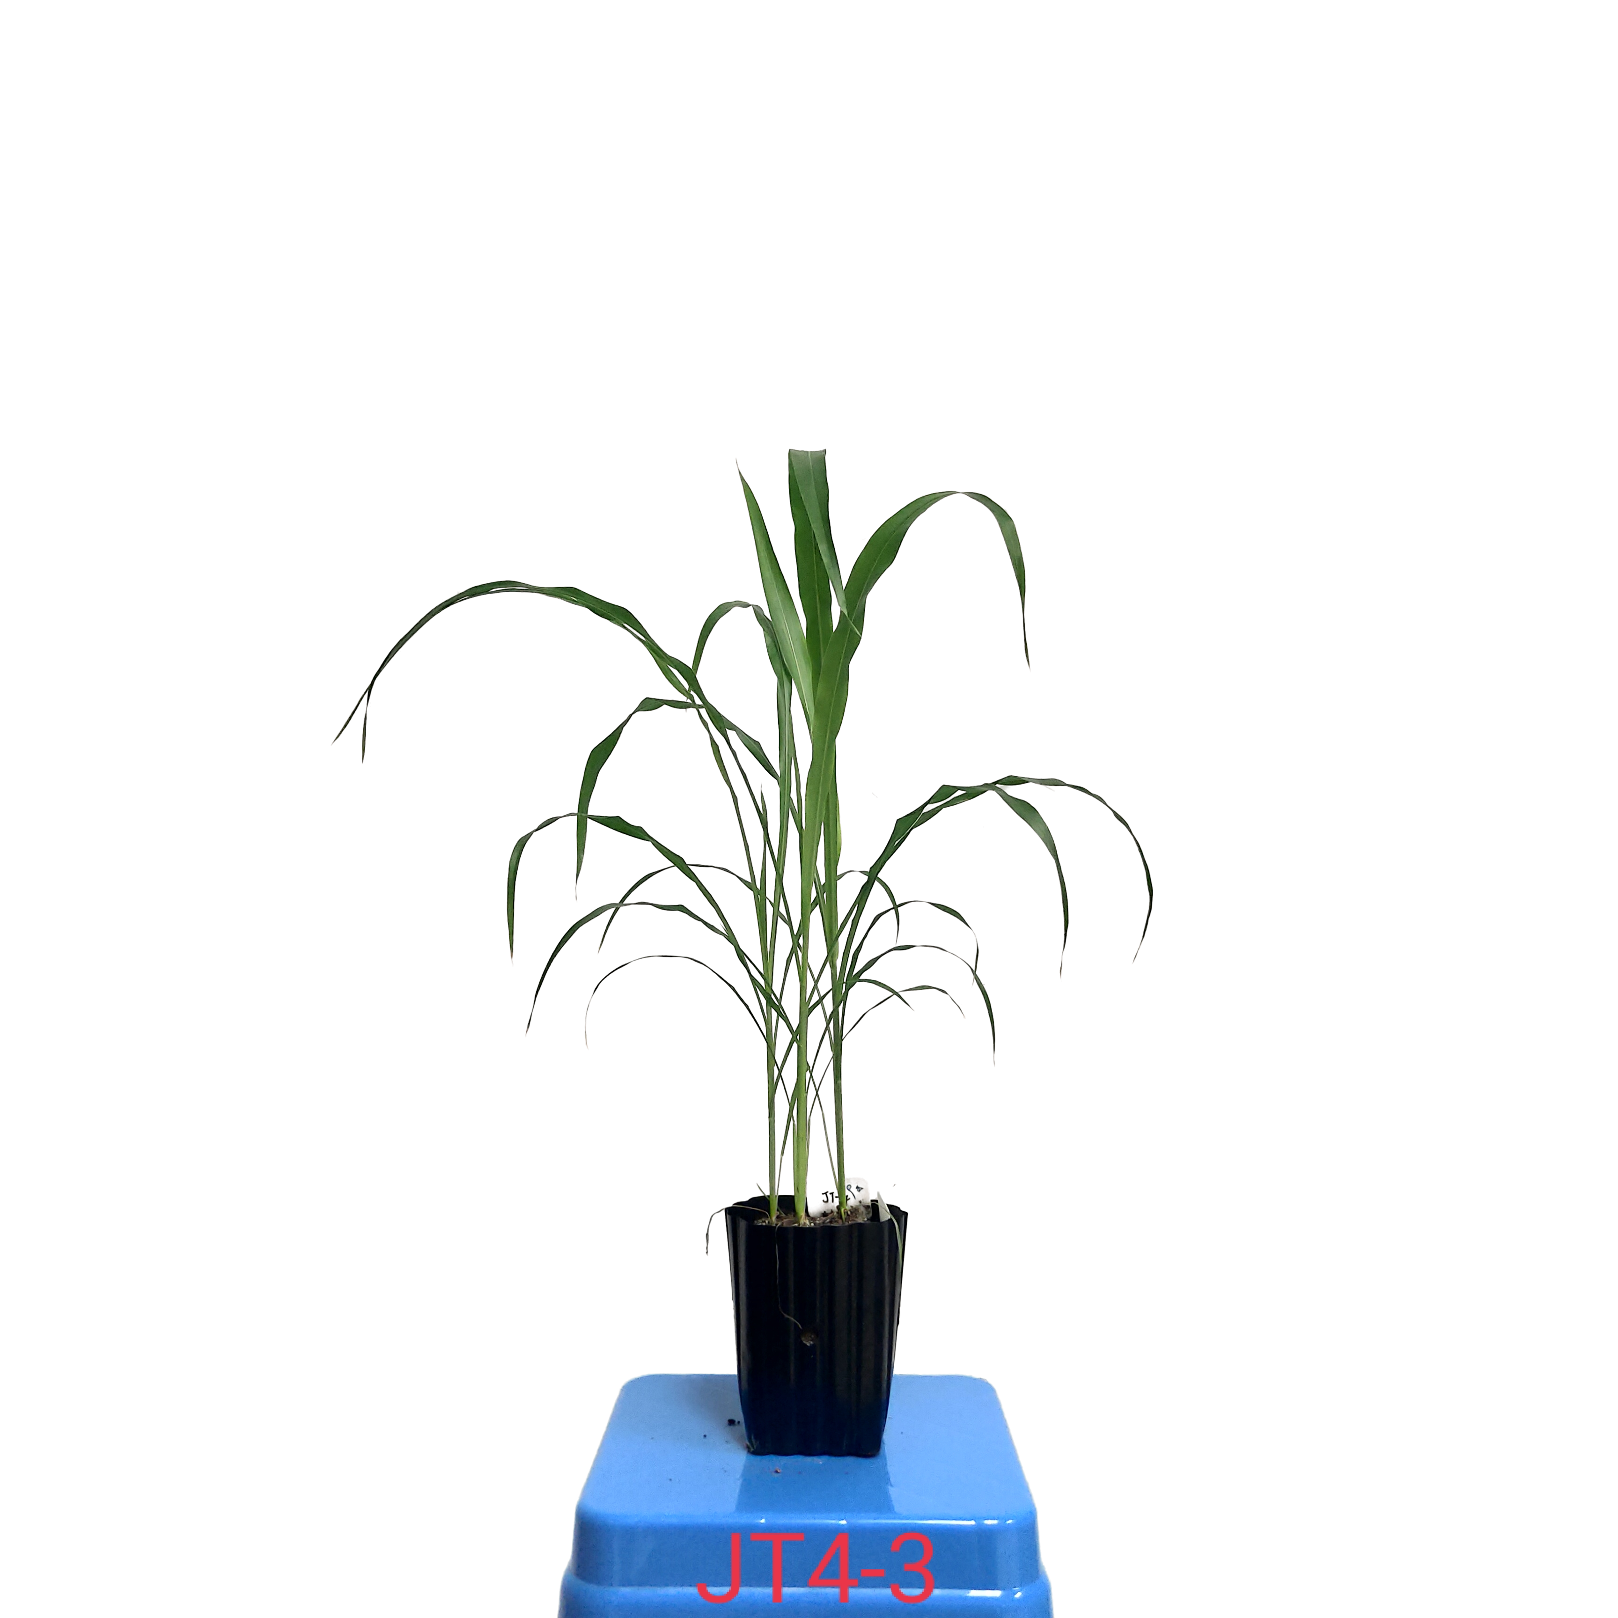
FIGURE S1 | Growth performance of sweet sorghum KFJT-4 after cultivation of 40 days

TABLE S1 | Growth traits of sweet sorghum KFJT-4 after cultivation of 40 days. n is the number of plants.
Parameters | Measured values (mean ± SE, n = 23)
Natural plant height (cm) | 62.96 ± 2.54
Banded plant height (cm) | 89.39 ± 3.32
Stem diameter (cm) | 7.75 ± 0.38
Number of leaves | 7.30 ± 0.23
Leaf area (cm²) | 103.40 ± 8.53
Leaf length (cm) | 52.71 ± 2.61
Average width (cm) | 1.85 ± 0.09
Maximum width (cm) | 2.64 ± 0.10

TABLE S2 | Fitted (Ye model and NRH model) and measured values of maximum net photosynthetic rate (A_{nmax}), saturation irradiance corresponding to A_{nmax} (I_{sat}), light-saturated stomatal conductance (g_{s-max}), saturation irradiance corresponding to g_{s-max} (I_{g-sat}), light-saturated transpiration rate (T_{r-max}), saturation irradiance corresponding to T_{r-max} (I_{T-sat}), maximum intrinsic water use efficiency (WUE_{i}), saturation irradiance corresponding to WUE_{i} (I_{i-sat}), maximum instantaneous water use efficiency (WUE_{inst-max}), and saturation irradiance corresponding to WUE_{inst-max} (I_{inst-sat}) for sweet sorghum under different temperature conditions at atmospheric CO₂ level.
T  (℃) | A_{nmax} (μmol m^{–2} s^{–1}) |  |  |  | I_{sat} (μmol m^{–2} s^{–1})
T  (℃) | Ye model | NRH model | Measured value |  | Ye model | NRH model | Measured value
25 | 20.70 ± 0.73 ^{b} | 21.07 ± 1.02 ª | 20.13 ± 0.68 ª |  | 1434.9 ± 92.9 ª | ― | 1400.0 ± 115.5 ª
30 | 30.54 ± 0.76 ª | 32.25 ± 1.68 ª | 29.96 ± 1.47 ª |  | 1460.8 ± 169.7 ª | ― | 1466.7 ± 66.7 ª
35 | 37.67 ± 0.96 ^{b} | 42.30 ± 1.21 ª | 37.49 ± 0.90 ª |  | 1710.8 ± 31.3 ^{b} | ― | 1866.7 ± 33.3 ª
 | g_{s-max} (mol m^{–2} s^{–1}) |  |  |  | I_{g-sat} (μmol m^{–2} s^{–1})
 | Ye model | NRH model | Measured value |  | Ye model | NRH model | Measured value
25 | 0.138 ± 0.012 ª | 0.123 ± 0.012 ª | 0.137 ± 0.012 ª |  | 1765.9 ± 158.0 ª | ― | 1800.0 ± 115.5 ª
30 | 0.194 ± 0.010 ª | 0.167 ± 0.011 ª | 0.191 ± 0.010 ª |  | 1654.9 ± 22.3 ª | ― | 1600.0 ± 0.0 ª
35 | 0.252 ± 0.009 ª | 0.259 ± 0.004 ª | 0.257 ± 0.008 ª |  | 1900.9 ± 74.5 ª | ― | 2000.0 ± 0.0 ª
 | T_{r-max} (mmol m^{–2} s^{–1}) |  |  |  | I_{T-sat} (μmol m^{–2} s^{–1})
 | Ye model | NRH model | Measured value |  | Ye model | NRH model | Measured value
25 | 1.68 ± 0.11 ª | 1.54 ± 0.11 ª | 1.72 ± 0.11 ª |  | 2292.3 ± 392.2 ª | ― | 2000 ª
30 | 3.56 ± 0.15 ª | 4.01 ± 0.48 ª | 3.58 ± 0.20 ª |  | 2578.4 ± 319.2 | ― | >2000
35 | 5.83 ± 0.27 ª | 6.52 ± 0.26 ª | 5.76 ± 0.21 ª |  | 2663.2 ± 310.5 | ― | >2000
 | WUE_{i-max} (μmol mol^{–1}) |  |  |  | I_{i-sat} (μmol m^{–2} s^{–1})
 | Ye model | NRH model | Measured value |  | Ye model | NRH model | Measured value
25 | 174.2 ± 3.6 ^{b} | 200.2 ± 9.8 ª | 174.3 ± 5.2 ^{b} |  | 615.4 ± 32.2 ª | ― | 466.7 ± 176.4 ª
30 | 163.1 ± 2.1 ^{b} | 192.5 ± 8.9 ª | 161.4 ± 2.4 ^{b} |  | 965.4 ± 76.8 ª | ― | 733.3 ± 66.7 ª
35 | 151.4 ± 6.5 ^{b} | 225.7 ± 18.6 ª | 167.4 ± 18.1 ^{b} |  | 859.9 ± 222.5 ª | ― | 733.3 ± 33.3 ª
 | WUE_{inst-max} (μmol mmol^{–1}) |  |  |  | I_{inst-sat} (μmol m^{–2} s^{–1})
 | Ye model | NRH model | Measured value |  | Ye model | NRH model | Measured value
25 | 14.12 ± 0.22 ^{b} | 16.03 ± 0.64 ª | 13.81 ± 0.28 ^{b} |  | 602.7 ± 18.0 ª | ― | 633.3 ± 120.2 ª
30 | 9.70 ± 0.20 ^{b} | 10.94 ± 0.58 ª | 9.71 ± 0.18 ^{b} |  | 799.1 ± 63.6 ª | ― | 666.7 ± 88.2 ª
35 | 7.21 ± 0.35 ^{b} | 10.45 ± 0.89 ª | 8.07 ± 0.87 ^{b} |  | 728.2 ± 130.1 ª | ― | 600.0 ± 115.5 ª
At a given temperature, different letters denote statistically significant differences (p<0.05) among the measured value, the value fitted by the Ye model and the value fitted by the NRH model.
TABLE S3 | Fitted (Ye model and NRH model) and measured values of maximum net photosynthetic rate (A_{nmax}), saturation irradiance corresponding to A_{nmax} (I_{sat}), light-saturated stomatal conductance (g_{s-max}), saturation irradiance corresponding to g_{s-max} (I_{g-sat}), light-saturated transpiration rate (T_{r-max}), saturation irradiance corresponding to T_{r-max} (I_{T-sat}), maximum intrinsic water use efficiency (WUE_{i}), saturation irradiance corresponding to WUE_{i} (I_{i-sat}), maximum instantaneous water use efficiency (WUE_{inst-max}), and saturation irradiance corresponding to WUE_{inst-max} (I_{inst-sat}) for sweet sorghum under different CO₂ concentrations at 30℃.
CO₂ level  (μmol mol^{–1}) | A_{nmax} (μmol m^{–2} s^{–1}) |  |  |  | I_{sat} (μmol m^{–2} s^{–1})
CO₂ level  (μmol mol^{–1}) | Ye model | NRH model | Measured value |  | Ye model | NRH model | Measured value
250 | 25.84 ± 0.65 ^{b} | 27.01 ± 0.71 ^{b} | 25.22 ± 0.617 ^{b} |  | 1393.8 ± 71.5 ª | ― | 1466.7 ± 133.3 ª
410 | 30.54 ± 0.76 ª | 32.25 ± 1.68 ª | 29.96 ± 1.47 ª |  | 1460.8 ± 169.7 ª | ― | 1466.7 ± 66.7 ª
550 | 29.88 ± 1.07 ^{b} | 33.43 ± 1.10 ª | 30.17 ± 0.88 ^{b} |  | 1782.4 ± 30.1 ª | ― | 1866.7 ± 66.7 ª
 | g_{s-max} (mol m^{–2} s^{–1}) |  |  |  | I_{g-sat} (μmol m^{–2} s^{–1})
 | Ye model | NRH model | Measured value |  | Ye model | NRH model | Measured value
250 | 0.293 ± 0.012 ª | 0.237 ± 0.040 ª | 0.291 ± 0.012 ª |  | 1484.6 ± 184.4 ª | ― | 1533.3 ± 66.7 ª
410 | 0.194 ± 0.010 ª | 0.167 ± 0.011 ª | 0.191 ± 0.010 ª |  | 1654.9 ± 22.3 ª | ― | 1600.0 ± 0.0 ª
550 | 0.156 ± 0.008 ª | 0.161 ± 0.002 ª | 0.156 ± 0.010 ª |  | 2533.6 ± 328.5 | ― | >2000
 | T_{r-max} (mmol m^{–2} s^{–1}) |  |  |  | I_{T-sat} (μmol m^{–2} s^{–1})
 | Ye model | NRH model | Measured value |  | Ye model | NRH model | Measured value
250 | 5.48 ± 0.36 ª | 5.13 ± 0.76 ª | 5.59 ± 0.53 ^{b} |  | 2378.8 ± 142.1 | ― | >2000
410 | 3.56 ± 0.15 ª | 4.01 ± 0.48 ª | 3.58 ± 0.20 ª |  | 2578.4 ± 319.2 | ― | >2000
550 | 2.62 ± 0.13 ª | 2.74 ± 0.04 ª | 2.58 ± 0.19 ª |  | 2837.3 ± 396.3 | ― | >2000
 | WUE_{i-max} (μmol mol^{–1}) |  |  |  | I_{i-sat} (μmol m^{–2} s^{–1})
 | Ye model | NRH model | Measured value |  | Ye model | NRH model | Measured value
250 | 88.6 ± 2.7 ^{b} | 120.8 ± 13.7 ª | 88.70 ± 1.70 ^{b} |  | 1227.7 ± 62.6 ª | ― | 1133.3 ± 133.3 ª
410 | 163.1 ± 2.1 ^{b} | 192.5 ± 8.9 ª | 161.4 ± 2.4 ^{b} |  | 965.4 ± 76.8 ª | ― | 733.3 ± 66.7 ª
550 | 232.4 ± 6.6 ^{b} | 281.7 ± 12.9 ª | 237.2 ± 8.9 ^{b} |  | 806.8 ± 54.0 ª | ― | 733.3 ± 66.7 ª
 | WUE_{inst-max} (μmol mmol^{–1}) |  |  |  | I_{inst-sat} (μmol m^{–2} s^{–1})
 | Ye model | NRH model | Measured value |  | Ye model | NRH model | Measured value
250 | 5.26 ± 0.19 ^{b} | 7.65 ± 0.94 ª | 5.27 ± 0.15 ^{b} |  | 985.7 ± 14.9 ª | ― | 933.3 ± 66.7 ª
410 | 9.70 ± 0.20 ^{b} | 10.94 ± 0.58 ª | 9.71 ± 0.18 ^{b} |  | 799.1 ± 63.6 ª | ― | 666.7 ± 88.2 ª
550 | 14.05 ± 0.47 ^{b} | 16.95 ± 0.91 ª | 14.30 ± 0.54 ^{b} |  | 815.7 ± 49.9 ª | ― | 733.3 ± 66.7 ª
At a given CO₂ concentrations, different letters denote statistically significant differences (p<0.05) among the measured value, the value fitted by the Ye model and the value fitted by the NRH model.
TABLE S4 | Interactive effects of elevating CO₂ and warming on photosynthesis of sweet sorghum.
Photosynthetic parameters | 35 ℃ | 30 ℃ | 35 ℃
Photosynthetic parameters | 410 μmol mol^{–1} | 550 μmol mol^{–1} | 550 μmol mol^{–1}
α | 0.0732 ± 0.0026 ª | 0.0610 ± 0.0068 ^{b} | 0.0649 ± 0.0033 ^{ab}
A_{nmax} (μmol m^{–2} s^{–1}) | 37.67 ± 0.96 ª | 29.88 ± 1.07 ^{b} | 39.87 ± 1.92 ª
I_{sat} (μmol m^{–2} s^{–1}) | 1710.8 ± 31.3 ^{b} | 1782.36 ± 30.13 ^{b} | 2064.90 ± 45.82 ª
I_{c} (μmol m^{–2} s^{–1}) | 39.27 ± 5.19 ª | 28.87 ± 1.90 ^{b} | 38.64 ± 2.9 ª
R_{d} (μmol m^{–2} s^{–1}) | 2.80 ± 0.44 ª | 1.70 ± 0.13 ^{b} | 2.43 ± 0.18 ª
α_{s} | 0.0004 ± 0.0000 ª | 0.0002 ± 0.0000 ^{b} | 0.0002 ± 0.0000 ^{b}
g_{s-max} (mol m^{–2} s^{–1}) | 0.252 ± 0.008 ª | 0.156 ± 0.008 ^{c} | 0.215 ± 0.01 ^{b}
I_{g-sat} (μmol m^{–2} s^{–1}) | 1900.89 ± 74.45 ^{b} | 2533.57 ± 328.53 ^{b} | 3484.01 ± 395.74 ª
g_{s0} (mol m^{–2} s^{–1}) | 0.011 ± 0.008 ª | 0.016 ± 0.001 ª | 0.006 ± 0.003 ª
α_{r} | 0.0072 ± 0.0006 ª | 0.0028 ± 0.0003 ^{c} | 0.0053 ± 0.0007 ^{b}
T_{r-max} (mmol m^{–2} s^{–1}) | 5.83 ± 0.27 ª | 2.62 ± 0.13 ^{b} | 4.94 ± 0.45 ª
I_{T-sat} (μmol m^{–2} s^{–1}) | 2663.16 ± 310.52 ª | 2837.28 ± 396.25 ª | 2561.44 ± 123.51 ª
T_{r0} (mmol m^{–2} s^{–1}) | 0.25 ± 0.16 ª | 0.27 ± 0.02 ª | 0.21 ± 0.06 ª
α_{i} | 3.9871 ± 1.412 ^{b} | 3.1903 ± 0.5037 ^{b} | 9.1759 ± 1.8803 ª
WUE_{i-max} (μmol mol^{–1}) | 151.34 ± 6.46 ^{c} | 232.37 ± 6.57 ^{b} | 255.46 ± 5.26 ª
I_{i-sat} (μmol m^{–2} s^{–1}) | 859.94 ± 222.47 ª | 806.83 ± 54.02 ^{ab} | 644.44 ± 49.65 ^{b}
K_{i} (μmol mol^{–1}) | 75.18 ± 19.12 ^{b} | 66.68 ± 7.90 ^{b} | 181.31 ± 25.48 ª
α_{inst} | 0.1706 ± 0.0618 ª | 0.1849 ± 0.0293 ª | 0.2941 ± 0.0656 ª
WUE_{inst-max} (μmol mol^{–1}) | 7.21 ± 0.35 ^{c} | 14.05 ± 0.47 ª | 9.91 ± 0.64 ^{b}
I_{inst-sat} (μmol m^{–2} s^{–1}) | 728.23 ± 30.09 ª | 815.71 ± 49.94 ª | 816.50 ± 54.83 ª
K_{inst} (μmol mol^{–1}) | 3.43 ± 0.88 ^{b} | 3.91 ± 0.47 ^{b} | 6.19 ± 0.99 ª
Different letters denote statistically significant differences (p<0.05) among the values fitted by the Ye model, the values fitted by the NRH model, and the measured values.

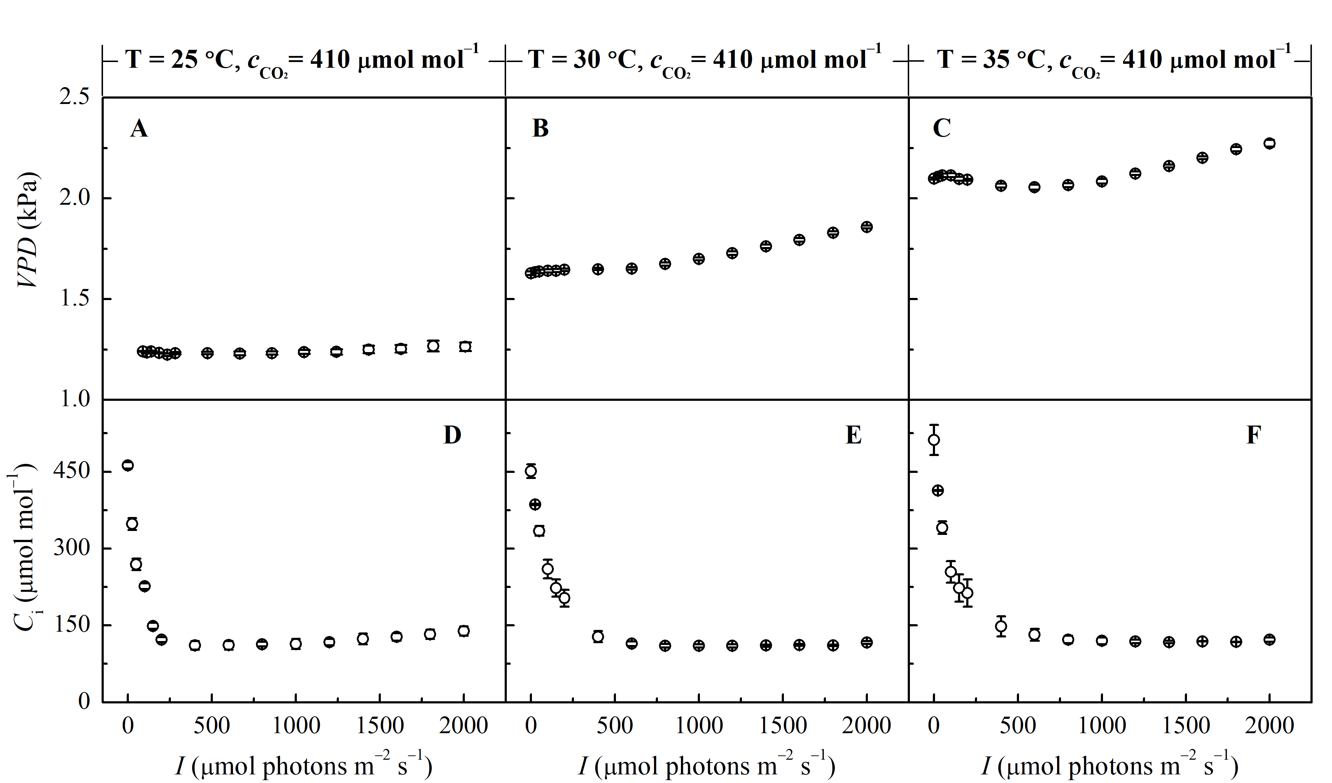
FIGURE S2 | Vapor pressure deficit (VPD) (A, B, C) and intercellular CO₂ concentration (C_{i}) (D, E, F) over irradiance (I) levels for sweet sorghum under different temperature conditions at atmospheric CO₂ level.

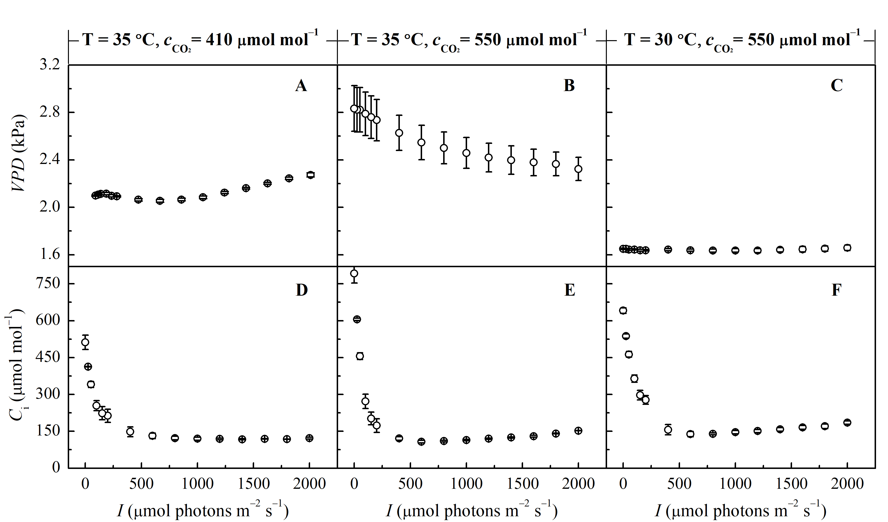
FIGURE S3 | Vapor pressure deficit (VPD) (A, B, C) and intercellular CO₂ concentration (C_{i}) (D, E, F) over irradiance (I) levels for sweet sorghum under different temperature and CO₂ concentration conditions.

