Supplementary Material

Soluble CD83 modulates human-monocyte-derived macrophages towards alternative phenotype, function and metabolism

Katrin Peckert-Maier1, Andreas B. Wild1, Laura Sprißler1, Maximilian Fuchs3, Philipp Beck1, Jean-Philippe Auger2, Pia Sinner1, Astrid Stack1, Petra Mühl-Zürbes1, Ntilek Ramadan1, Meik Kunz3, Gerhard Krönke2, Lena-Stich1, Alexander Steinkasserer1, Dmytro Royzman1

1Department of Immune Modulation, Universitätsklinikum Erlangen, Friedrich– Alexander Universität Erlangen–Nürnberg, 91052 Erlangen, Germany

2Department of Internal Medicine 3 – Rheumatology and Immunology, Friedrich-Alexander University Erlangen-Nürnberg (FAU) and Universitätsklinikum Erlangen, Erlangen 91054, Germany

3Fraunhofer Institute for Toxicology and Experimental Medicine (ITEM), Hannover, Germany

**\* Correspondence:** Katrin.peckert@uk-erlangen.de

## Supplementary Figures

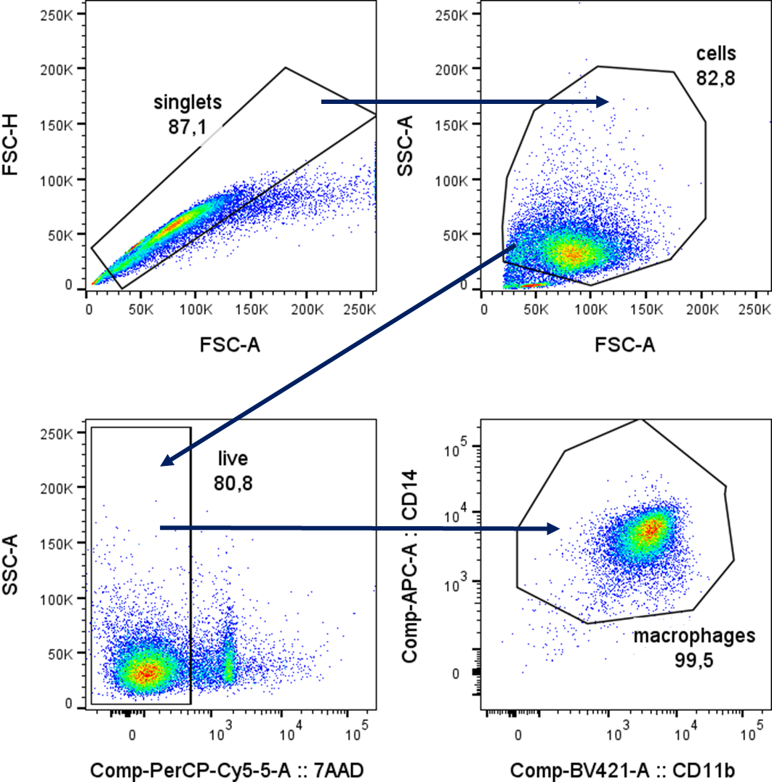

**Supplementary Figure 1:** **Gating strategy for the analyses of human monocyte-derived Mϕ** At first douplet cells were excluded to gate on single cells. Subsequently cell population was gated using SSC and FSC. Subsequently, dead cells were excluded by gating on the 7-AAD- negative population. Lastly Mφ were identified using a CD14+ CD11b+ gate. 20,000 events were measured within the CD14 – CD11b gate to analyze expression of different molecules on human macrophages.



**Supplementary Figure 2:** **Soluble CD83 induced modulation of surface receptors are independent of LXR pathway activation.** PBMCs were isolated via density gradient centrifugation and subsequently monocytes were seeded for adherence. Monocytes were differentiated into Mφ in the presence of M-CSF (20 ng/ml), +/- sCD83 (25 µg/ml). sCD83 was added on day 0 as well as day 3 during the differentiation process. GSK2033 (1mM) was applied one hour before sCD83 administration. Mφ were harvested on day 6 and subsequently analyzed by flow cytometry for the expression of CD14, MHC-II, CD163, MSR-1 and CD83.Gating strategy is displayed in S1**.** Data are represented as mean ± SEM. Statistical analysis was performed using a One-way ANOVA. Experiments were performed at least three times. One dot per bar graph represents one donor. n.s., not significant, which indicates there is no statistical significance; * p<0.05; ** < 0.01; *** p < 0.001; **** p < 0.0001.