***Supplementary Material 2***

1. **Wetland classification**

Wetlands are ecosystems at the interface between terrestrial and aquatic environments, continental or coastal, permanently or periodically flooded by shallow waters or with saturated soils. The seas can be fresh, brackish, or salty, with plant and animal communities adapted to their dynamics. This ecosystem is essential for storing and purifying water, storing organic carbon, providing food and shelter, regulating the microclimate, and maintaining biodiversity.

We created annual mosaics of the dry and wet periods for the vegetation components, non-photosynthetically active vegetation, soil, shade, and cloud. In addition, we added auxiliary information from the Shuttle Radar Topography Mission (SRTM), Height Above the Nearest Drainage (HAND), and canopy height (GEDI) to the mosaic. Supplementary Figure 1 shows the workflow with all methodological steps to map wetlands in the Brazilian Amazon:

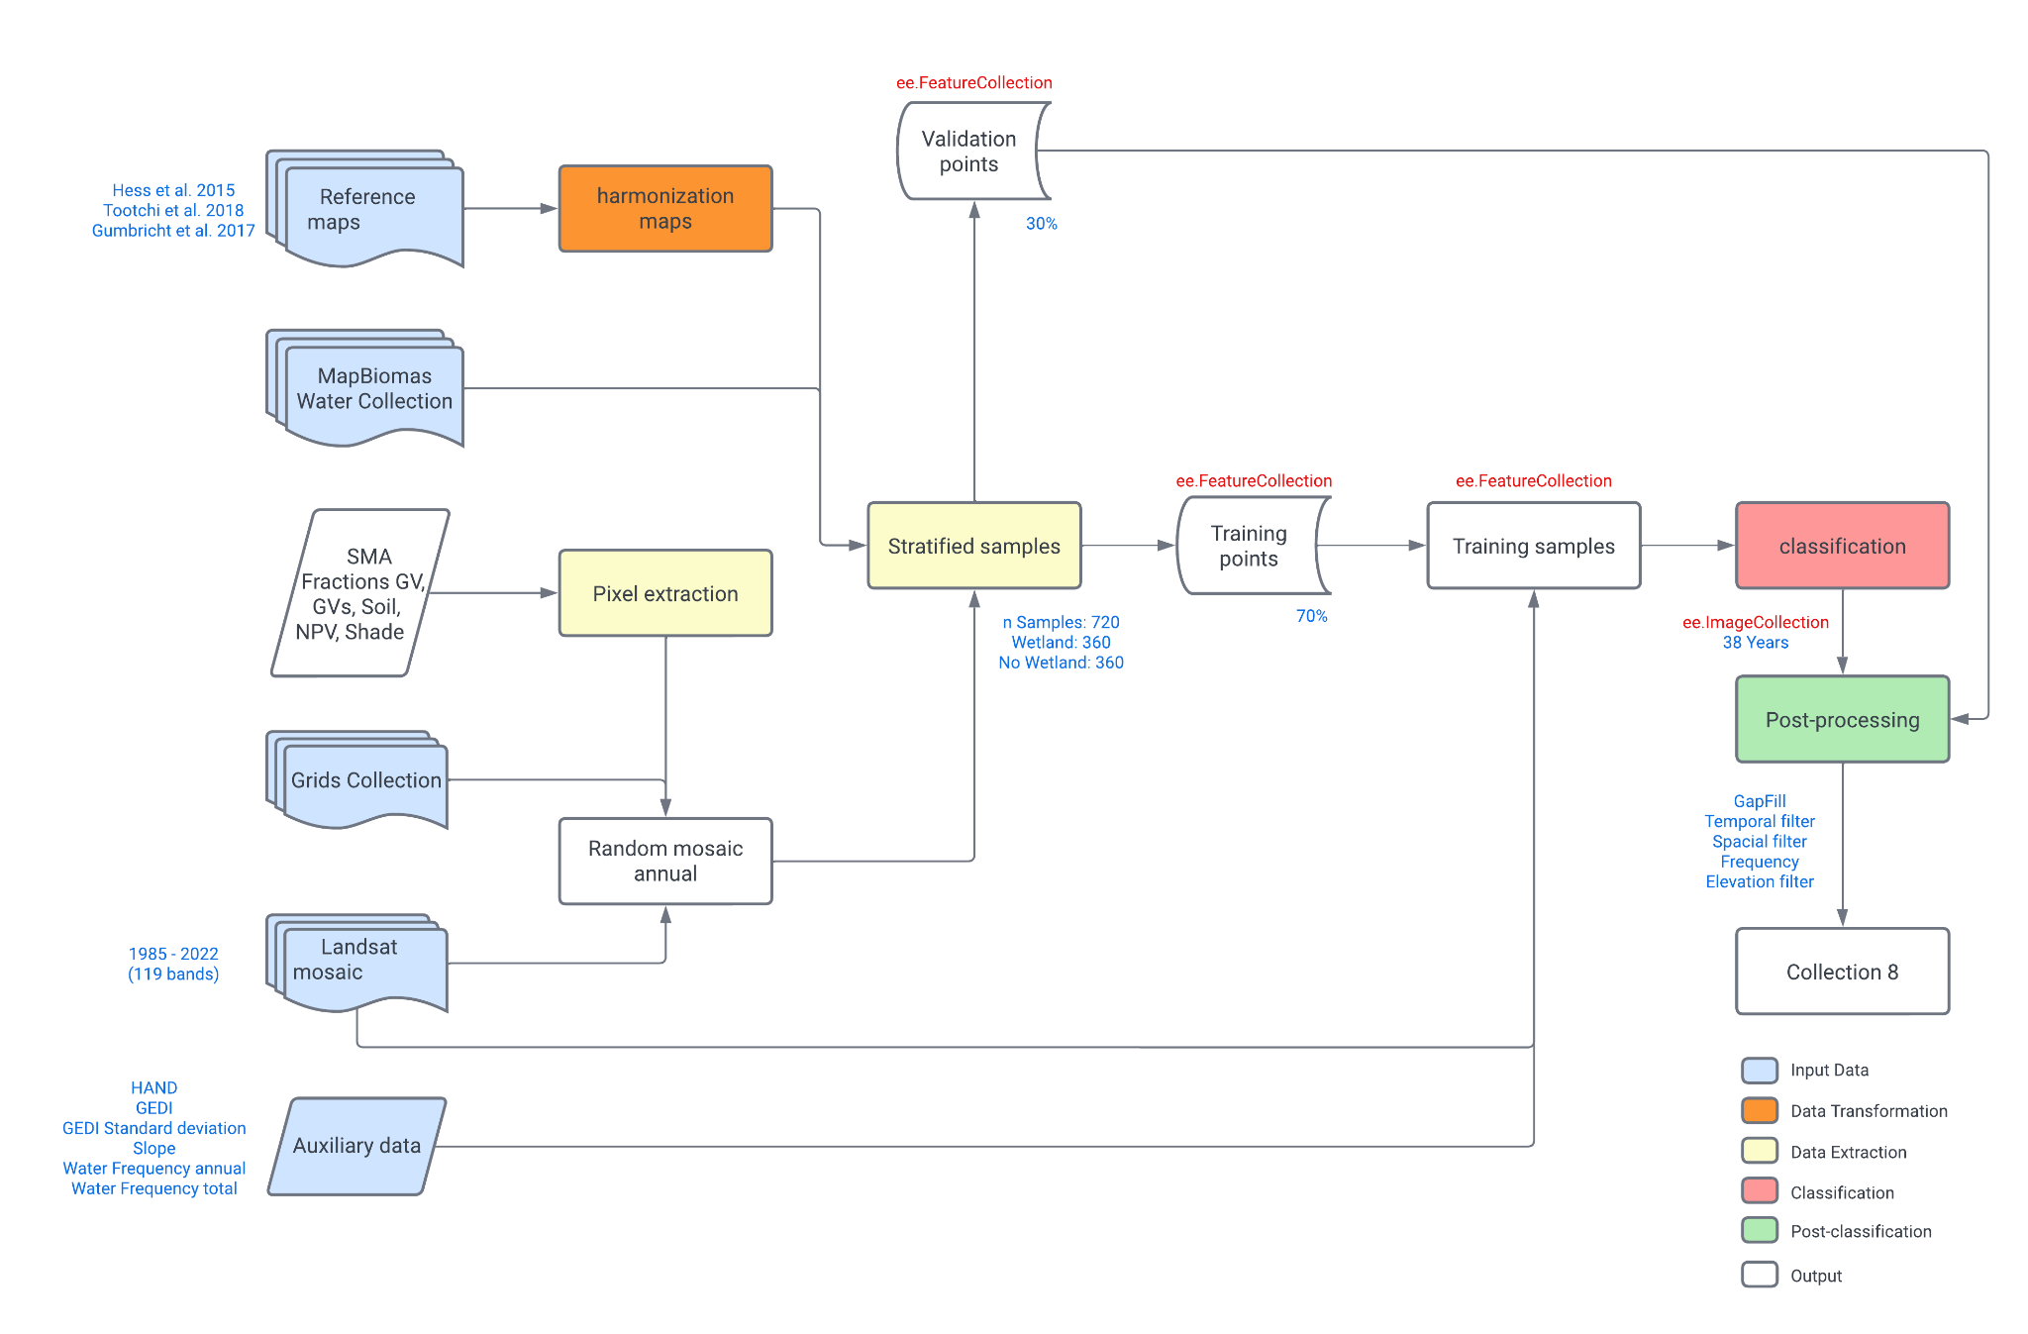

**Supplementary Figure 1.** Workflow with all methodological steps to map Wetlands in the Brazilian Amazon.

We randomly divided the mosaics into 30x30km grids to collect samples so each grid presented a mosaic from a specific year. We then compile and harmonize Amazon Wetland Reference Maps (HESS et al., 2015; TOOTCHI et al., 2018; GUMBRICHIT et al., 2017) for wetland and non-wetland classes. We used these maps and the water surface maps from MapBiomas Agua to collect, train, and calibrate stratified samples. Here, we separate 70% of the models for training and 30% for validation.

This way, we could classify the annual mosaics into a probabilistic wetland map. For each altitude range, we defined a threshold to consider wetlands. The following steps are post-classification processes based on a fill filter, temporal filter, spatial filter, and frequency filter. All scripts used to generate the wetlands map are available on [GitHub wetlands](https://github.com/mapbiomas-brazil/amazon/blob/master/modules/PreProcessing.py). Supplementary Figure 2 shows an example of wetland mapping along the Amazon River:

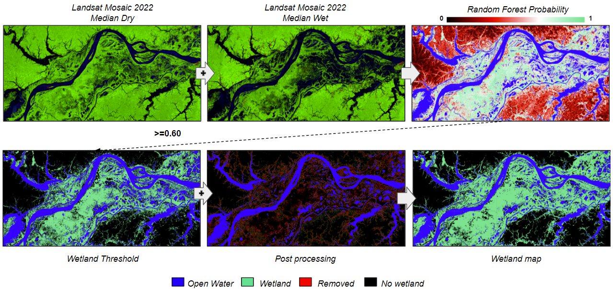

**Supplementary Figure 2.** Example of wetland mapping along the Amazon River.

***References***

Gumbricht, T., Román-Cuesta, R.M., Verchot, L.V., Herold, M., Wittmann, F., Householder, E., Herold, N., Murdiyarso, D.. 2017. An expert system model for mapping tropical wetlands and peatlands reveals South America as the largest contributor. ﻿ Global Change Biology 23(9):3581-3599 [doi:](http://dx.doi.org/10.1111/gcb.13689) <http://www.cifor.org/pid/6419>

Hess, L.L., J.M. Melack, A.G. Affonso, C.C.F. Barbosa, M. Gastil-Buhl, and E.M.L.M. Novo. 2015. LBA-ECO LC-07 Wetland Extent, Vegetation, and Inundation: Lowland Amazon Basin. ORNL DAAC, Oak Ridge, Tennessee, USA. <https://doi.org/10.3334/ORNLDAAC/1284>

Tootchi, Ardalan; Jost, Anne; Ducharne, Agnès (2018): Multi-source global wetland maps combining surface water imagery and groundwater constraints. Sorbonne Université, Paris, France, PANGAEA, <https://doi.org/10.1594/PANGAEA.892657>