***Supplementary Material***

**Unraveling the genetic evolution of SARS-CoV-2 Recombinants using mutational dynamics across the different lineages**

Varsha Ravi1,$, Uzma Shamim1,$,*, Md Abuzar Khan1, Aparna Swaminathan1, Pallavi Mishra1, Rajender Singh2, Pankaj Bharali3, Nar Singh Chauhan4, Rajesh Pandey1,5,*

1Division of Immunology and Infectious Disease Biology, INtegrative GENomics of HOst-PathogEn (INGEN-HOPE) laboratory, CSIR-Institute of Genomics and Integrative Biology (CSIR-IGIB), Mall Road, Delhi-110007, India.

2CSIR-Central Drug Research Institute, (CSIR-CDRI), Lucknow, India.

3CSIR-North East Institute of Science and Technology (CSIR-NEIST), Pulibor, Jorhat, Assam-785006, India.

4Department of Biochemistry, Maharshi Dayanand University, Rohtak, India.

5Academy of Scientific and Innovative Research (AcSIR), Ghaziabad-201002, India.

$Equal contribution

*Co-corresponding Authors

**Contact Details**

Rajesh Pandey, PhD

Principal Scientist,

INtegrative GENomics of HOst-PathogEn (INGEN-HOPE) laboratory,

CSIR-Institute of Genomics and Integrative Biology (CSIR-IGIB),

North Campus, Near Jubilee Hall, Mall Road, Delhi-110007, India.

Email: rajeshp@igib.in; rajesh.p@igib.res.in; Tel.: 011-27002200 (Ext. 254)

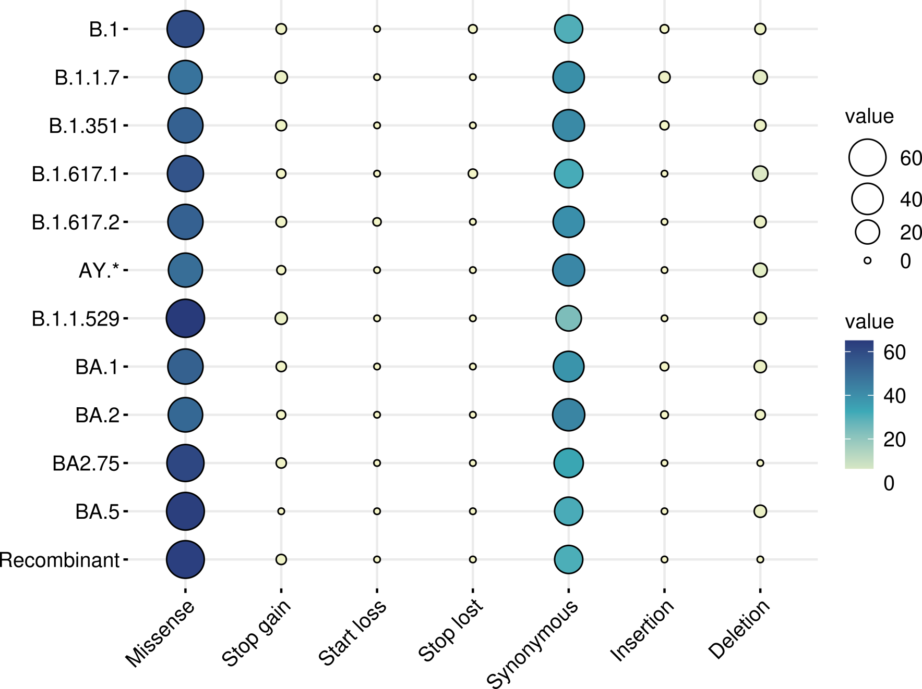

**Supplementary Figure S1**: Types of mutations and their correlation with respect to lineages from the Pre-VOC (B.1) to the Recombinant in the discovery data.

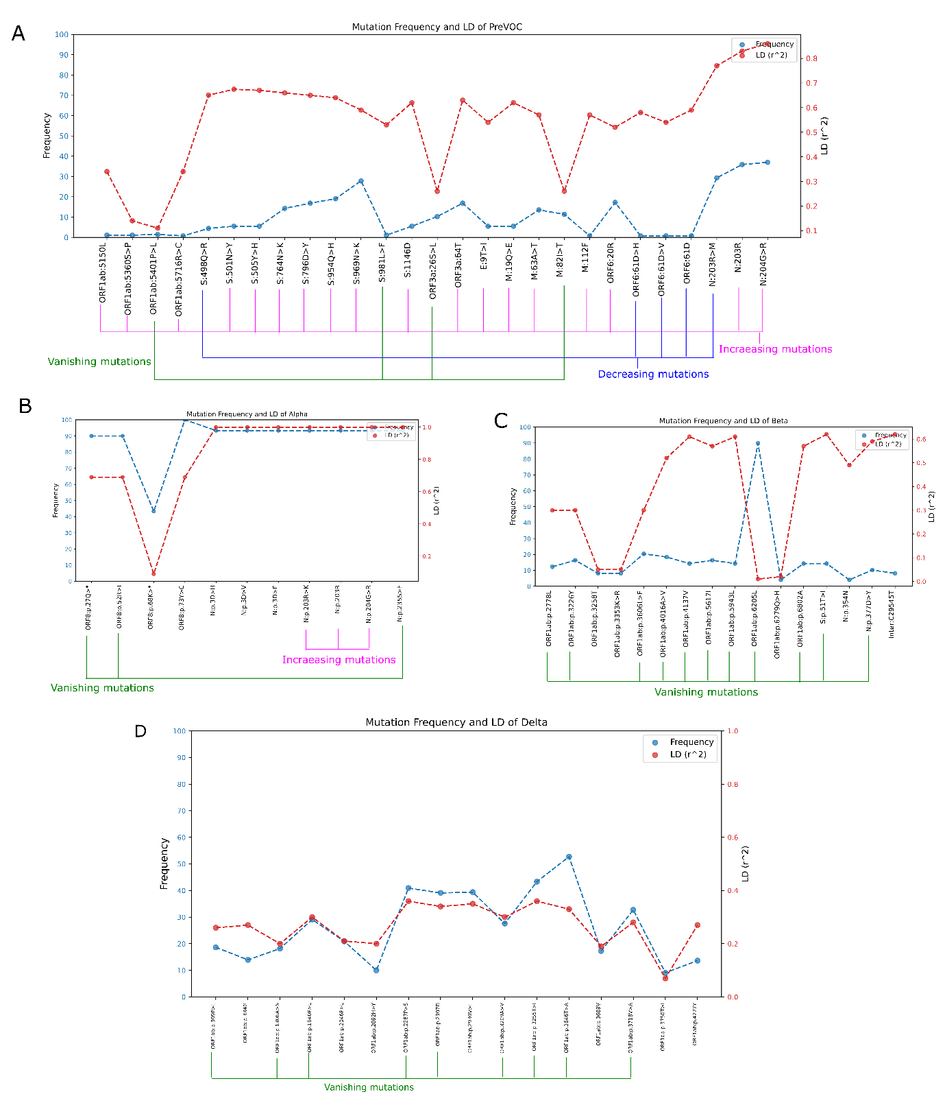

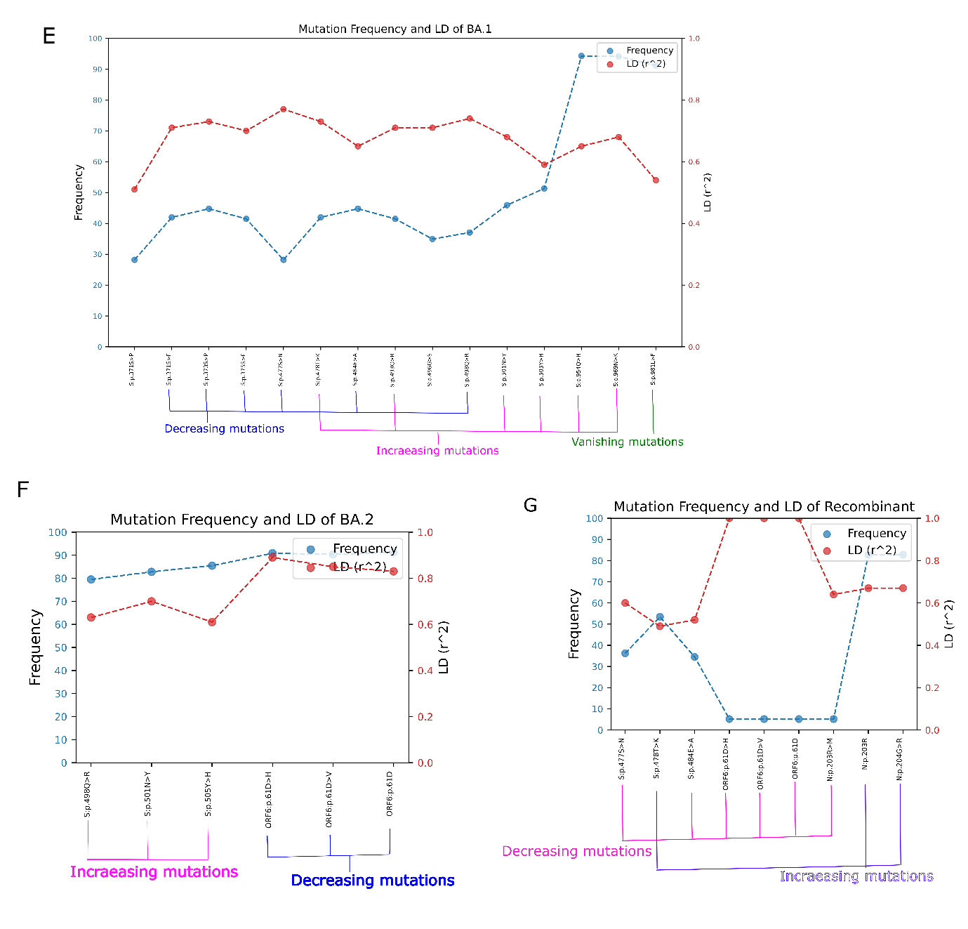

**Supplementary Figure S2**: Mutation Frequency and LD (r2) trend plots depicting increasing, decreasing and vanishing mutations.

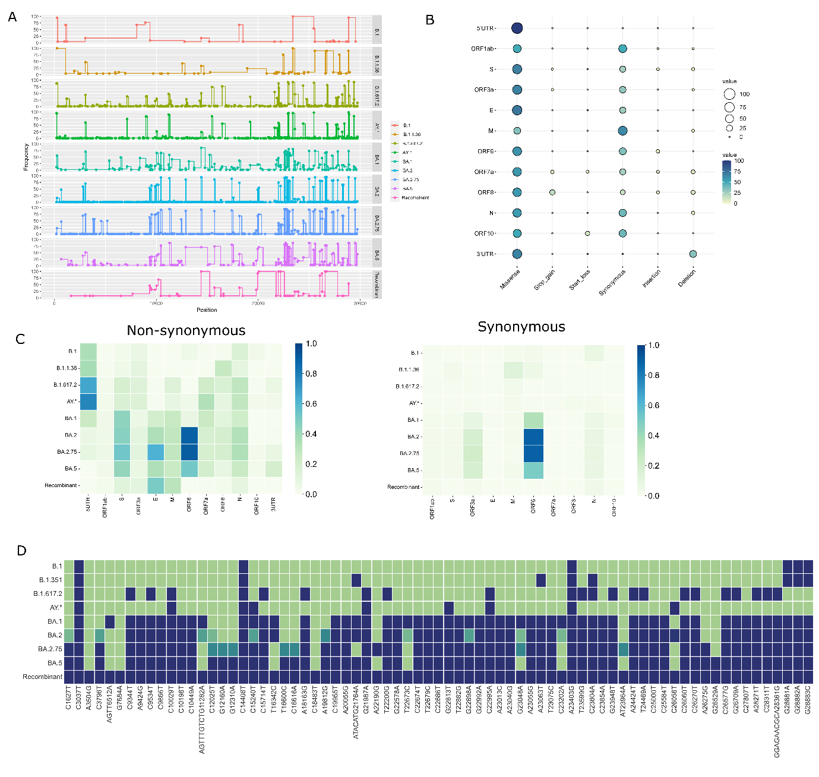

**Supplementary Figure S3**: Mutational dynamics of validation data. **(A)** Mutational trends of the Pre-VOC to Recombinant. **(B)** Types of mutations and their affluence in Gene-region. **(C)** Mutational abundance in Gene-regions with respect to lineages. **(D)** Heat map represents Recombinant mutations and respective mutation frequency in other lineages.

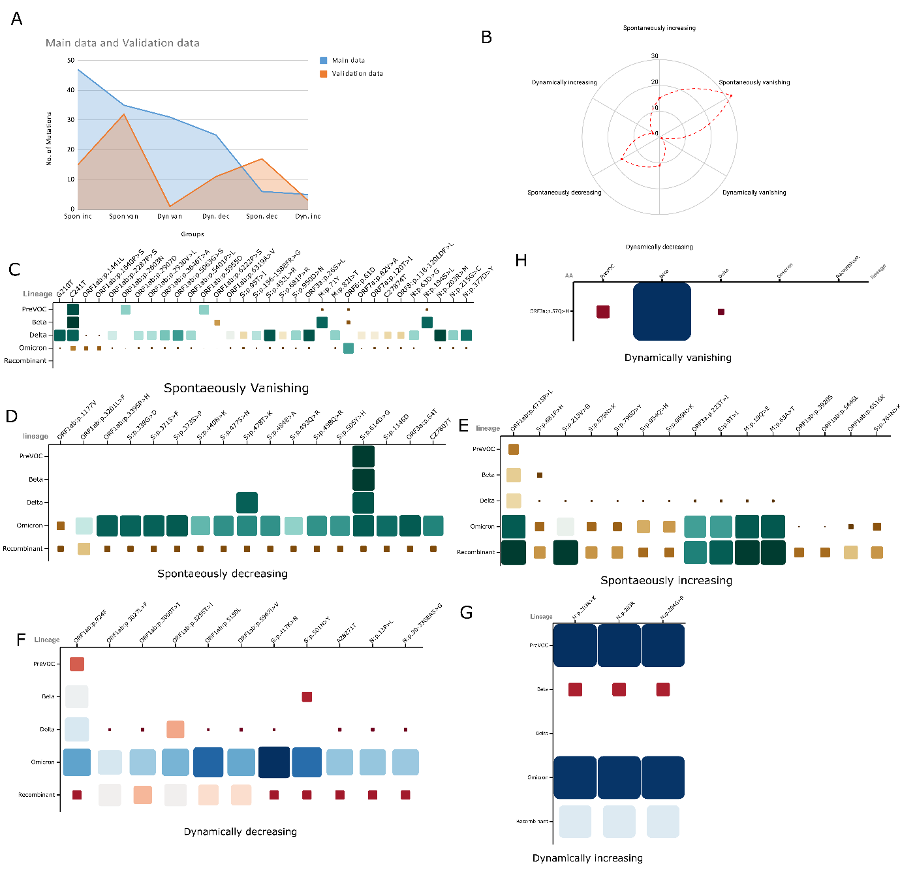

**Supplementary Figure S4**: Trends of mutations across lineages in validation cohort. **(A)** Comparison of mutation groups between discovery and validation data. **(B)** Spider plot depicts the proportion of mutations in the groups for validation data. **(C-E)** Matrix plot for *Spontaneously vanishing, decreasing* and *increasing* groups. **(F-H)** Matrix plot for *Dynamically decreasing, increasing* and *vanishing* groups.

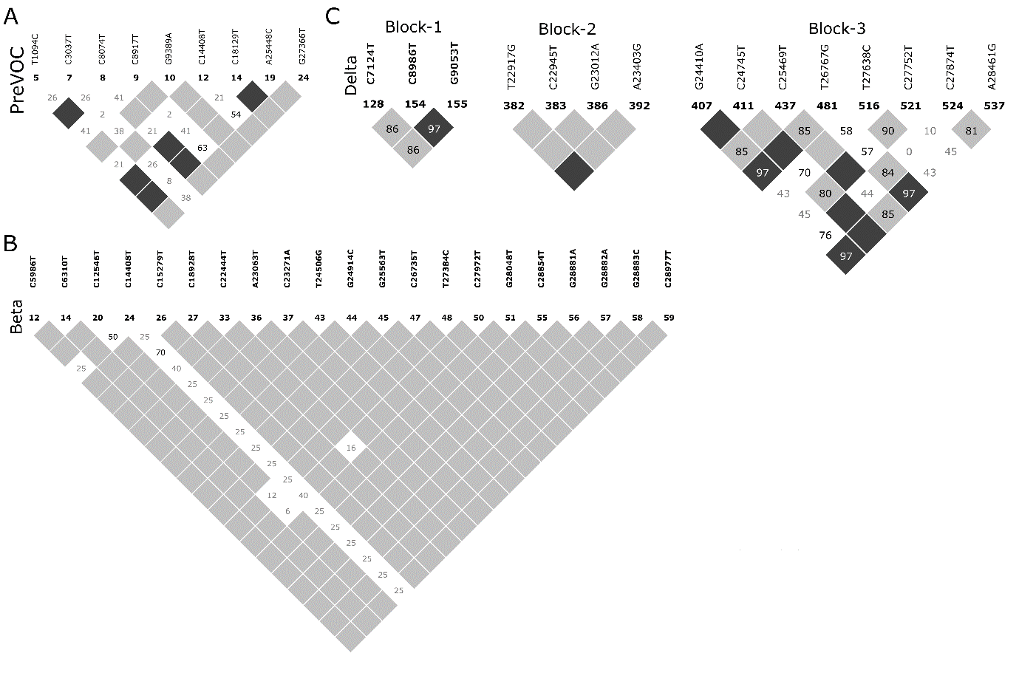

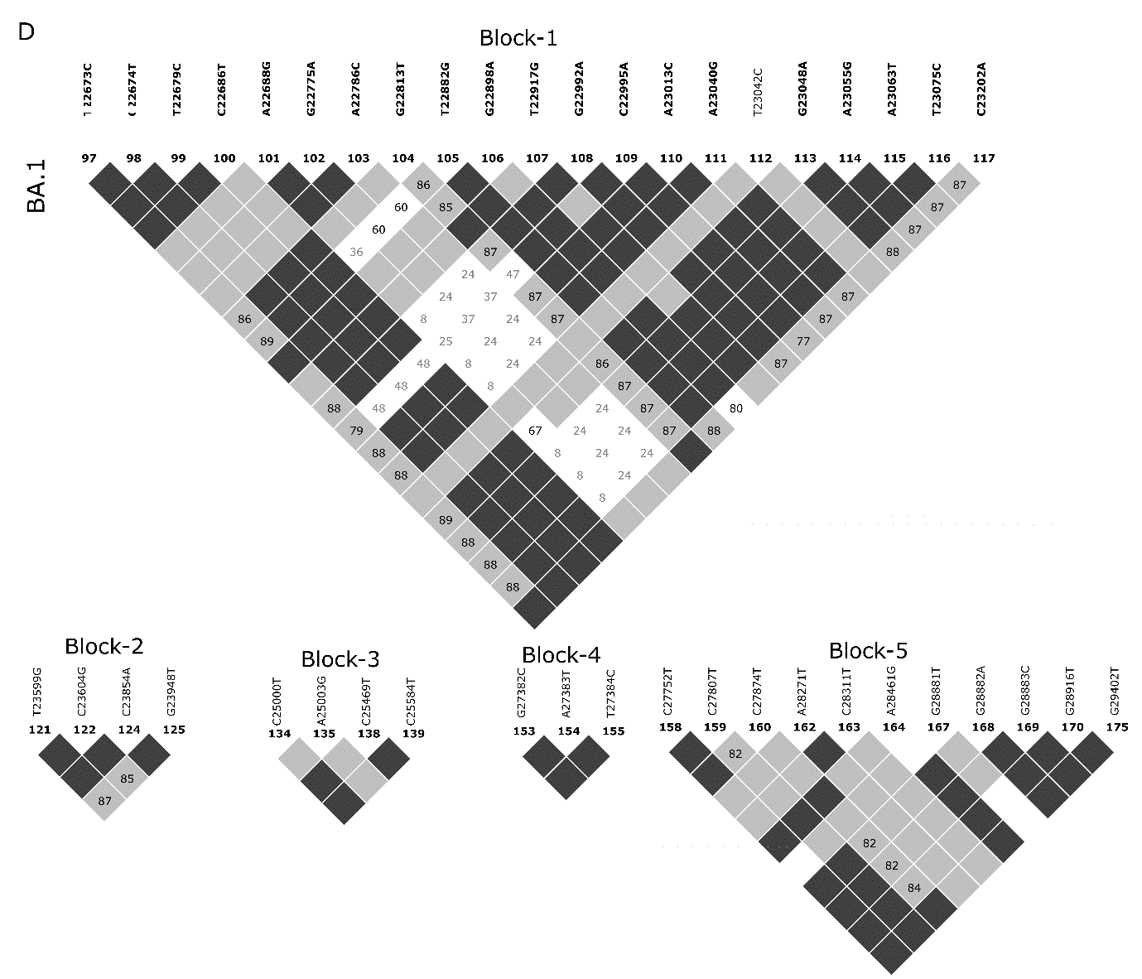

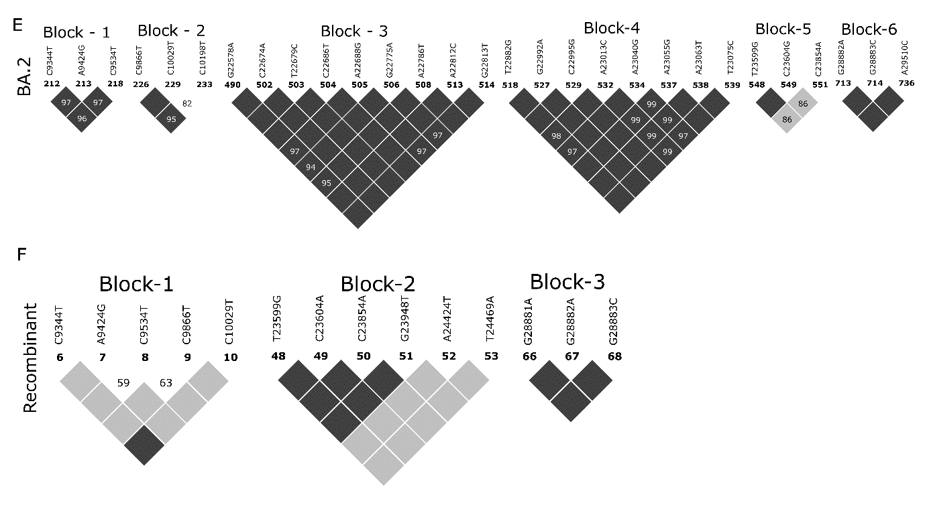

**Supplementary Figure S5**: Linkage Disequilibrium and Haplotype blocks of Validation data. (A-F) Pre-VOC to Recombinant.

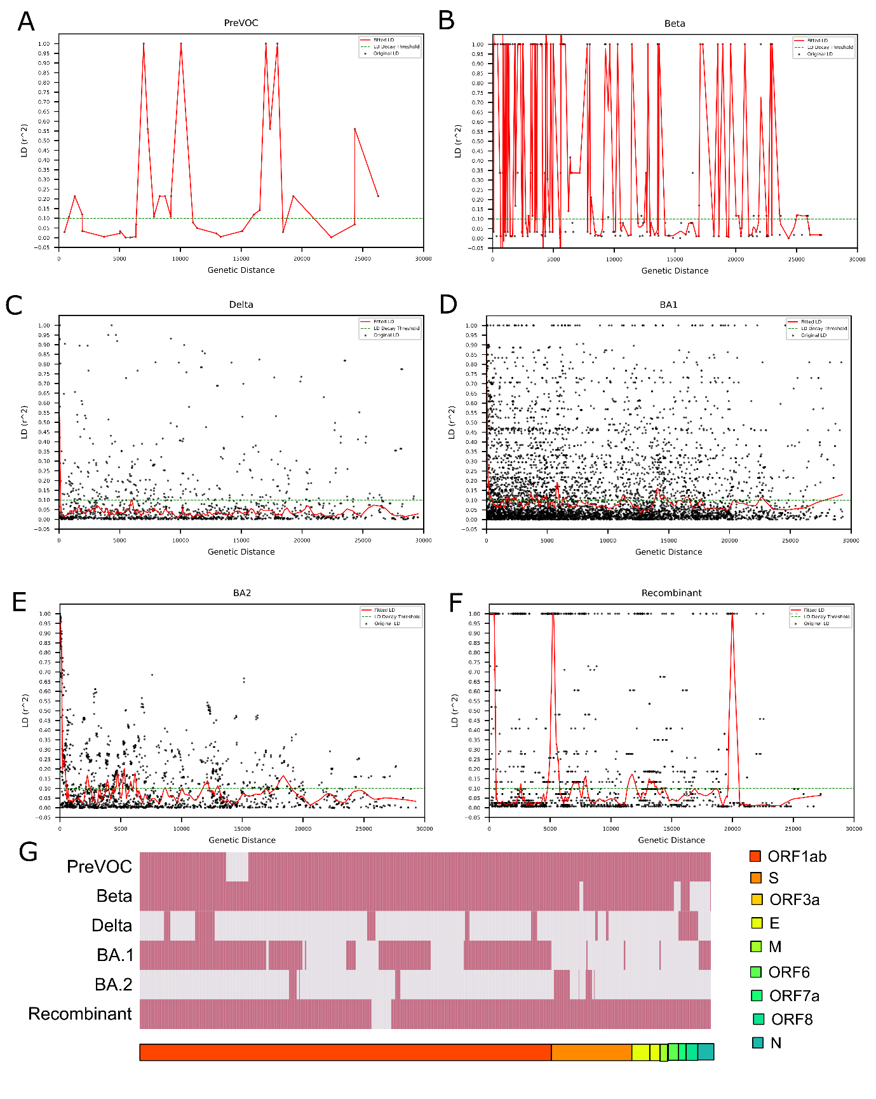

**Supplementary Figure 6**: LD decay for the Pre-VOC to Recombinant and breakpoint. (A-F) Pre-VOC, Beta, Delta, BA.1, BA.2, and Recombinant. (G) Heat map demonstrated the breakpoint from the Pre-VOC to the Recombinant. **Pink colour signifies breakpoint in that position.